CRoW Appendix 4 (140_10_SD02)  CRoW Act 2000: Natural Resources Wales application for permission - Formal Notice |  | 
Natural Resources Wales Formal Notice.
Requirements of Section 28I of the Wildlife & Countryside Act 1981 as amended by the Countryside and Rights of Way Act (CRoW) 2000.
Duty in relation to granting any consent, licence or permit for activities likely to damage Sites of Special Scientific Interest (SSSI).
Guide to filling in this form for Natural Resources Wales staff:
To be completed by Permitting Officers for any applications for a permission which the Natural Resources Wales has considered under S28G duties to protect and enhance SSSIs. This applies to all proposed permissions within a SSSI, and to operations outside the SSSI boundary which are likely to damage its special features.
Refer to OI 140_10 ‘Applying the Countryside and Rights of Way (CRoW) Act 2000 to applications for permits with potential for impact on Sites of Special Scientific Interest (SSSI)’, including the flowchart in Appendix 2.
Pink italic text – drafting notes, to be deleted before completion/consultation.
Blue text – examples, to be replaced with permission-specific information.
Ensure you have completed all sections.
- Natural Resources Wales area/region/NPS hub: | Mid Wales
- Name of SSSI: | The River Usk SSSI
- Type of permission: | Land spreading deployment under standard rules permit SR 2010 No4 Mobile plant for land spreading.
- Date for Natural Resources Wales permit determination: | 10/01/2023
- Predicted 28 day date for response from NRW conservation/ecology (under S28 I(4)): | 10/01/2023
- Natural Resources Wales reference no: | PAN-019774
- National grid reference: | Farm location: SO 05078 25701  Fields:  Abercynrig 2 - SO 07297 26904  Abercynrig 10 - SO 06919 26499  1 - SO 11043 23464  2 - SO 11169 23269  10 - SO 12318 22415  11 - SO 12064 22598  16 - SO 12325 22953  Storage: SO 04988 25616
- Description of proposal: | A land spreading application to spread 10 waste streams (EWC 19 09 02) at Tylebrithos Farm, Brecon, Powys. Wastes are to be spread on 7 fields which contain grass. The application rate of the wastes ranges from 98-250 tonnes per ha, with a total tonnage to spread a maximum of 11,725 tonnes.  The waste will be spread over 46.9 ha hectares of land within the listed fields at Tylebrithos Farm. All waste spread under this deployment are non-stackable sludges. The wastes are intended to be spread via dribble bar application.  The wastes will be stored in an storage tank and lagoon at a quantity not exceeding 1,250 t complying with the SRP. The storage locations are not within 10m of any ditch, watercourse, or footpath, not within a SPZ1, and are at least 50m from any well spring or borehole. They are also a safe distance from overhead powerlines.  Targeted periods of spreading on grass & winter barley fields include spring, after cutting of silage, and prior to grazing through summer and autumn.  The following nutrients crop types in each field are detailed in the table below:  The land spreading activity will comply with the Code of Good Agricultural Practice guidelines (COGAP).  Documents related to this deployment can be found on the DMS.
  Field Name | Crop
  Abercynrig 2 | 2 cuts silage (25% dry matter) with aftermath grazing
  Abercynrig 10 | 2 cuts silage (25% dry matter) with aftermath grazing
  1 | Winter barley
  2 | Winter barley
  10 | 2 cuts silage (25% dry matter) with aftermath grazing
  11 | 2 cuts silage (25% dry matter) with aftermath grazing
  16 | 2 cuts silage (25% dry matter) with aftermath grazing
- Is the proposed activity within (wholly or partially) the SSSI boundary? | NO  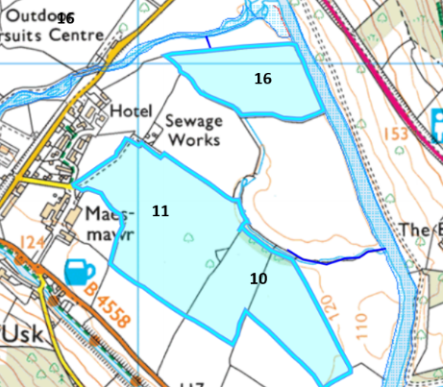  Field 16 is located next to the River Usk SSSI. There is a 20 meter no spread buffer zone in the field to prevent nutrients entering the river.  Fields 11 and 10 border water courses that drain into the River Usk SSSI over a 280 meter distance.  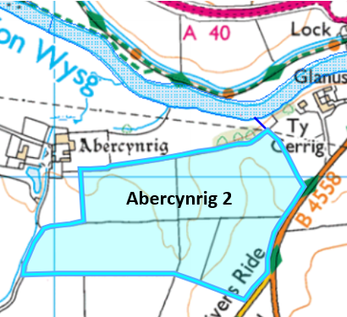  Field Abercynrig 2 is located 35 meters at its closest point from the River Usk SSSI.  The River Usk (Tributaries Monmouthshire & Newport) SSSI was not considered in this appendix 4 as it does not cover the area of where this proposed landspreading activity is based.  Below is a table detailing the distance that all the fields will be to the SAC:  The location map related to this application can be found here.
  Field | Distance field is from SAC (meters)
  Abercynrig 2 | 35
  Abercynrig 10 | 23
  1 | 600
  2 | 770
  10 | 100
  11 | 175
  16 | Borders River Usk SAC (20 meter no spread buffer zone in place).
- Has there been any pre-application discussion or correspondence with NRW conservation/ecology | NO
- What aspect(s) of the proposed permission may damage the features which are of special interest for the SSSI?

The following ‘Operations Requiring Consent’ (or other activities associated with the permission) that may cause damage) are relevant to the proposed permission.

River Usk (Upper Usk)/Afon Wysg (Wysg Uchaf)

5. Application of manure, fertilisers and lime except to agriculturally improved permanent grass, forest and all other
unimproved riparian habitats.

1. Cultivation, including ploughing, rotovating, harrowing and re-seeding.

7. Dumping, spreading, discharging or storage of any materials.

26. Use of vehicles, vessels or craft likely to damage semi-natural habitats or disturb species of interest.

The following SSSI features and mechanisms of impact have been considered to assess the likelihood of damage:

River Usk (Upper Usk)/Afon Wysg (Wysg Uchaf)

• Vegetation dominated by water crowfoot
• Rare mosses and liverworts
• Welsh thread-moss
• Tiny pocket-moss
• Spruce’s bristle-moss
• Aquatic lichen
• Otters
• Atlantic salmon
• Twait shad
• Sea, brook and river lamprey
• Bullhead
• Invertebrates associated with exposed river sediments

Potential mechanisms for damage

There is an surface runoff risk of nutrients and/or PTE entering the river due to the close proximity field 16 is to the SSSI. This could impact water quality and inhabitants of the river which are listed above.
- Decision
i) The proposed permission is not likely to damage any of the flora, fauna or geological or physiological features which are of special interest.

The proposed permission is not likely to damage any of the flora, fauna or geological or physiological features which are of special interest.

- Field 16 which borders the SSSI contains a 20 meter no spread buffer zone to mitigate the risk of nutrients/PTEs entering the SSSI.

- Field 16 is located on flat to gently sloping land meaning the risk of runoff/leachate is lower as the waste will be incorporated into the soil effectively.

- Field Abercynrig is located 35 meters from the River Usk SSSI. This distance will mitigate the risk of nutrients entering the SSSI.

- To mitigate the pollution risk to watercourses/SSSIs the waste materials will not be applied at a rate greater than 50 t/ha in any 3-week period.

- Wastes will be spread by dribble bar application. Which is an appropriate application method for the waste type which are efficient methods to prevent odour transmission & nutrient losses.

- As shown on the nutrient calculator for this application, all fields being spread on have a greater overall offtake of phosphate than is being added by the spreading, so the overall levels of phosphate in the soils will decrease from their current level within the 12 month period of this deployment. There will be no overall phosphate increase to the land as a result of this application. Note: Waste stream Whiteboune sludge is adding 10kg/ha of additional phosphorus for listed fields in this deployment to account for the aftermath of grazing.

- All wastes streams are non-stackable liquid sludges, so dust should not be generated during the activity and as such, no dust from this activity should enter any protected water courses.

- Wastes will be spread at appropriate times when the crop will benefit from the nutrients provided i.e. spring, summer & autumn. Applications will be carried out as per CoGAP i.e. when ground conditions are suitable.

- The wastes will be applied following the Code of Good Agricultural Practice.

- A site-specific risk assessment has been provided by the operator to take into account any potential issues and provide any mitigation that may be required.

- All machinery will be fully serviced.

- There will be sufficient trained staff available to ensure that the operation continues throughout operational hours.

Natural Resources Wales is minded to: Issue the permission

- Name and job title of Natural Resources Wales officer: | Owen Clee  Permitting Officer
- Date form sent to NRW conservation/ecology | 12/12/2022
For Natural Resources Wales use only, once NRW conservation/ecology response received
- NRW conservation/ecology comment on assessment: | Please delete as appropriate:  i) NRW conservation/ecology advise the operation can go ahead  ii) NRW conservation/ecology advise the operation can go ahead with conditions  iii) NRW conservation/ecology advise against permitting the operation  Please ensure that the NRW conservation/ecology response is attached to this Formal Notice.
- Name and job title of NRW conservation/ecology officer:
- Date of receipt of NRW conservation/ecology response:

