PAN-019908 My Map Report:
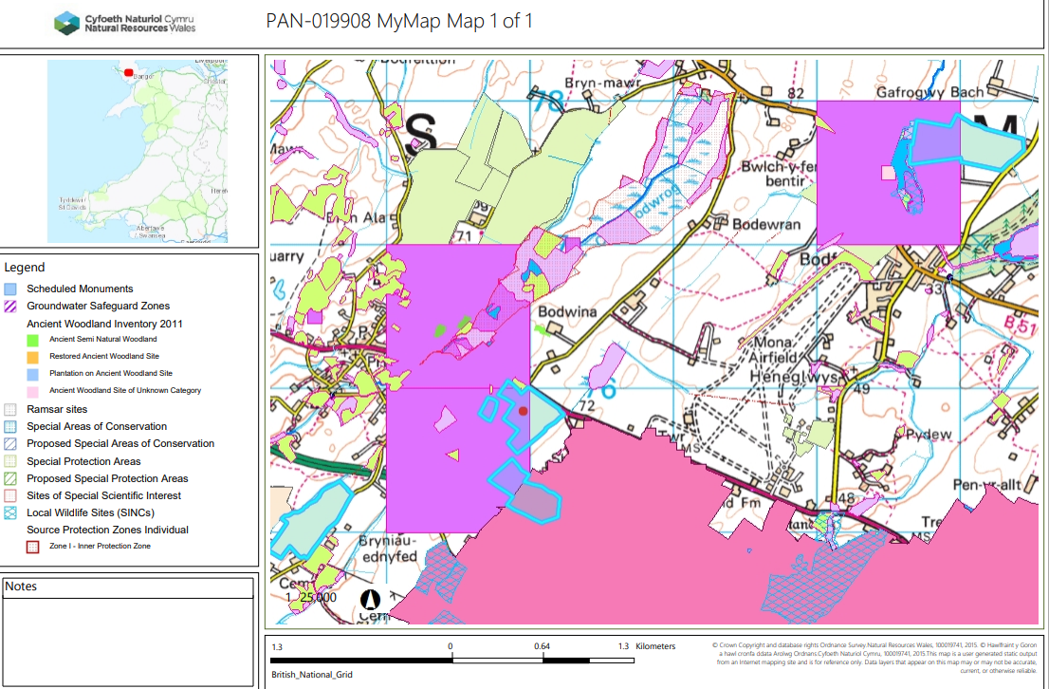

Spreading Maps
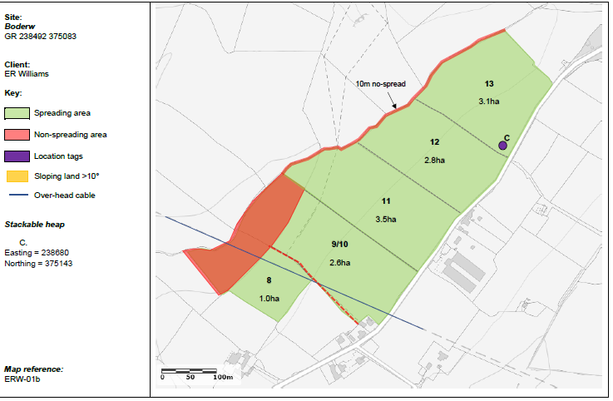
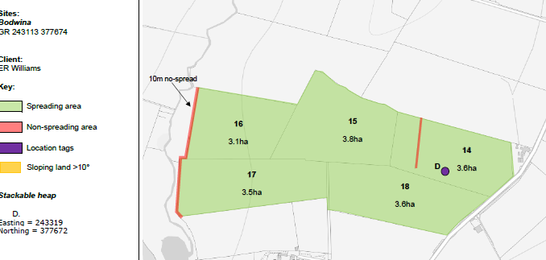
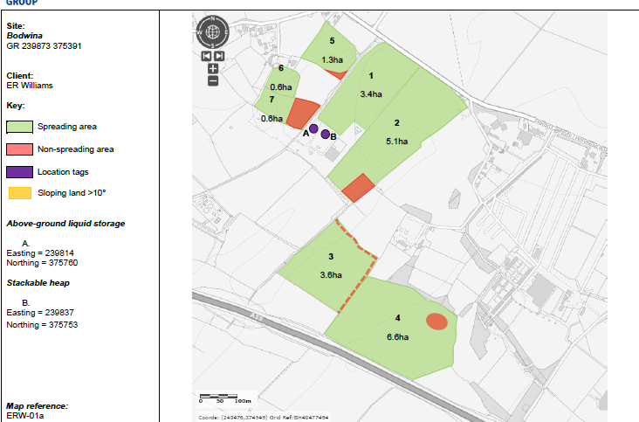
Detailed river network:
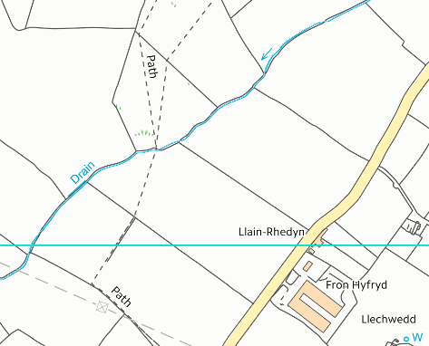
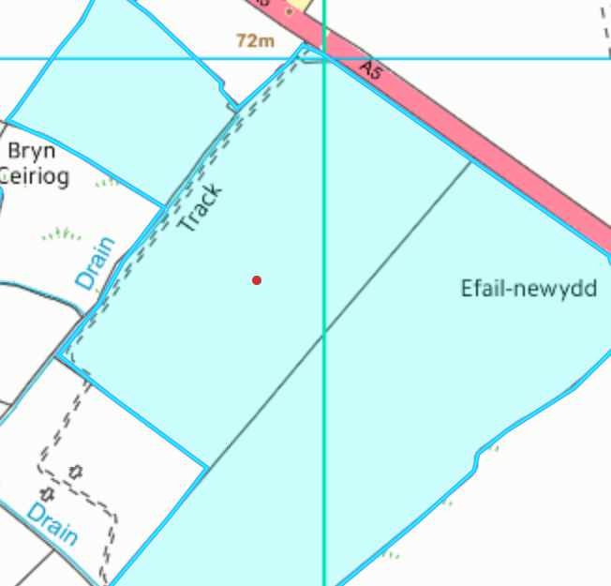
13

12

11
9/10

Fields 1, 2 & 5 border land drains. There are buffer zones and non-spreading areas near the land drains. W
2
1

5
Fields 9/10, 11, 12 & 13 border surface waters/land drains which have been correctly buffered by 10 meters in accordance with the SRP.
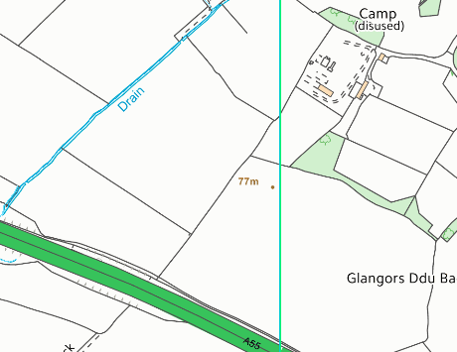

16

17

Fields 16 & 17 border surface waters/land drains which have been correctly buffered by 10 meters in accordance with the SRP.

Groundwater protection zones

None in range.

Wells, springs or boreholes used for the supply of water for human consumption including from a private water supply or supplies
None in range.

any springs wells or boreholes not used to supply water for domestic or food production purposes within 50m

None in range.

European designated sites- Natura 2000 (SPA, pSPA, SAC or cSAC) or Ramsar- or SSSI within 500m
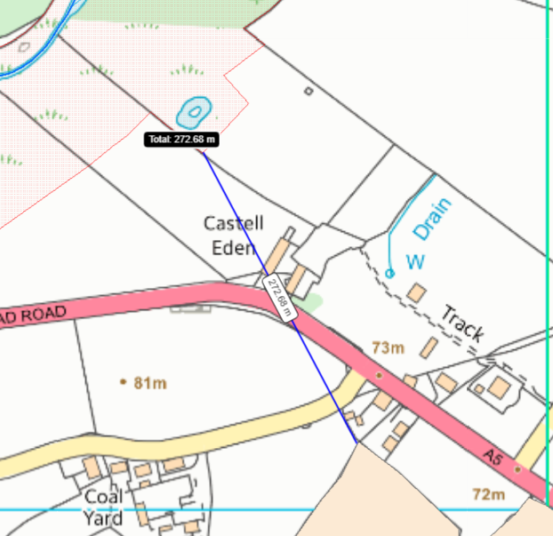
5
Cors Bodwrog SSSI
Field 5 is located 272 meters from Cors Bodwrog SSSI Field 5 is the closest field to the SSSI. There is no direct impact pathway to the site due to distance the closest field is from the SSSI. There are also physical barriers prevent the waste to enter the SSSI such as two main roads. The ground is also flat to gently sloping at 0-7º which means the waste will not drain into the SSSI.

5

Other protected sites:

- Protected Species-

6

7
1

5
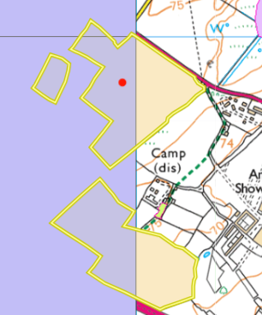
Fields 1, 2, 3, 4, 5 & 6 are located in an area containing threatened Bryophyte. As waste is being applied to field and not hedges/ trees it is not likely the protected species will be effected from this landspreading activity. No action required.

3

4

2

- Protected Habitats-

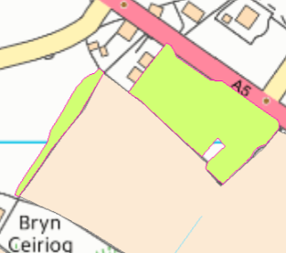
Field 5 borders a protected habitat: Lowland dry acid grassland and Lowland calcareous grassland. This has been referenced in the new site plan. A 10 meter no spread buffer zone is also in place around the border of field 5 and the protected habitat. This will ensue no wastes enter the protected habitat.

5

- Scheduled Ancient Monument- None in range.

- Local Nature Reserve- None in range.

- National Nature Reserve- None in range.

- Ancient Woodlands- None in range

- Local Wildlife Sites (SINC)- None in range.

- National Park- None in range.

- Nitrate Vulnerable Zone (NVZ)-

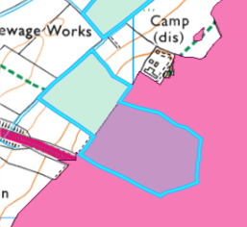
Field 4 is located within a NVZ. Field . The request for information has asked to account for this in ABS as waste streams Penhesgyn tank & lagoon have a highly readily available nitrogen content (76% + 38% respectively).

4

- Groundwater Safeguard Zone- None in range.

- Hedges- Nothing of concern.

- Ditches- Nothing of concern.

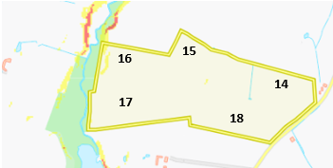
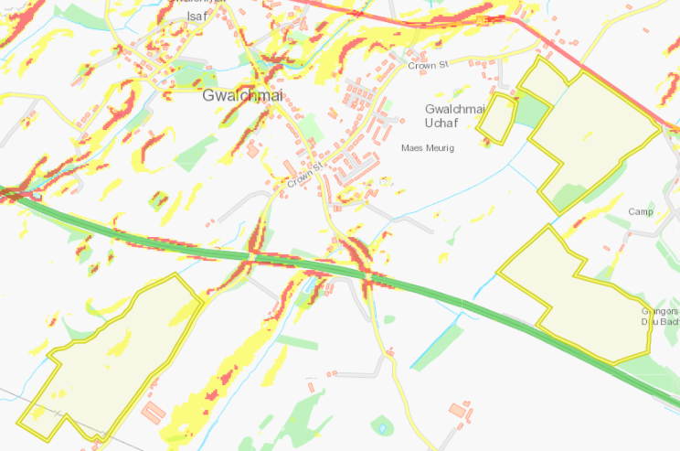
Slope Map
The rest of the fields in this deployment application contain flat to gently sloping areas of land (0-7º) which do not pose a runoff risk.
Fields 13 , 11 & 8 contain small areas of land that are moderately sloping at 7-12º. These areas are contained to the spreading fields with little risk of runoff outside the spreading area. The application method of applying the stackable sludge via rear discharge spreader is appropriate and also the use low trajectory splash plate or dribble bar for liquid sludges. No more than 50t/ha will be spread on a field in any 3-week period to allow the soil to effectively absorb the wastes and mitigate runoff.
7

6

5

1

2

9/10

8

12

13

11

3

4

