Lovatt Brothers Site Compliance Visit

27 September 2022: Photographs by Malcolm Dines

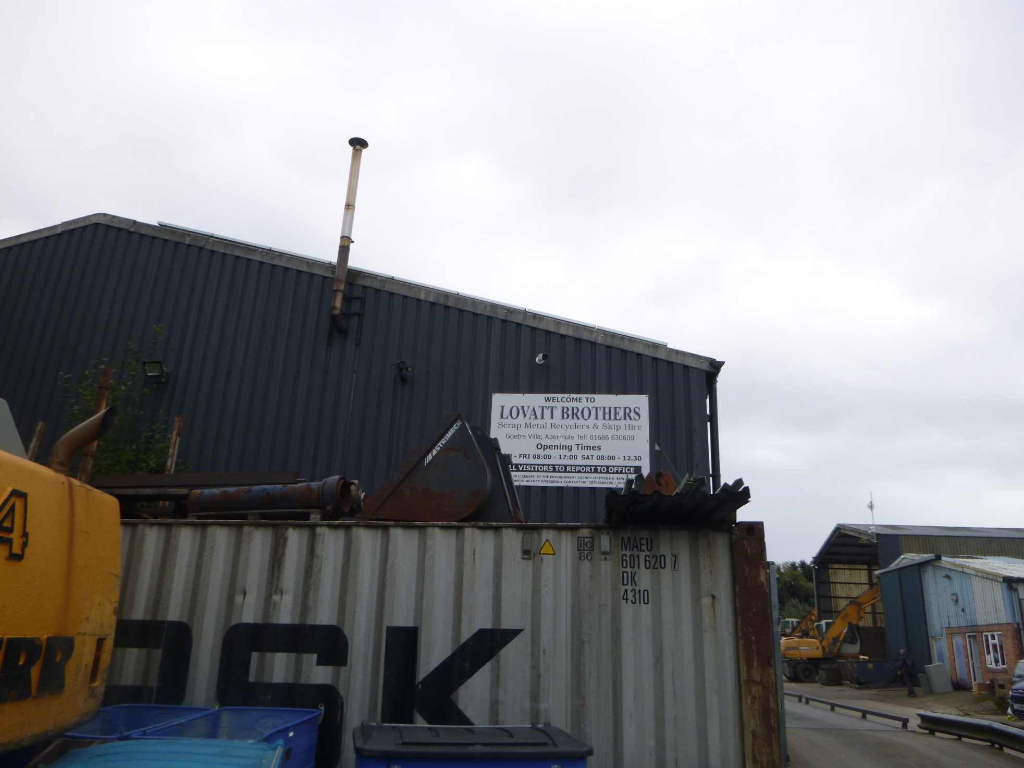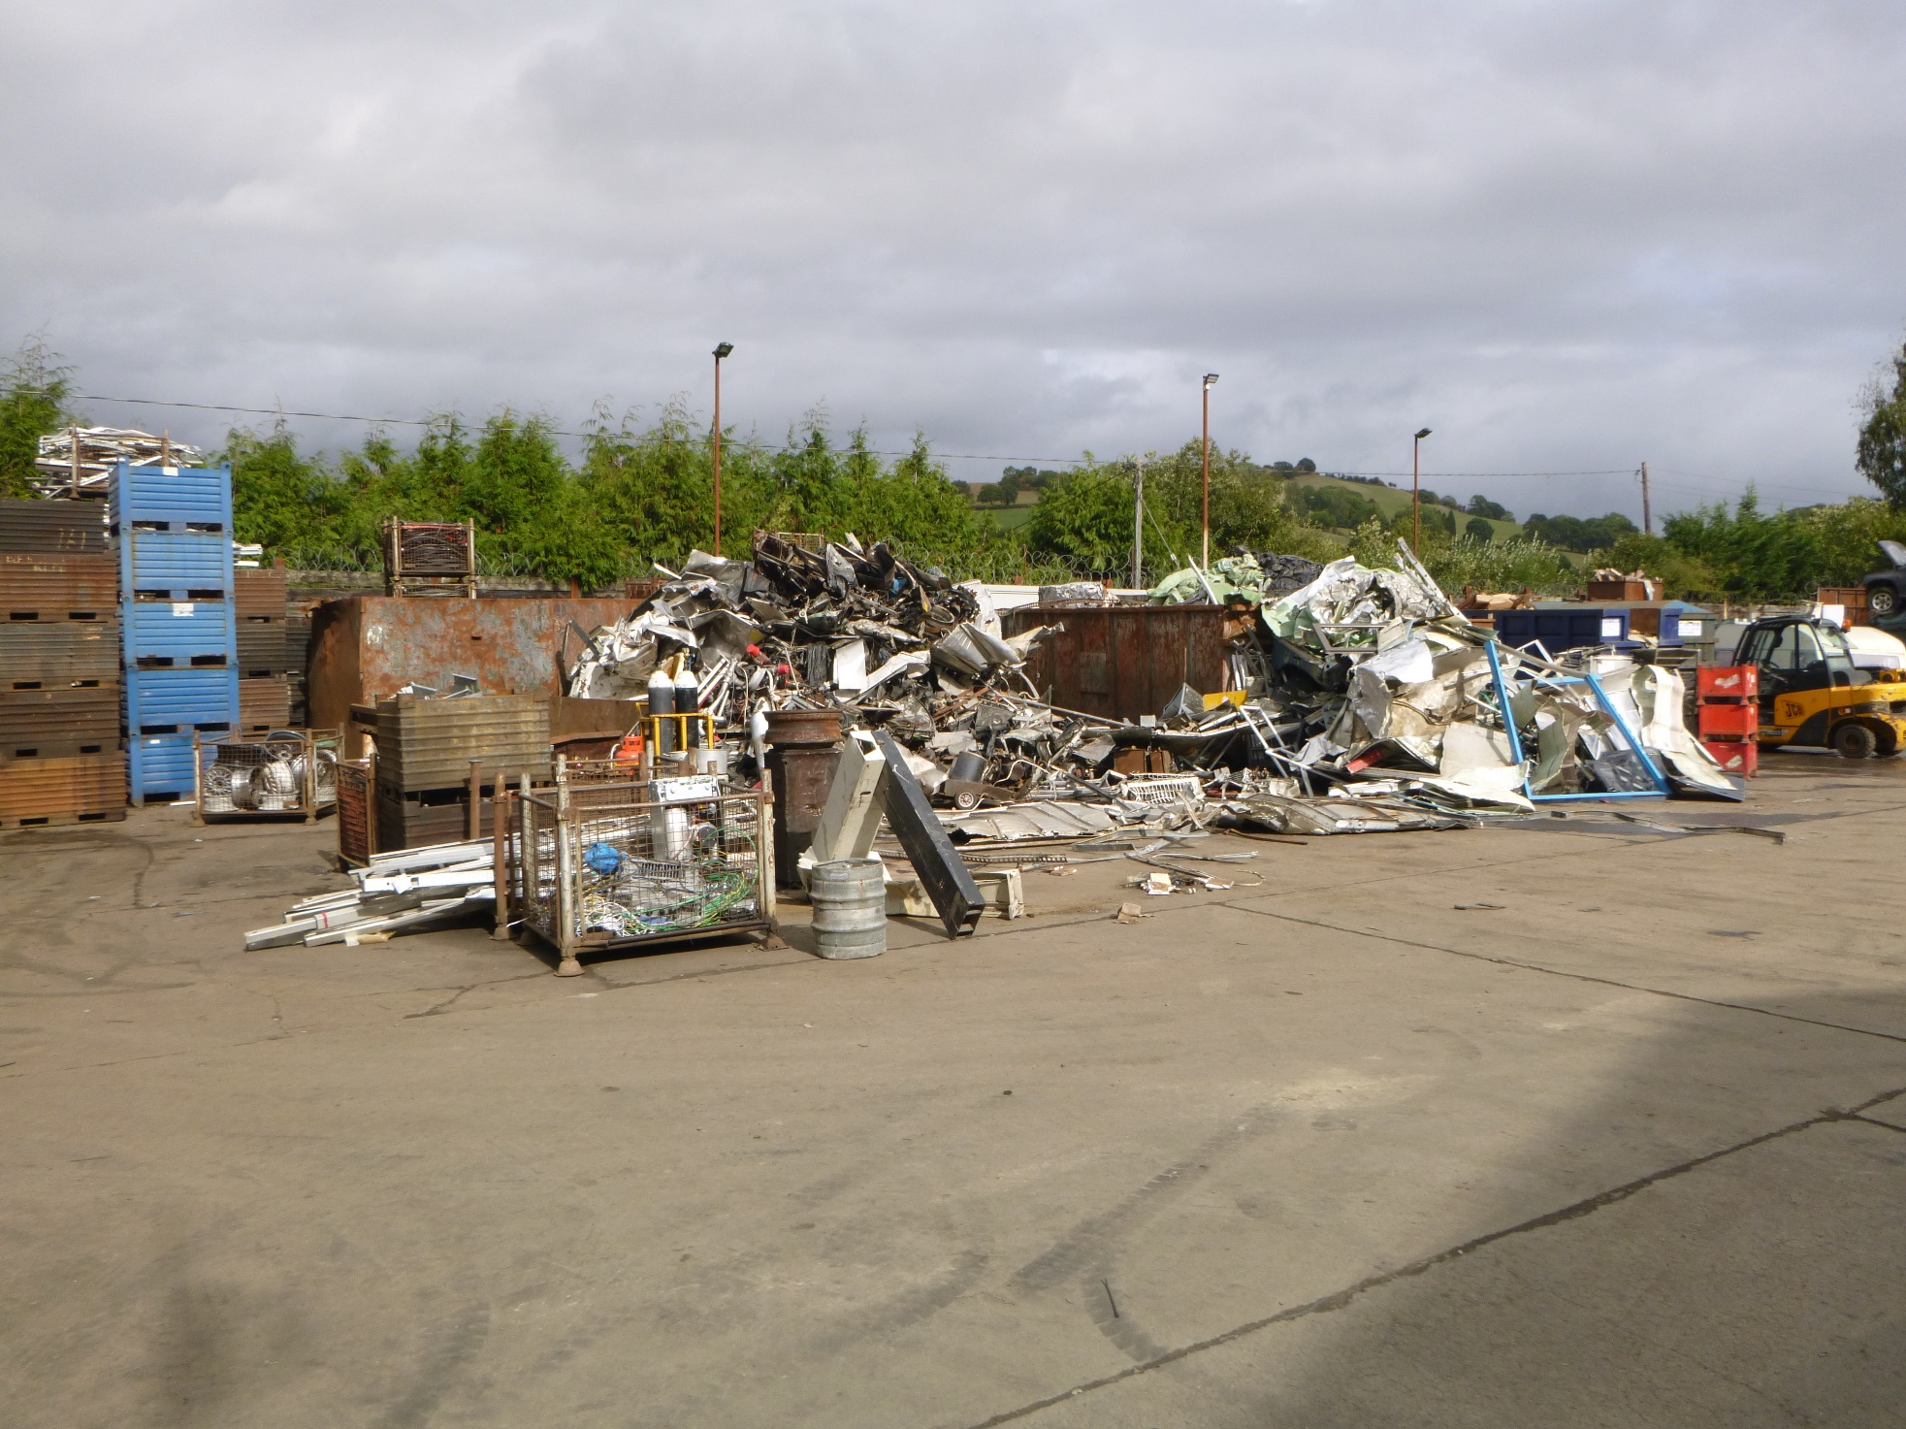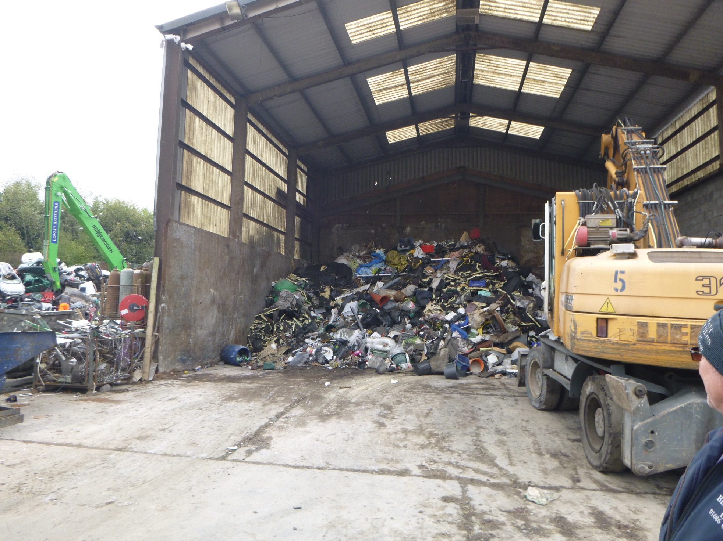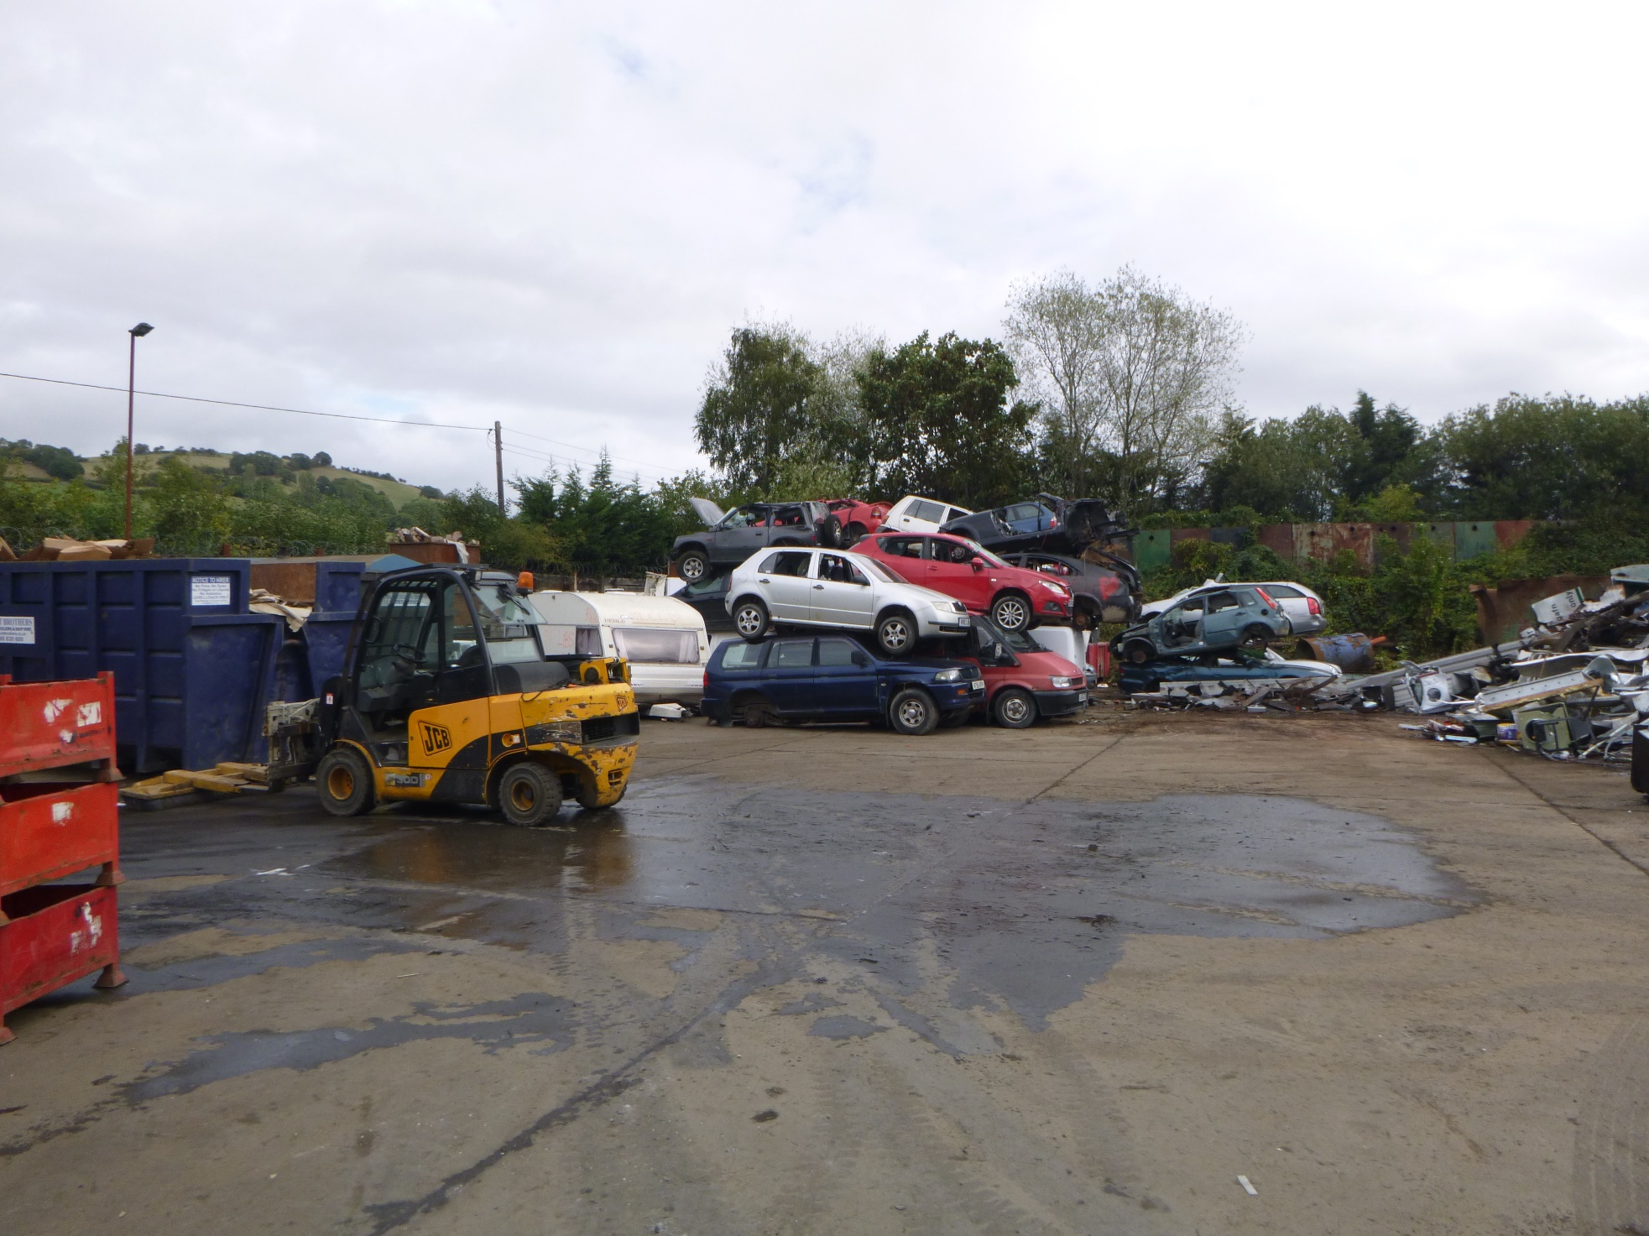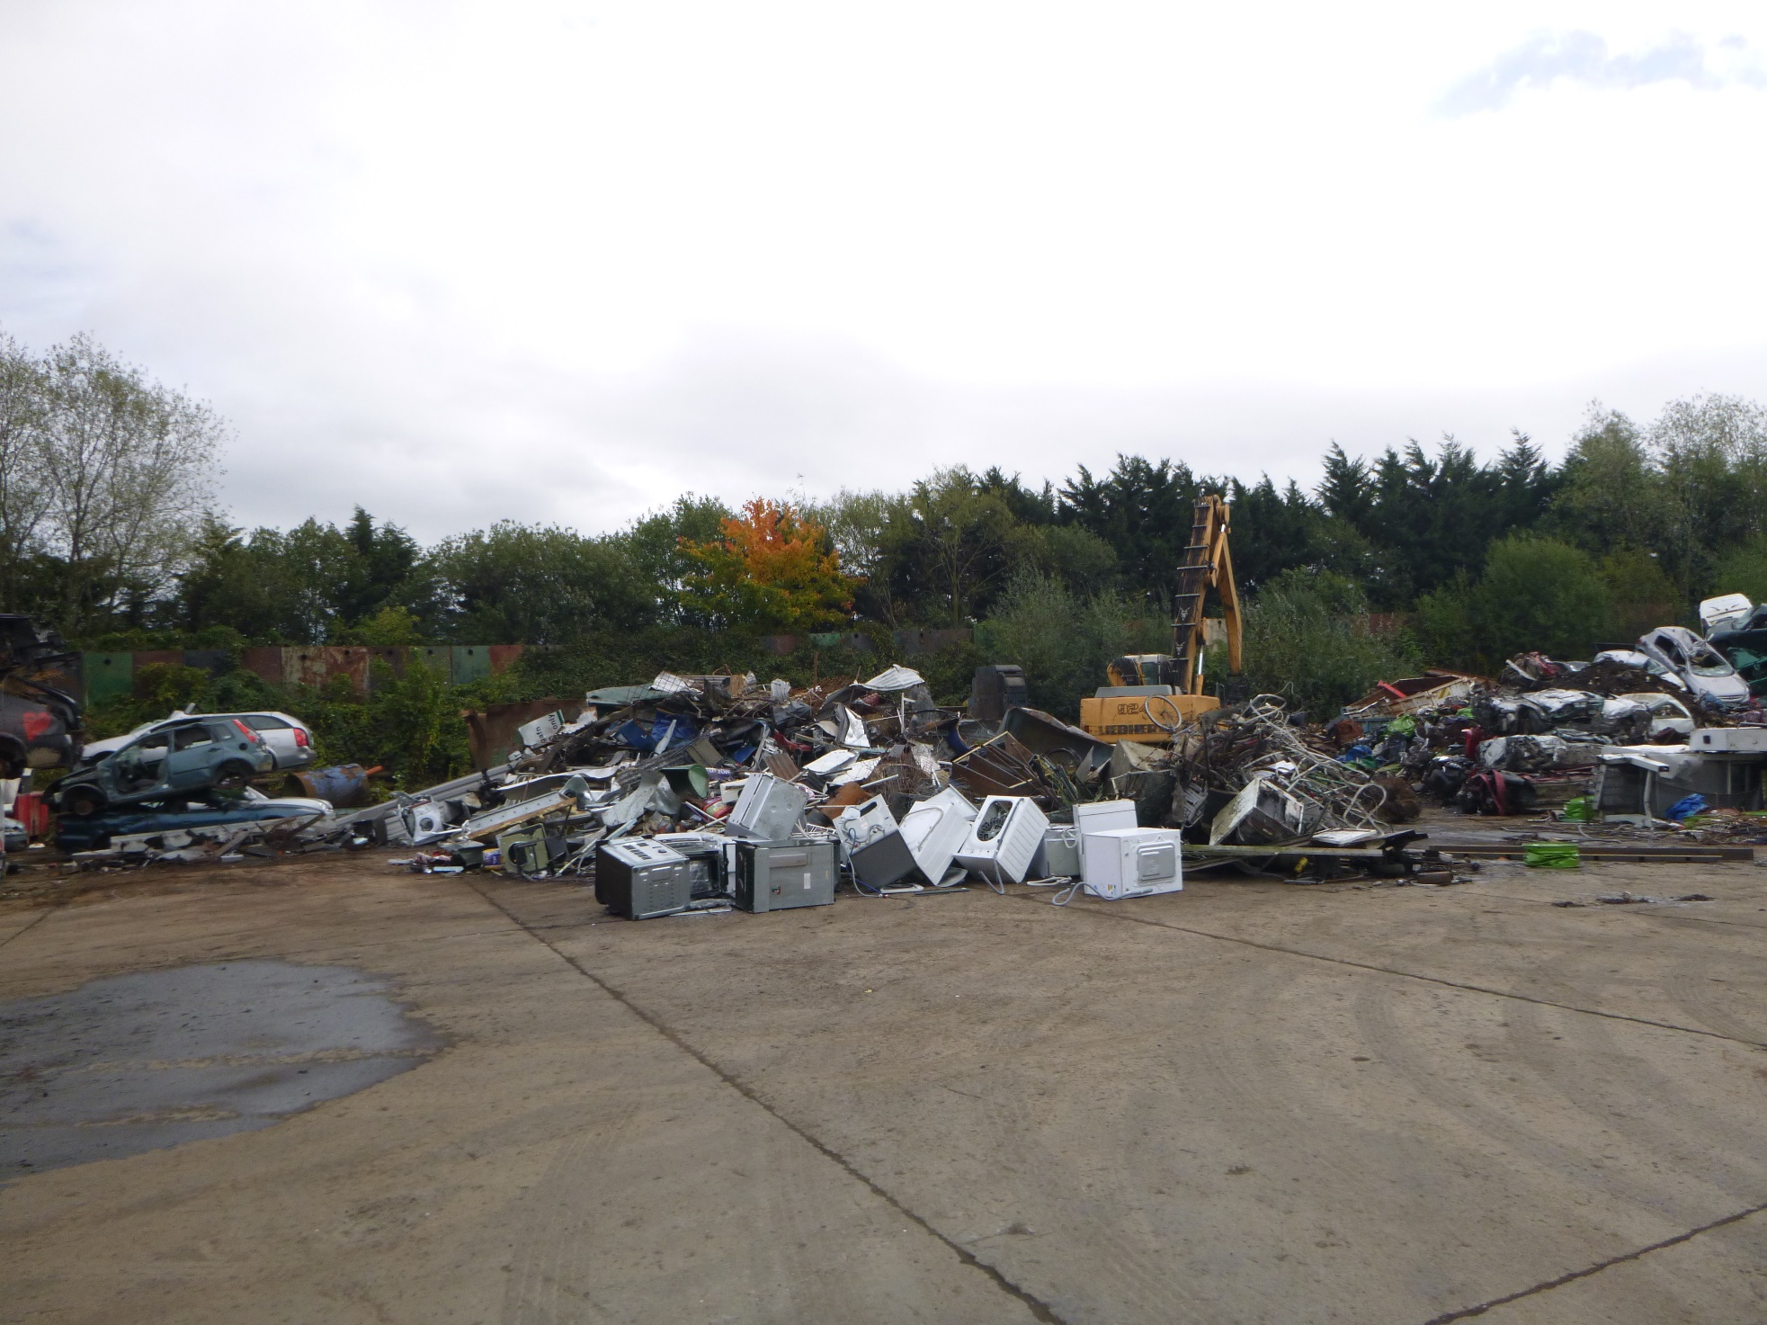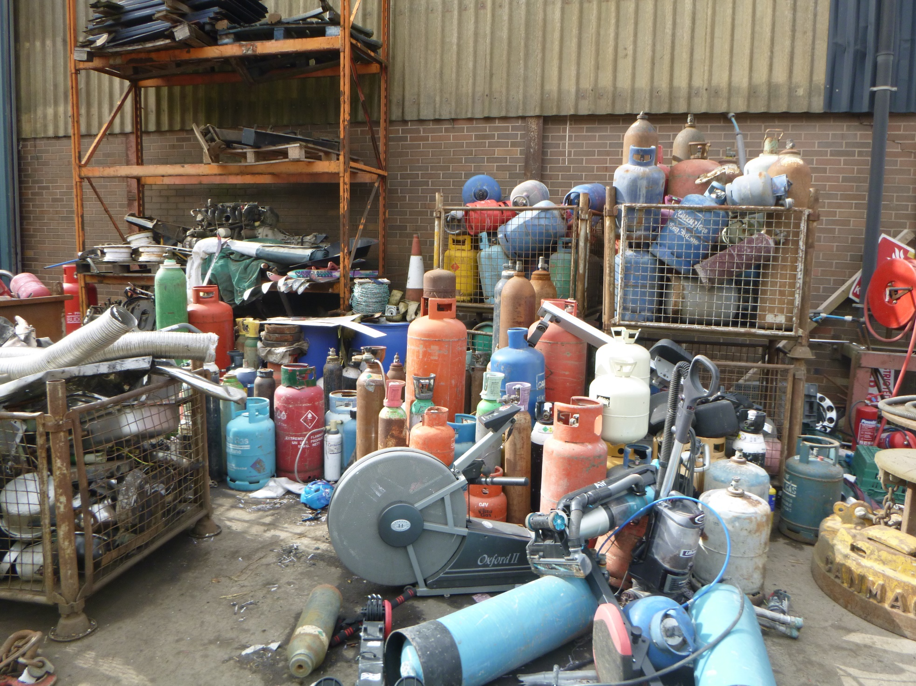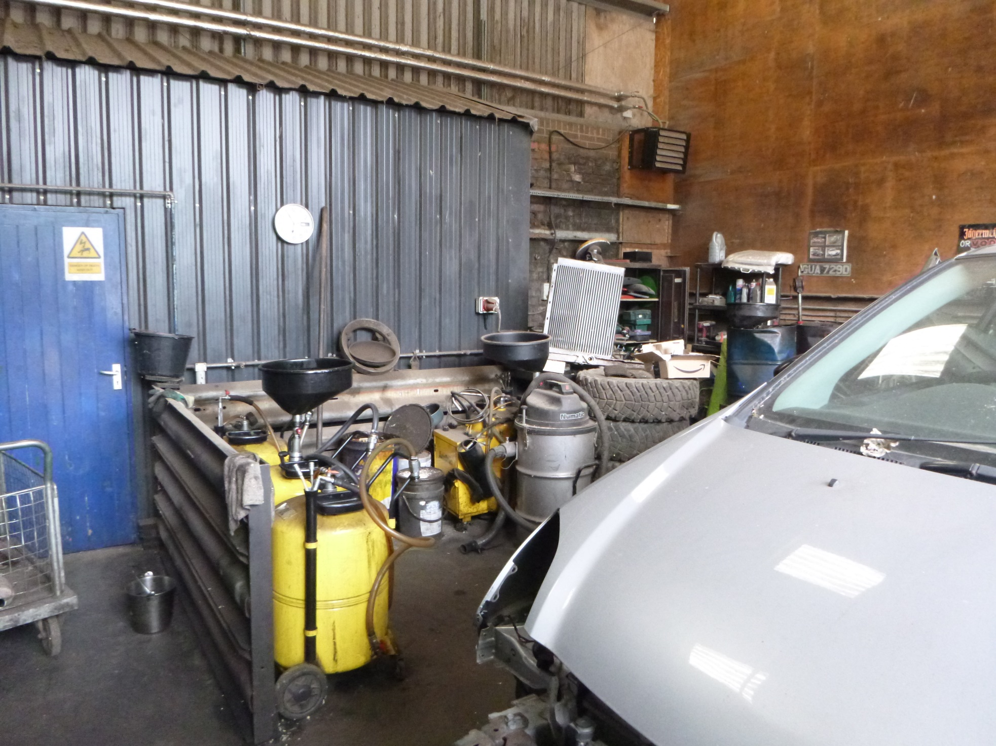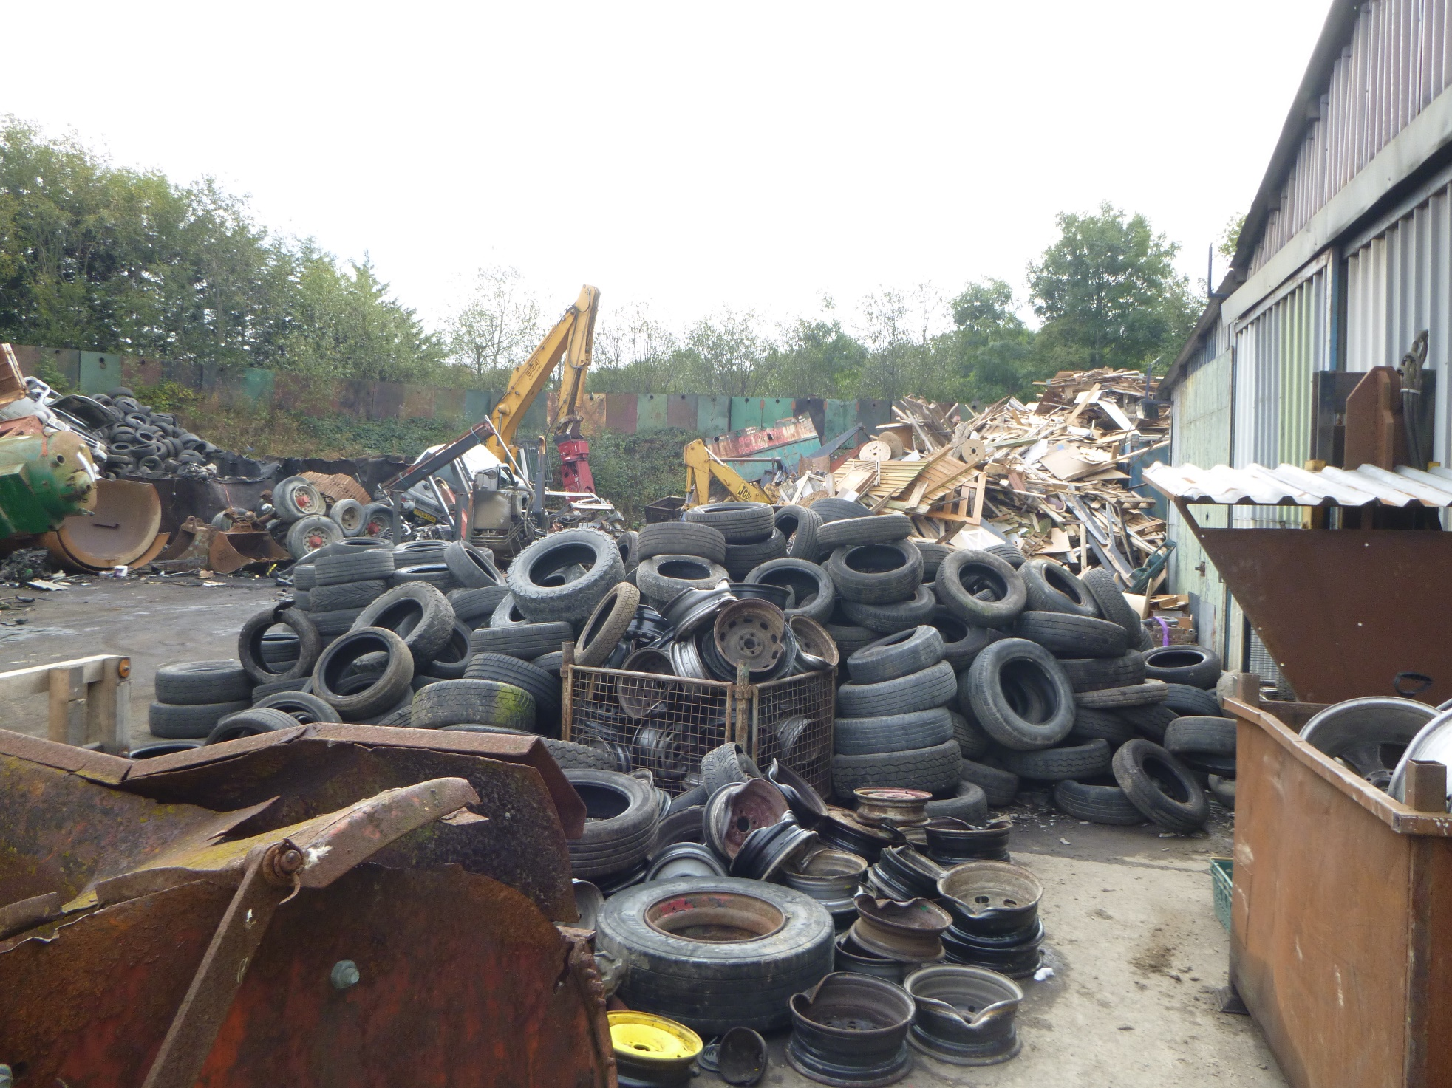
Lovatt Brothers site entrance showing out of date sign/noticeboard
Main yard showing segregated scrap metal storage
Mixed waste reception and sorting shed
Main yard showing storage of un-depolluted ELVs
Main yard showing scrap metal pile prior to sorting
Non-waste Gas Bottles stored on site. Gas bottle are owned by the named company or by a responsible company in the event the original company no longer exists
ELV De-pollution bay
Waste tyres stored outside the ELV de-pollution bay
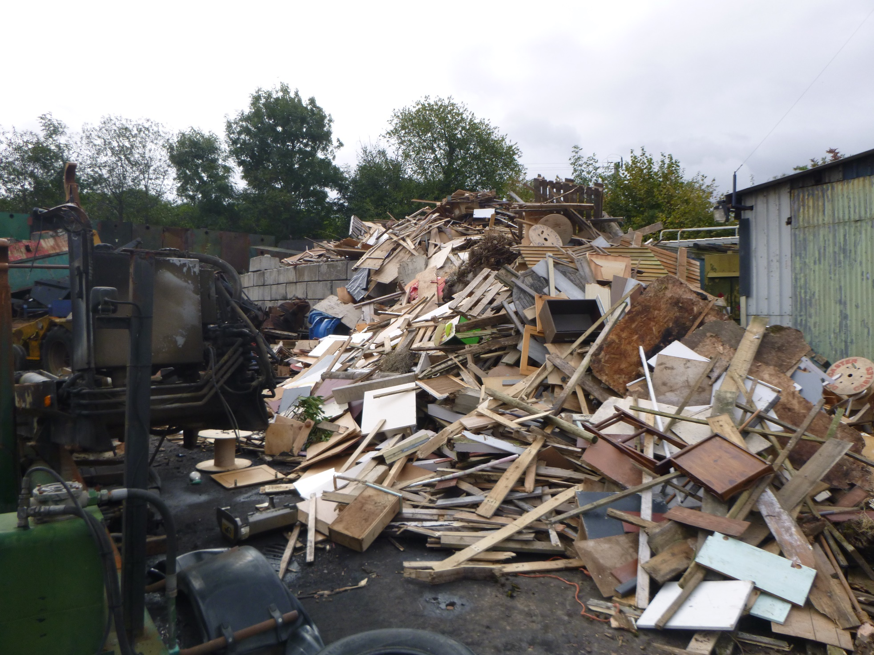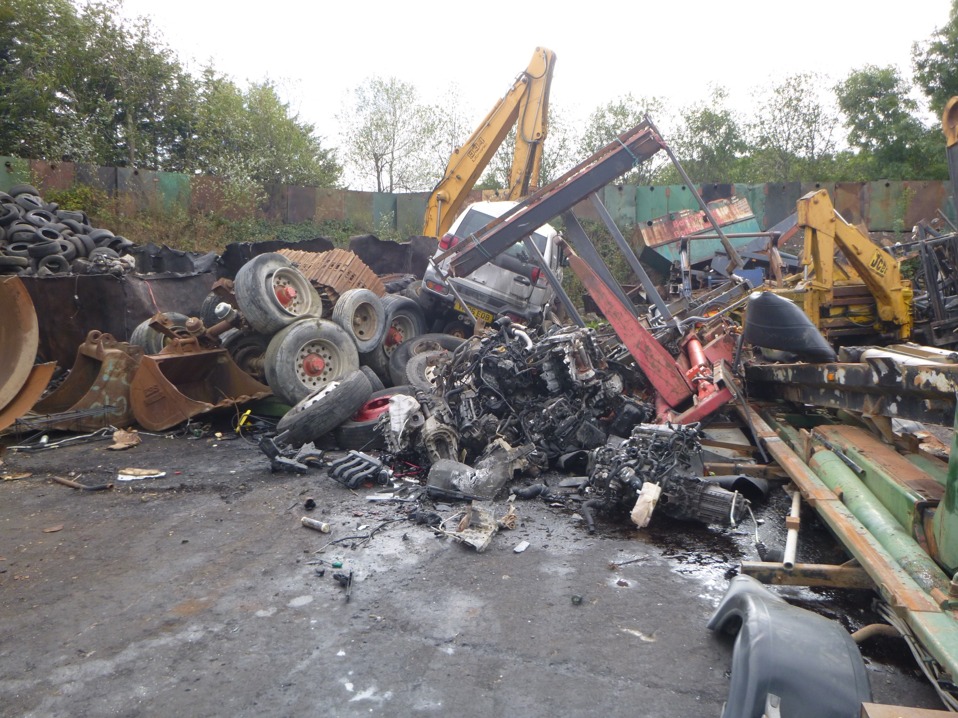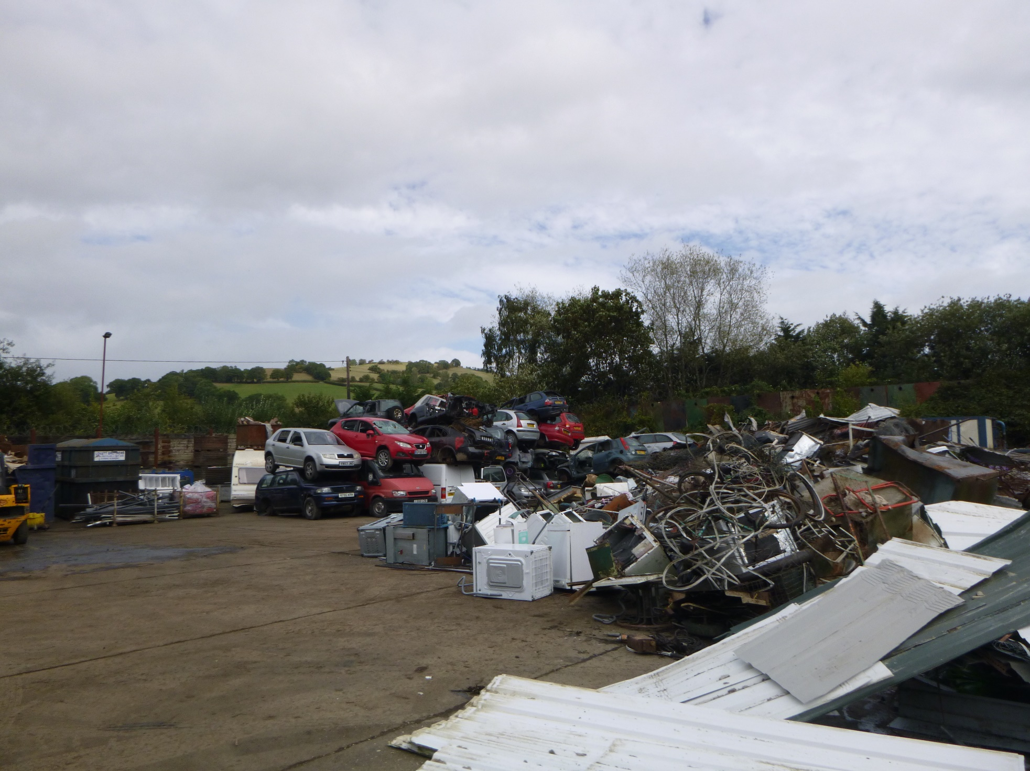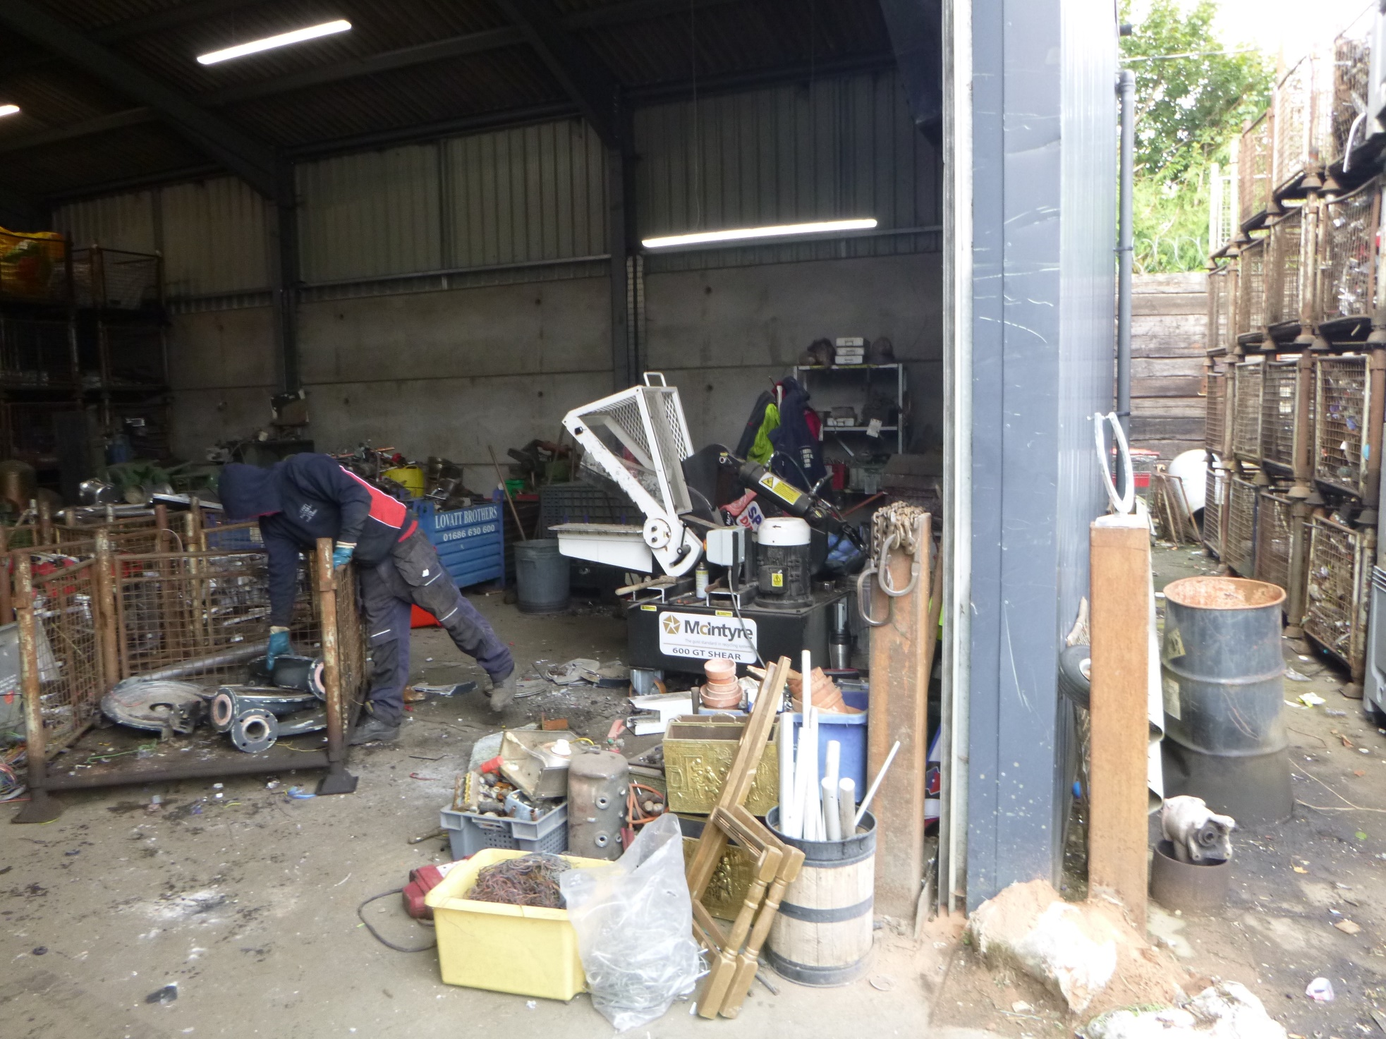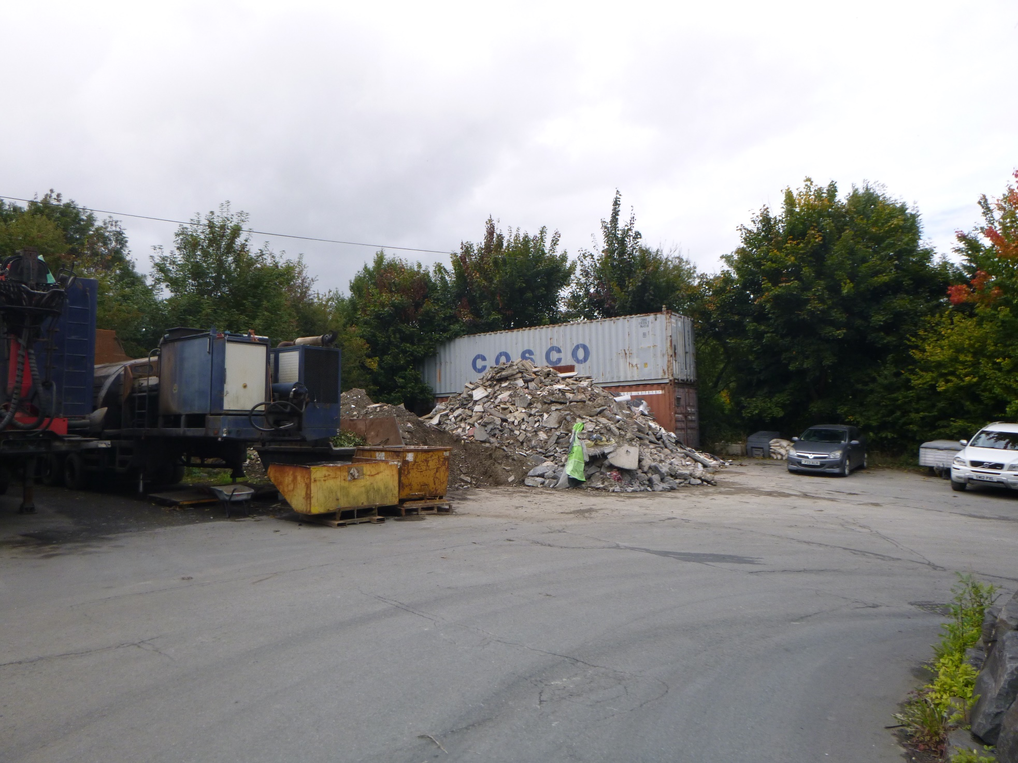
Wood waste stockpile: larger than usual due to grab breakdown
Scrap metal pile from ELV waste due to be sorted. Additional ELV tyre stockpile in the background
De-polluted ELV and scrap metal stockpile
Scrap metal shear inside metal waste workshop
Inert waste stockpile near to site entrance

