Site boundary
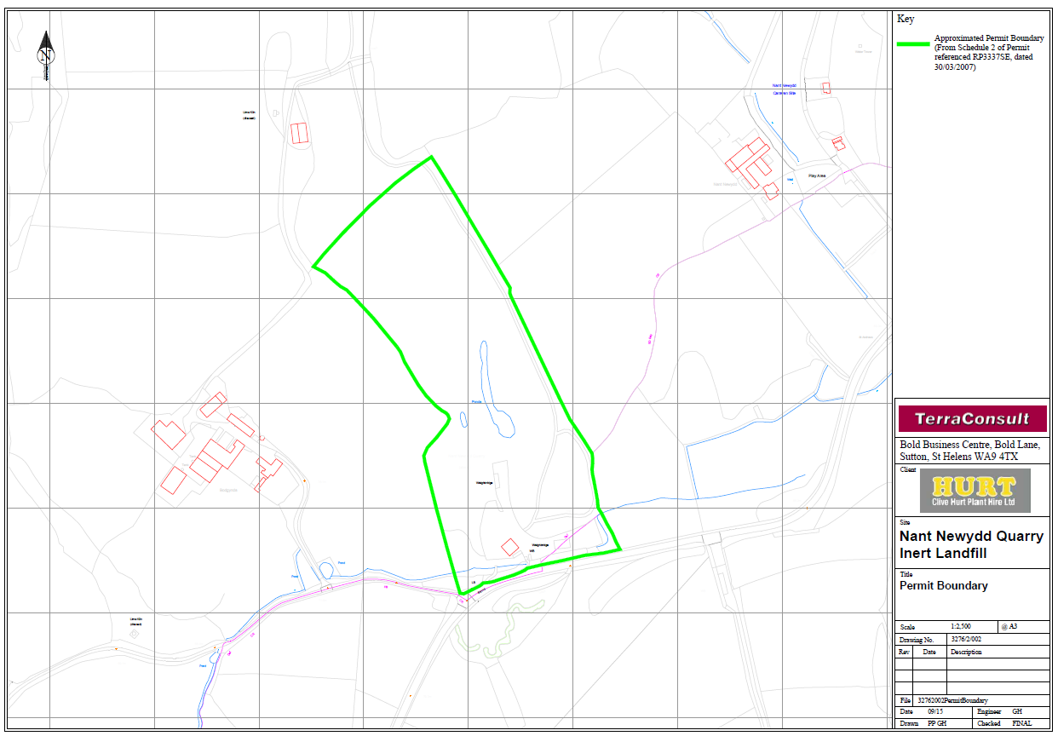
Site boundary
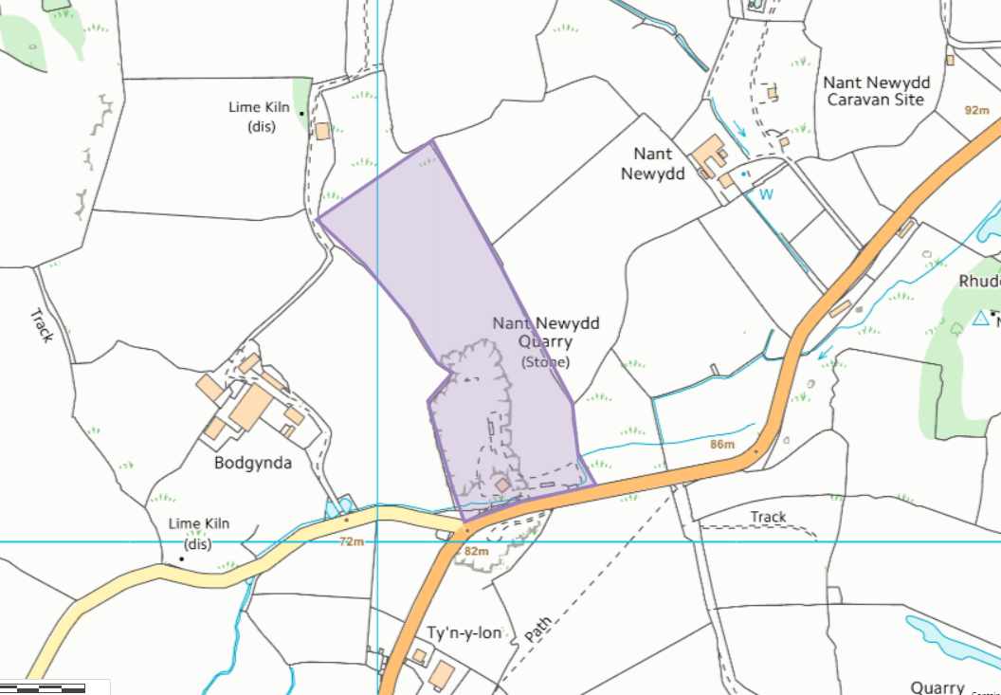

SSSI within 2km of the site
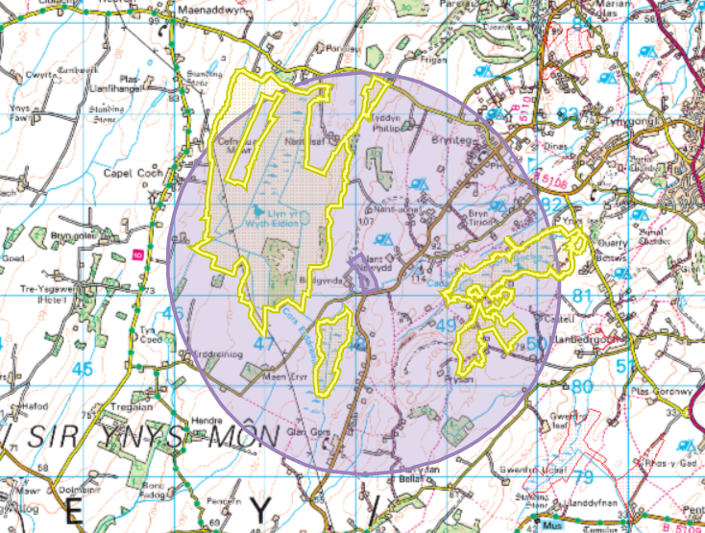
Cors Erddreiniog SSSI
Cors Goch SSSI
Craig Wen / Cors Castell SSSI
Cors Erddreiniog
Cors Goch
Craig Wen / Cors Castell
SAC within 1km- Corsydd Mon / Anglesey Fens SAC
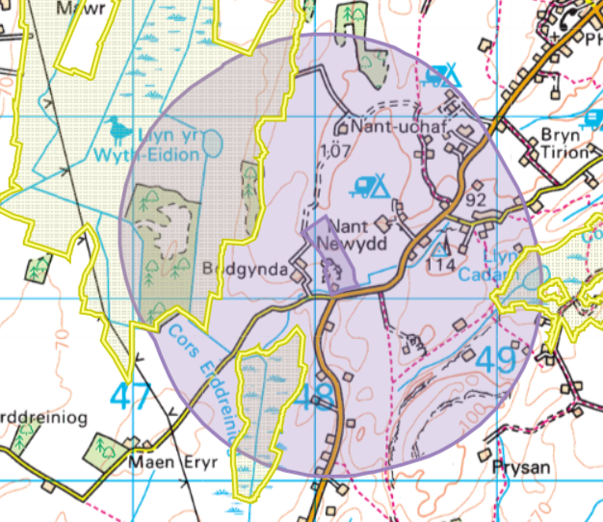
Ramsar within 1km- Corsydd Môn a Llyn / Anglesey and Llyn Fens Ramsar


