PAN-019864 My Map Screening Report:
Application map
Identifies Non spreading areas
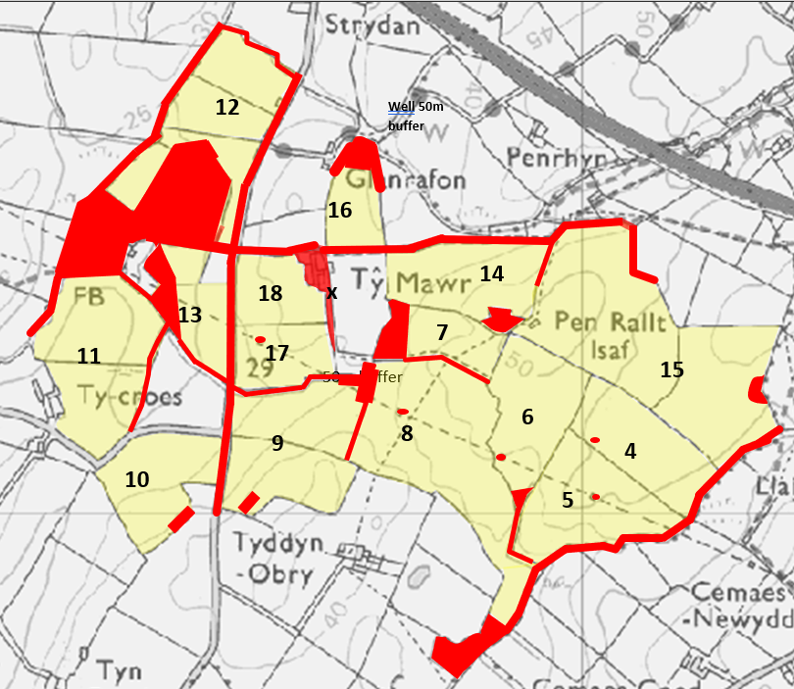
Storage location
No Storage following RFI

Detailed river network:
Watercourse immediately adjacent to NW of Fields 11, 12 and N, NE of Field 12. Drain intersects Field 11. Non spreading buffers in place on application maps.
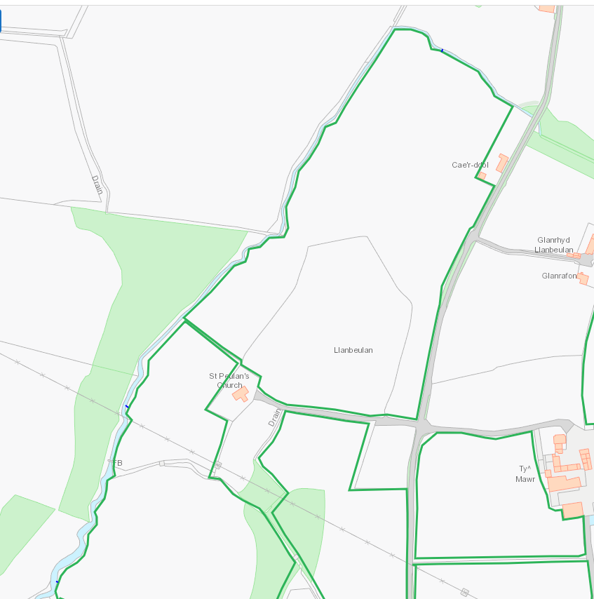

Watercourse to N of Fields 14,15. Non spreading buffer in place on application maps
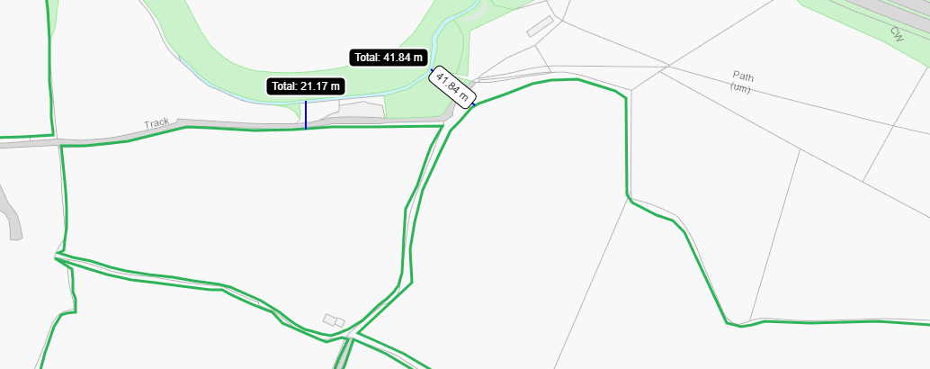

Watercourse and drain to SE of Fields 15, 4, 5, 8. Watercourse to SW of Field 8. Non spreading buffer in place on application maps
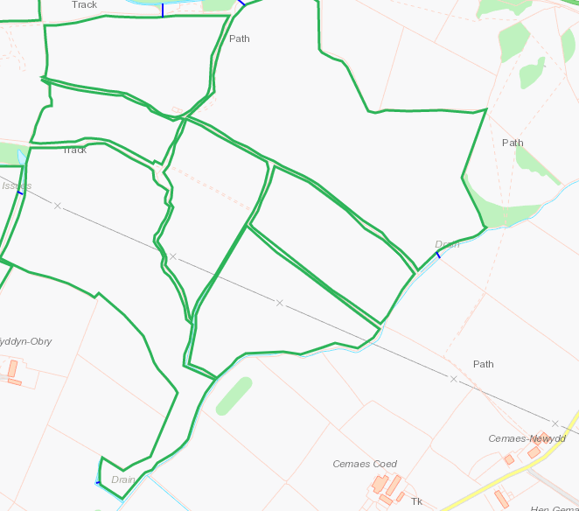

Groundwater protection zones
None within range

Wells, springs or boreholes used for the supply of water for human consumption including from a private water supply or supplies
Issue and pond directly adjacent to Fields 8, 9. Ponds adjacent to Fields 9, 17. Non spreading buffer in place on application maps
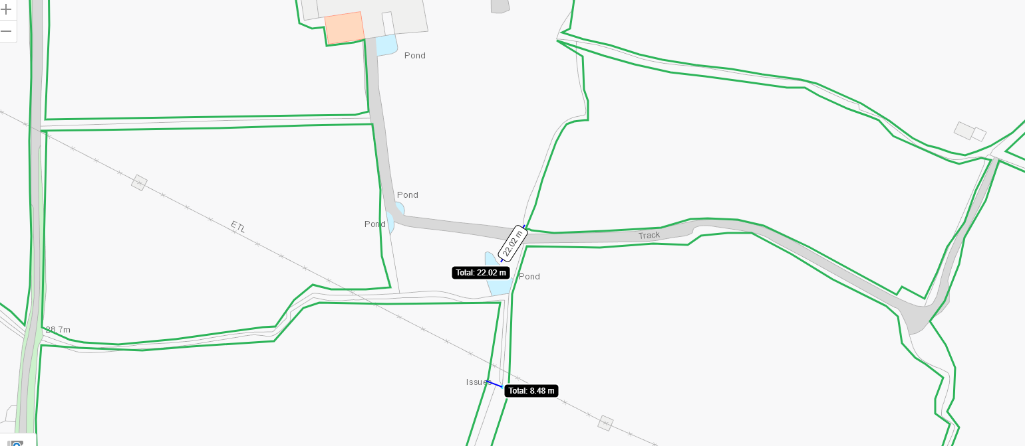

Well to NE of Field 16. Non spreading buffer in place on application maps
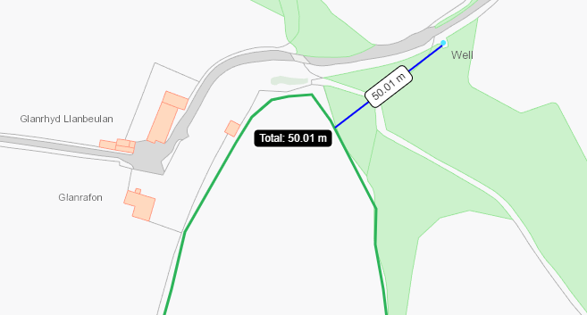

European designated sites- Natura 2000 (SPA, pSPA, SAC or cSAC) or Ramsar- or SSSI within 500m

None within range

Other protected sites:
- Protected Species-
- Protected Habitats-
- Scheduled Ancient Monument-
- Local Nature Reserve-
- National Nature Reserve-
- Ancient Woodlands-
- Local Wildlife Sites (SINC)-
- National Park-
- Nitrate Vulnerable Zone (NVZ)-
- Groundwater Safeguard Zone-
- Hedges-
- Ditches-

Purple moor grass and rush pastures to W and NE of application area and within fields 11, 13. Lowland dry acid grassland and Lowland calcareous grassland to NE of field 15 and adjacent to fields 9,10,11, 13, 17. Non spreading buffer in place on application map.
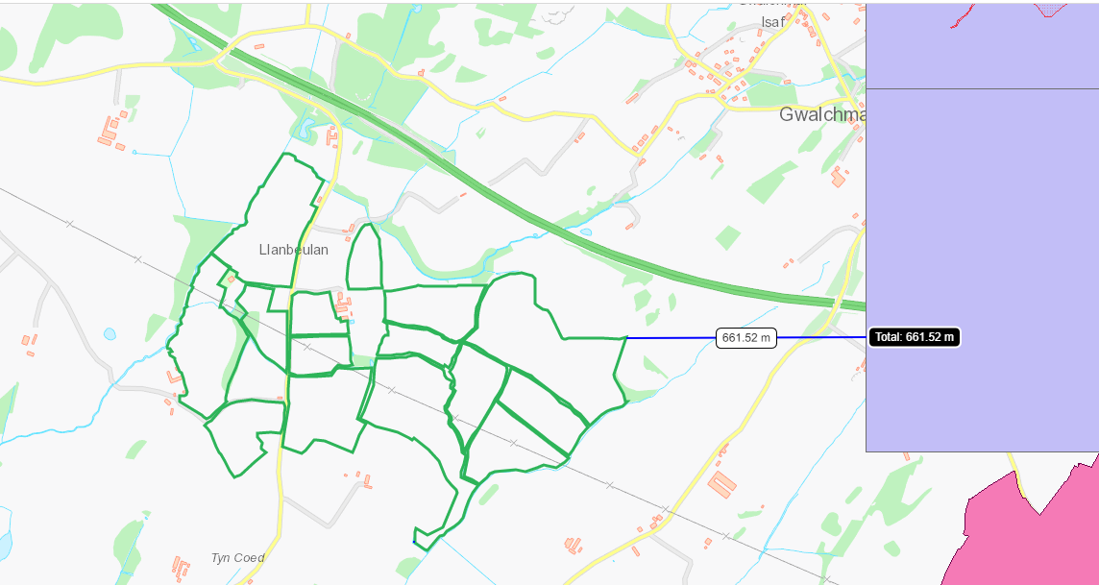
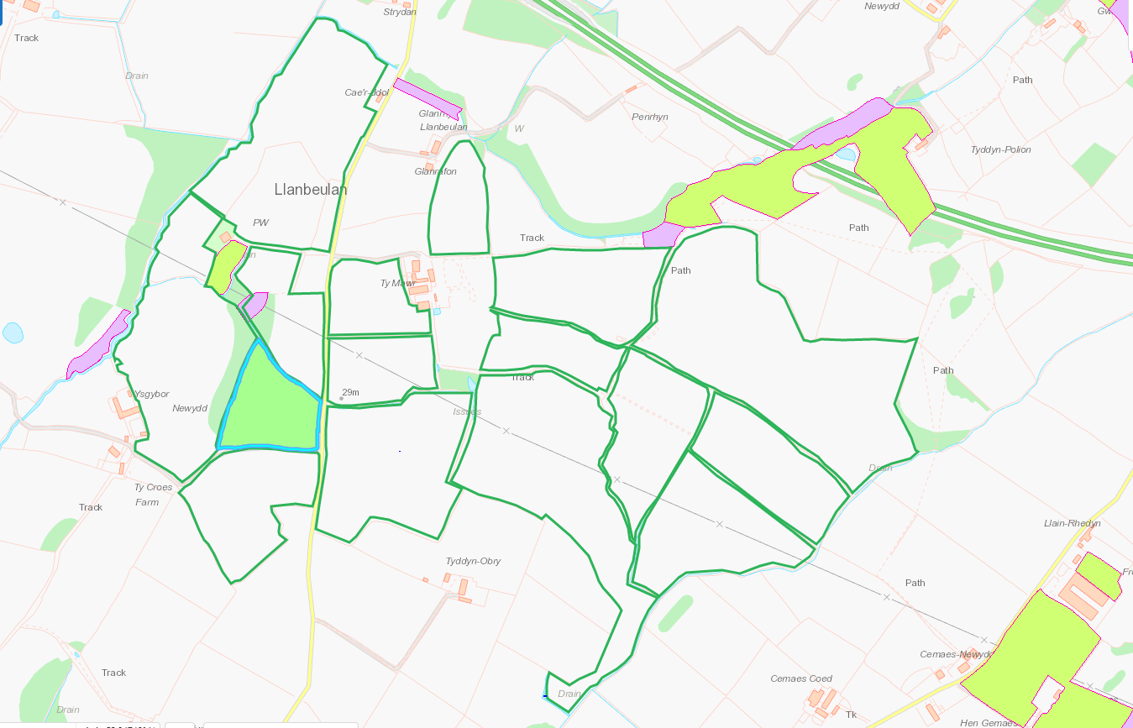

Local Wildlife site Cors Tafarn-y-Grib to NNE of field 12 at 368.5m A very wet basin mire, with predominantly aquatic vegetation, also smaller areas of sedge-rich wet meadow and willow carr. A large part of the site is dominated by water horsetail with bottle sedge and bogbean. The rare greater spearwort and common spearwort. Topography indicates land slopes towards Field 12 so risk is low. Non spreading buffer is also in place on application map.
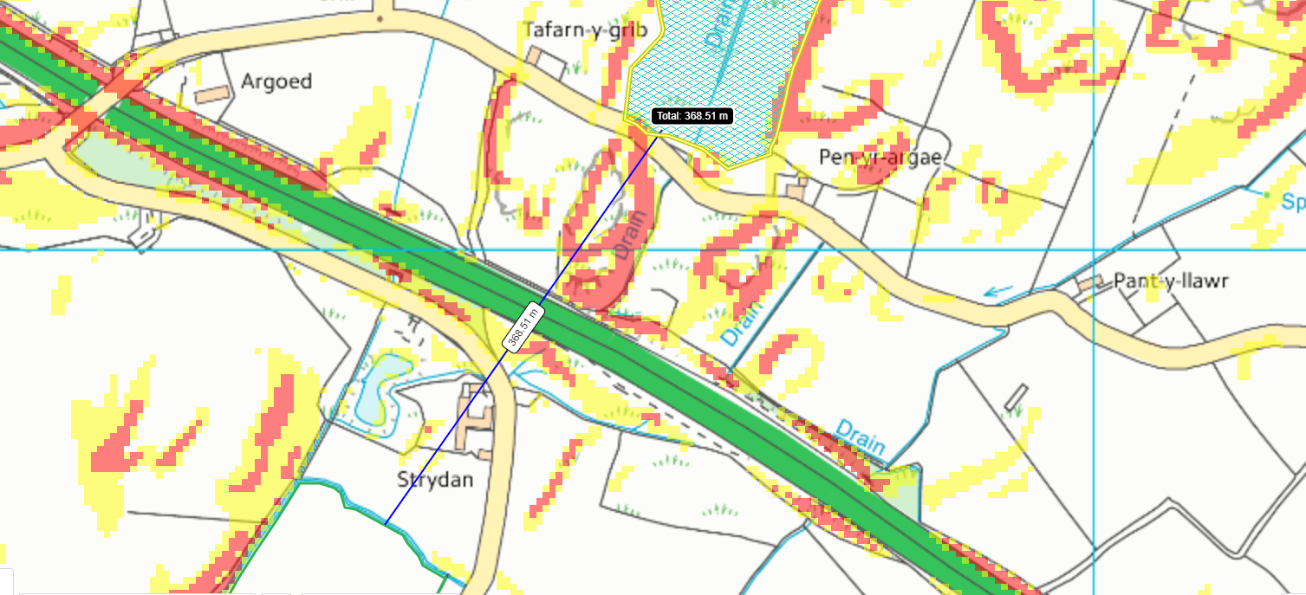

Historic Monuments-
ST PEULAN'S CHURCH
Religious, Ritual and Funerary
Medieval
CAPEL-BACH
Religious, Ritual and Funerary
Post Medieval Chapel

Both adjacent to fields 11,12 & 13. Non spreading buffers in place on application maps
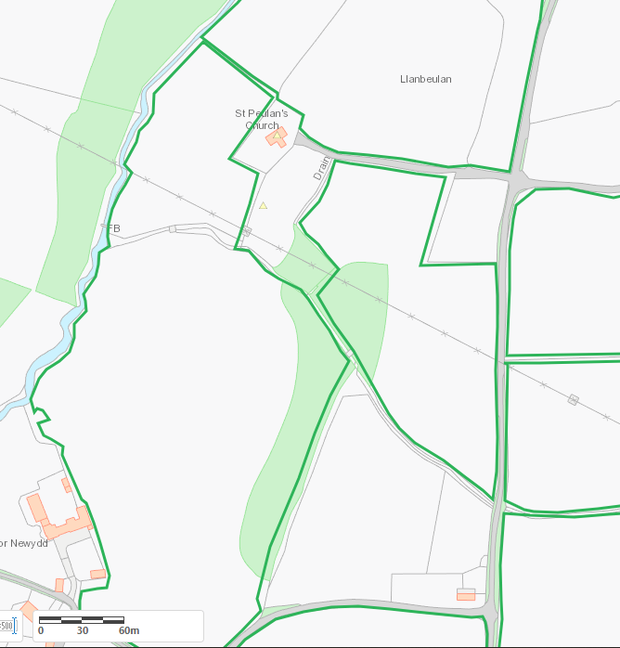
No other sites of interest within range.

Slope Map
All fields 0-7, some areas 7-12 with minimal areas >12.

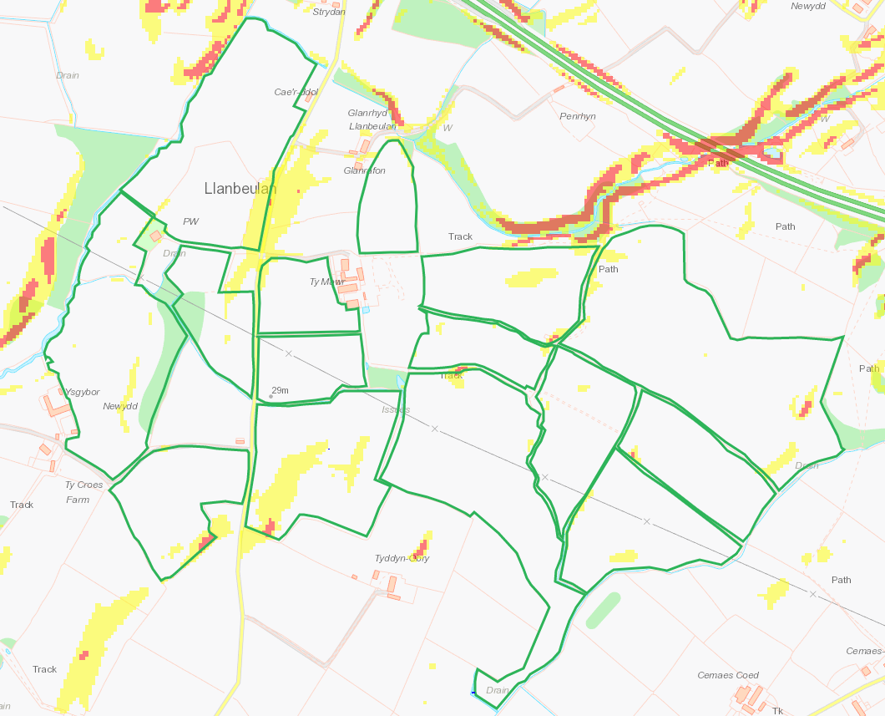

Public right of way
Non spreading buffers in place on application map
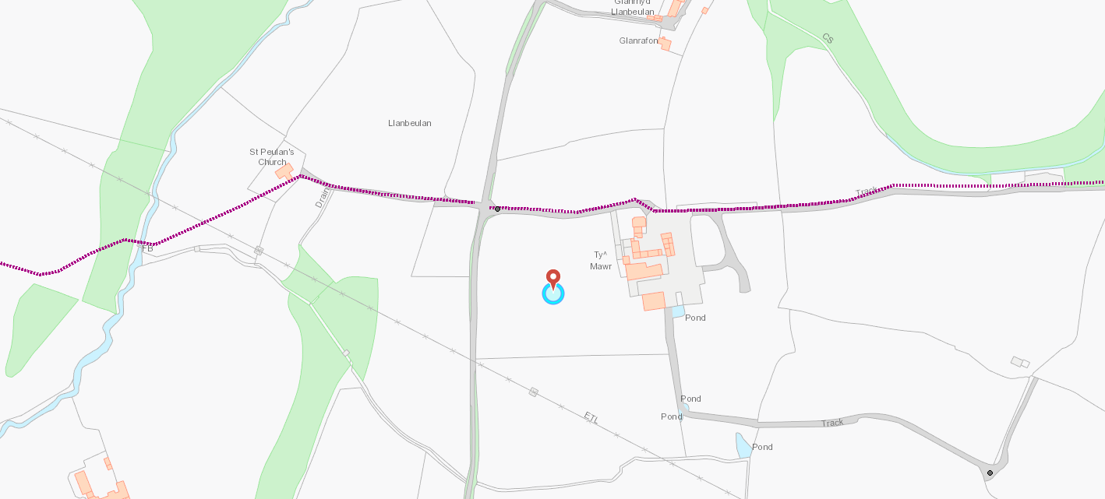

END

