Current permitted site boundary
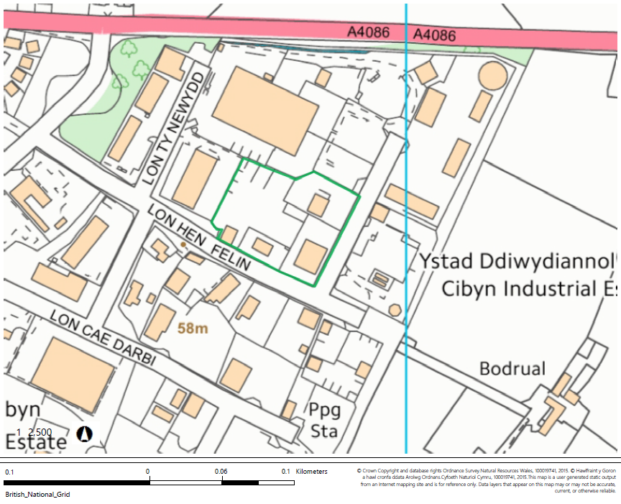

Proposed site layout
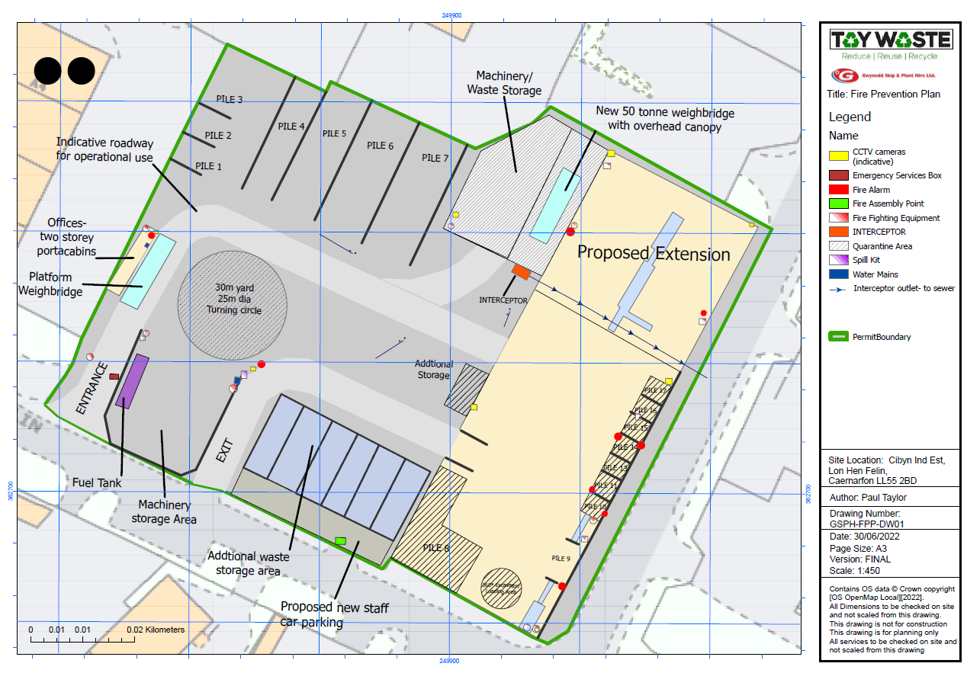

SSSI within 2km- Afon Seiont SSSI
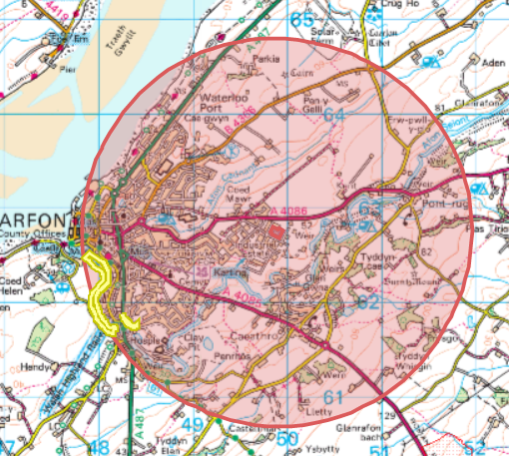

No SAC, pSAC, SPA, pSPA or Ramsar found within 2km

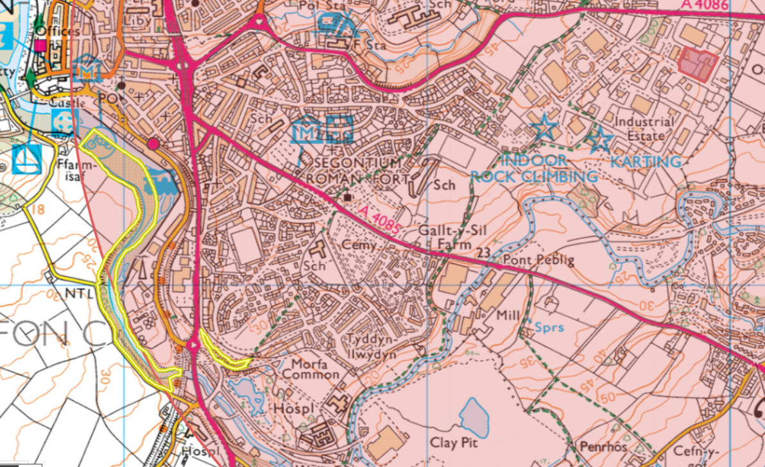

Aquifer Designation (Superficial)
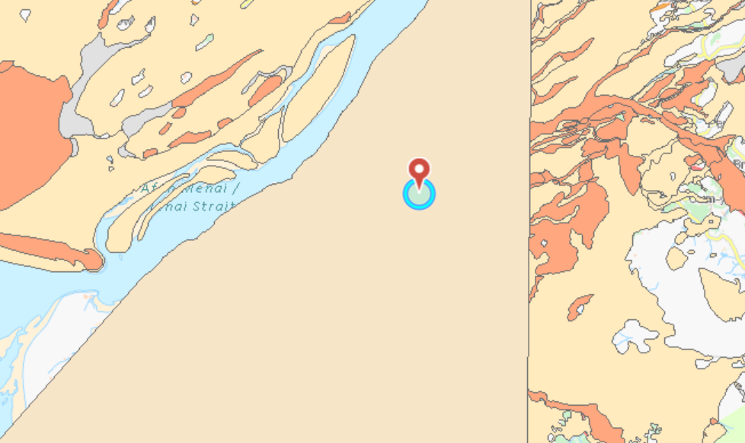
- no source protection zones found

Aquifer Designation (Bedrock)
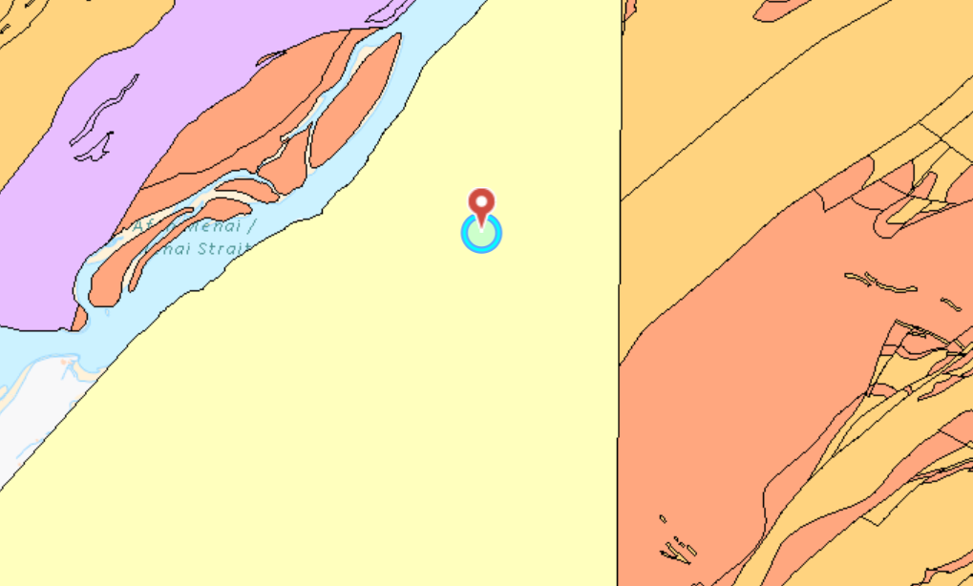
- no source protection zones found
Surface water course
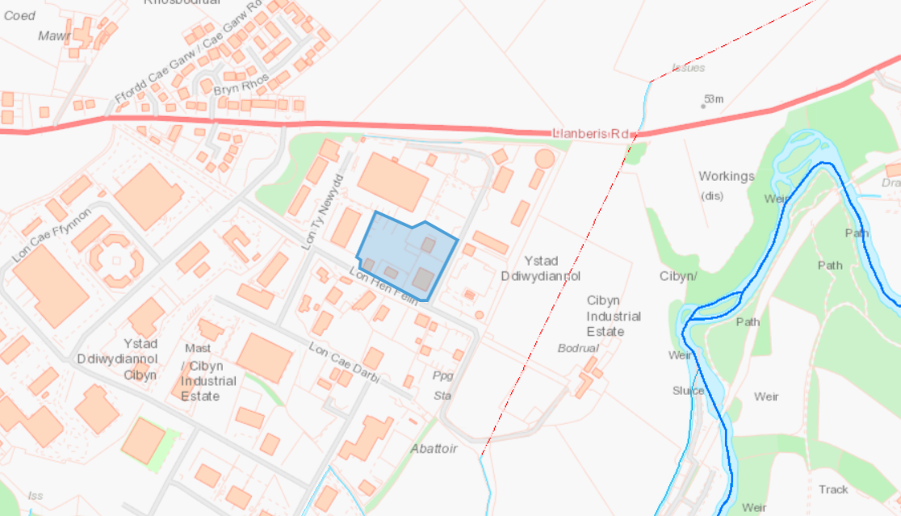

Air Quality Management Zone
- site is not within
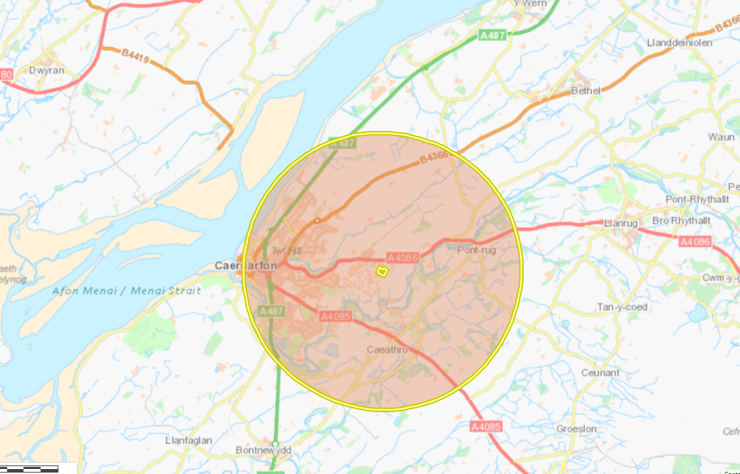

Flood risk
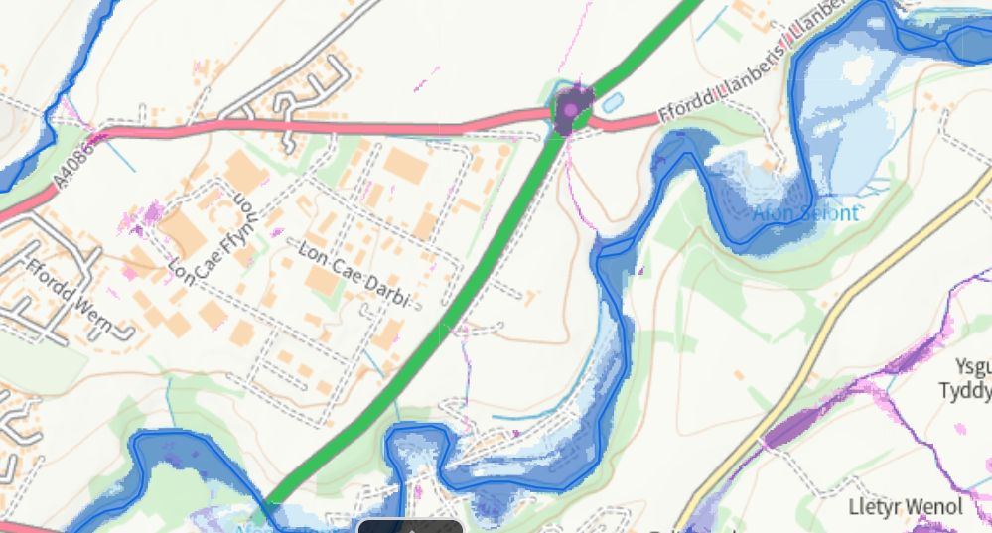

Protected habitats and species
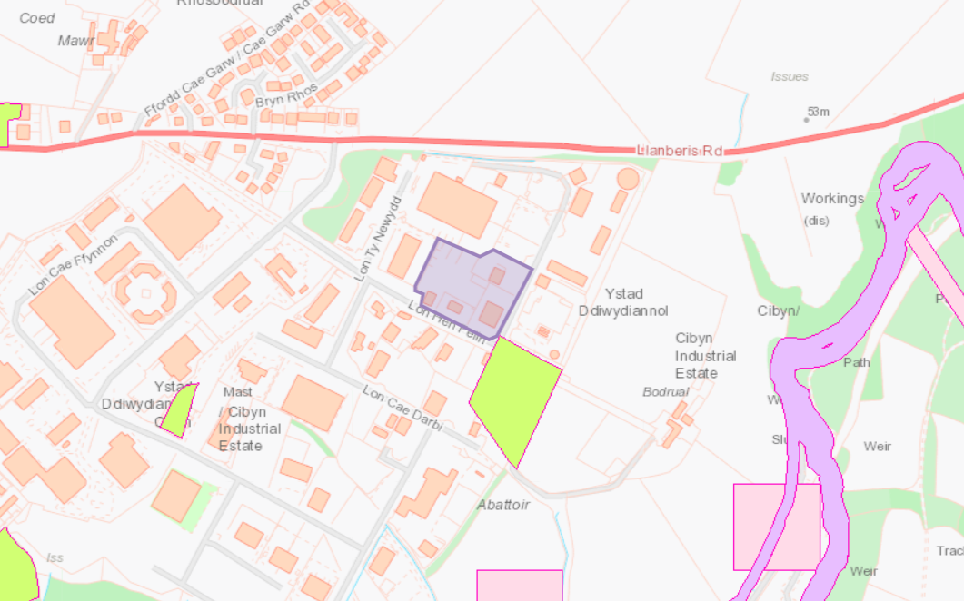
- habitats immediately to the south is labelled as Lowland dry acid grassland and Lowland calcareous grassland, however this is an industrial site

Ancient Woodland Inventory 2011
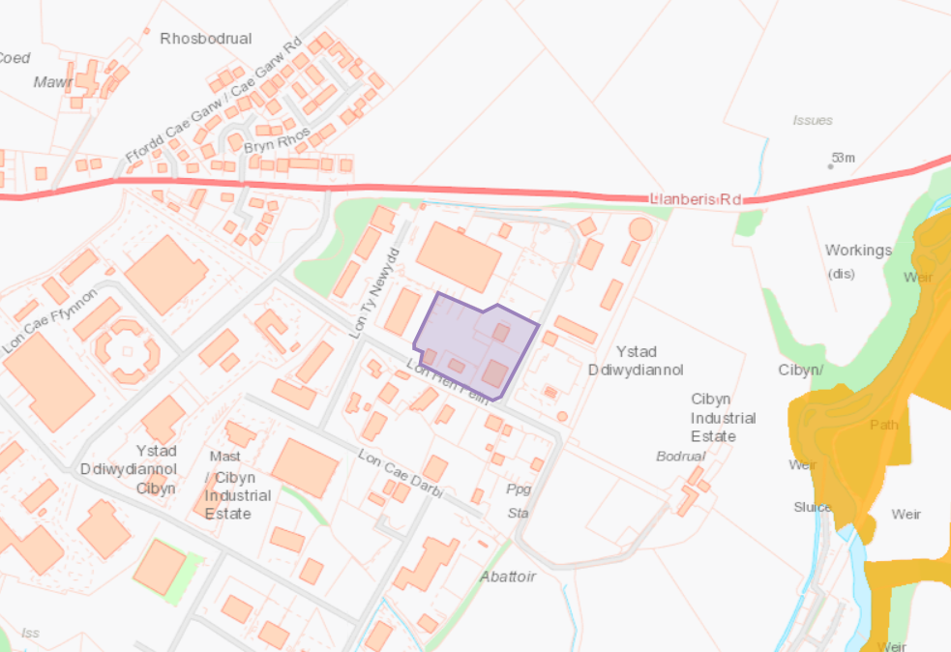

Local Wildlife Sites (SINCs)
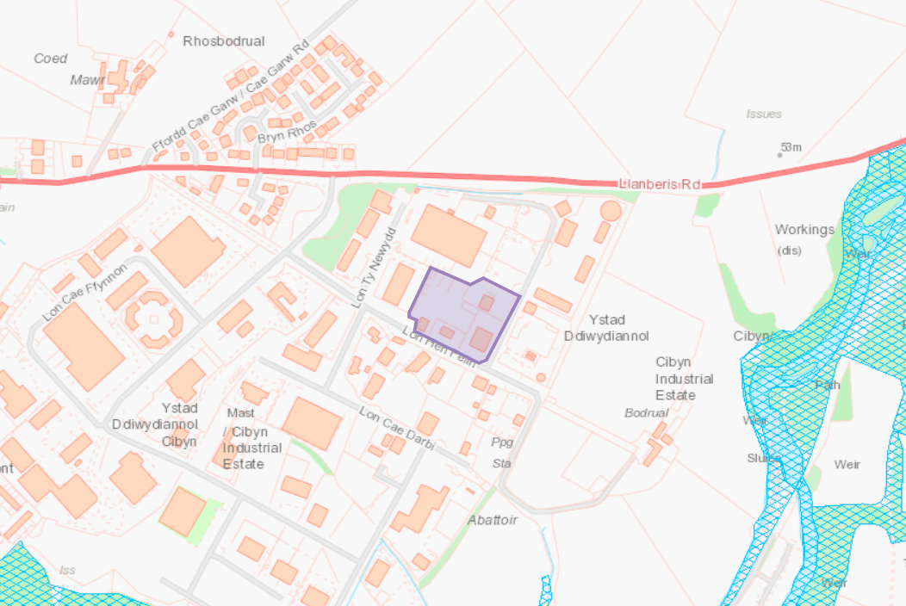

None found

Historical
- Listed Buildings
- Historic Monuments
- Scheduled Monuments
- Heritage Sites
- Heritage Coast

Designated sites
- Areas of Outstanding Natural Beauty
- Local Nature Reserves
- National Nature Reserves
- National Parks

