CRoW Appendix 4 (140_10_SD02)  CRoW Act 2000: Natural Resources Wales application for permission - Formal Notice |  | 
Natural Resources Wales Formal Notice.
Requirements of Section 28I of the Wildlife & Countryside Act 1981 as amended by the Countryside and Rights of Way Act (CRoW) 2000.
Duty in relation to granting any consent, licence or permit for activities likely to damage Sites of Special Scientific Interest (SSSI).
Guide to filling in this form for Natural Resources Wales staff:
To be completed by Permitting Officers for any applications for a permission which the Natural Resources Wales has considered under S28G duties to protect and enhance SSSIs. This applies to all proposed permissions within a SSSI, and to operations outside the SSSI boundary which are likely to damage its special features.
Refer to OI 140_10 ‘Applying the Countryside and Rights of Way (CRoW) Act 2000 to applications for permits with potential for impact on Sites of Special Scientific Interest (SSSI)’, including the flowchart in Appendix 2.
Ensure you have completed all sections.
- Natural Resources Wales area/region/NPS hub: | Wales, Cardiff, Ty Cambria
- Name of SSSI: | Montgomery Canal
- Type of permission: | Environmental Permit – New bespoke permit for an intensive poultry unit at Drefor, Kerry, Newtown, Powys, SY16 4PQ
- Date for Natural Resources Wales permit determination: | 21/05/2019
- Predicted 28 day date for response from NRW conservation/ecology (under S28 I(4)): | For information only
- Natural Resources Wales reference no: | PAN-004240
- National grid reference: | SO 16930 89116
- Description of proposal: | Application for the construction of two broiler sheds with a maximum capacity of 110,000 broiler chickens for meat production. The annual meat production capacity will be 1735t; there will be 7.6 crop cycles per annum at a length of 42-days with 7-day turnarounds per crop.  The units will be ventilated by high speed ridge mounted fans, each with a short chimney. Litter will not be stored at the installation but will be spread on operator-controlled land in compliance with a manure management plan.  The sheds are fully insulated with a U-value of 0.4W/m2/°C to reduce condensation and heat loss.
- Is the proposed activity within (wholly or partially) the SSSI boundary? | No  Montgomery Canal SSSI is approximately 4.9km from the proposed site  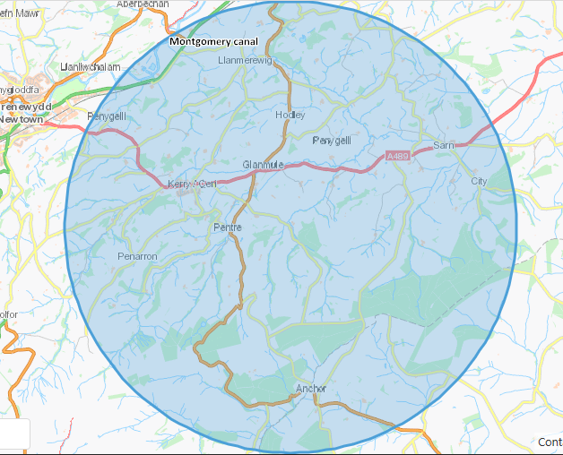
- Has there been any pre-application discussion or correspondence with NRW conservation/ecology | No
- What aspect(s) of the proposed permission may damage the features which are of special interest for the SSSI?
The following ‘Operations Requiring Consent’ (or other activities associated with the permission) that may cause damage) are relevant to the proposed permission:
Emissions from the housing of broilers

The following SSSI features and mechanisms of impact have been considered to assess the likelihood of damage:
Potential for increased ammonia concentration and potential increase in nitrogen deposition
- Decision
The proposed permission is not likely to damage any of the flora, fauna or geological or physiological features which are of special interest.

Comparison against Critical Loads
The applicant has presented a detailed assessment of ammonia concentration and nitrogen deposition as part of the application. The process contribution from the installation has been calculated and compared against the minimum and maximum critical loads for each habitat type found within the SSSI’s. The process contribution is >1% and therefore screens out. No significant impact is considered likely.

Natural Resources Wales is minded to issue the permission

- Name and job title of Natural Resources Wales officer: | Danielle Carey  Permitting Officer (Regulated Industry)
- Date form sent to NRW conservation/ecology | 31/01/2019
For Natural Resources Wales use only, once NRW conservation/ecology response received
- NRW conservation/ecology comment on assessment: | NRW conservation/ecology advise the operation can go ahead
- Name and job title of NRW conservation/ecology officer: | Catherine Blower, Conservation Officer
- Date of receipt of NRW conservation/ecology response: | 31/01/2019

