PAN-019961 My Map Report

Application Maps
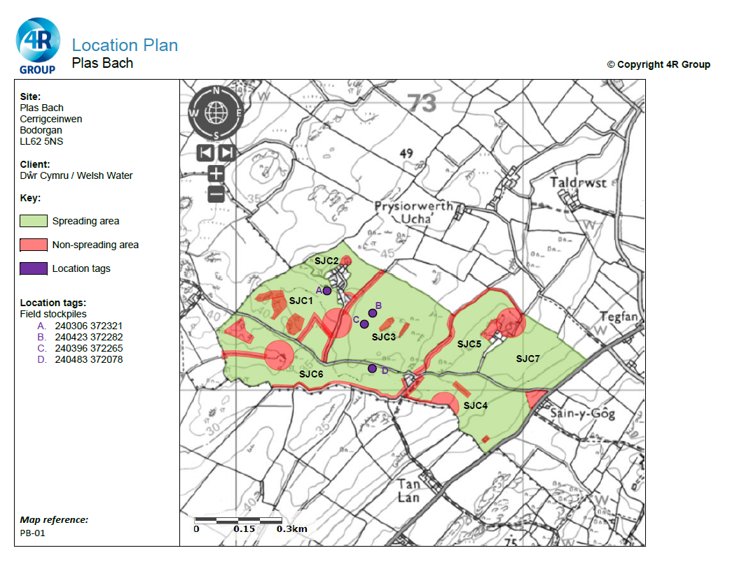
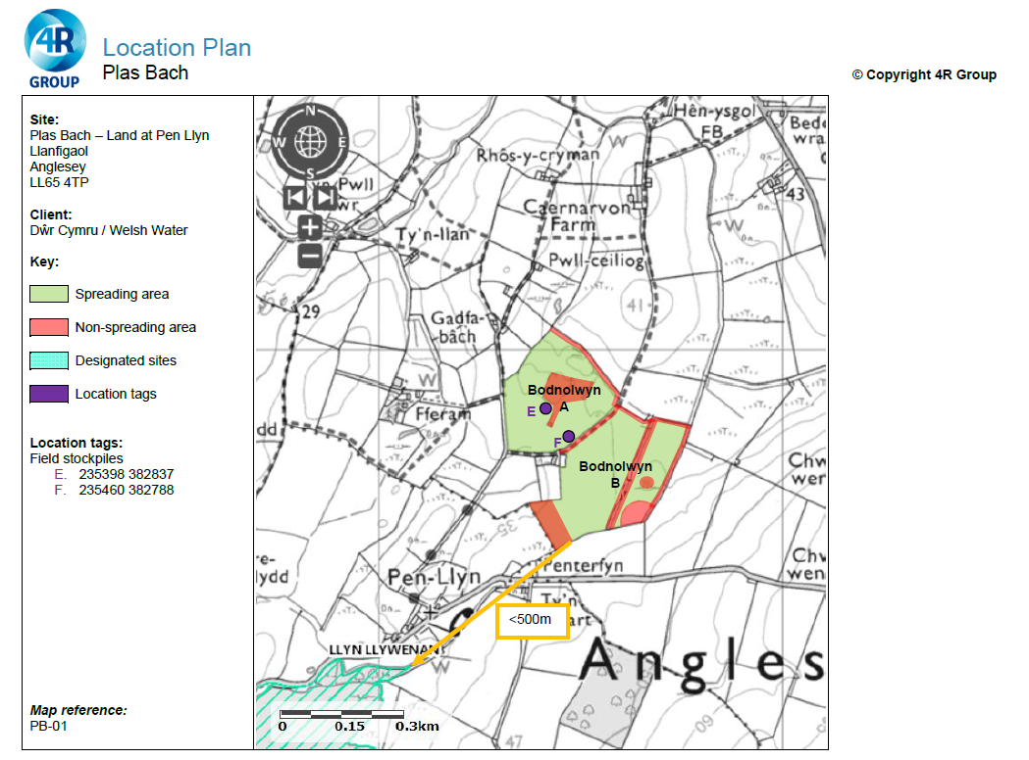
Previous Storage Locations PAN-015997 Issued 20/01/22
Previous locations A, D, E and F are same locations as proposed storage for this application.
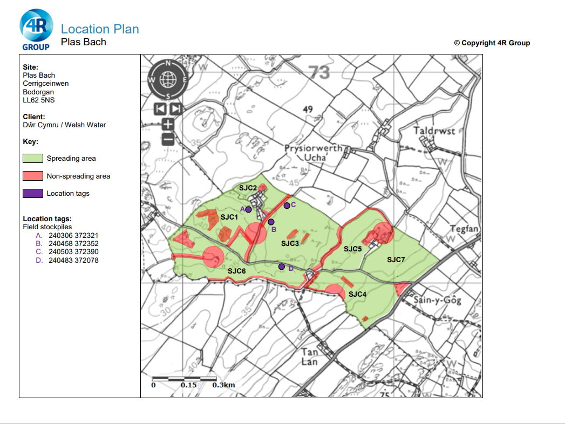
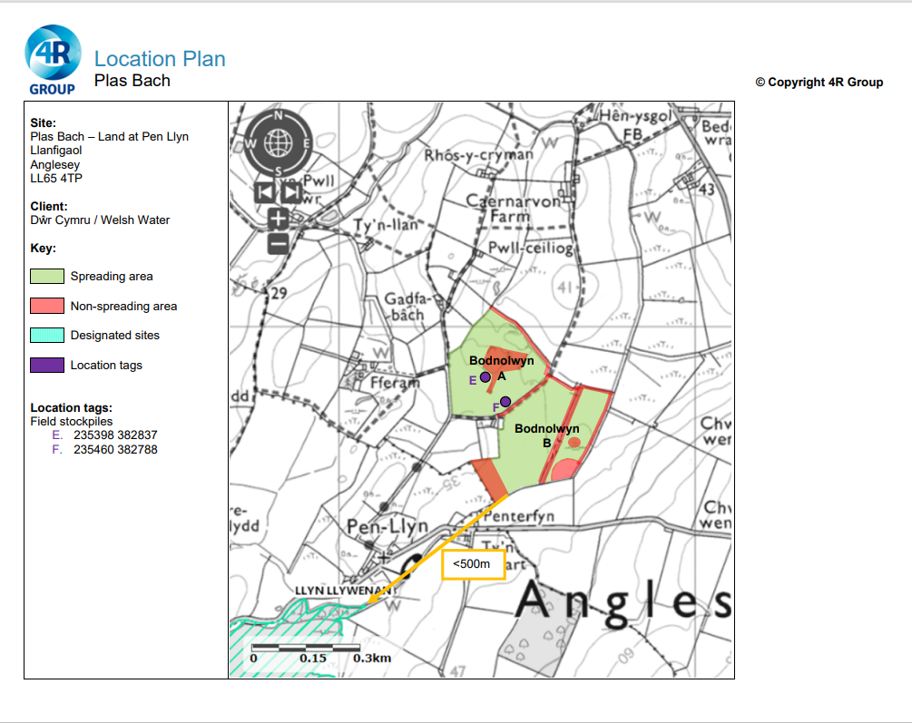

Permitted Boundary
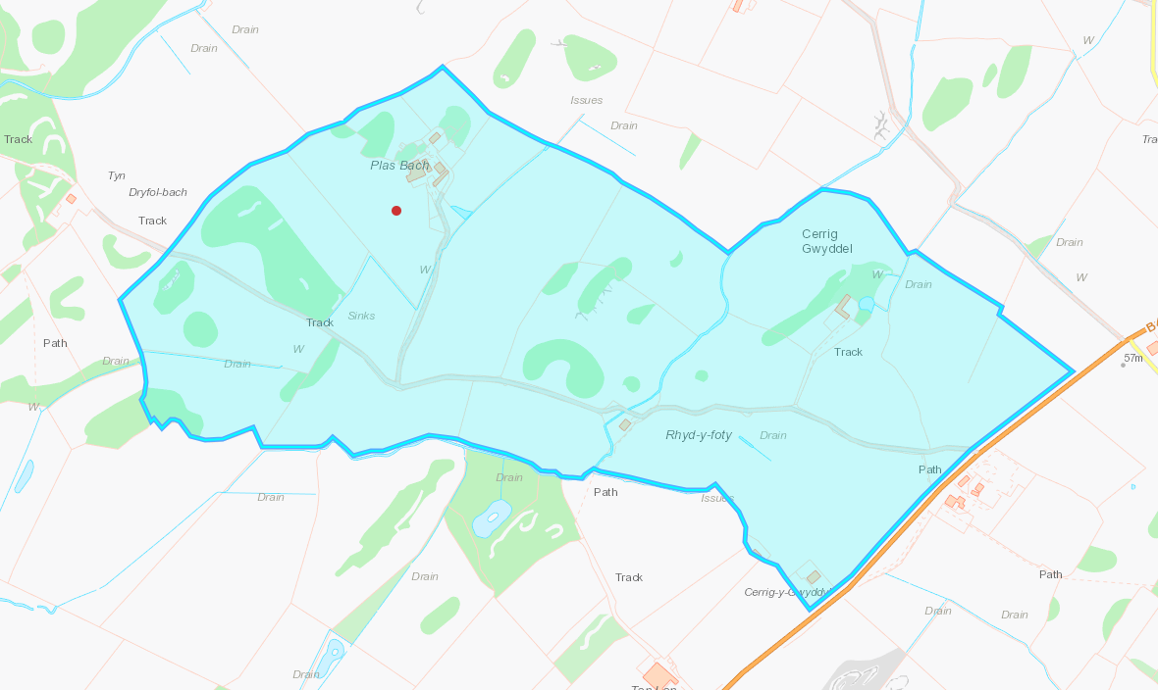
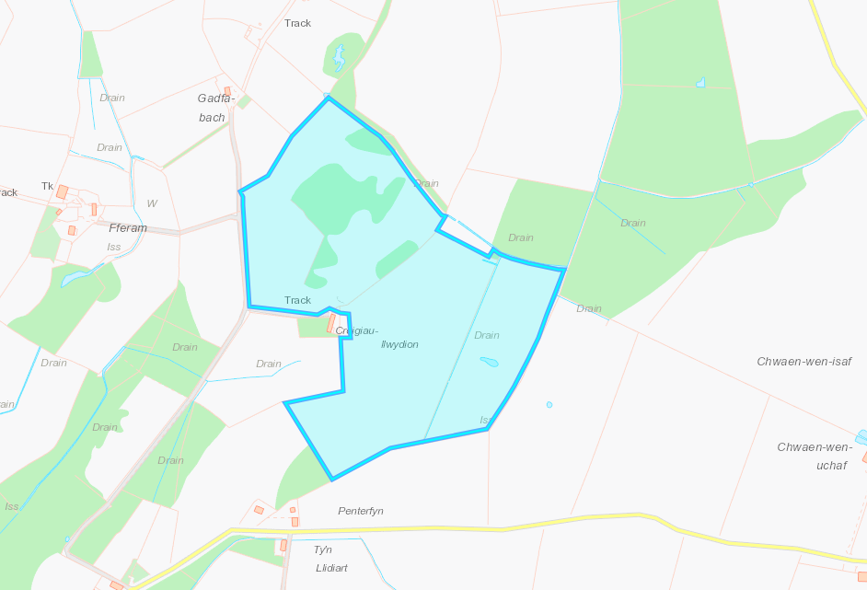

Distance between sites
7 miles from main site to other fields.
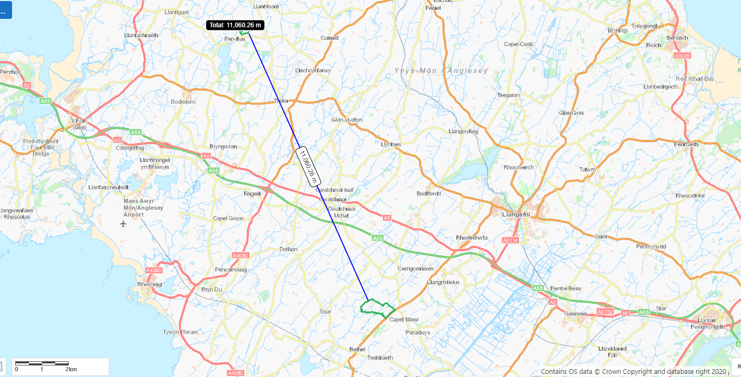

Detailed river network
Watercourse runs through locations, non spread buffers in place on application maps.
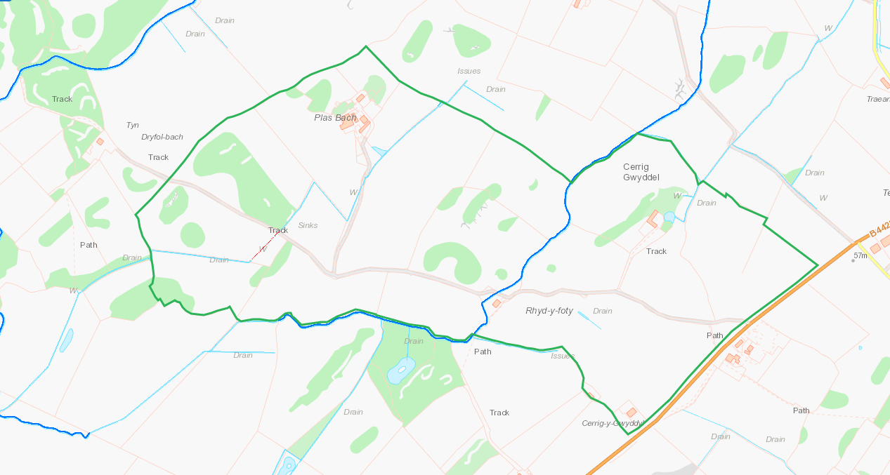

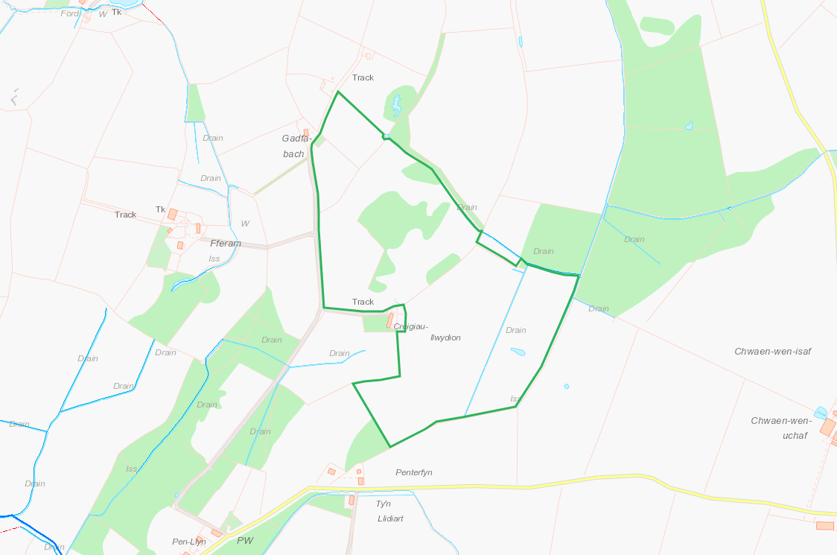

Buildings and houses
Several Buildings and houses within the location and adjacent. Non spread buffers in place on application maps.
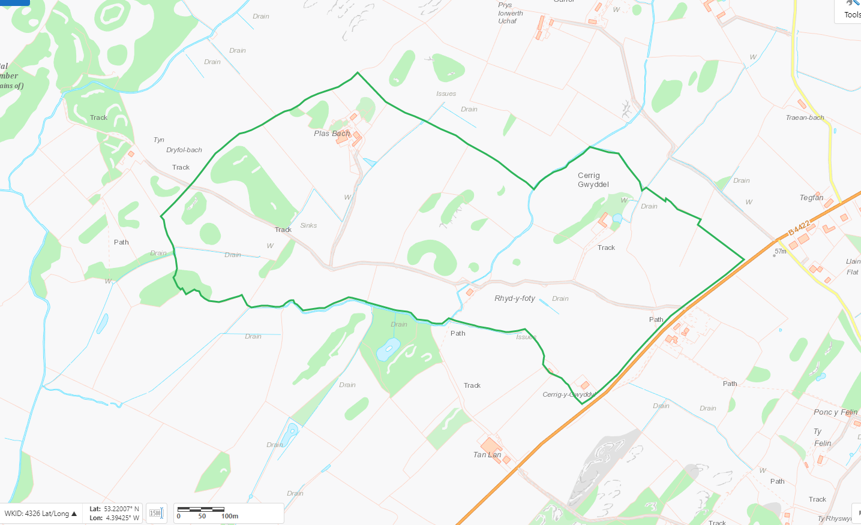
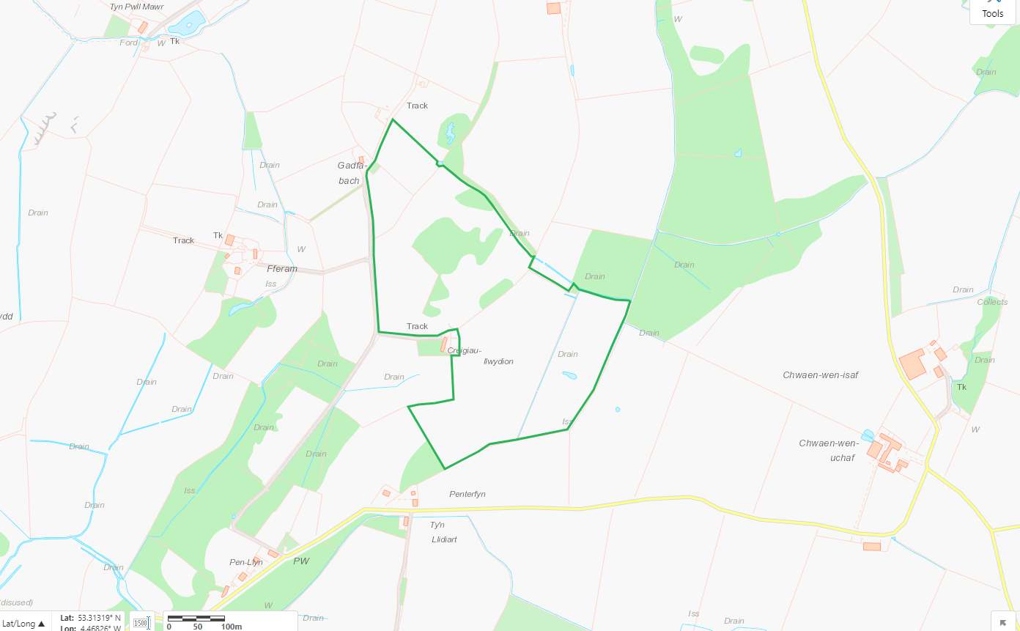

Groundwater protection zones
Locations not within GPZ
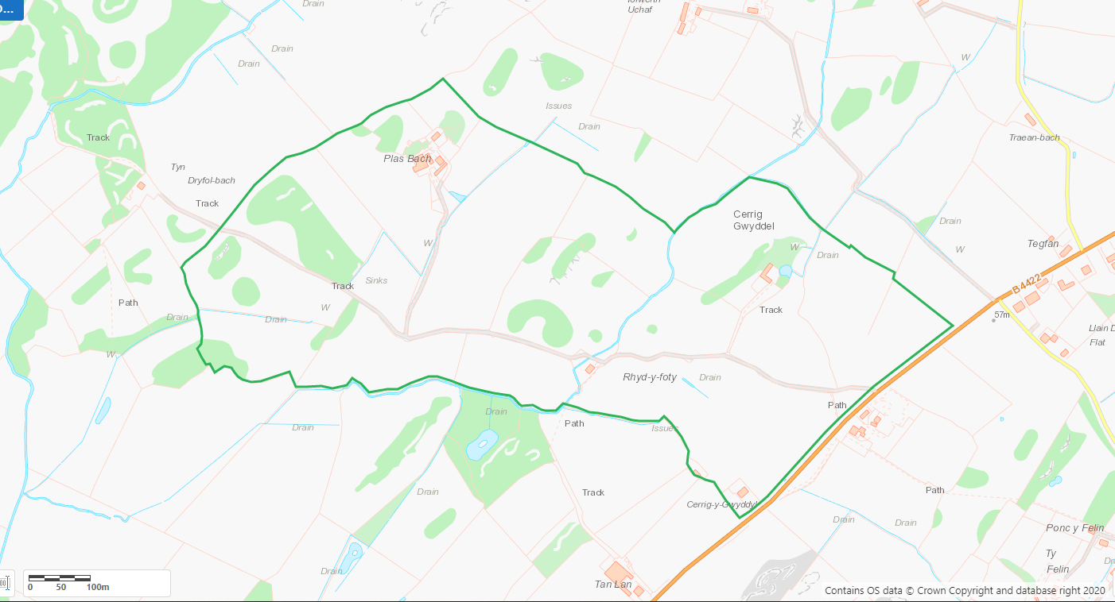

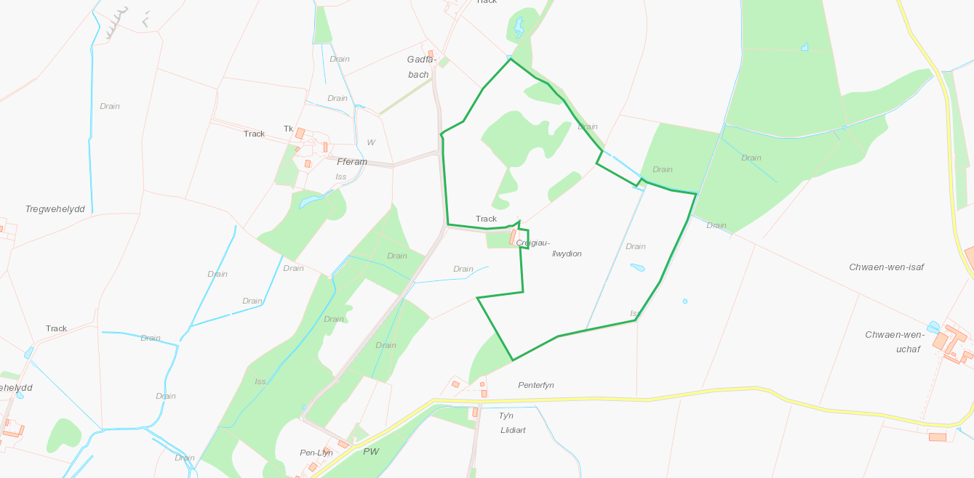

Wells, springs or boreholes used for the supply of water for human consumption including from a private water supply or supplies
Any springs wells or boreholes not used to supply water for domestic or food production purposes within 50m

Several within and adjacent to the locations, non spread buffers in place on application maps

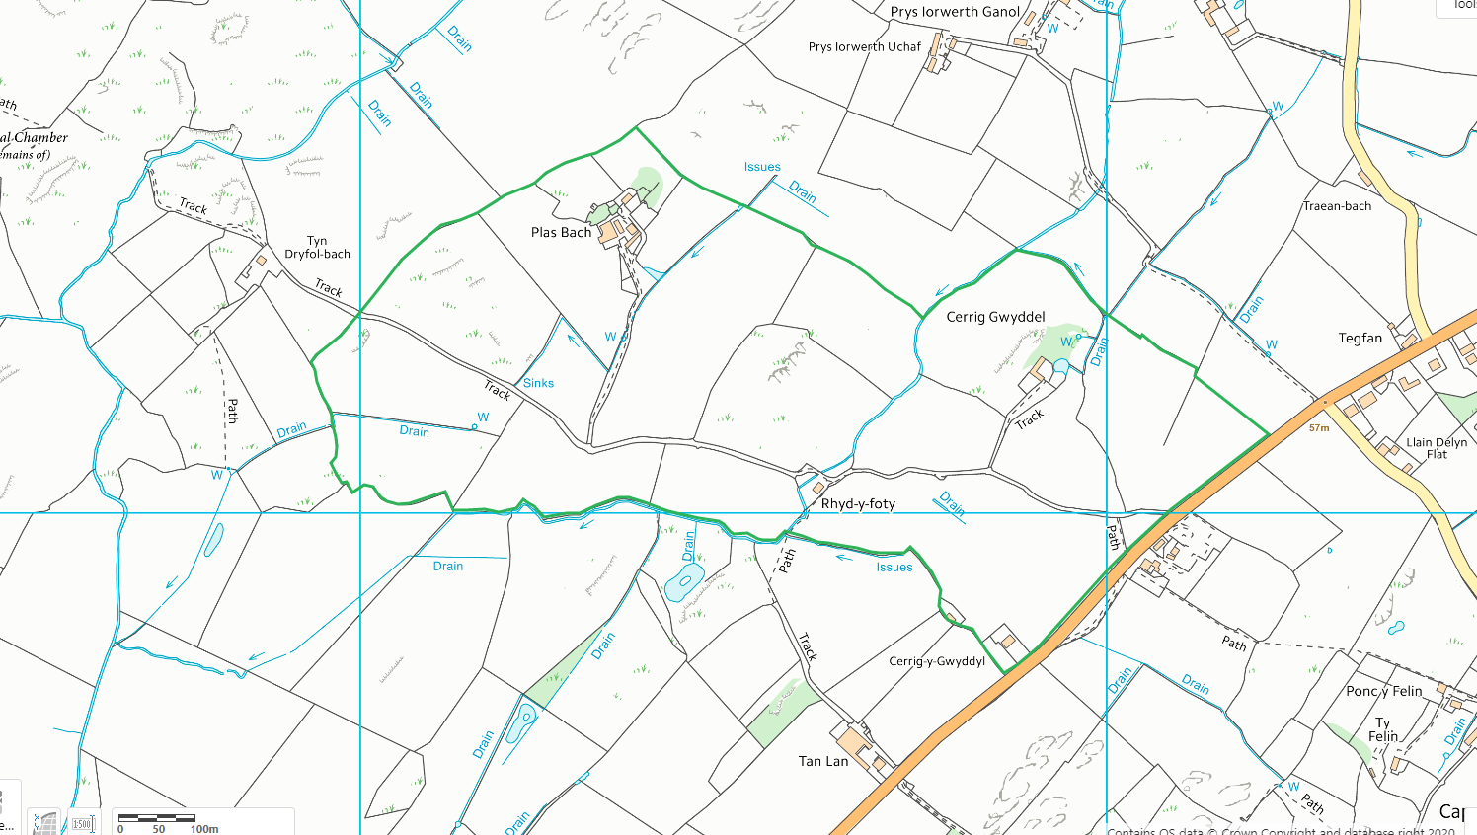

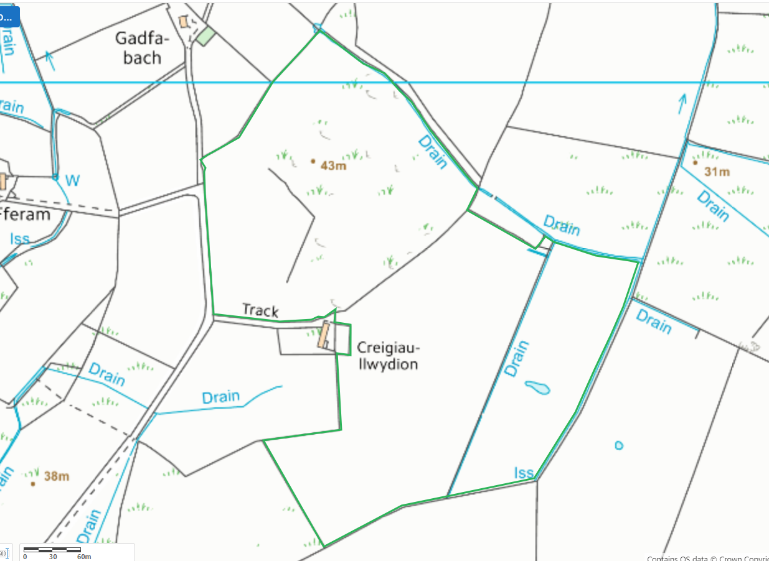

Several within 250m, non spread buffers in place on application maps
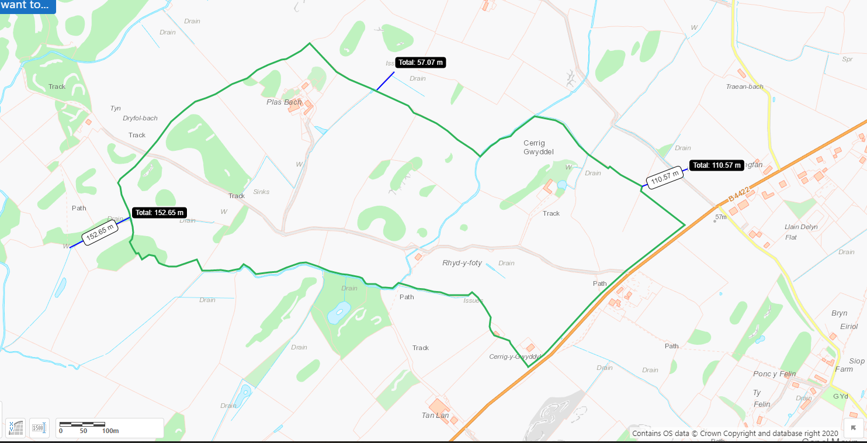
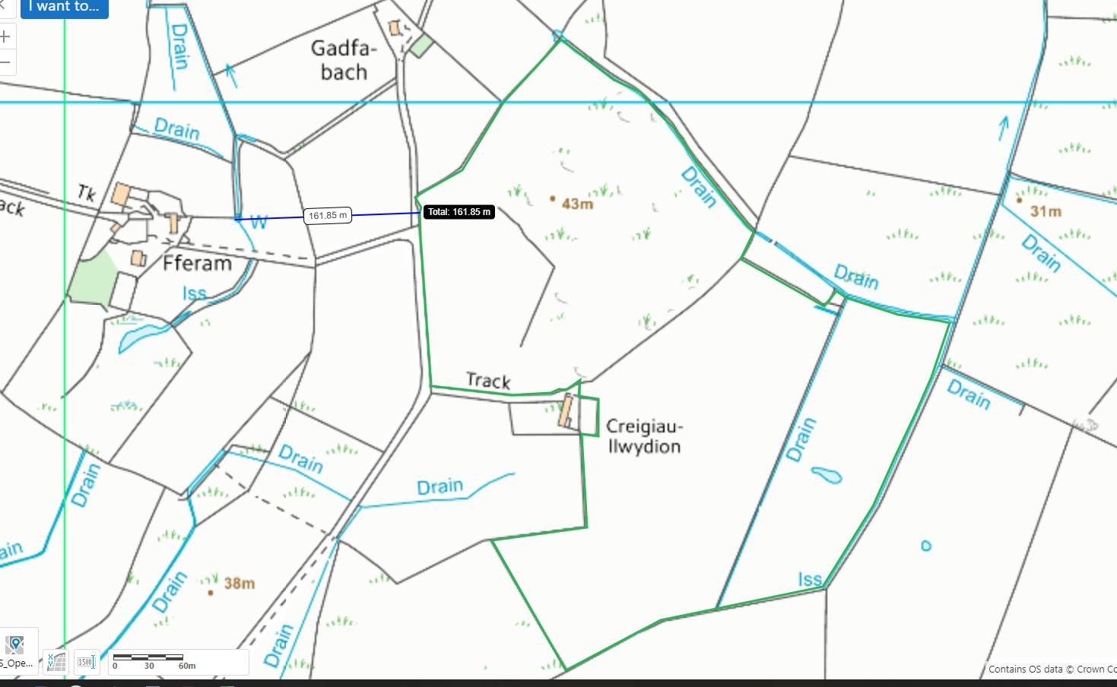

European designated sites- Natura 2000 (SPA, pSPA, SAC or cSAC) or Ramsar- or SSSI within 500m

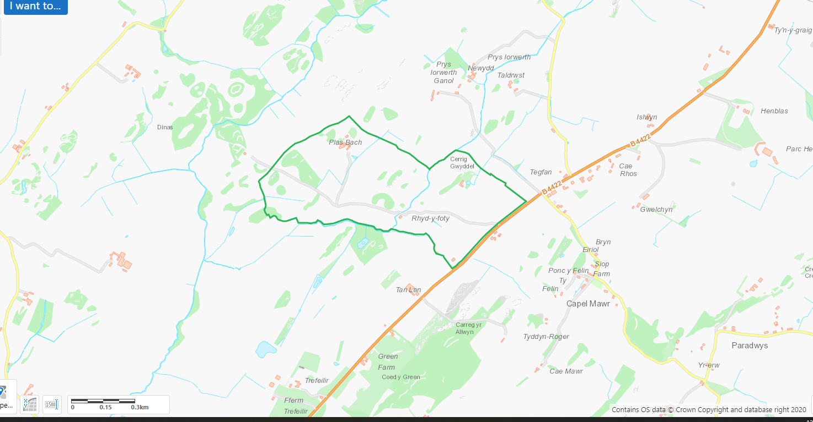

SSSI Llyn Llywenan <500m SW of Bodnolwyn B, non spread buffer in place which extends distance beyond 500m
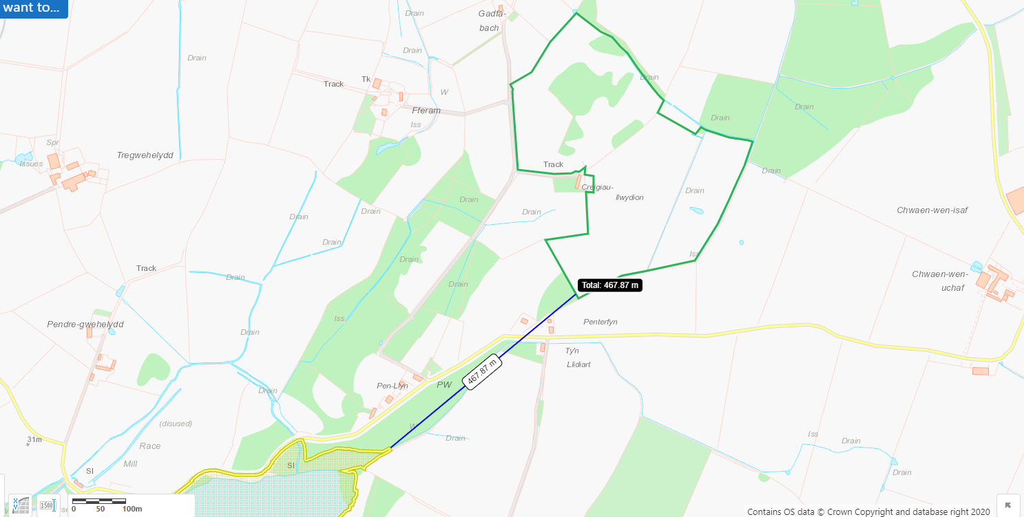
Other protected sites:
- Protected Species-
- Protected Habitats-
- Scheduled Ancient Monument-
- Local Nature Reserve-
- National Nature Reserve-
- Ancient Woodlands-
- Local Wildlife Sites (SINC)-
- National Park-
- Nitrate Vulnerable Zone (NVZ)-
- Groundwater Safeguard Zone-
- Hedges-
- Ditches-

Nitrate vulnerable zone and runs to lake 3km south
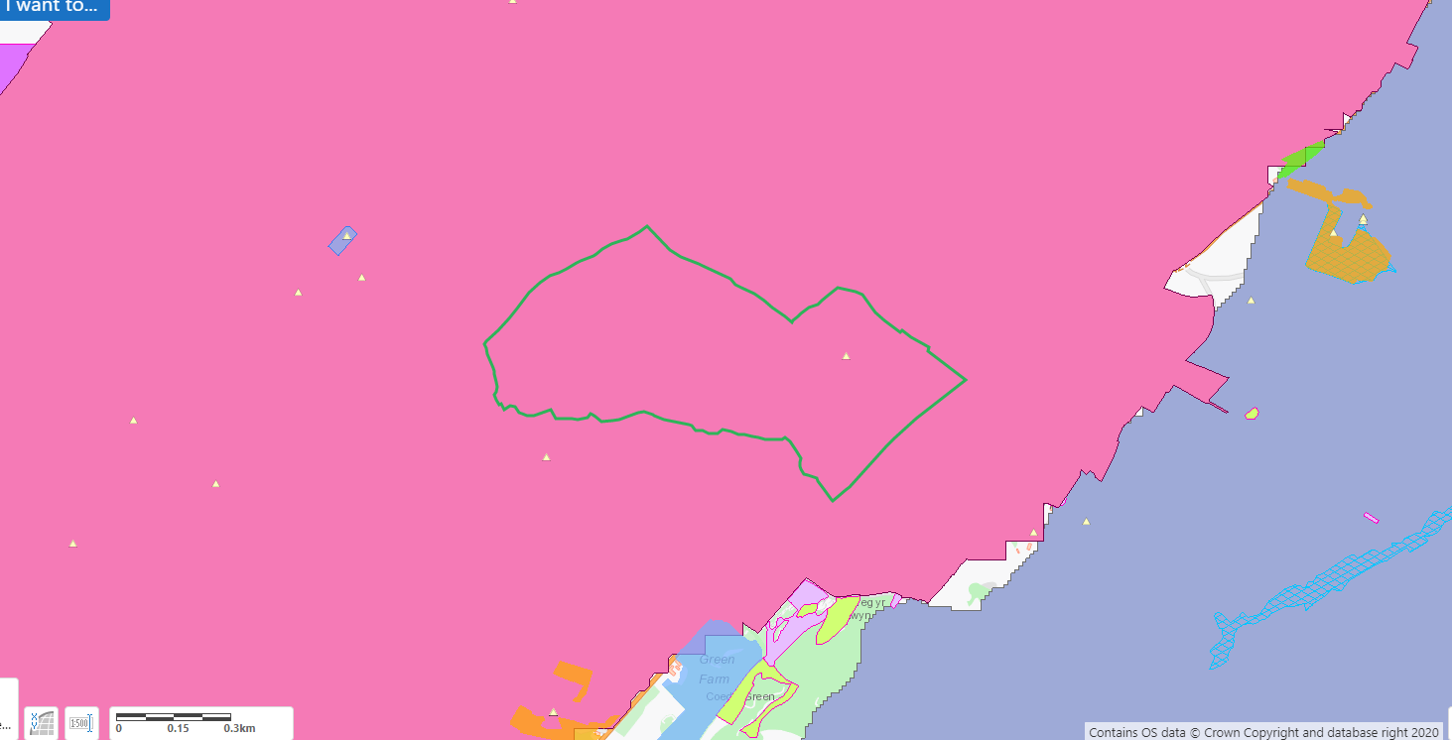
Ancient woodland S at 434m
Threatened Bryophyte NW
Threatened Lichen N
Purple moor grass and rush pastures SE and S
Lowland dry acid grassland and lowland calcareous grassland N, SE and S.
Non spread buffers in place on application maps.
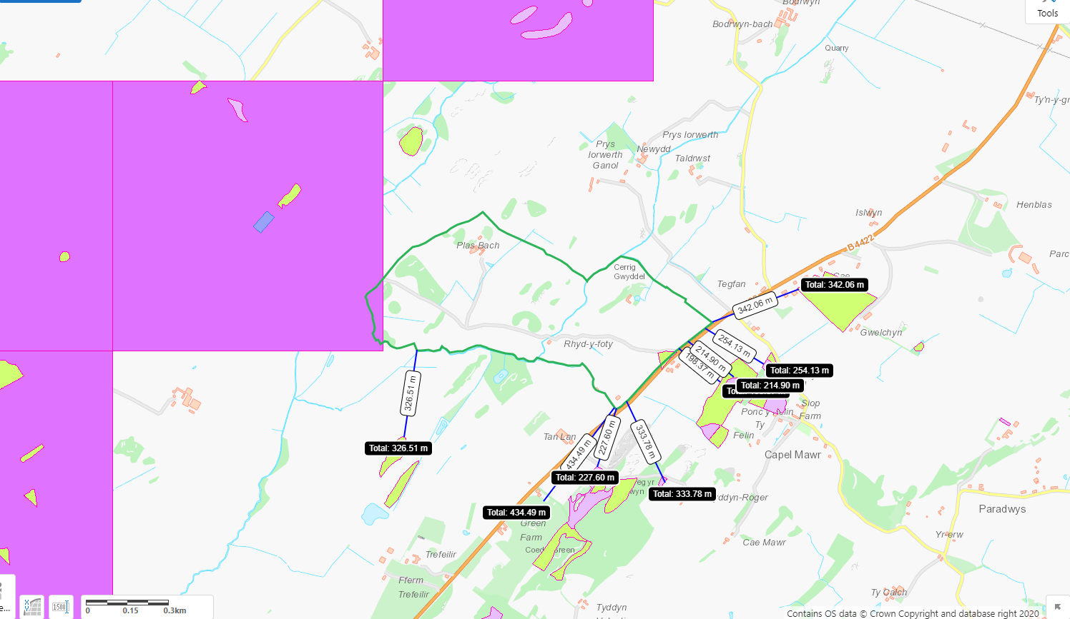

Purple moor grass and rush pastures bordering NE, NW, W, SW
Lowland dry acid grassland and lowland calcareous grassland SW
Non spread buffers in place on application maps
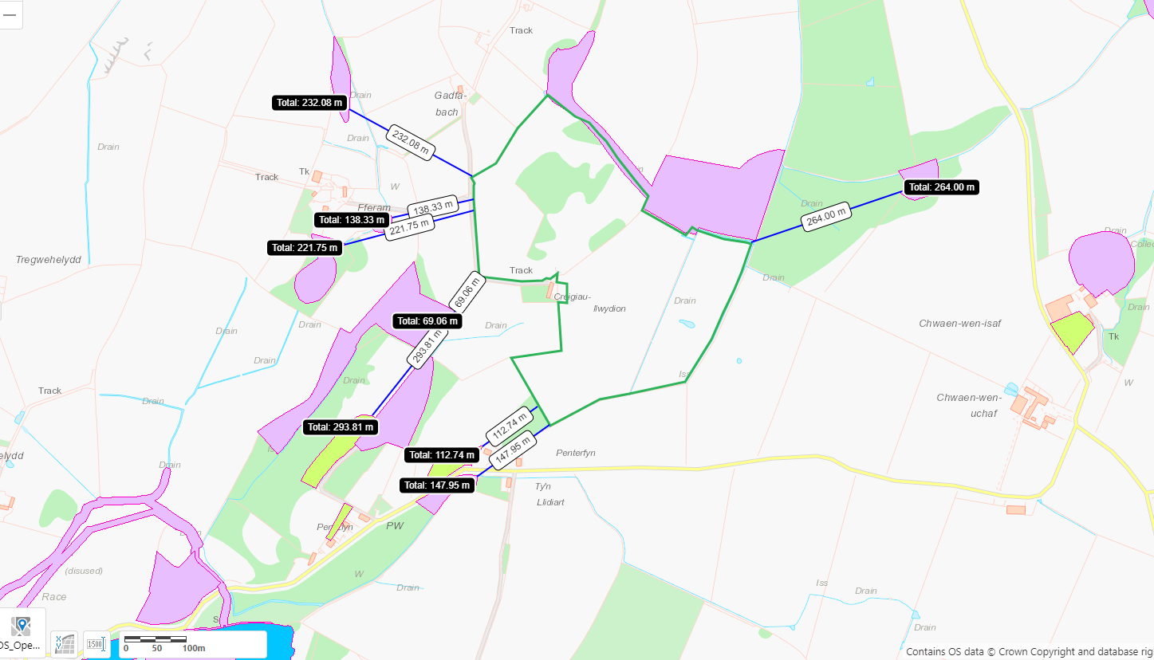

Public Rights of Way
Rights of way enter and cross the locations.
Non spread buffers in place on application maps
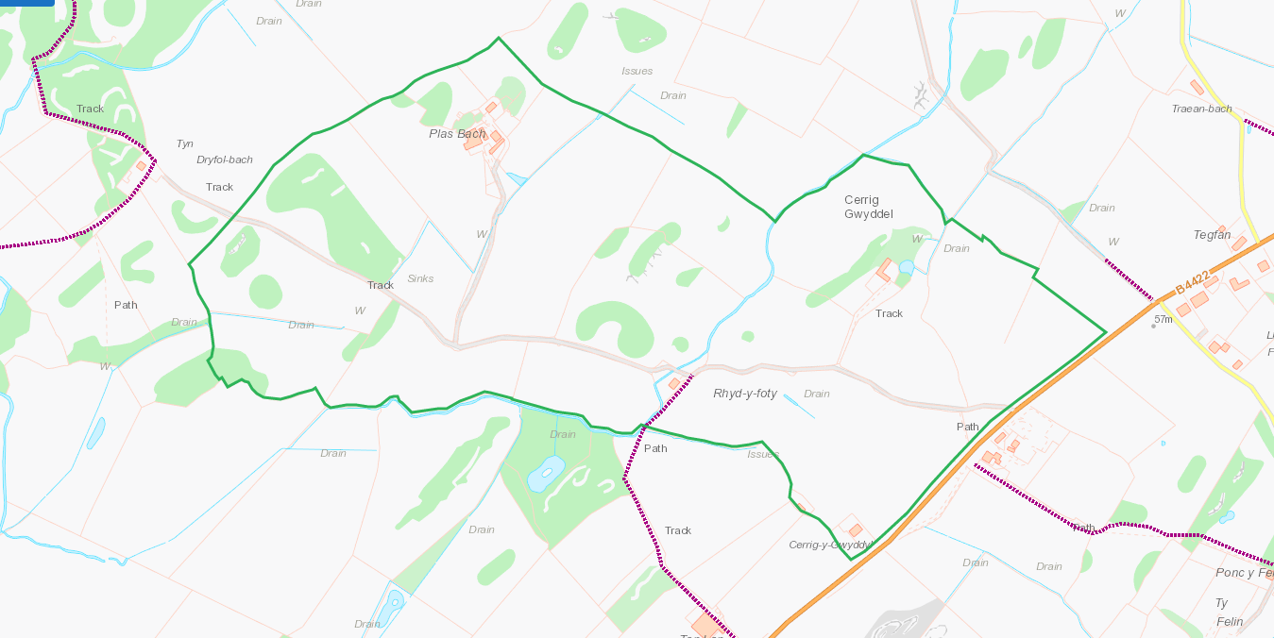

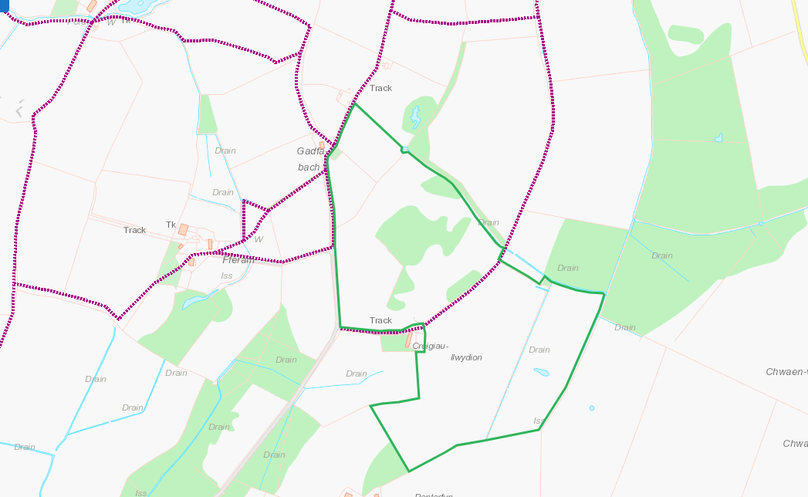

Slope Map
All fields 0-7 degrees with minor areas of 7-12 to the SW in SJC6, non spread buffers in place on application maps
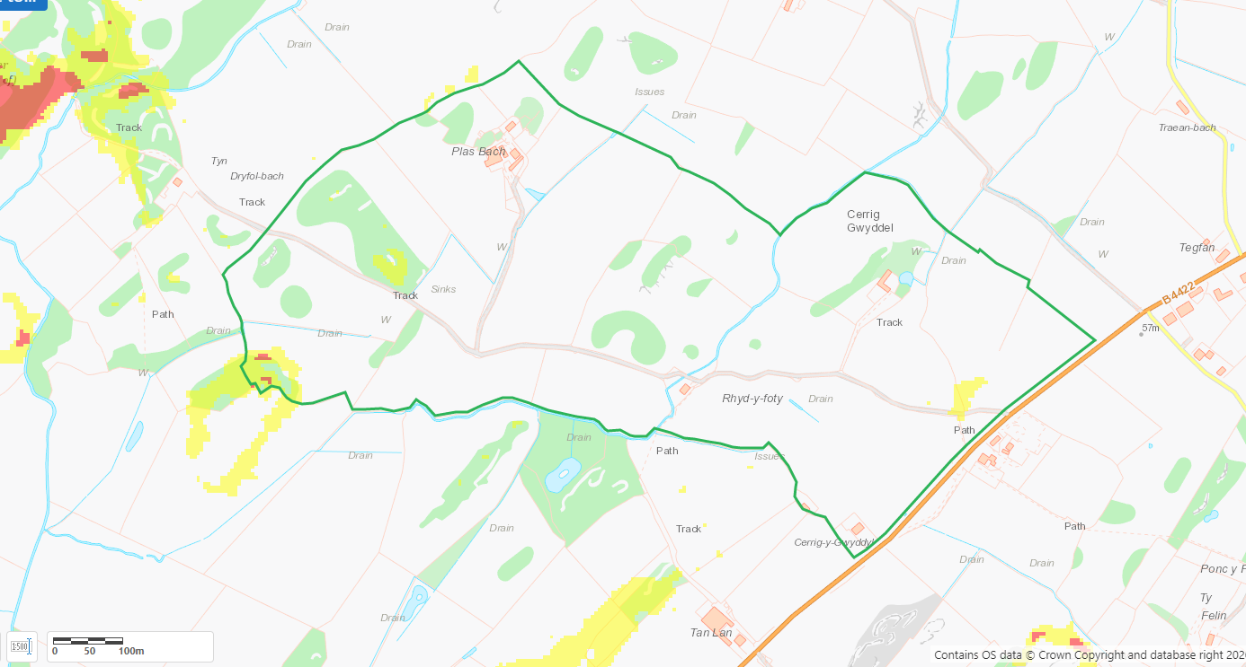
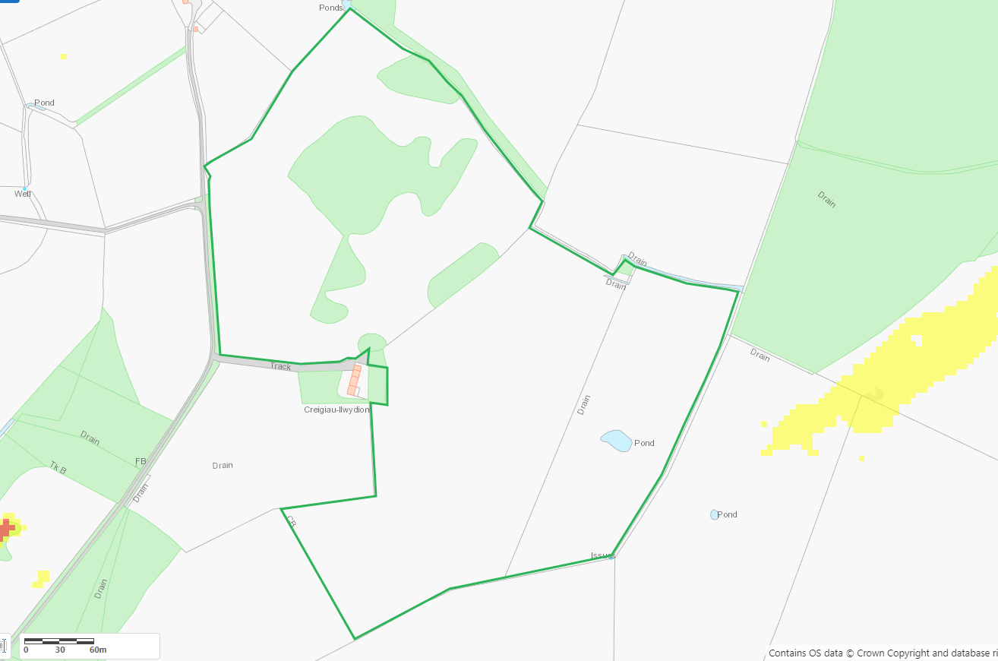

Topography


