Form

Record of a Habitats Regulations Assessment of a project

OGN 200 Form 1
Document owner: Protected Sites Team, EPP

Version History:
Document Version | Date Published | Summary of Changes
1.0 | March 2016 | Document created
1.1 | 30 November 2017 | References to the 2010 Habitats Regulations updated to reflect new consolidated version of the regulations which entered into force on 30th November 2017;  References to KSP and National Services Directorates updated to EPP
1.2 | 28 June 2018 | With marked up changes in light of ruling in CJEU case c-323/17 ‘People over Wind’. See Interim Guidance HERE
Next review date: April 2018

Record of a Habitats Regulations Assessment of a project

1. Project Details

1(a): Project details where an external party has applied to NRW for any form of authorisation
Application reference number (if applicable) | PAN-004240
Date application received | 19/12/2018
Applicant details | Mr Morton Powell
Activity proposed | Application for the construction of two broiler sheds with a maximum capacity of 110,000 broiler chickens for meat production. The annual meat production capacity will be 1735t; there will be 7.6 crop cycles per annum at a length of 42-days with 7-day turnarounds per crop.  The units will be ventilated by high speed ridge mounted fans, each with a short chimney. Litter will not be stored at the installation but will be spread on operator-controlled land in compliance with a manure management plan.  The sheds are fully insulated with a U-value of 0.4W/m2/°C to reduce condensation and heat loss.
Relevant legislation | The Environmental Permitting (England & Wales) Regulations 2016 - Schedule 1  Section 6.9 Part A 1 (a) Rearing poultry or pigs intensively in an installation with more than  - 40,000 places for poultry
Location | Drefor, Kerry, Newtown, Powys, SY16 4PQ  NGR: 16930 89116  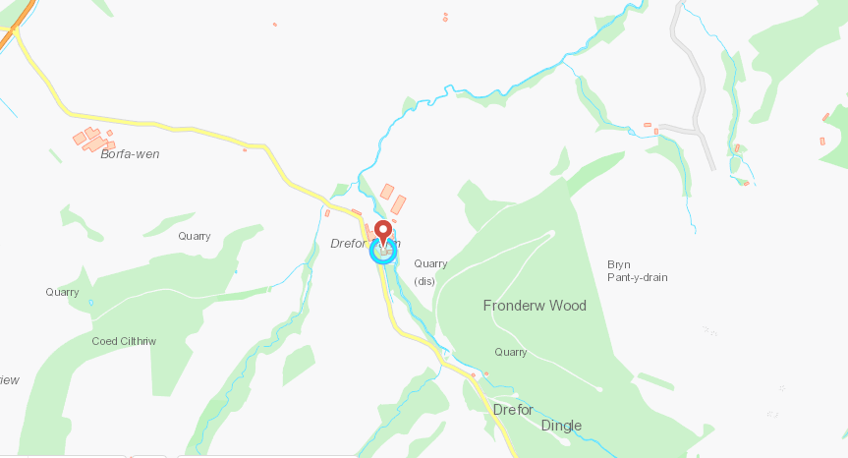
Application documents | DMS
Environmental Statement | N/A
Pre-application correspondence | N/A
NRW team responsible for drafting this HRA report, and name of lead officer | Danielle Carey  Permitting Officer 1  Regulated Industry

2. Determining the need for a Habitats Regulations Assessment

2.1 Is the whole of the project directly connected with or necessary to the management of one or more Natura 2000 sites, for the purposes of conserving the habitats or species for which the Natura 2000 site(s) is/are designated? | No
2.2 Is there a possibility that the project could affect a different Natura 2000 site to the one(s) the project is intended to conserve? | No
2.3 Is it necessary to carry out an HRA? | Yes

3. Considering the likelihood of a significant effect (LSE)

3.1 Renewal of a permission on the same or more restrictive terms as the extant permission

Is this project a renewal of a current permission which complies with NRW approved criteria for ruling out significant effects of renewals (see section 6.2A of OGN 200) without conducting a project-specific LSE test? | No

3.2 Likelihood of significant effects (LSE) test

3.2.1 Which Natura 2000 sites might be affected by the proposal? | Based on the project specification or information provided in the application, it is considered that the following Natura 2000 sites have features which could be affected by the project:  Montgomery Canal SAC – Approximately 4.9km northwest  The potential for the project to affect the following Natura 2000 sites was also initially considered, but can be ruled out without further consideration:  N/A
3.2.2 Screening assessment

Colour coding should be used in the ‘impact pathway’ column II as follows:

There is no impact pathway from the proposal to the designated feature
There is an impact pathway in principle, but significant effects from the proposal when considered alone can be ruled out
There is an impact pathway and significant effects cannot be ruled out

 | Assessment of likelihood of significant effect
 | I  Relevant conservation objectives | II  Potential impact pathway | In light of the ruling of the CJEU in case C-323/17 ‘People over Wind’, avoidance measures should not be considered at this stage of HRA, so this column is left blank.
Montgomery Canal SAC

Annex II species that are a primary reason for selection of this site  2.1 Vascular plants of aquatic habitats  Floating water-plantain Luronium natans | CORE MANAGEMENT PLAN INCLUDING CONSERVATION OBJECTIVES FOR MONTGOMERY CANAL SAC (& SSSI)  Version: 1  Date: 22nd January 2008  Approved by: David Mitchell | Toxic contamination  Nutrient enrichment  Acidification  A critical level of 3 has been assumed. The process contribution is >1% and therefore screens out. No significant impact is considered likely.  Modelling predicts that the process contribution of the proposed activity at Drefor to ammonia concentrations would be lower than the critical level/load of 3 for SAC.  The applicant’s ammonia modelling indicates that the prevailing wind is away from the site. | Missing table in Ammonia report with the relevant figures
Changes in salinity regime

Changes in thermal regime

Turbidity

Siltation

N/A – Wash water from poultry houses is directed in a sealed system to underground storage tank. Spillages of litter on yard areas during cleanout swept up. Lightly contaminated yard wash directed to underground tank. All clean site drainage directed to soakaways
Habitat Loss

Physical Damage

N/A. Proposed broiler unit is approximately 4.9km away from the SAC

3.2.3 Screening decision of the project ‘alone’

(a) If ALL rows in column II of Table 3.2.2 are GREEN | The project is not likely to have a significant effect on any Natura 2000 site, because there is no impact pathway from the project to any Natura 2000 features, and no further consideration under the Habitats Directive/Regulations is required in order to determine the application.
(b) If there are NO rows coloured RED in column II of Table 3.2.2, and there are ANY rows which are BLUE | The project is not likely to have a significant effect on any Natura 2000 sites when considered alone, but the possibility of significant effects in combination with other plans and projects needs to be considered.
(c) If ANY rows in Column II of Table 3.2.2 are RED | The project is likely have a significant effect on one or more Natura 2000 sites and therefore an appropriate assessment is required.

5 In combination assessment

5.1 Identifying possible in combination effects

BLUE impact pathway from Table 3.2  and/or  Residual effect (from appropriate assessment in section 4) | Natura 2000 site feature(s) concerned | Other plans/projects with effects that might interact with the effects of the project to render its effects significant (if any) | Nature of the in-combination effect (if any) | Is there likely to be any significant in-combination effect, in view of the site’s conservation objectives?
Toxic contamination  Nutrient enrichment  Acidification | Montgomery Canal (SAC_UK0030213; SSSI_32WPP) | For Intensive farming installations, the NRW position is that in combination effects are only taken into account if the process contribution exceeds 1% of the critical level. In this case the process contribution is >1% of the critical level. Therefore, in combination is not required | N/A | No
- If the right hand column is ‘NO’ for all rows |  | The project, when considered in combination with other plans and projects, is either not likely to have a significant effect on, or will not adversely affect the integrity of any Natura 2000 site.
- If any rows in the right hand column are ‘YES’ or ‘DON’T KNOW’ |  | The project is likely to have a significant effect in combination with other plans or projects.

5.2 Addressing in-combination effects

In combination effect | Describe any conditions, restrictions or other measures, if any, applicable to the subject project, and/or to the other plans/projects giving rise to the in combination effect, which could remove the risk of adverse effects on the Natura 2000 site features. Include details of how such measures would be applied, and who would be responsible for applying them. | Taking into account any additional measures identified and how they would be applied, can adverse effects on site features from in-combination effects be ruled out?
N/A | N/A | N/A
- If the right hand column is ‘YES’ in all cases | It can be concluded that the project will not adversely affect the integrity of any Natura 2000 sites, either alone or in combination with other plans or projects.
- If any row is ‘NO’ in the right hand column | It cannot be concluded that the project will not adversely affect the integrity of any Natura 2000 sites, when considered in combination with other plans or projects.

6. Conclusion
HRA is not required because the whole of the project is directly connected with or necessary to the management of one or more Natura 2000/Ramsar sites, for the purposes of conserving the habitats or species for which the site(s) is/are designated, and the project is not likely to have a significant effect on any other Natura 2000/Ramsar sites.
(As documented in section 2.1 and 2.2 of this form)

HRA is not required because there is no conceivable impact pathway to any Natura 2000/Ramsar site
(As documented in section 2.3 of this form)

This project is a renewal of a current permission which complies with NRW agreed criteria for ruling out significant effects of a renewal without conducting a project-specific LSE test. Therefore it is considered not likely to have a significant effect on any Natura 2000/Ramsar sites, either alone or in-combination with other plans and projects.
(As documented in section 3.1 of this form)

The project has been screened for likelihood of significant effects and, taking account of the advice received from protected sites advisors, is considered not likely to have a significant effect on any Natura 2000/Ramsar site  (As documented in section 3.2 of this form, or section 5 if applicable) | X
In light of the conclusions of an appropriate assessment, and taking account of the advice received from protected sites advisors, it has been established that the project will not adversely affect the integrity of any Natura 2000/Ramsar site, taking into account any conditions or restrictions as applicable, either alone or in-combination with other plans and projects.
(As documented in section 4 of this form, and section 5 if applicable)

In light of the conclusions of the appropriate assessment, it has not been ascertained that the project will not adversely affect the integrity of any Natura 2000/Ramsar site, as documented in section 4 of this form, and section 5 is applicable.

Approval for the project cannot be given unless either:
- the project specification, and/or the terms under which it might be approved, are modified so as to remove the risk of adverse effects, and a revised HRA report is prepared, or
- the project satisfies the requirements of Article 6(4) of the Habitats Directive, an Article 6(4) Statement of Case is prepared (OGN 200 Form 3) and submitted for consideration by the appropriate authority, normally Welsh Ministers
Signed: Danielle Carey

Name: Danielle Carey

Position: Permitting Officer, Regulated Industry

Date: 30/01/2019

7. Consultation with protected sites advisor(s) and how sections 2, 3, 4 and 5 of this HRA report (as applicable) take into account that advice.

Delete any rows that do not apply.

Relevant section of the HRA report | Date(s) of correspondence* and any meeting(s) with protected sites advisor(s) | Description of how the comments from protected sites advisors have been taken into account
2
3
4
5

*Attach copies of all written representations (Form 2) received from protected sites advisor(s)
8. Conservation Technical Specialist’s comments

This section should be completed in any cases where the protected sites advice and sign off of the HRA report (section 6) is within the same team. Otherwise this section should be deleted

I have reviewed the HRA documented in this form and confirm that I agree/do not agree* with its findings.
(*strike out as applicable)

Additional comments (if any):

Signed:

Name:

Position:

Date:

