PAN-019963 Mymap Report
Required Water buffers
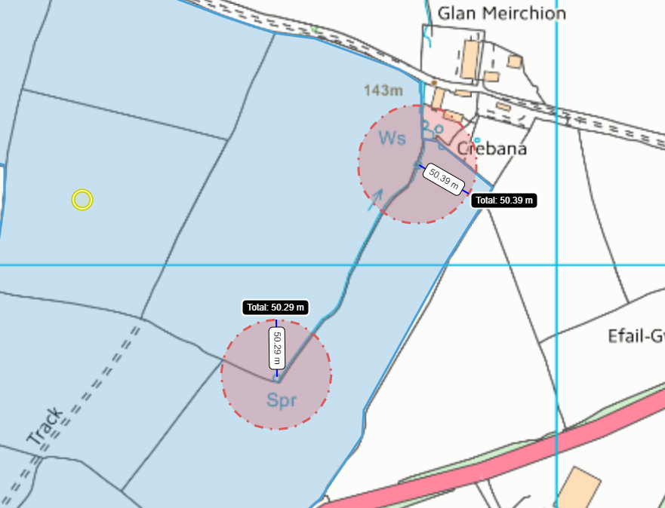
Rights of Way Map 1
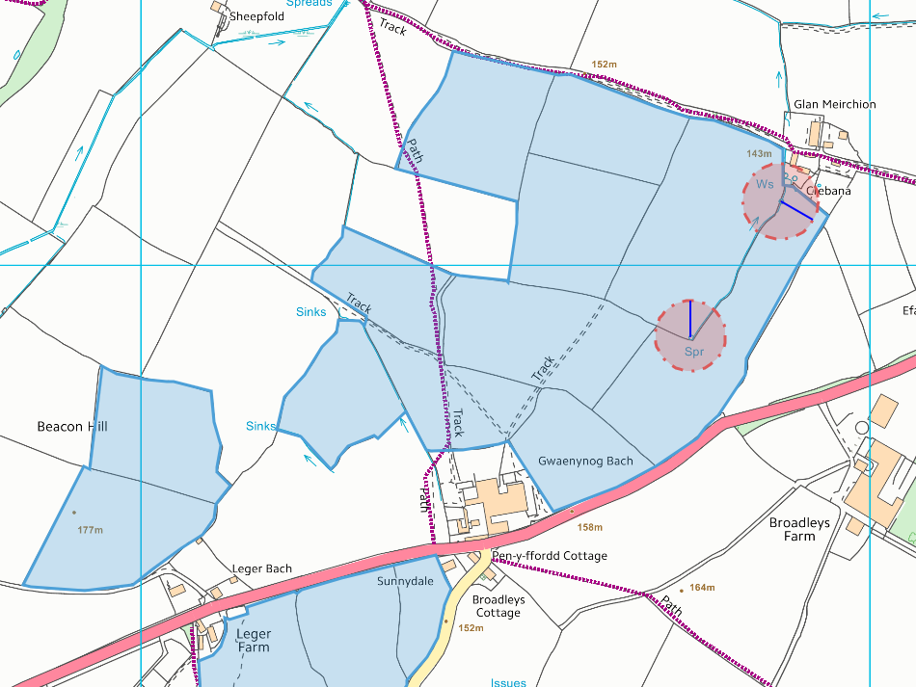
Not marked on applicants map
Rights of way map 2
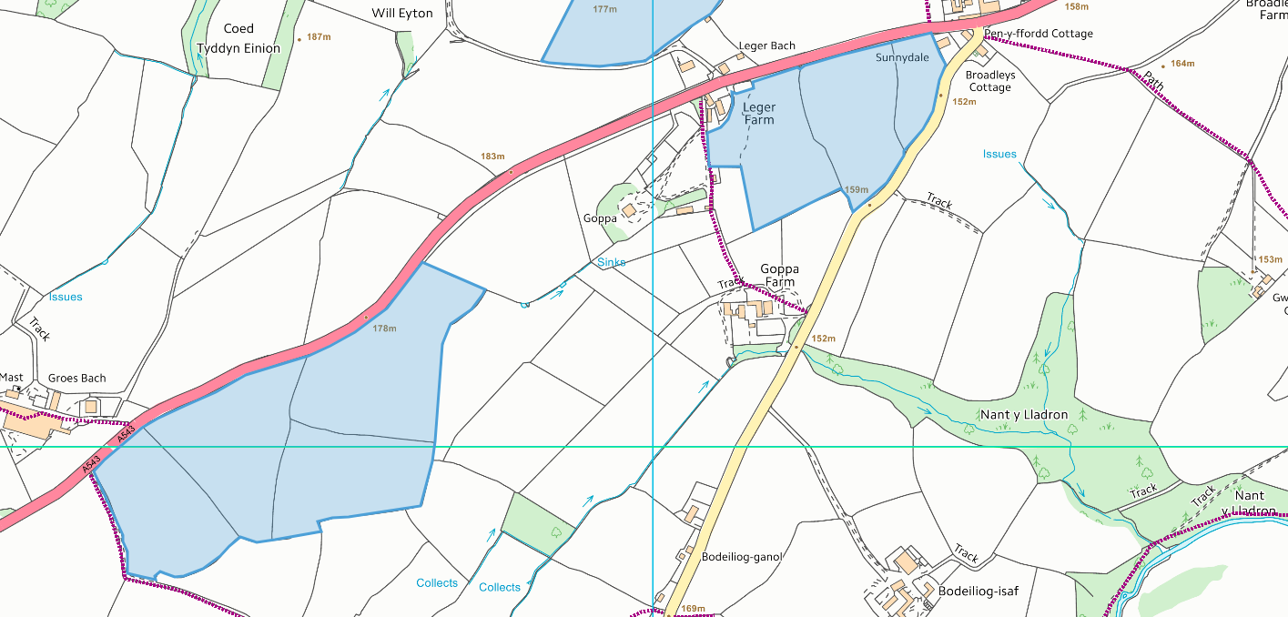
Slope Map
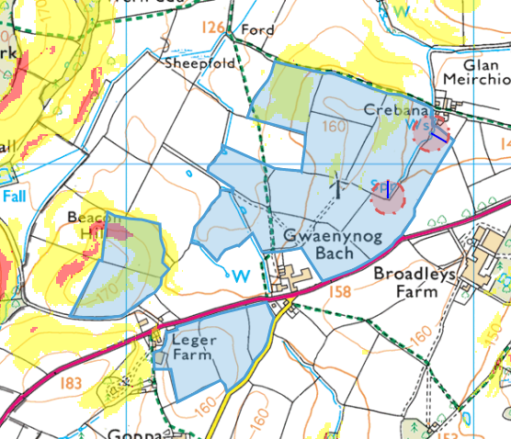
Fields 7605, 4719, 0276 and 9763 contain slopes between 7-12 degrees of slope.
Field 0276 contains an are of slope above 12 degrees of slope this area needs to be removed.
Slope Map 2
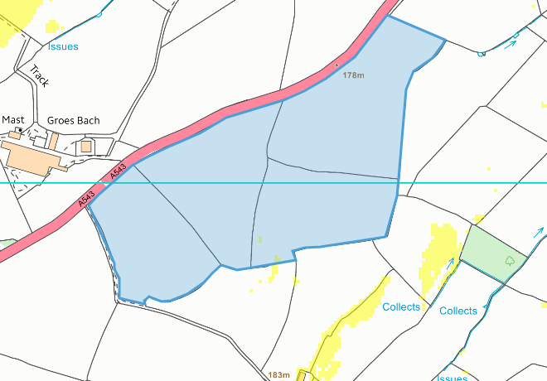
Mapping assessment 1
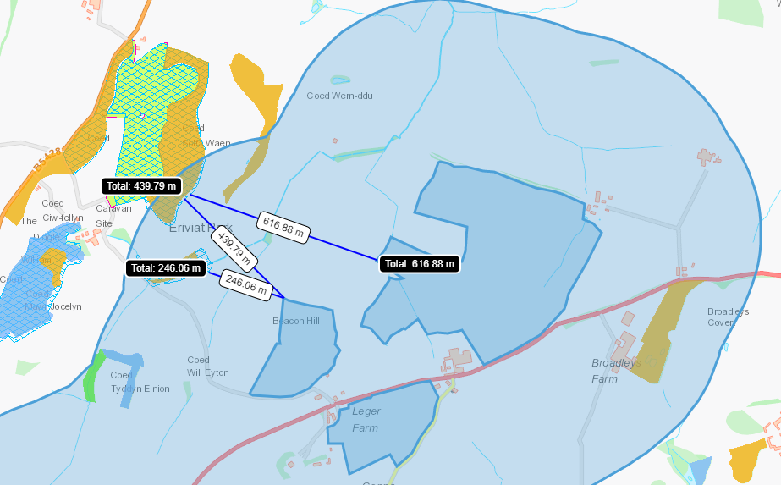
10 areas of ancient woodland
2 SINCs Coed Solfa Waen 439m to North west of spread area, Eniviat Hall Lake 246m to the west of spread area
Mymap Assessment 2


