PAN-020076 My Map Report

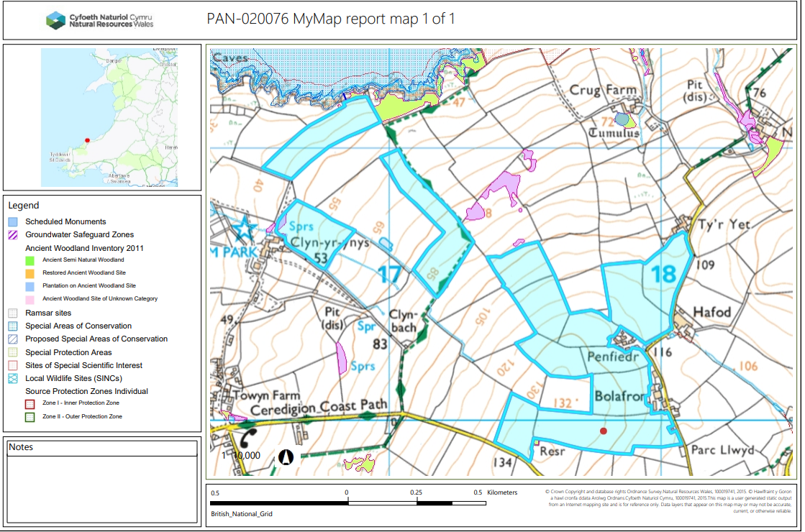

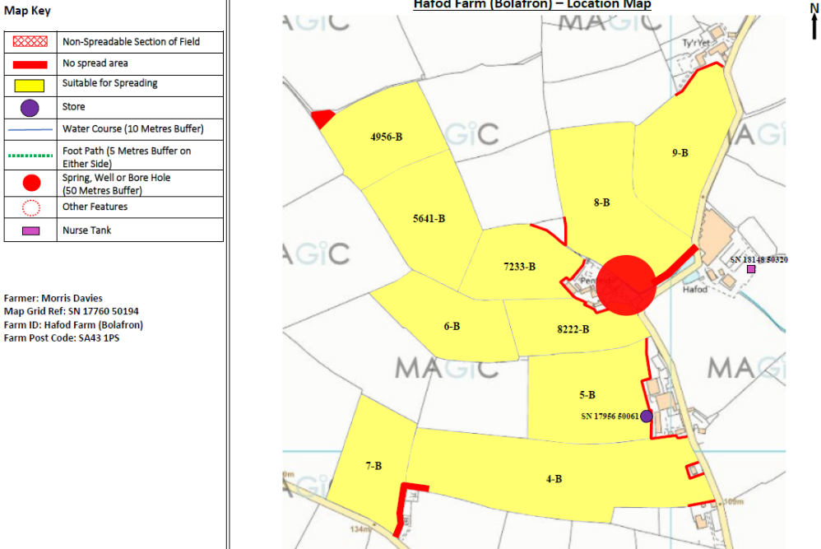
Proposed spreading map
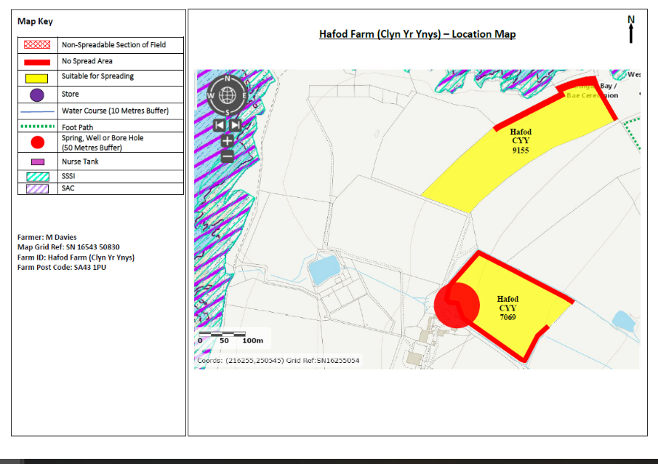
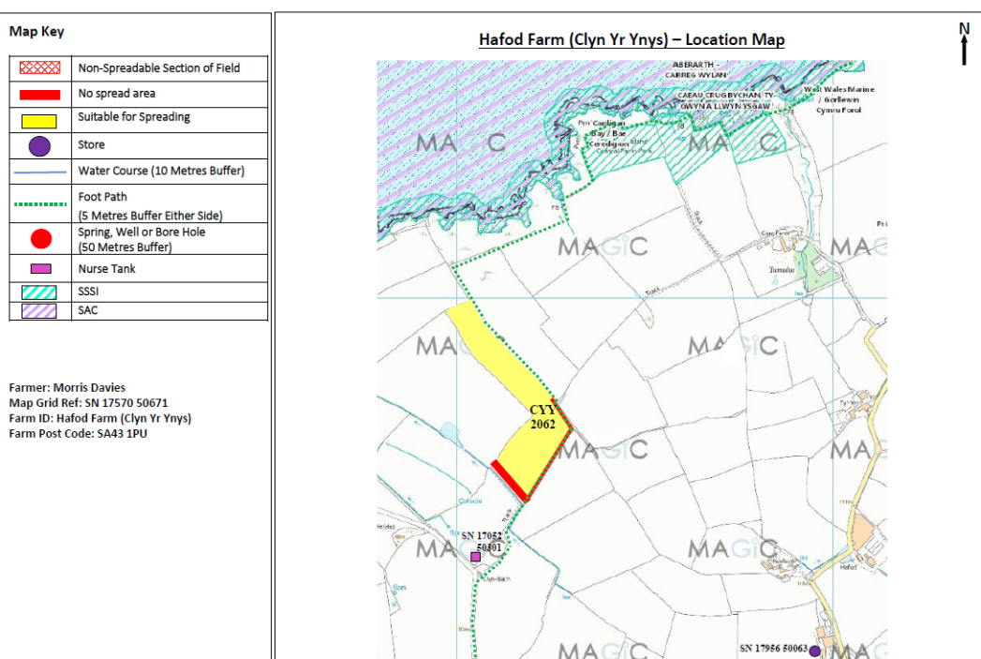

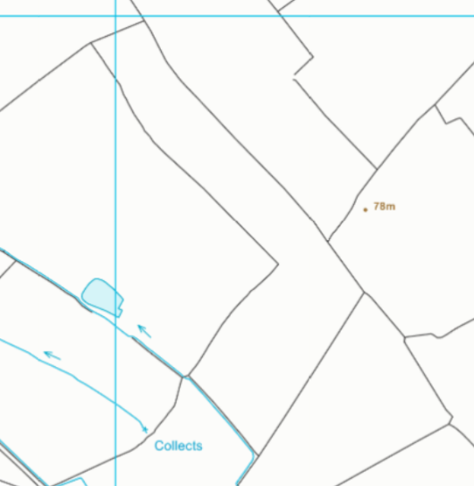
Detailed river network:
CY 2062
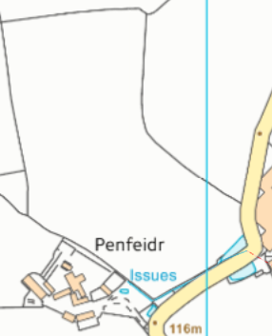
8-B
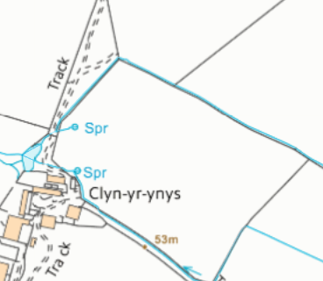
CY 7069

Field 8-B, CY2062, CY 7069 field boundaries are located next to water issues. They have been buffered by a 10 meter no spread zone in accordance with the SRP.

Groundwater protection zones
None in range.

Wells, springs or boreholes used for the supply of water for human consumption including from a private water supply or supplies
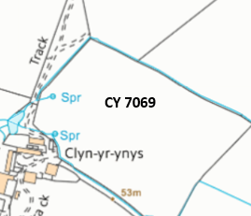
Field CY 7069 contains 2 springs that have been correctly buffered by a 50 meter no spread zone, in accordance with the SRP.

Any springs wells or boreholes not used to supply water for domestic or food production purposes within 50m

None in range.

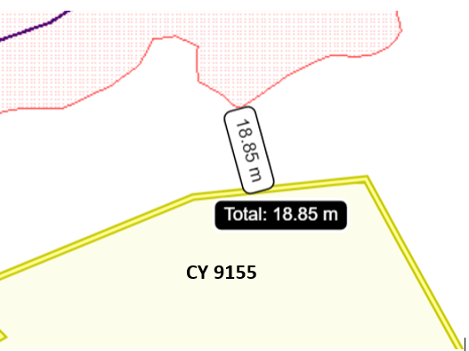
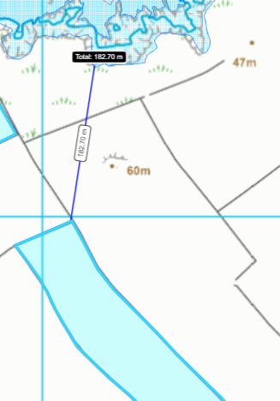
European designated sites- Natura 2000 (SPA, pSPA, SAC or cSAC) or Ramsar- or SSSI within 500m
Fields CY 9155 & CY2062 are located 19 m and 183 meters from:
- Cardigan Bay SAC
- West Wales Marine SAC
- Aberarth - Carreg Wylan SSSI

CY 2062

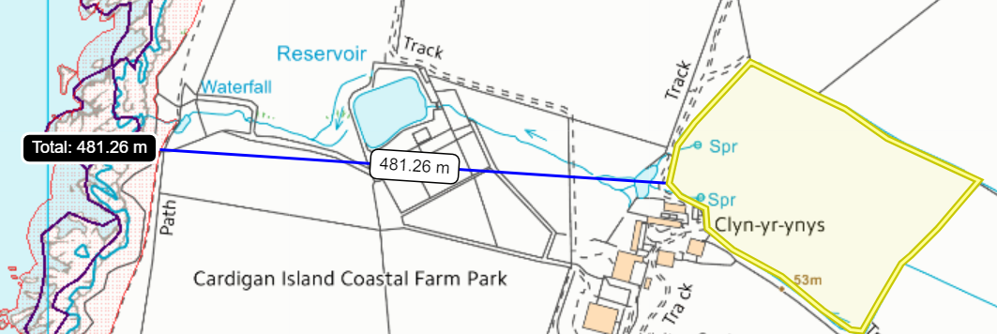
CY 7069

Fields CY7069 is located 481 meters from:
- Cardigan Bay SAC
- West Wales Marine SAC
- Aberarth - Carreg Wylan SSSI
There are two springs located in field CY 7069 that have a 50 meter no spread buffer zone in place around the springs in according with the SRP. The Springs are hydrologically connected to the SACs & SSSI. As the springs are buffered by 50 meters and are a distance of 481 meters, it is unlikely nutrients and or PTEs will enter these areas.

Other protected sites:
- Protected Species- None In range.
- Protected Habitats-
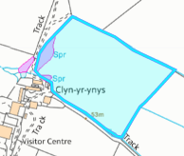
CY 7069
Field CY 7069 contains a protected habitat: Purple moor grass and rush pastures. Although from the nearby located springs there is a 50 meter no spread buffer zone located within this area. As a result it is highly unlikely that nutrients and/or PTEs will enter the protected habitat.

- Scheduled Ancient Monument- None In range.

- Local Nature Reserve- None In range.

- National Nature Reserve- None In range.

- Ancient Woodlands- None In range.

- Local Wildlife Sites (SINC)- None In range.

- National Park- None In range.

- Nitrate Vulnerable Zone (NVZ)- None In range.

- Groundwater Safeguard Zone- None In range.

- Hedges- Nothing of concern.

- Ditches- Nothing of concern.

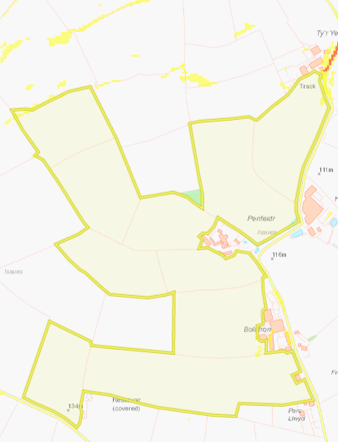
Slope Map
Fields 4-B to 7223B all contain areas of land that is flat to gently sloping at 0-7º. The method of application for the non-stackable liquid wastes is appropriate where a dribble bar or a shallow slot injector will be used. The application timing is also appropriate where the wastes will be spread in early spring 2023, after silage cuts and spring & summer 2023. The waste will be soil incorporated as soon as possible & within 24 hours where spread prior to cultivations & planting of the maize crops. As a result these fields do not pose a surface runoff risk.
9-B
8-B
5-B
4-B
7-B
6-B
8222-B
7233-B
5641-B
4956-B
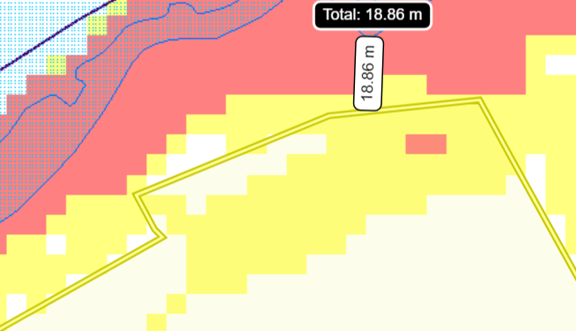
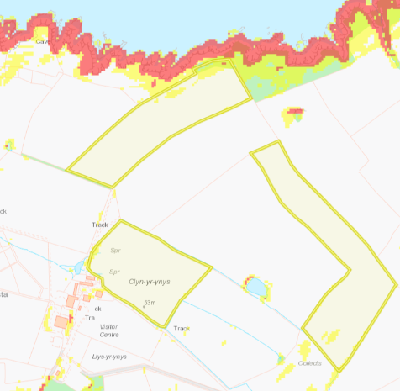
Field CY 7069 and CY 2062 contain areas small areas of land moderately sloping in yellow (7-12º). These small areas of land are contained to the land spreading area and do not pose a high surface runoff risk.

Field CY 9155 northern border is located on moderately sloping land (7-12º) which then drops off into a cliff into the Cardigan Bay SAC West Wales Marine SAC and the Aberarth Carreg Wylan SSSI. There is minimum of a 12m buffer in field Hafod Farm CY 9155 at the nearest point to the SAC and SSSI to ensure there is an minimum 30m buffer from field CY 9155 to the SAC/SSSI. Although in the request for information dated 31/01/23 it was requested the no spread buffer zone in field CY 9155 to be extended to include this moderately sloping area to mitigate the risks of nutrients and/or PTEs from entering the SACs & SSSI. This is because the wastes are non-stackable liquids where there is an elevated runoff risk.

CY 9155
CY 7069
CY 2062
CY 9155

