Permit
The Environmental Permitting (England & Wales) Regulations 2016

RDR Woodchip Ltd

Unit 8
31 Sambucus Avenue
Llandow Trading Estate
Cowbridge
Vale of Glamorgan
CF71 7PB

Permit number

EPR/CB3797FY

Permit
The Environmental Permitting (England and Wales) Regulations 2016
Permit number

EPR/CB3797FY

The Natural Resources Body for Wales (“Natural Resources Wales”) authorises, under regulation 13 of the Environmental Permitting (England and Wales) Regulations 2016

RDR Woodchip Ltd (“the operator”),

whose registered office is

Rosedew Farm

Beach Road

Llantwit Major

Wales

CF61 1PZ

company registration number 10012498

to operate waste operations at

Unit 8

31 Sambucus Avenue

Llandow Trading Estate

Cowbridge

Vale of Glamorgan

CF71 7PB

to the extent authorised by and subject to the conditions of this permit.

Under regulation 27(2) of the Regulations, standard rules SR2011 No4 are conditions of this permit.

Name | Date
Huw Davies | 10/02/2023

Authorised on behalf of Natural Resources Wales

Schedule 1 - Site plan

This is the plan referred to in the standard rules SR2011 No4

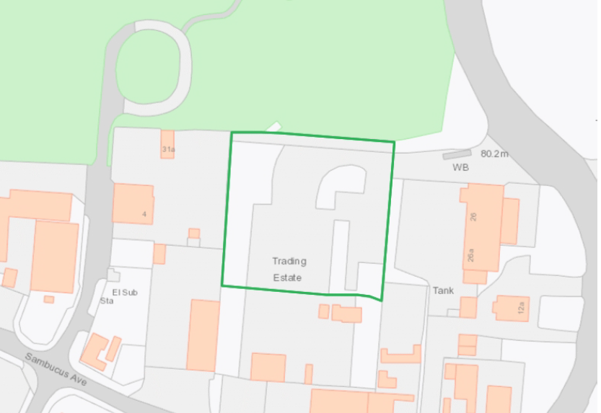

© Crown Copyright and database right [2023]. Ordnance Survey licence number 100019741.

END OF PERMIT

