PAN-020277 My Map Report:
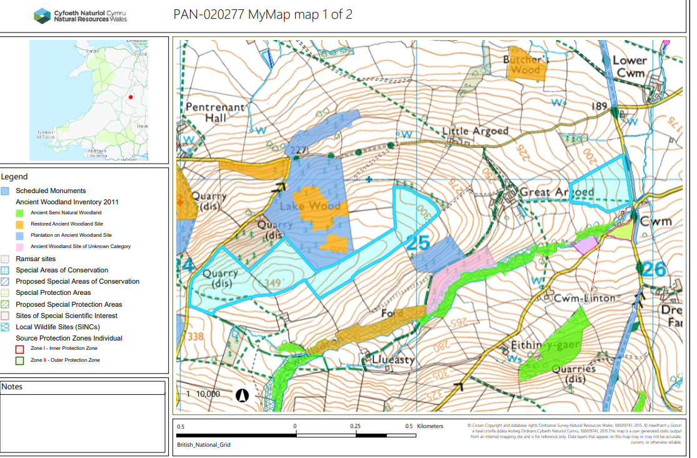
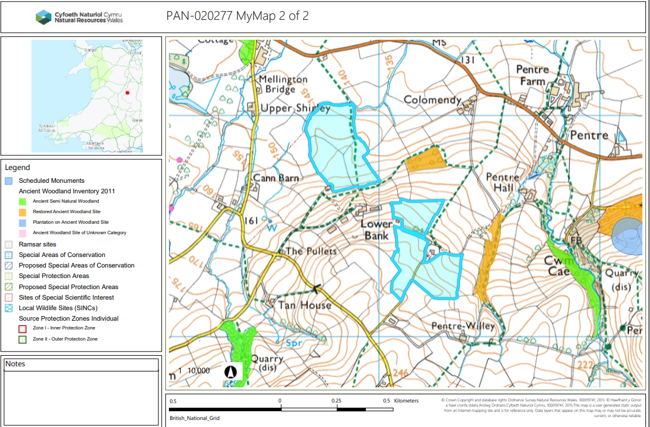

Proposed spreading map
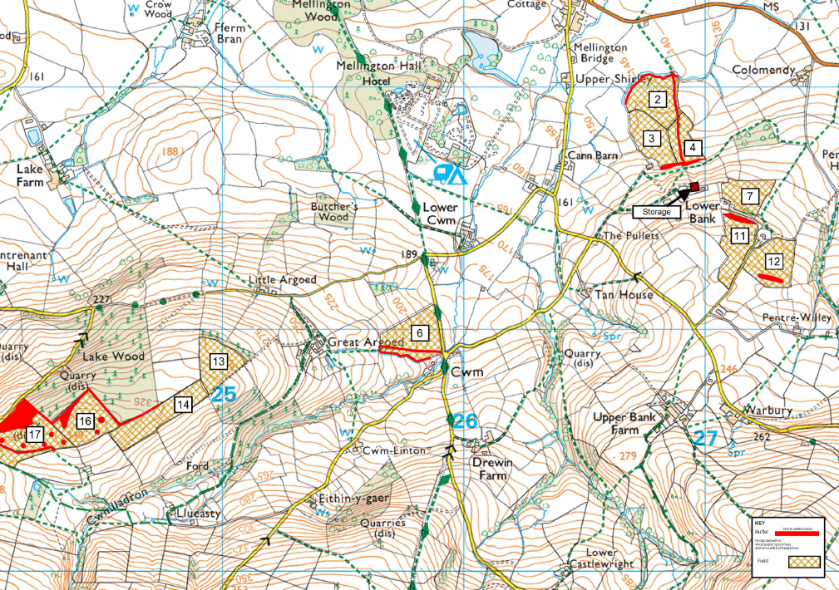

Detailed river network:
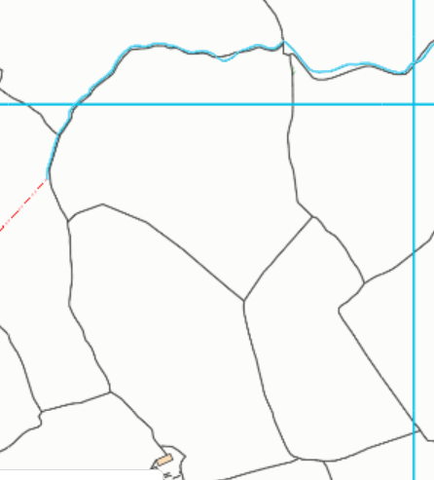
Field 2 northern border is located next to a water issue. The submitted site plan shows a 10 meter no spread buffer zone is in place to prevent nutrients from entering the issue and complies with the SRP.
2

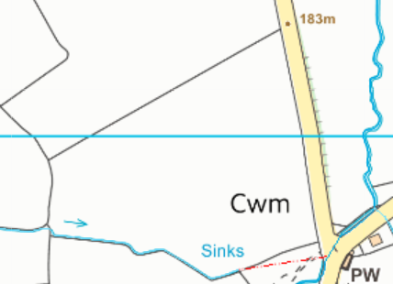
Field 6 southern border is located next to a water issue. The submitted site plan shows a 10 meter no spread buffer zone is in place to prevent nutrients from entering the issue and complies with the SRP.
6
Groundwater protection zones
None in range.

Wells, springs or boreholes used for the supply of water for human consumption including from a private water supply or supplies
None in range.

any springs wells or boreholes not used to supply water for domestic or food production purposes within 50m

None in range.

European designated sites- Natura 2000 (SPA, pSPA, SAC or cSAC) or Ramsar- or SSSI within 500m

None in range.

Other protected sites:
- Protected Species- None in range.

- Protected Habitats- None in range.

- Scheduled Ancient Monument- None in range.

- Local Nature Reserve- None in range.

- National Nature Reserve- None in range.

- Ancient Woodlands-
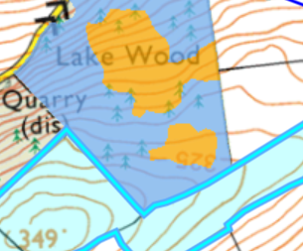
Field 14 and 16 border 2 ancient woodlands:
1. Plantation on Ancient Woodland Site
2. Restored Ancient Woodland Site
There is a 10 meter no spread zone in place around the border of the fields/ancient woodlands to prevent nutrients from entering the woodland.
14
16

- Local Wildlife Sites (SINC)- None in range.

- National Park- None in range.

- Nitrate Vulnerable Zone (NVZ)- All of Wales is now a NVZ. Waste stream D.SIDOLI has a high readily available content at 51.5%. In the submitted ABS there is no mention this waste stream will not be spread in the appropriate closed periods. The request for information asked for this to be confirmed.
- Groundwater Safeguard Zone-

- Hedges- There will be a 2 meter no spread buffer zone in place around hedges.

- Ditches- See slope assessment below.

Slope Map
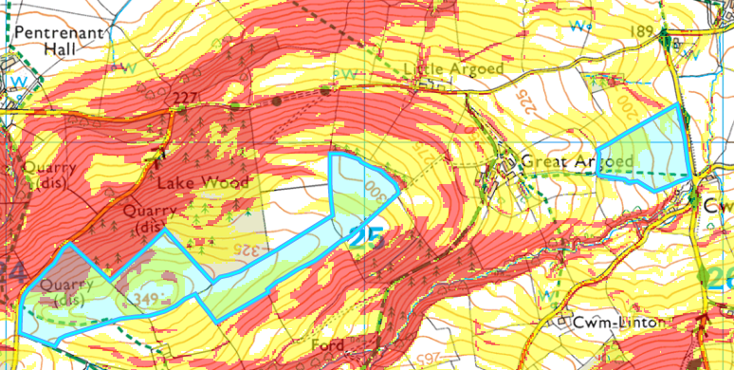
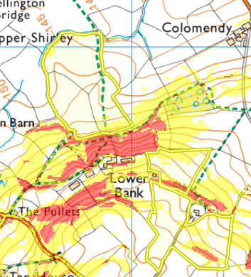
17
16
14
6
13
Fields 4, 6, 7, 11, 12, 13, 14, 16 and 17 are on either moderately sloping land (7-12º) or partially located on highly sloping land (12º+). The areas that are highly sloping contain no spread buffer zones to reduce the risk of surface runoff when applying the wastes to the fields. The wastes will be applied to the fields via band spreader or injection which are appropriate methods to apply the liquid wastes to the field. As the wastes are being applied directly to the grounds surface or inject
Fields 2 & 3 are on flat to gently sloping land and do not pose a surface runoff risk.

12
11
7
2
4
3

