PAN-020448 My Map Report:
Application Maps
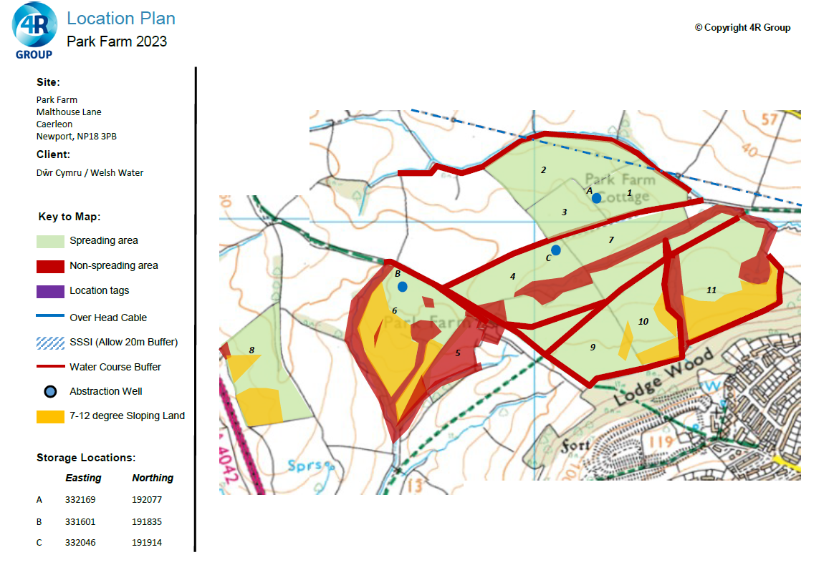
Permit Boundary
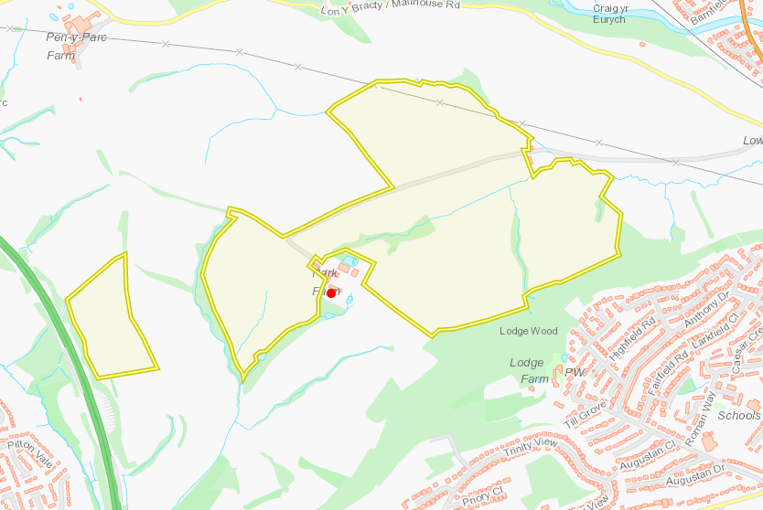

Detailed river network
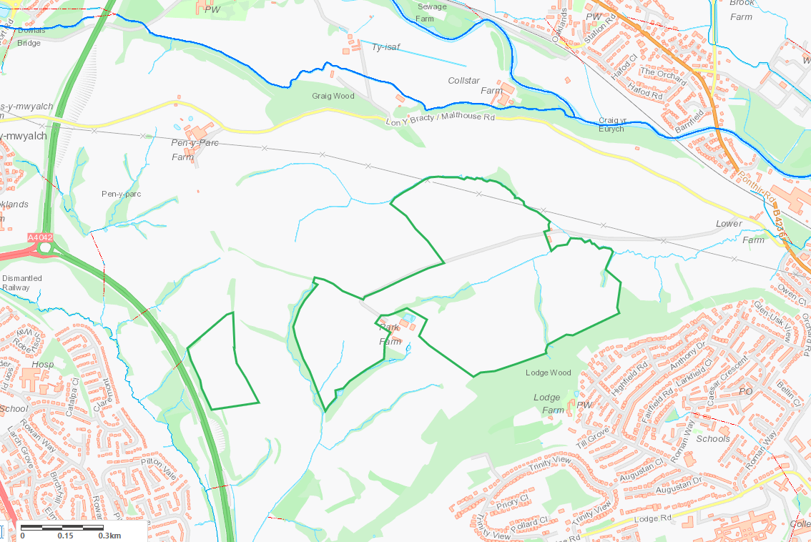
Groundwater protection zones
Nil
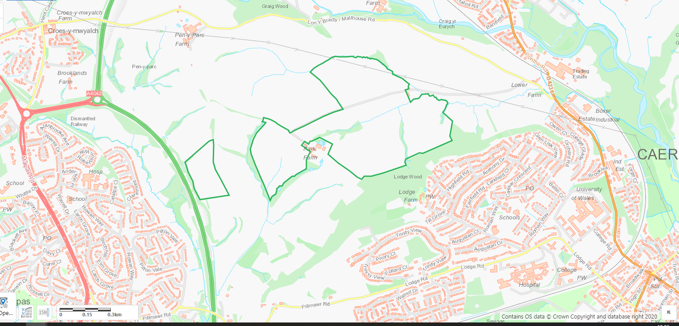

Wells, springs or boreholes within 50m
Several springs, issues and collects within and adjacent to spreading area. Buffer zones indicated on application map.
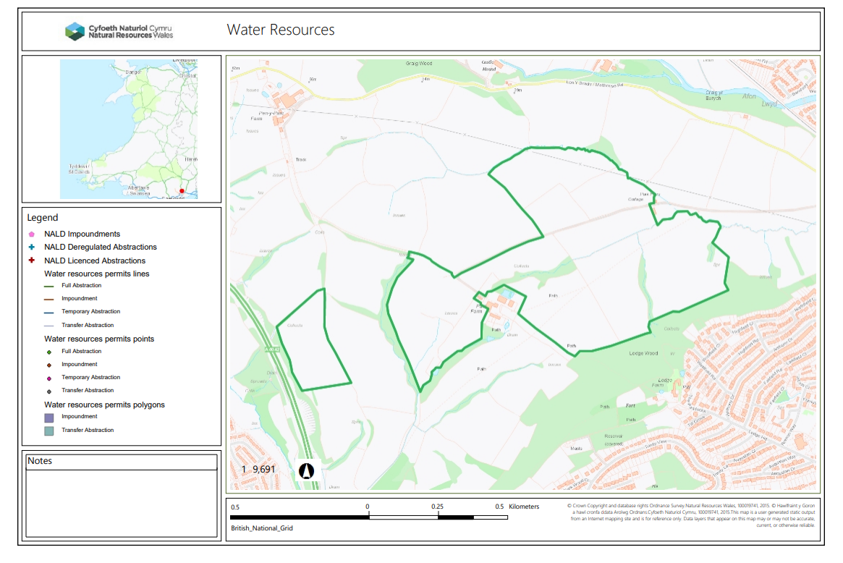
Storage locations
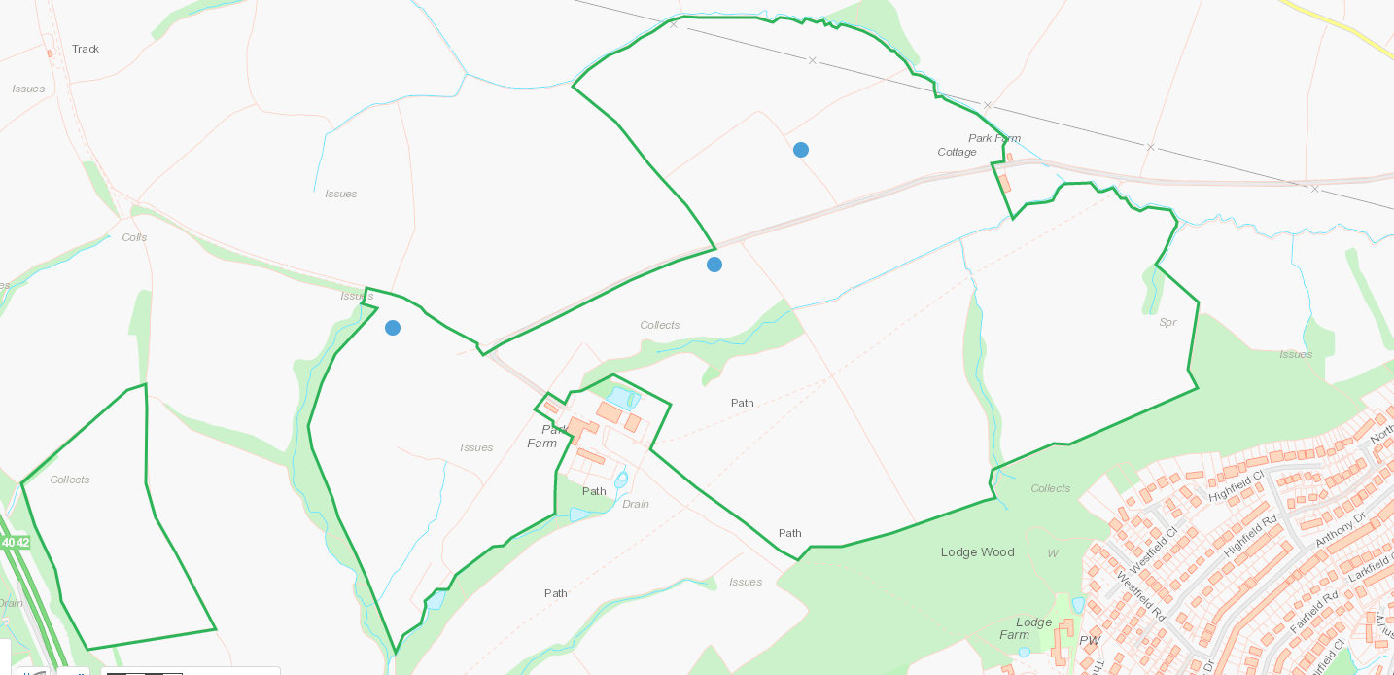

European designated sites- Natura 2000 (SPA, pSPA, SAC or cSAC) or Ramsar- or SSSI within 500m
Nil
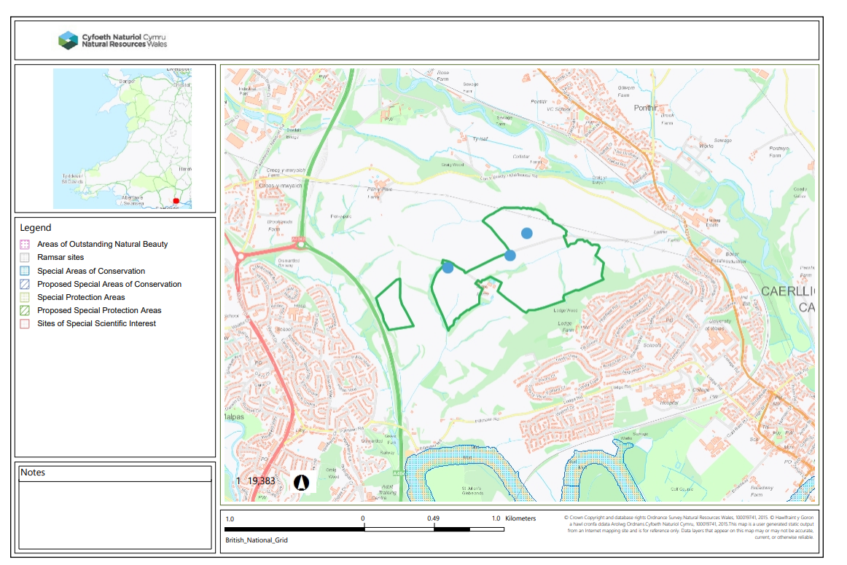
Other protected sites:
- Protected Species-
- Protected Habitats-
- Scheduled Ancient Monument-
- Local Nature Reserve-
- National Nature Reserve-
- Ancient Woodlands-
- Local Wildlife Sites (SINC)-
- National Park-
- Nitrate Vulnerable Zone (NVZ)-
- Groundwater Safeguard Zone-
- Hedges-
- Ditches-

N of Field 2 - Lesser horshoe bat roost within bell tower, known otter breeding sites, multiple bat roost, Site exists within the fork or confluence of the Dowlais Brook (main river) and Afon Lwyd (main river), Ancient Woodland and species-rich hedgerow are present. Also Ancient semi-natural woodland, Castle Mound E of Graig Wood, Protected fish migratory route.

W of field 8- Lowland dry acid grassland and Lowland calcareous grassland, Ancient Semi Natural Woodland.

W of field 6 - Ancient Semi Natural Woodland.

Within field 4 - Ancient Semi Natural Woodland

S and SE of Field 9, 10, 11 - Lodge Wood Camp, Ancient Semi Natural Woodland, Purple moor grass and rush pastures,

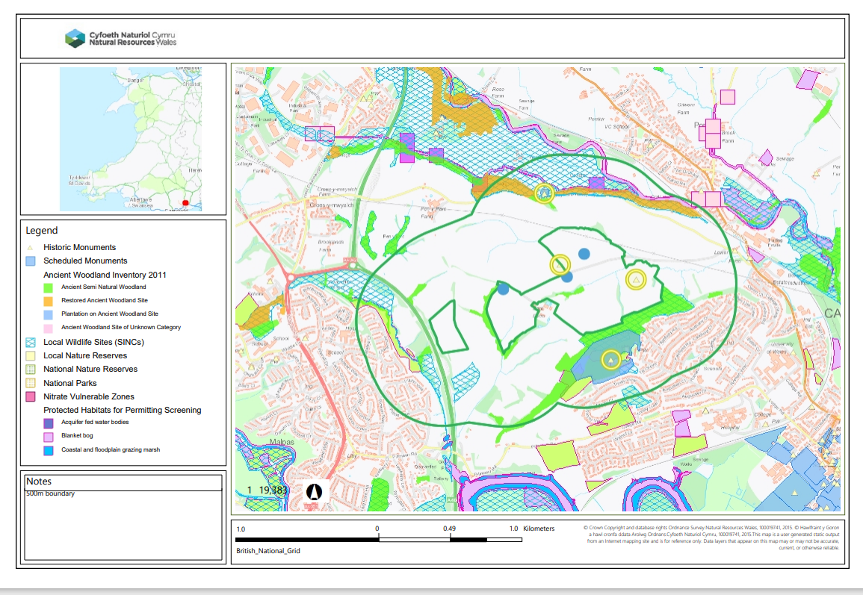
Public Rights of Way
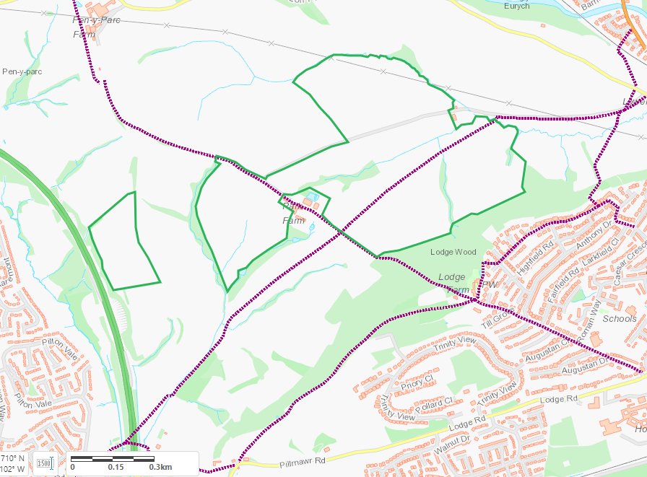

Slope Map
Field 1 – 0-7
Field 2 – 0-7, some 7-12
Field 3 – 0-7
Field 4 – 0-7, some 7-12 and 12+. Watercourse to SE - buffer zones in place
Field 5 indicated on application map but not within this deployment – Nil Spread
Field 6 – some 0-7, mainly 7-12, some 12+ adjacent to watercourses within the field and adjacent to W and SE - buffer zones in place.
Field 7 – mainly 0-7, some 7-12. Watercourse borders SE. Buffer zones in place
Field 8 – 0-7, 7-12, some 12+. Buffer zones in place
Field 9 – mainly 0-7, some 7-12 sloping towards field. Watercourse borders to NW. buffers in place
Field 10 – mainly 0-7, some 7-12 sloping toward the field, some 7-12 and 12 sloping to watercourse to E. buffers in place
Field 11 – mainly 0-7, 7-12 and 12+ sloping towards the field and to watercourse to W. buffers in place


