PAN-020504 MyMap Report:
Application Maps
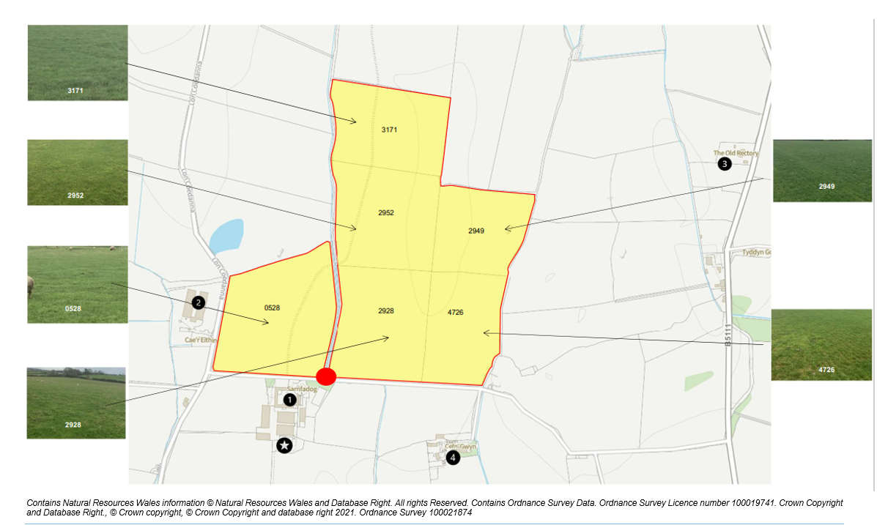
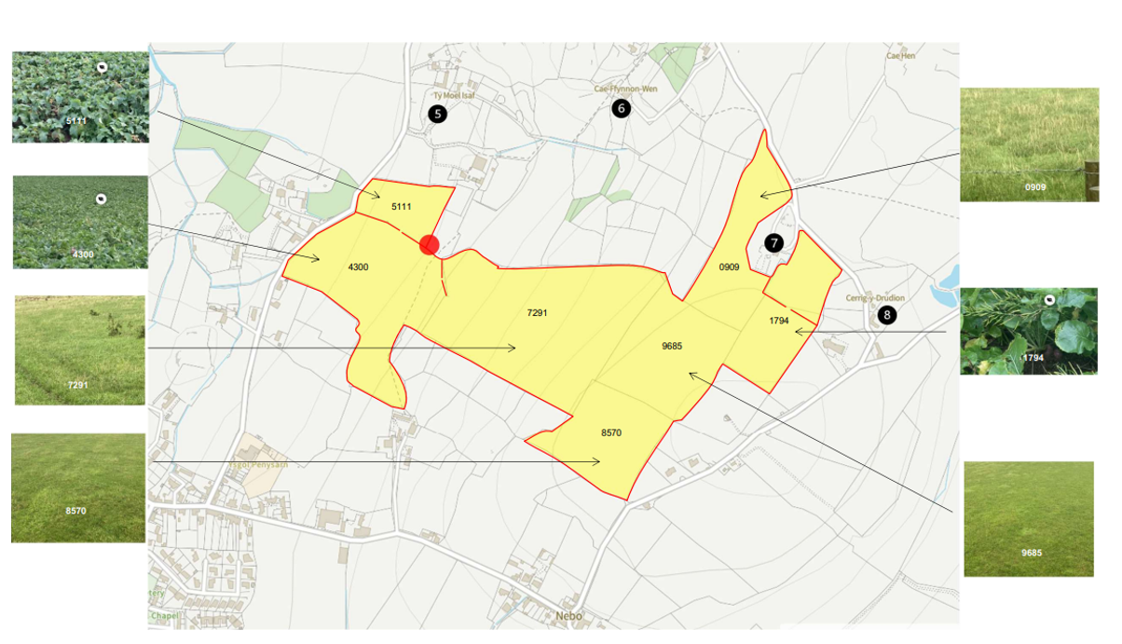


Deployment Boundaries
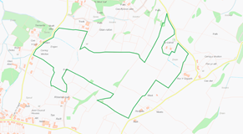
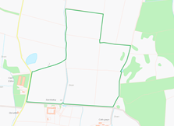
Distance between spreading locations
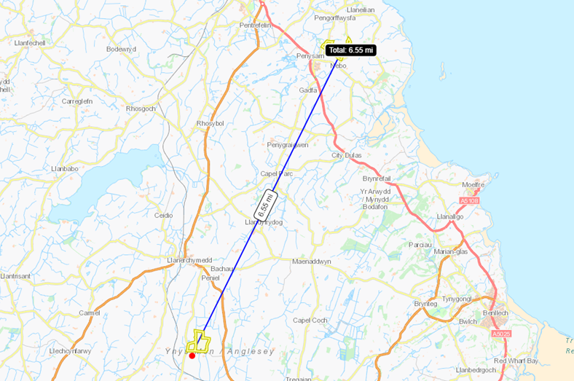
Detailed river network:
.
Drains and ponds within 1794 and well to SE of 5111. Watercourse running SE to NW through 7291 and 5111. Buffers in place on application maps.
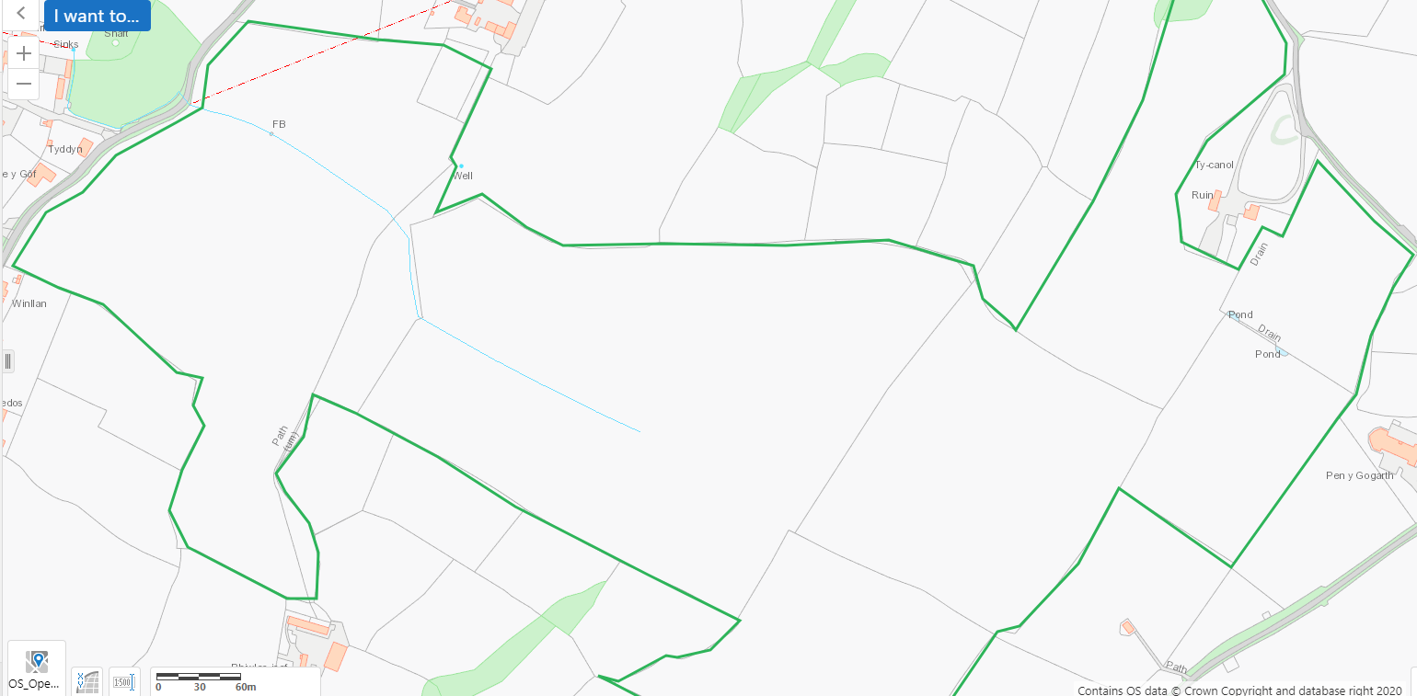
Drain runs N to S and well to south on land at Sarnfadog. Buffers in place on application maps.
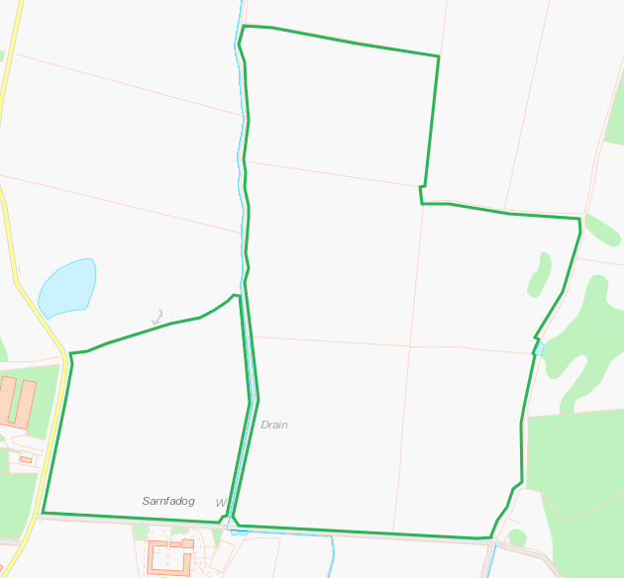

Groundwater protection zones
Nil

Wells, springs or boreholes used for the supply of water for human consumption including from a private water supply or supplies
Well to SE of Field 5111, buffer in place on application map.
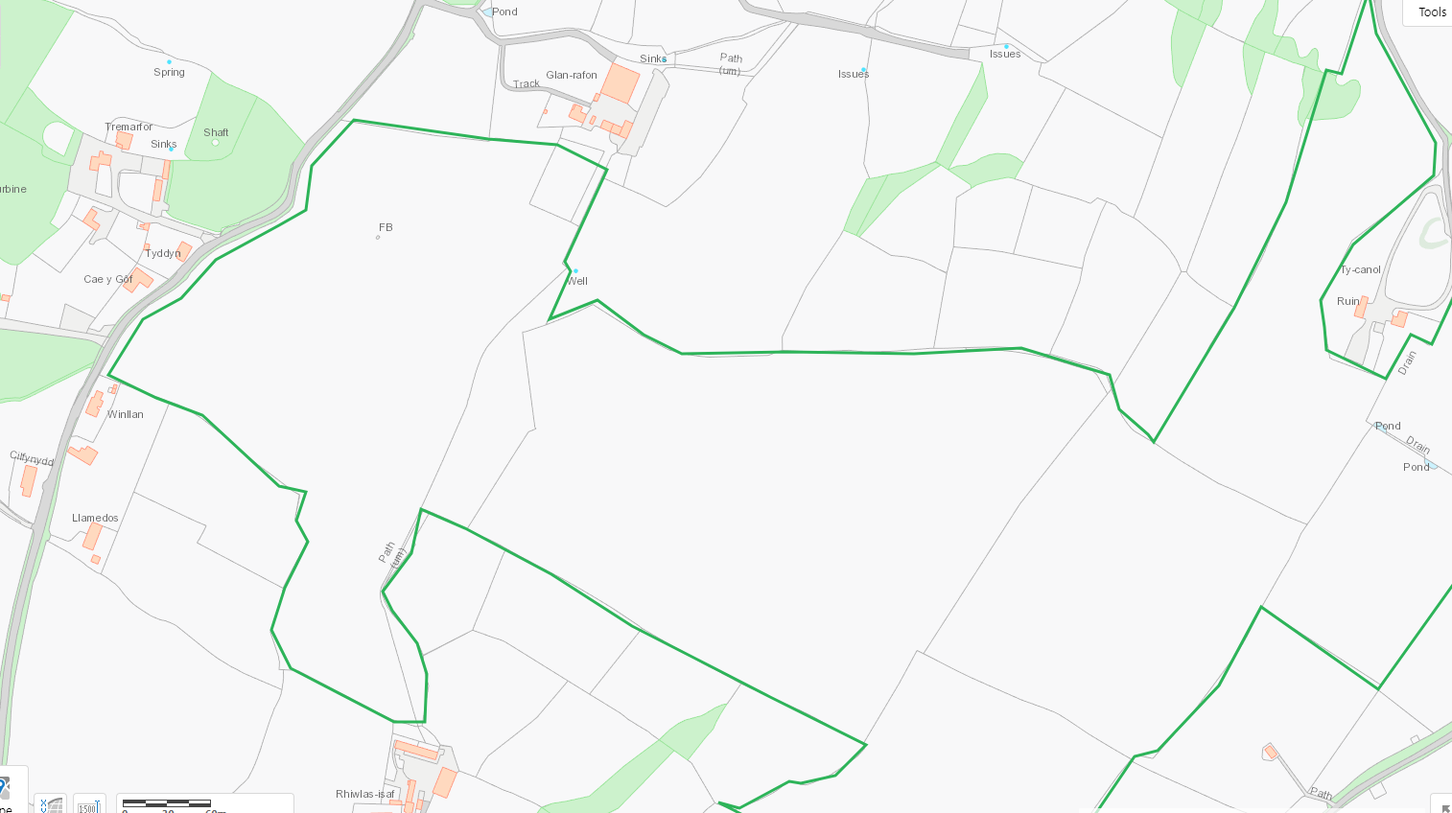
Well to SE of field 0528. Pond to E of field 2949. Pond south of field 2928. Drain flows N to S, buffer in place on application maps.
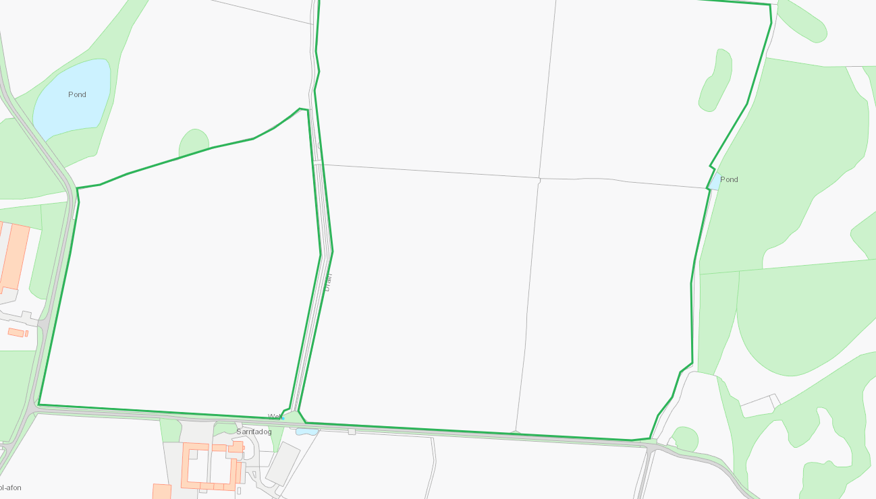
European designated sites- Natura 2000 (SPA, pSPA, SAC or cSAC) or Ramsar- or SSSI within 500m

Nil
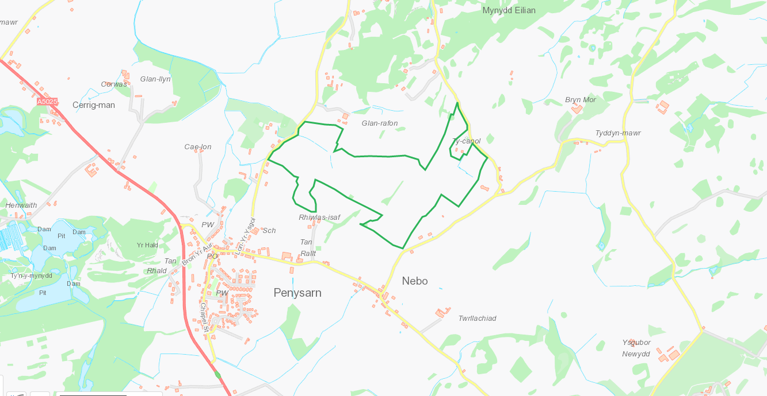

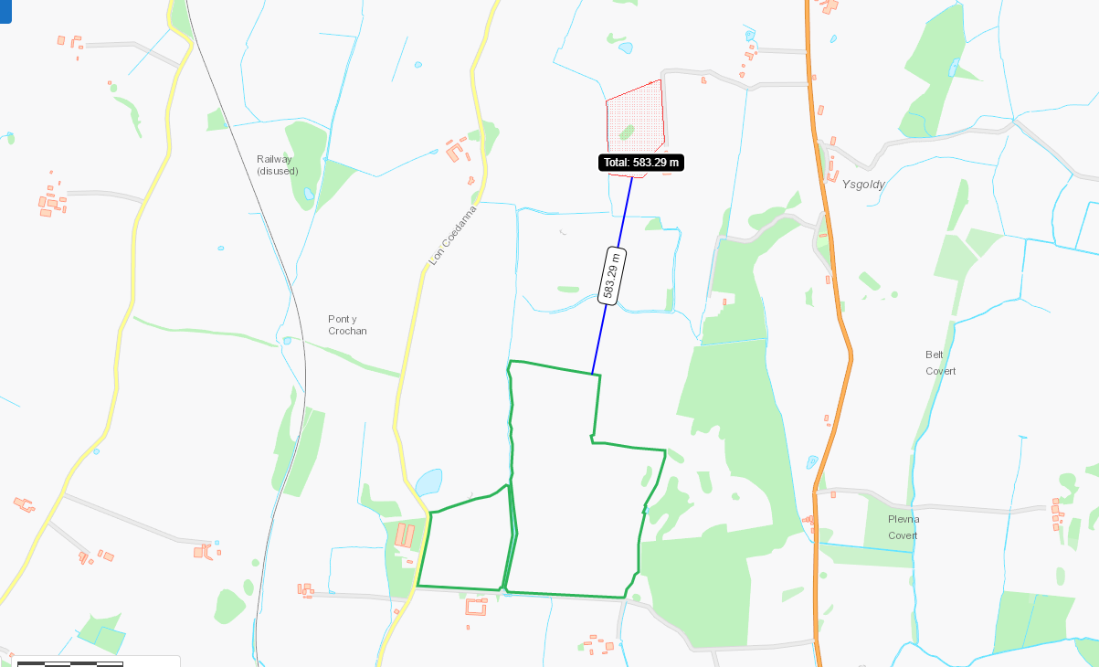

Other protected sites:
- Protected Species-
- Protected Habitats-
- Scheduled Ancient Monument-
- Local Nature Reserve-
- National Nature Reserve-
- Ancient Woodlands-
- Local Wildlife Sites (SINC)-
- National Park-
- Nitrate Vulnerable Zone (NVZ)-
- Groundwater Safeguard Zone-
- Hedges-
- Ditches-

Lowland dry acid grassland and Lowland calcareous grassland
Purple moor grass and rush pastures
Lowland dry acid grassland and Lowland calcareous grassland
Restored Ancient Woodland Site
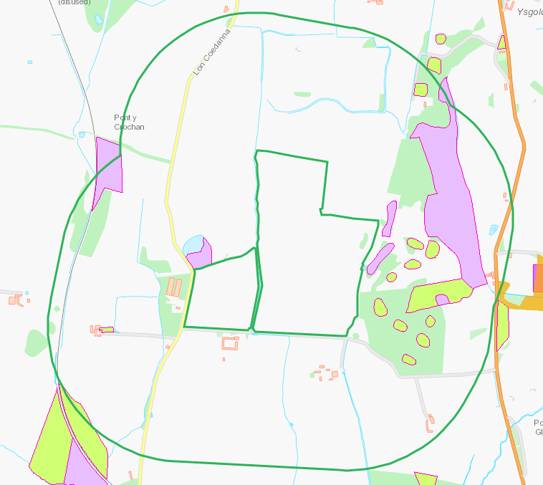
Lowland dry acid grassland and Lowland calcareous grassland
Lowland heathland
Purple moor grass and rush pastures
Lowland dry acid grassland
Restored Ancient Woodland Site
A large area of acid dry heath with patches of improved land on the northern slopes and the summit of Mynydd Eilian.

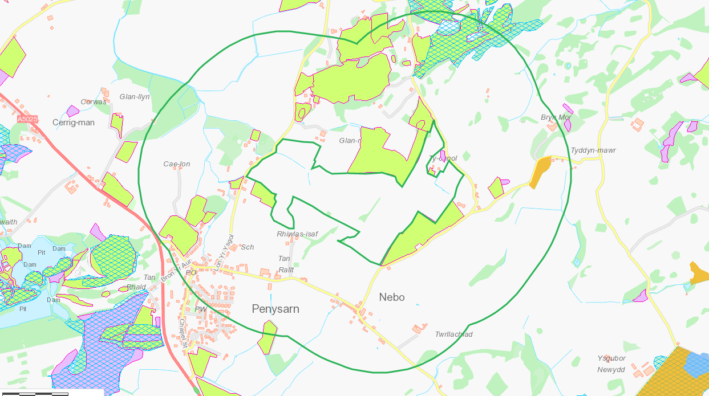

Public rights of way
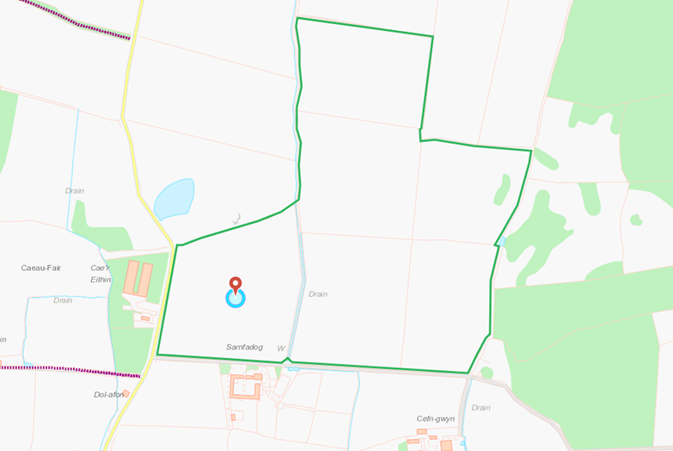
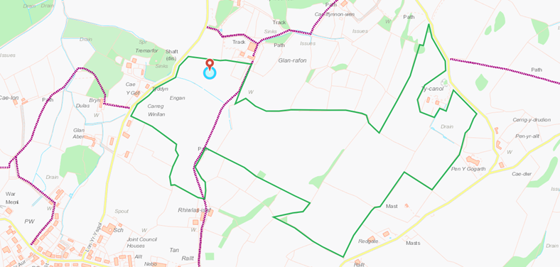

Slope Map
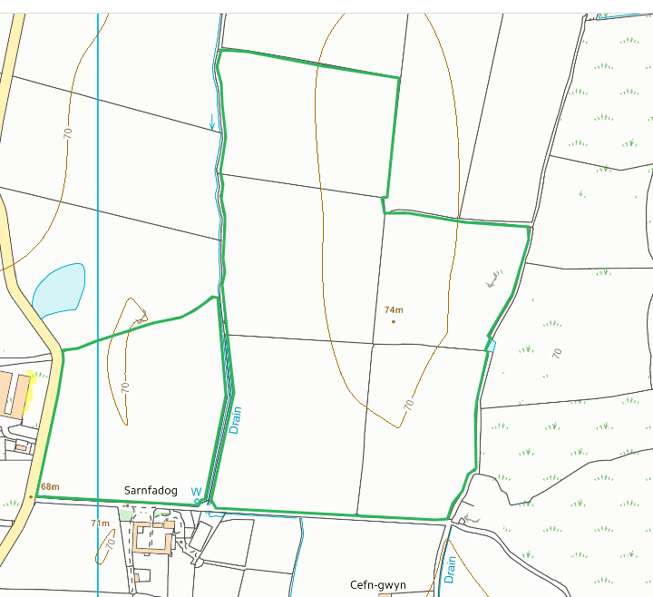
All fields 0-7 apart from field 7291 which is 7-12 gradually sloping SE to NW. Minimal 12+ but low risk of run off. Consideration to watercourse to NW should be given.
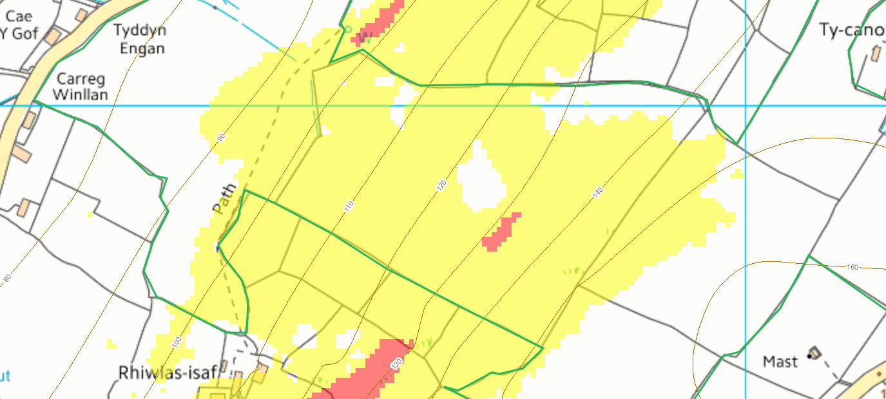
Storage location


