Site boundary
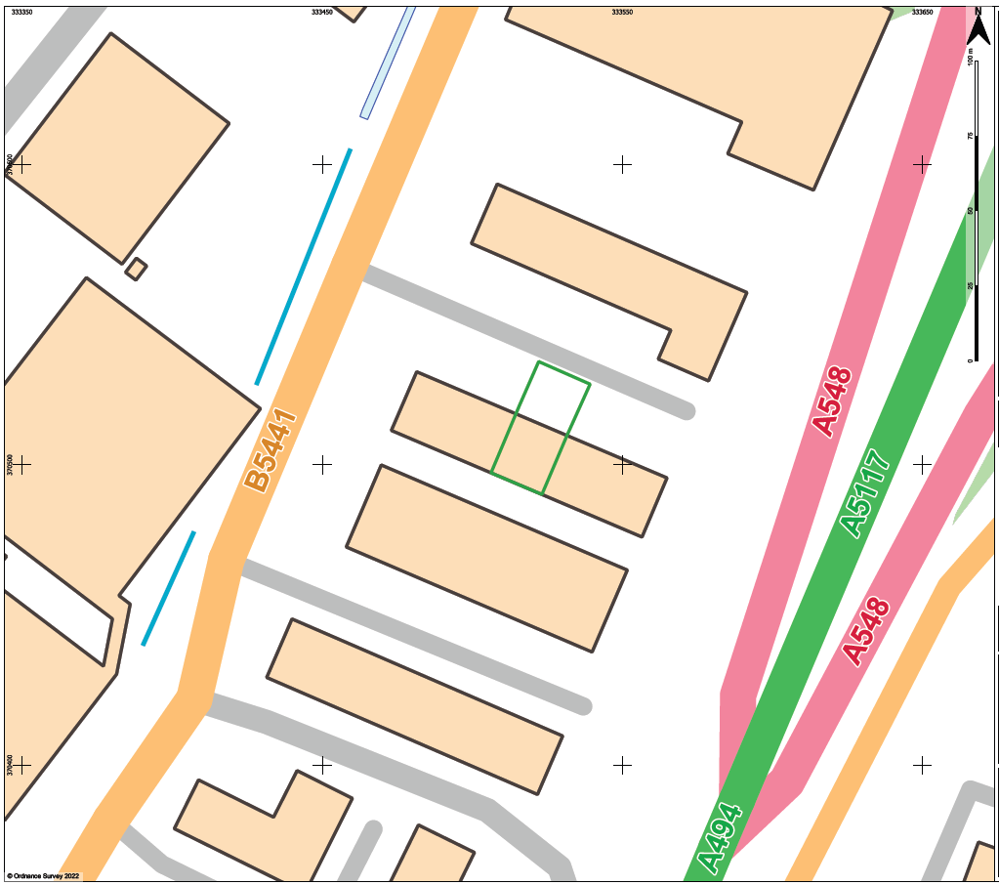

Proximity to human occupation
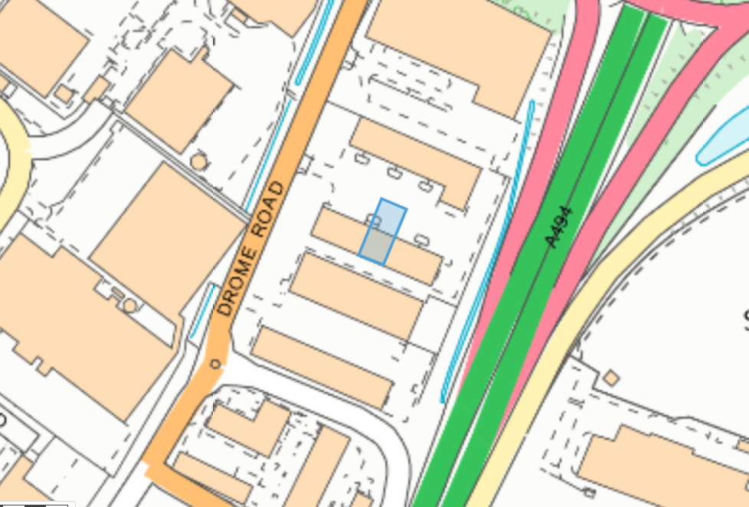

Ramsar, SAC, pSAC, SPA, pSPA within 1km
None
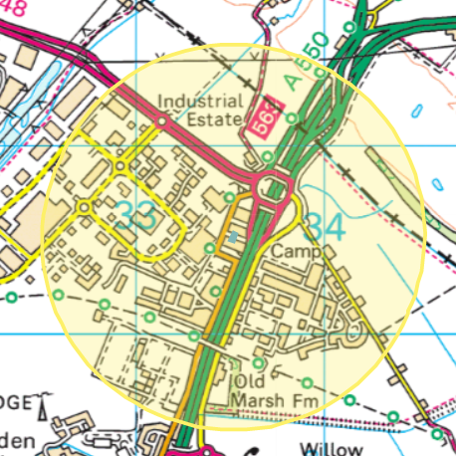

SSSI within 2km of the site
None
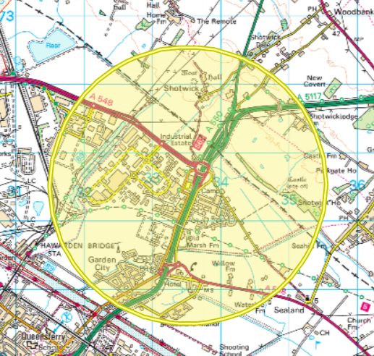

Aquifer Designation (Superficial)

But not on a GSPZ

Aquifer Designation (Bedrock)
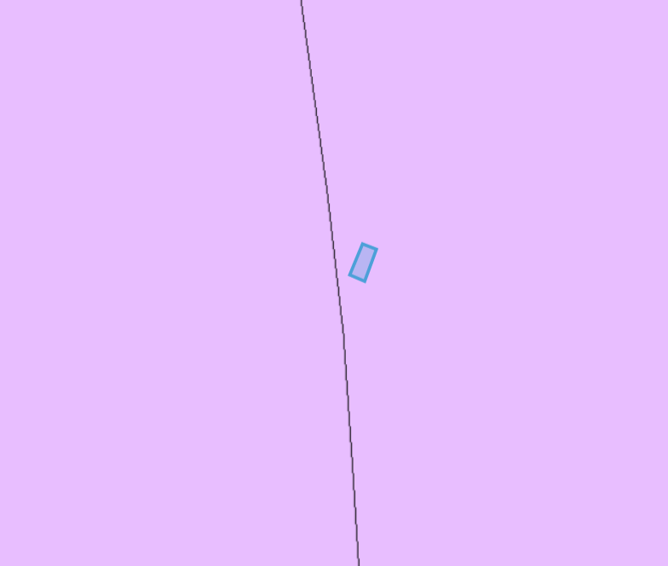
But not on a GSPZ
Detailed River Network
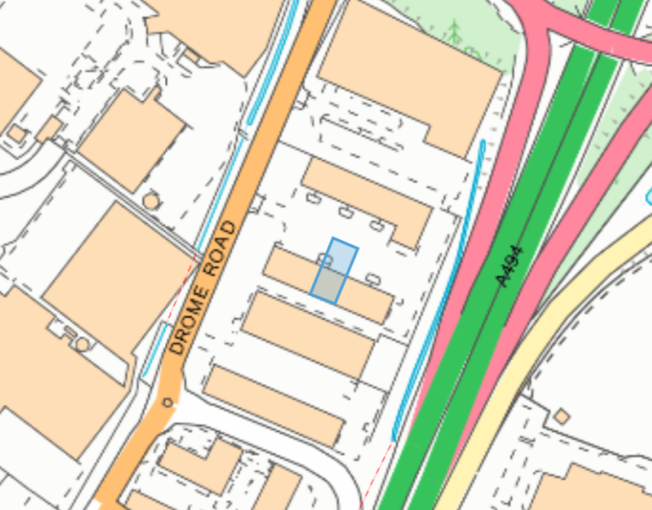

Air Quality Management Areas
None found within 2km
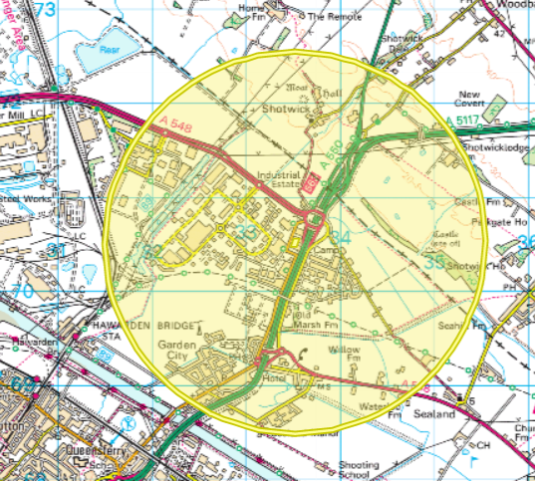

Flood risk
From rivers (none)
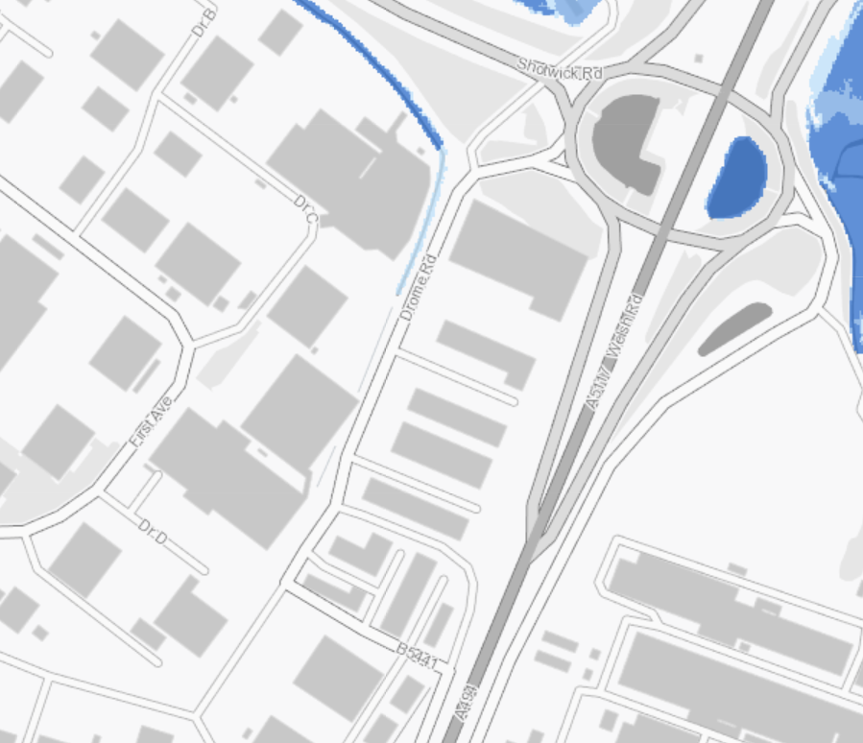

From the sea (low risk)
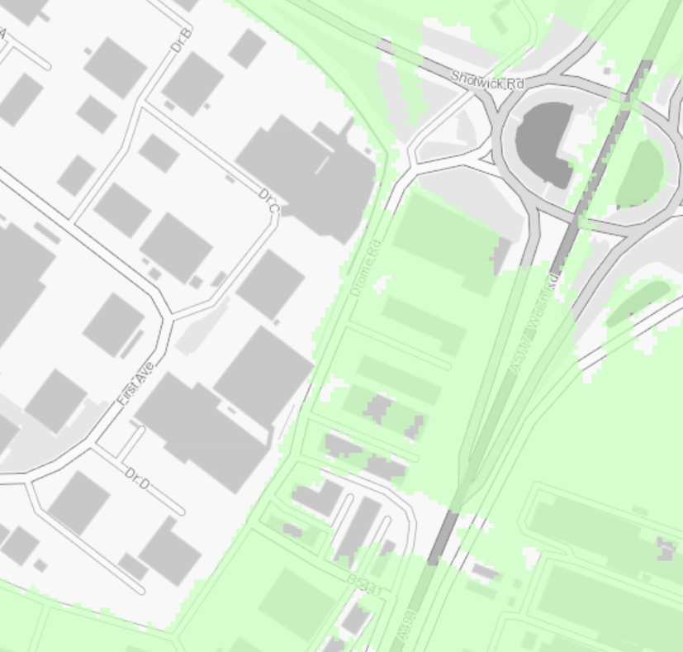

From Surface Water & Small Watercourses (low- external areas of the site)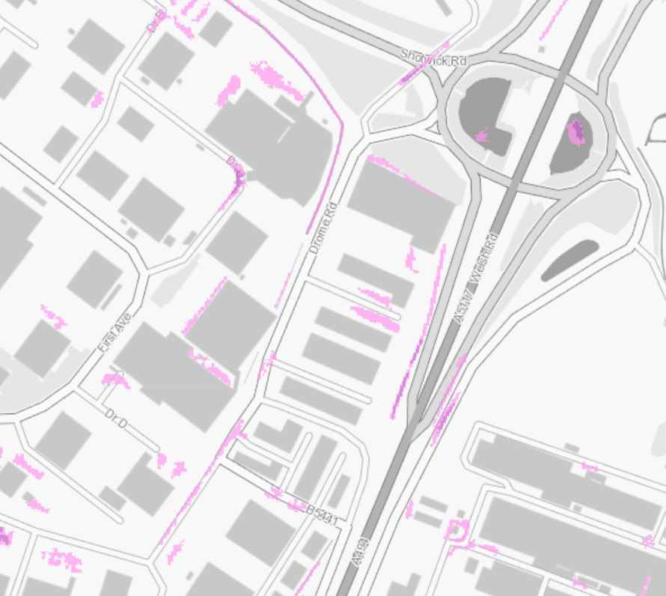

Protected Habitats within 1km
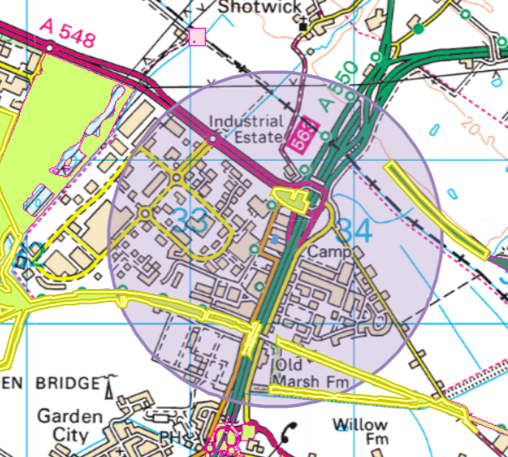
Deciduous woodland (to the NE)
Lowland dry acid grassland and Lowland calcareous grassland (all other sites)
No protected species within 1km

Historic Monuments within 1km
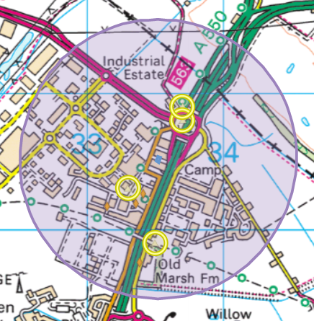
Sealand Airfield and 3 Pillboxes

Listed buildings within 1km
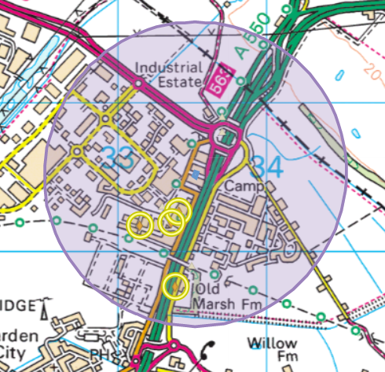
2x aircraft hangers and Old Marsh Farm

Ancient Woodland Inventory within 1km
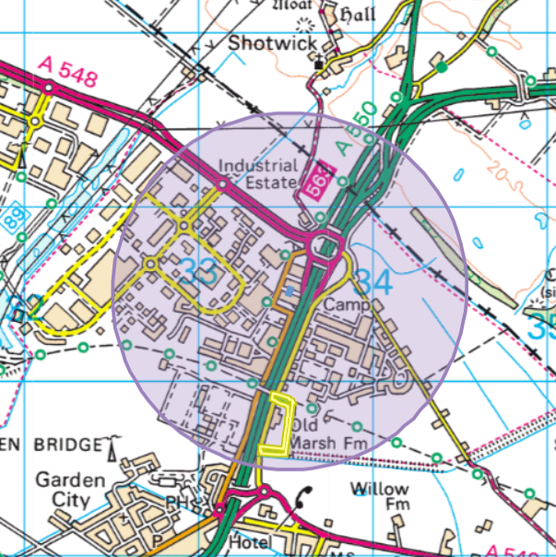
Ancient Semi Natural Woodland

Not found
Scheduled Monuments, Heritage Coast or World Heritage Sites
Areas of Outstanding Natural Beauty, Local Wildlife Sites, Local Nature reserve, Marine Conservation Zone, National Nature Reserve, National Park

