Site boundary as per application
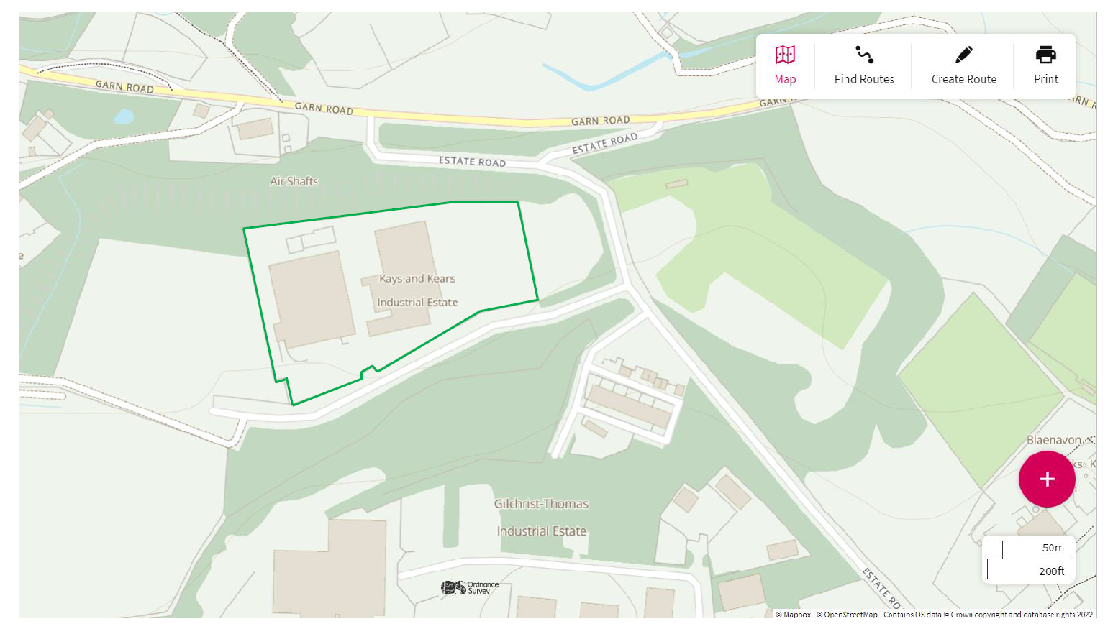

Site location
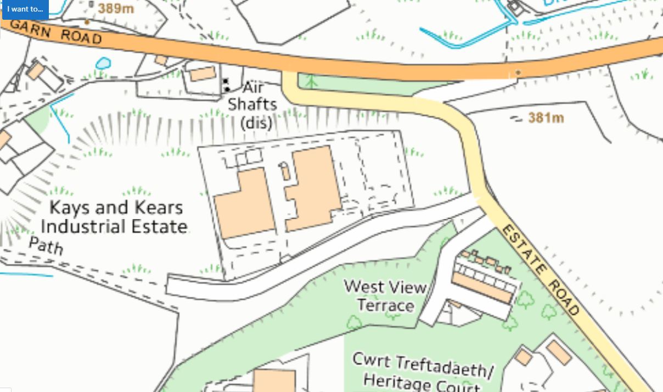

SSSI within 2km of the site
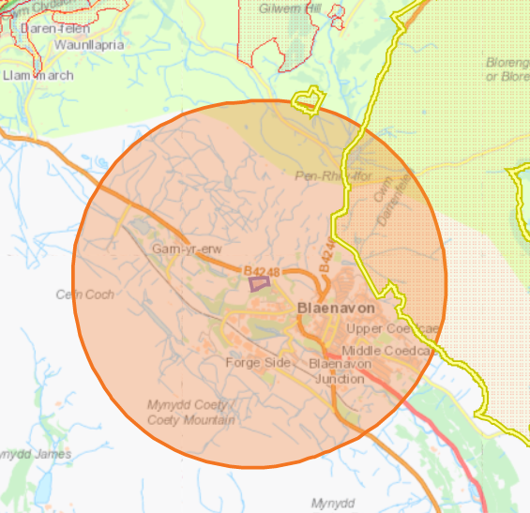
Blorenge SSSI approx. 875 m 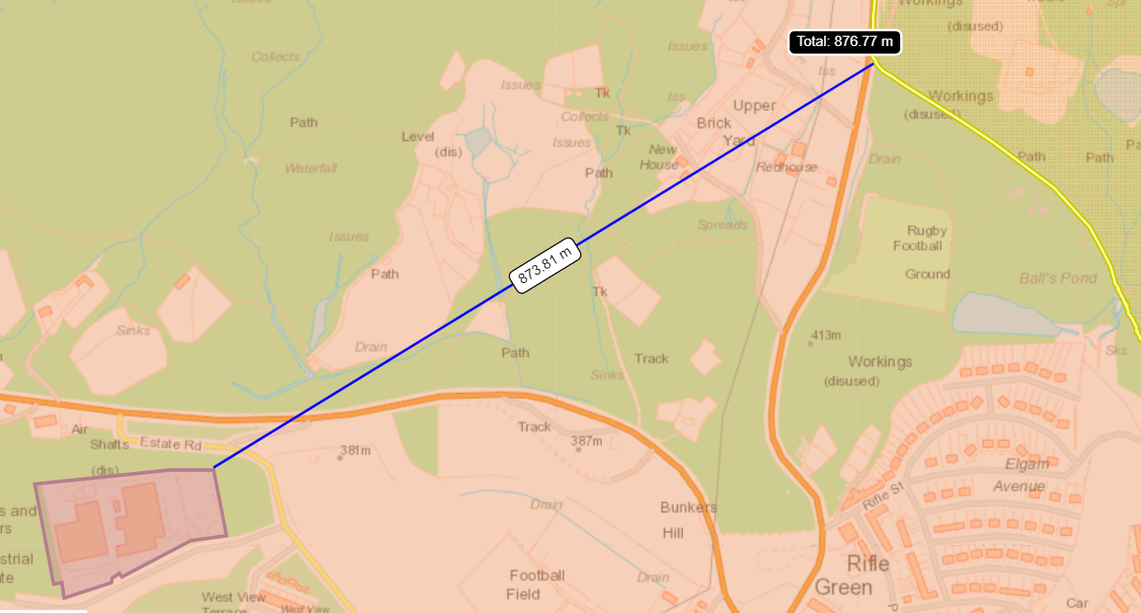

Siambre Ddu SSSI- approx. 1,912 meters
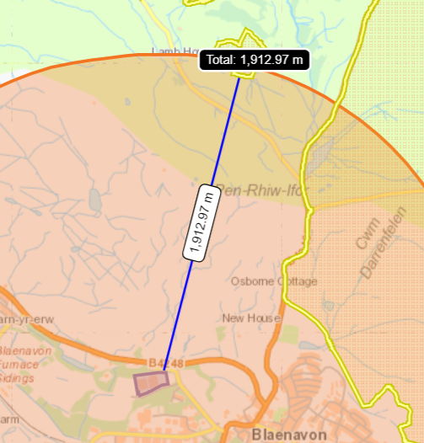

Aquifer Designation (Superficial)
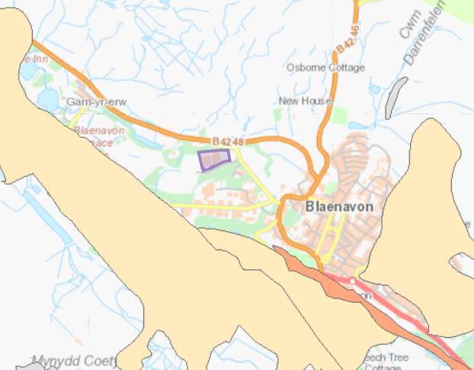

Aquifer Designation (Bedrock)
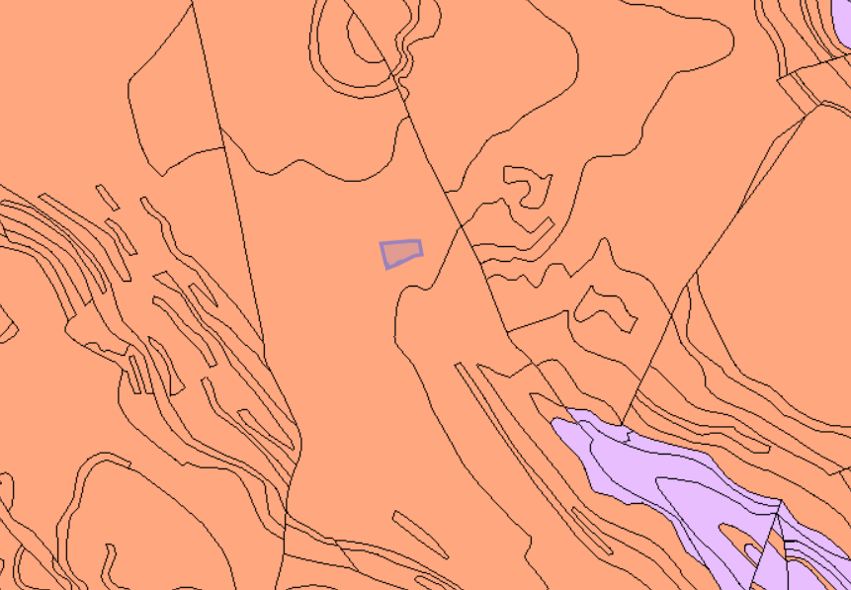

Source Protection Zones
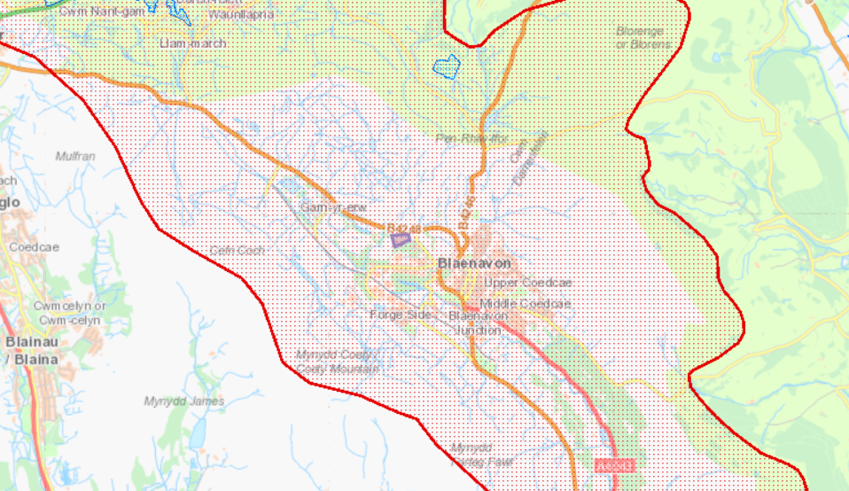
Northern Limestone Outcrop SPZ1

Detailed river network
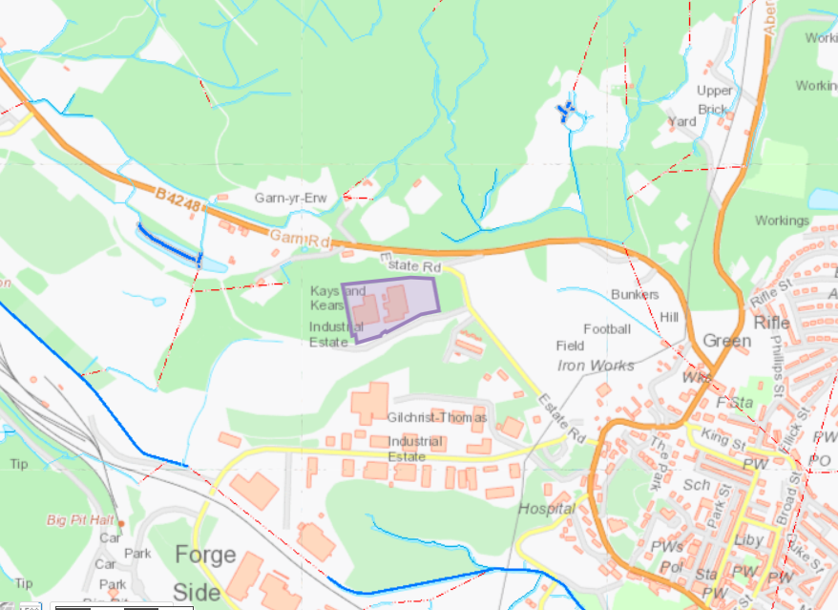
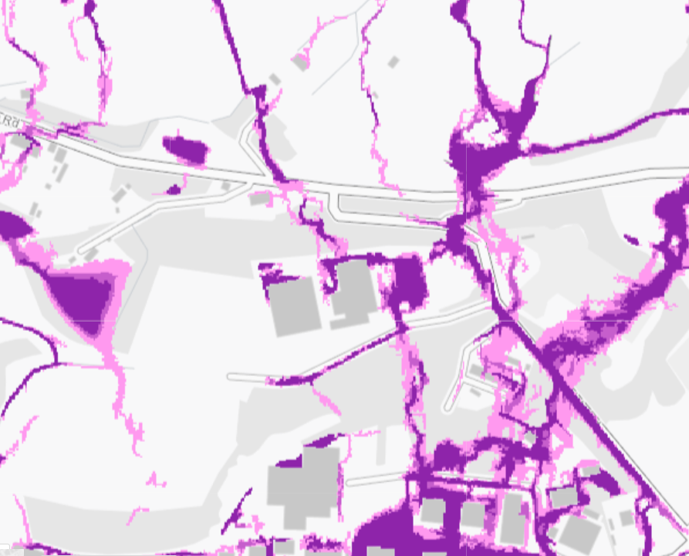
Flood risk
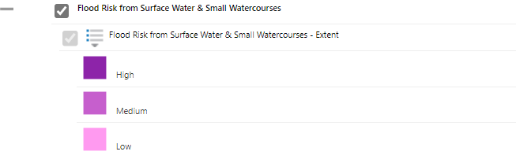
High risk from surface water
and small watercourses
Protected Habitats for Permitting Screening within 1km
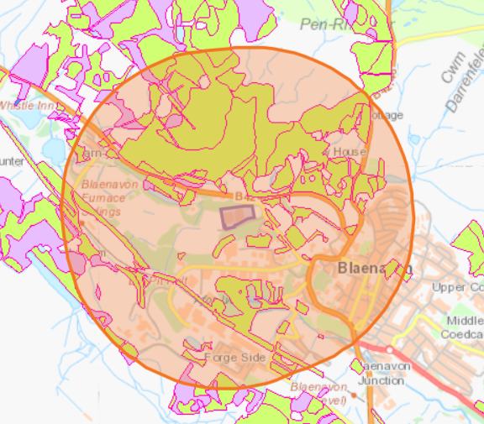
- Lowland dry acid grassland and Lowland calcareous grassland
- Lowland heathland
- Purple moor grass and rush pastures
- Lowland dry acid grassland

Listed buildings within 1km
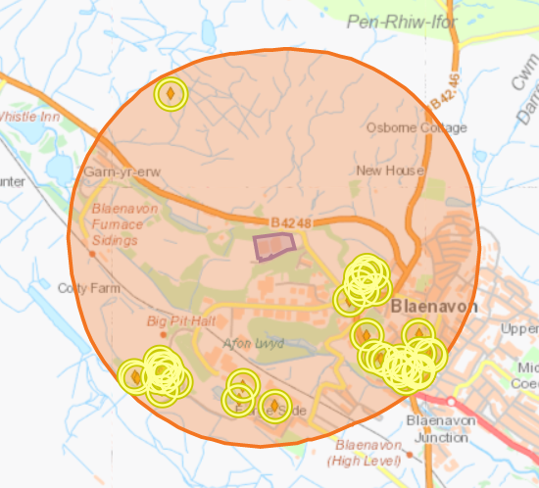
44 found- clusters on Blaenavon Iron Works, town centre and Big Pit

Historic Monuments
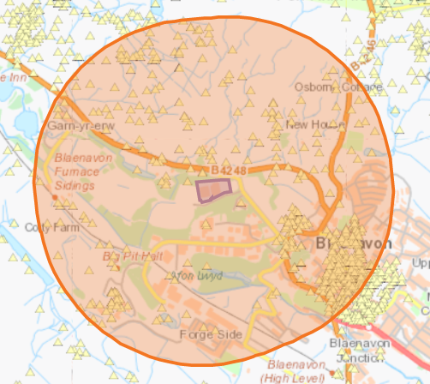
564 found
Scheduled Monuments
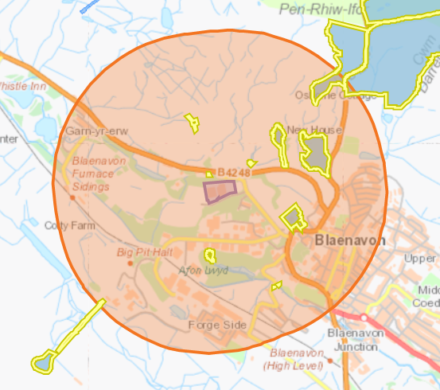
11 found
World Heritage Sites
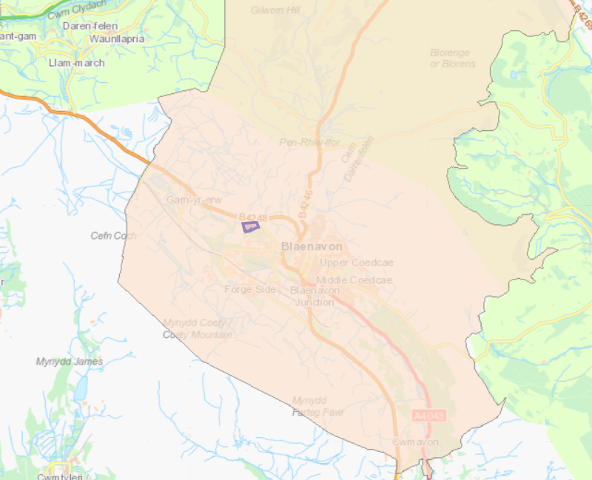
Blaenavon Industrial Landscape
Local Wildlife Sites
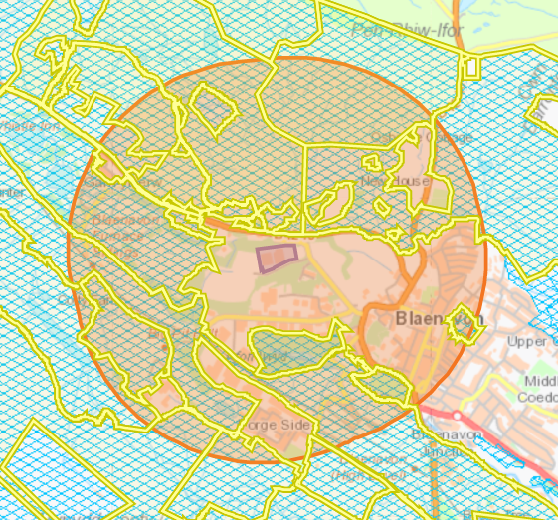
- Garn-yr-Erw designated for Upland Moorland, fens, bogs, Pools, Heathland, Coal waste. Quality: Upland moorland.
- World Heritage Centre Lesser Horseshoe Bat Roost and foraging area designated for Lesser horseshoe bat resting place and foraging areas. Good connectivity to the main river through grassland, scrub and hedgerows in adjacnt grave yard. Quality: Under-managed. Diversity: Good.
- Pontypool & Blaenavon Railway & Doncatser Pond designated for Acid Grassland / Heath mosaic, wet flushes, bare ground, colliery spoil, streams, ponds and ditches, Ancient Woodland. Quality: Excellent. Diversity: High quality mosaic habitat.
- Coity Pond designated for Large ponds, wet flushes, acid grassland / heath mosaic, bare ground colliery spoil. Quality: Excellent quality. Diversity: High.
- Addition to Garn Yr Erw SINC
- Mine Water treatment Reedbed designated for Reedbed, stream corridor, species-rich calcareous grassland, Scrub, Mixed woodland.
- Coedcae School Meadow designated for Neutral species-rich grassland. Quality: Semi-improved grassland.
- Forgeside Meadow
- Garn Lakes designated for Lakes and streams, marshy grassland. Quality: Two man made lakes - one conservation, one for angling. Conservation pond has been naturalised with marginal vegetation for amphibians and wildfowl and both lakes support 3 species of amphibians. Large area o
- Coity and Mynydd James mountains designated for Common Land.
- The Blorenge Common designated for Common Land.
- Big Pit designated for Acid Grassland / Marshy grassland / Coity Pond. Quality: U2, U4 and M25 NVC. Diversity: Pond plants include Flote grass, Greater reedmace, Broad-leaved pondweed, Tufted hair grass.
- Garn y Erw Meadow designated for Haymeadow - Neutral grassland. Quality: MG5 NVC.
- Forgeside Fields designated for Large area of level and gently sloping ground with acidic pasture, marshy grassland, and flushes, wet heath. Quality: NVC U4 and M23.
- Garn Yr Erw Field designated for 2 small fields of acid grassland, neutral grassland and wet ground. Quality: NVC MG5 and M25.
- Ducky Pond designated for Pond, willow scrub, with associated marshy grassland. Quality: NVC M23.
- Pwll Ddu designated for Wet Heath. Quality: M25a NVC - Purple moor-grass with cross-leaved heath, Calluna heather and heath rush.
- Pwll Du 2 designated for Extensive Colliery Spoil. Quality: U4 NVC. Diversity: Acid grassland.

Local Nature Reserves within 1km
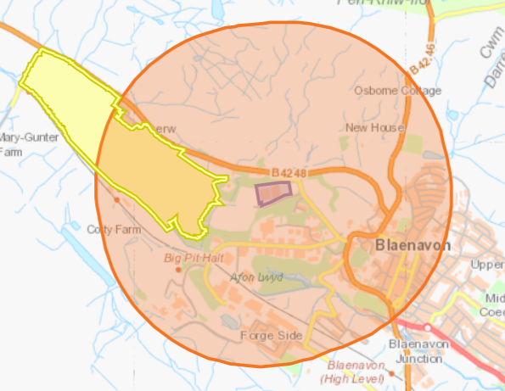
Garn Lakes
Not found
- SAC, pSAC, SPA, cSPA, Ramsar- none with 1km of the site
- Air Quality Management Zone within 2km of the site
- Protected Species for Permitting Screening within 1km of the site
- Ancient woodlands within 1km of the site
- National Nature Reserves within 1km of the site
- National Parks within 1km of the site

