BW2203001 Tycoch SPS plan

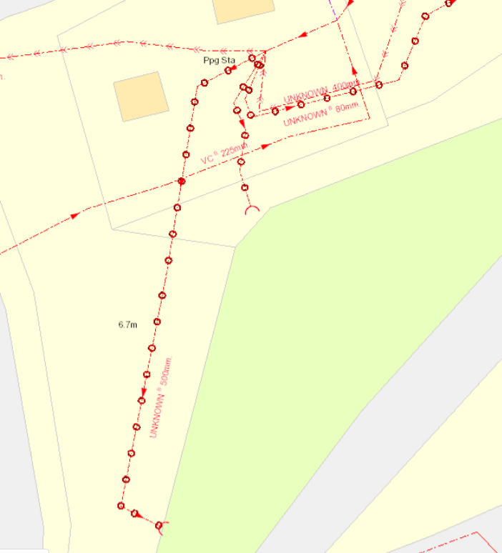
EDM Monitoring Point
Storm Sample Point
EO sample point
Emergency Discharge point
Storm Discharge Point

