PAN-019909 MyMap Screening Report

Application Map
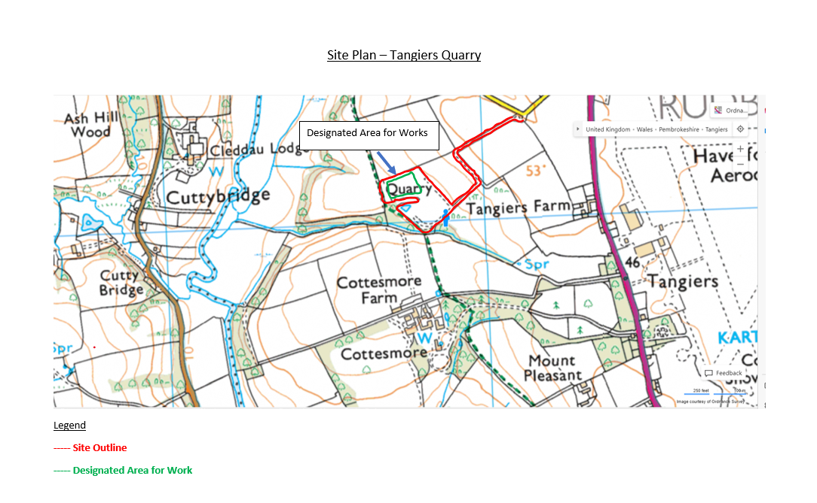
Permit Boundary
As agreed with applicant 13/03/23.
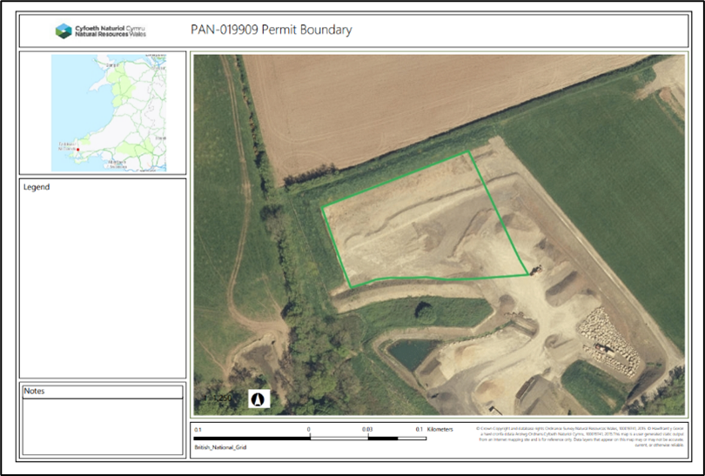
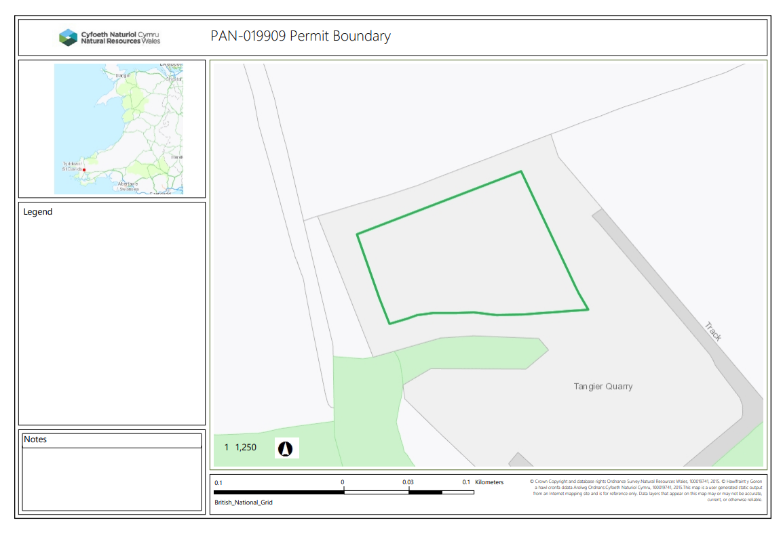
SAC, SPA, RAMSAR, SSSI - 500m.
Afon Cleddau Gorllewinol / Western Cleddau River, both a SSSI and SAC, at approx. 448m to the W of the proposed boundary. Permit condition 2.2.2 states ‘The activities shall not be carried out within:
(a) 500 metres of a European Site or Site of Special Scientific Interest (SSSI)’
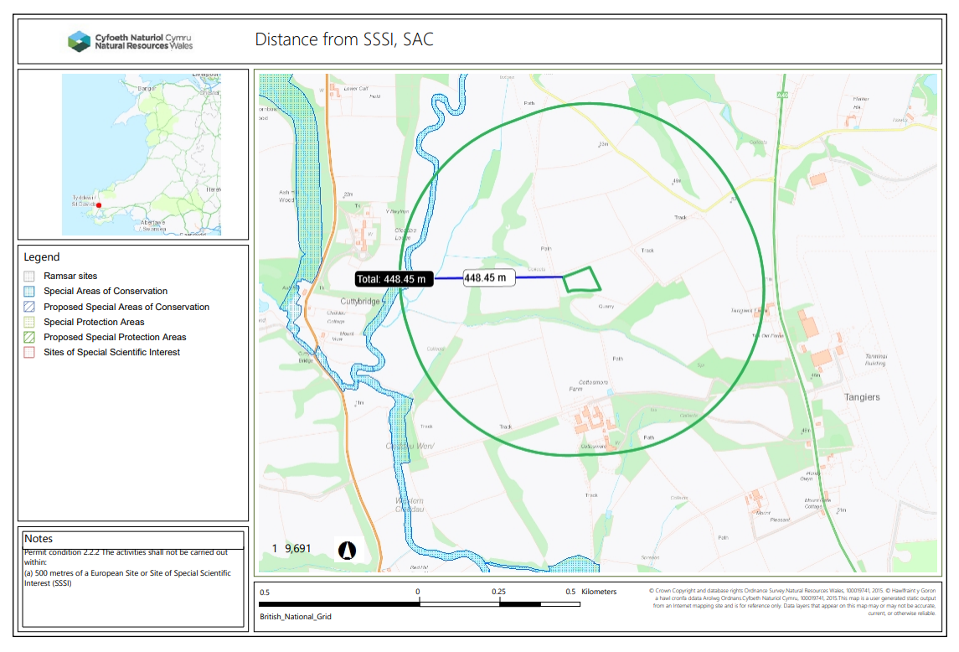
Site boundary would need to be moved approx. 50m E.
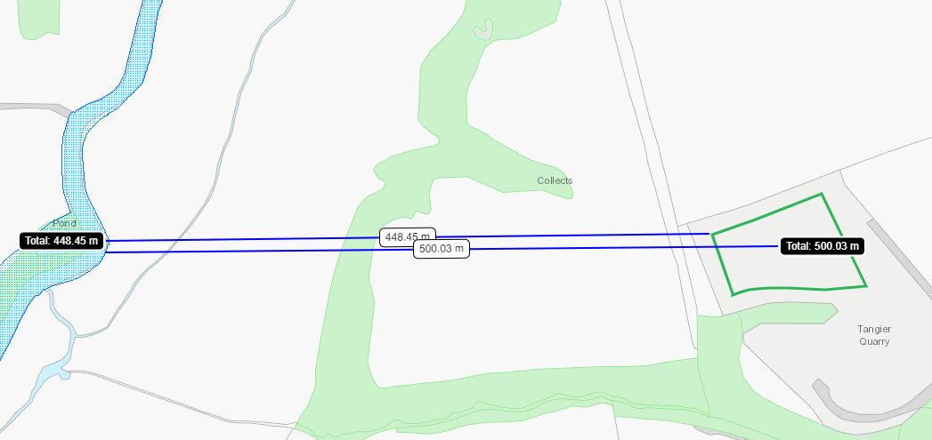

NNR, LNR, LWS, Ancient Woodland, SAM – 50m
None although Restored Ancient Woodland Site approx. 55m SW.
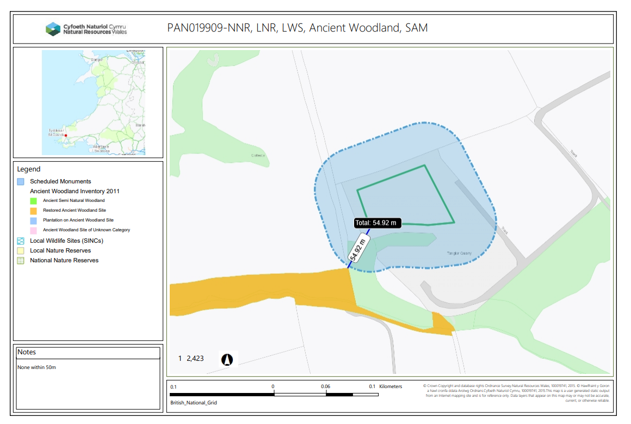

Protected Species, Protected Habitats, 50m
To note there are Threatened Bryophyte shown within the purple zone, Porella pinnata. The purple zone represents the whole grid reference, therefore does not show the specific location where the bryophyte is located. Regarding the permit applied for, the only species of concern are ones protected / priority under section 7 of the Environment (Wales) Act 2016. The only bryophyte listed under this act is Oceanic Ravine Assemblage. All species under section 7 are screened in the map Section 7 Environment Wales Act 2016 (formerly BAP) below which shows none are present.
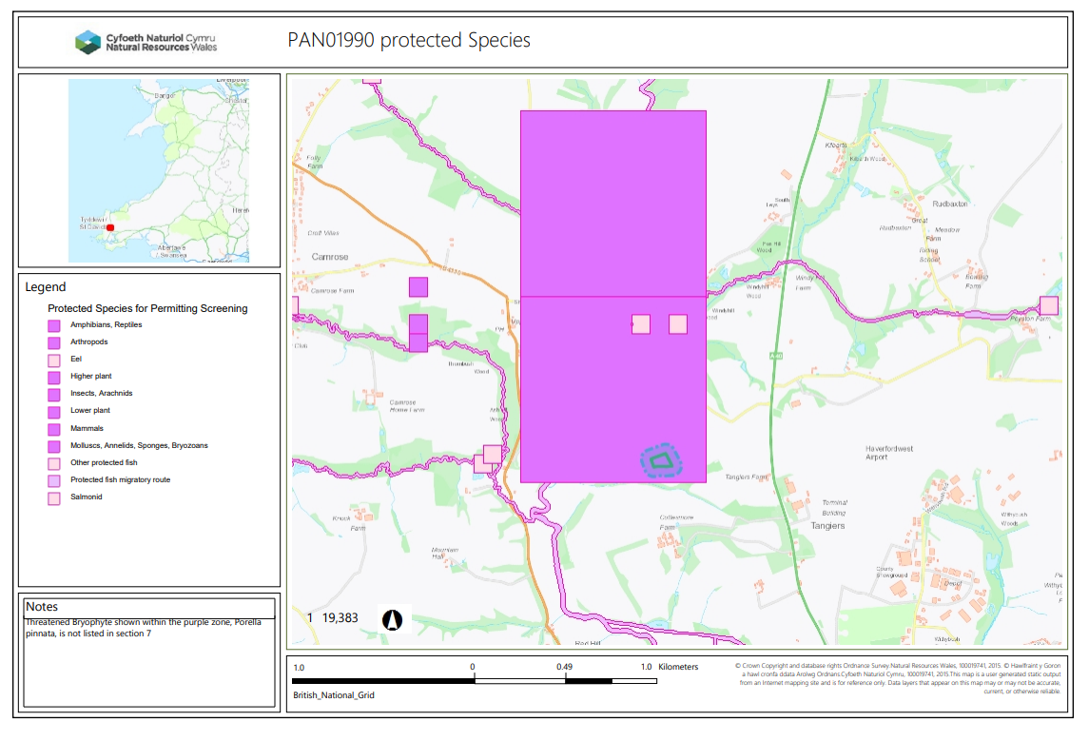
Section 7 Environment Wales Act 2016 (formerly BAP) – 50m
None
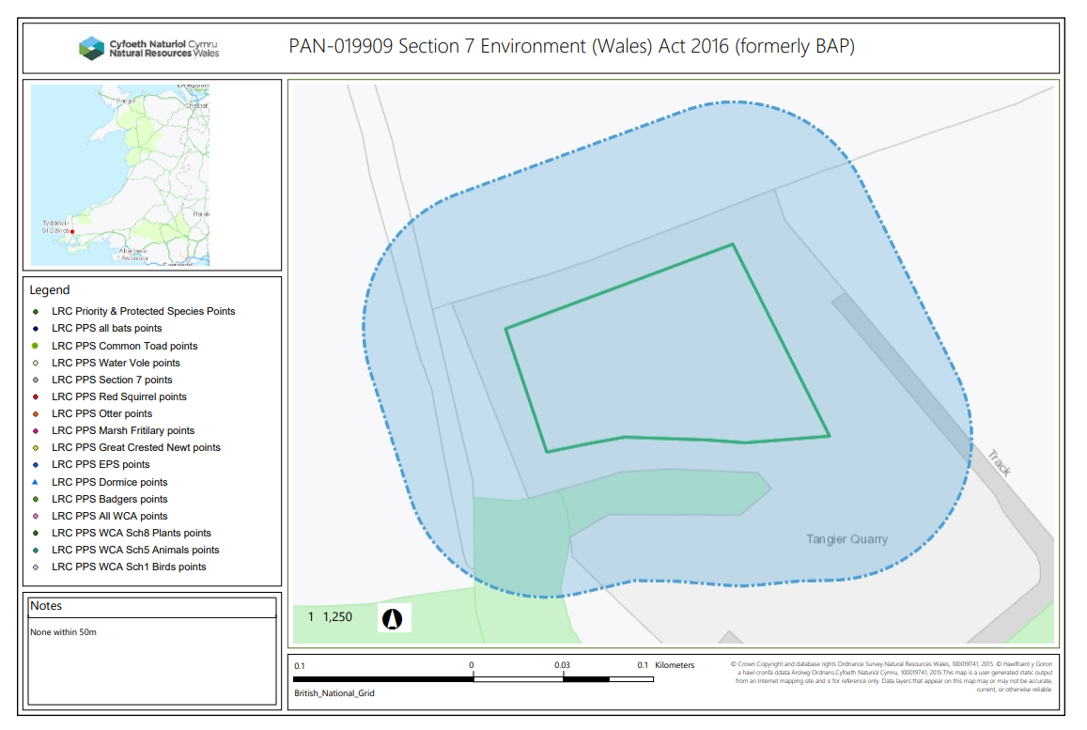

Great crested newts – 250m
none
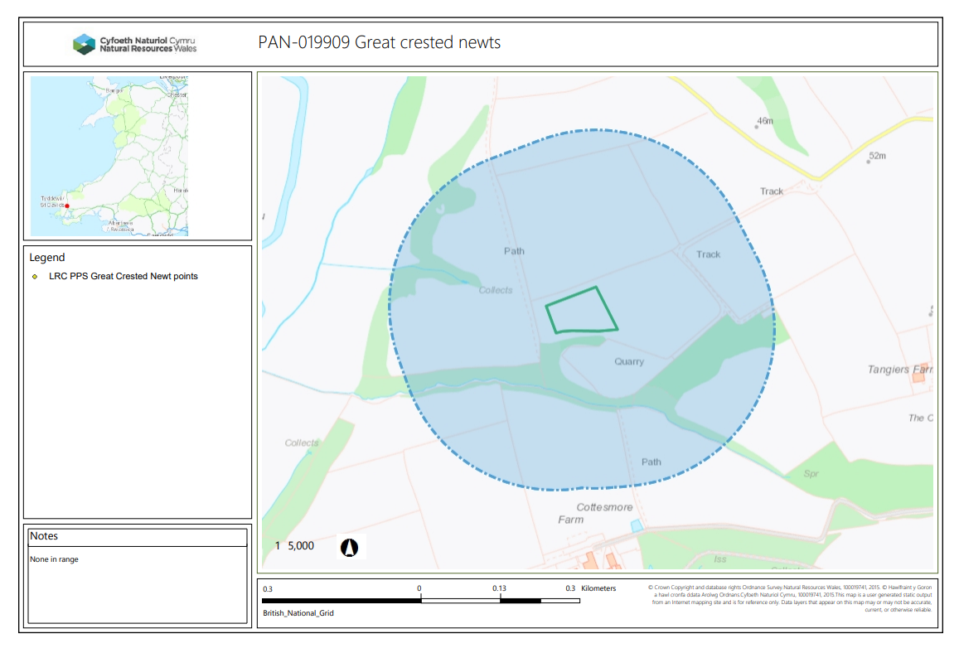
Wells, Springs, Boreholes – 50m
none
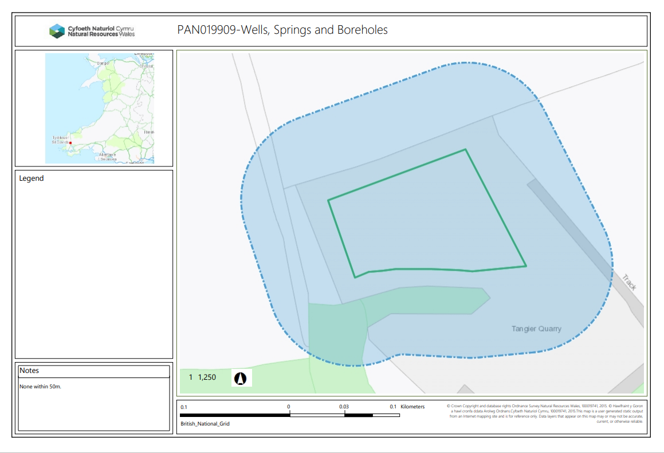

Although a man-made pond appears to be approx. 32m to the S within 50m
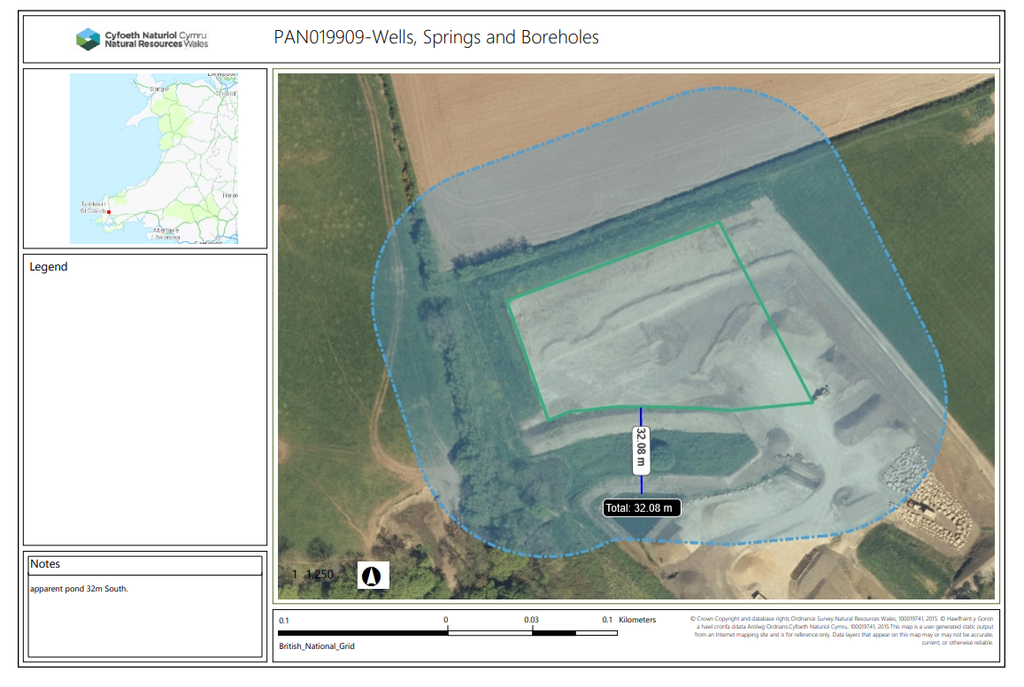
Watercourses – 10m
None
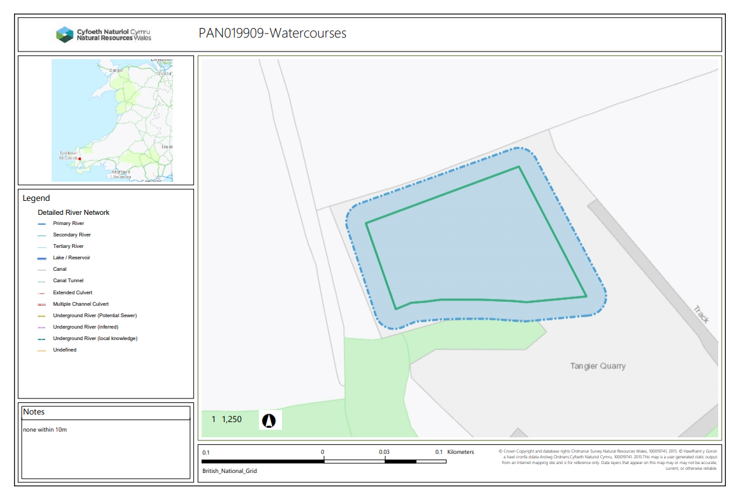
AQMA – 0m
None
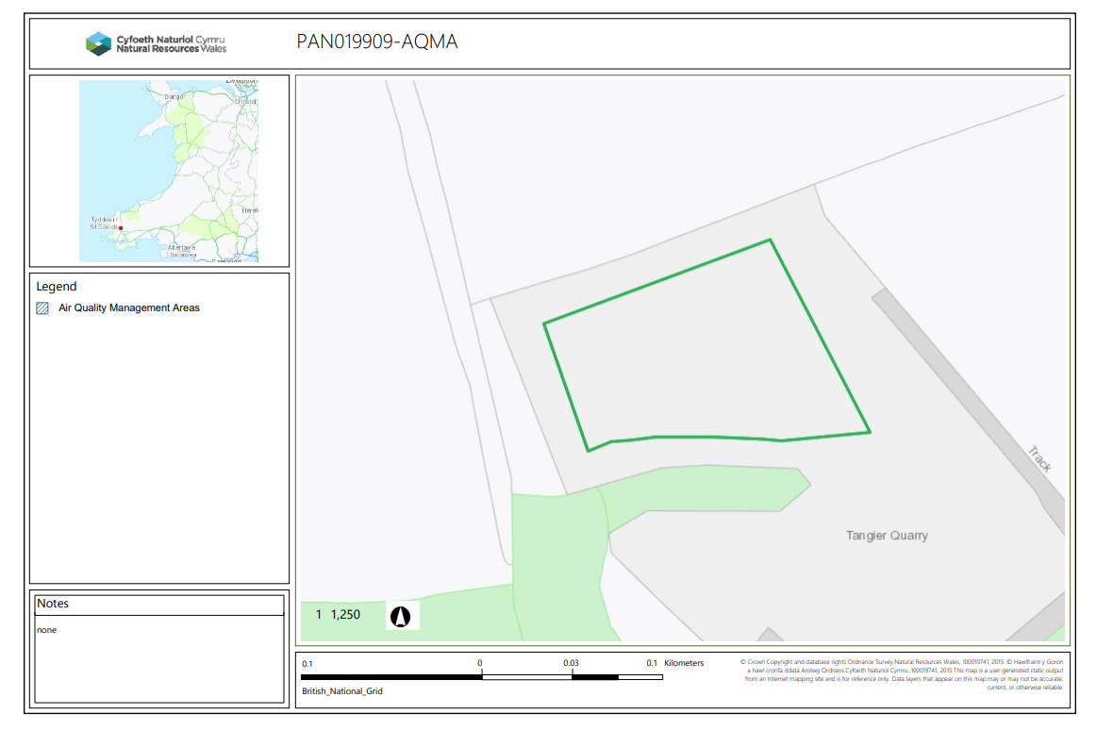
END

