PAN-020612 My Map Report:
Application map
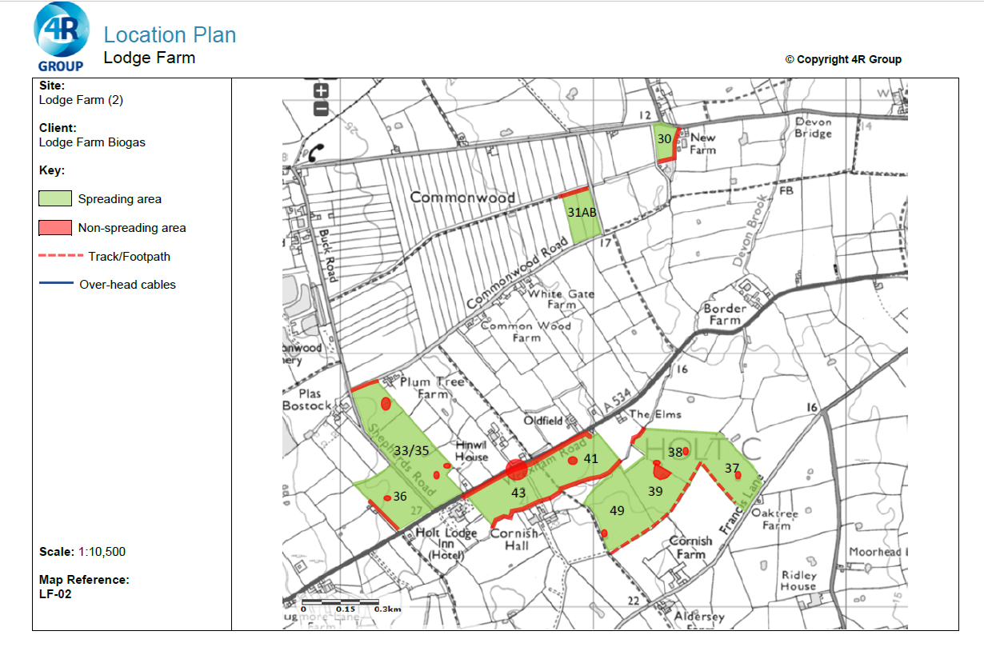
Deployment Boundaries

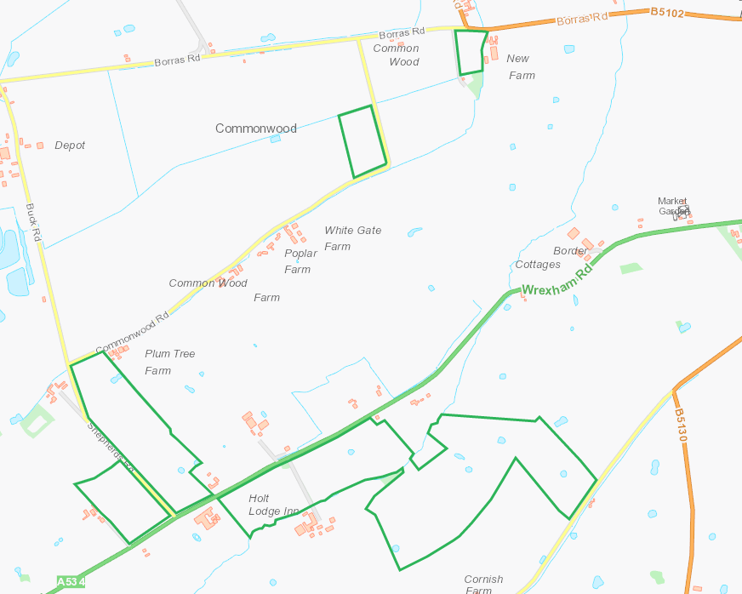

Detailed river network:
Watercourse to S and E of 30 flowing N, buffer in place.
Watercourse to N of 31AB flowing N, buffer in place.
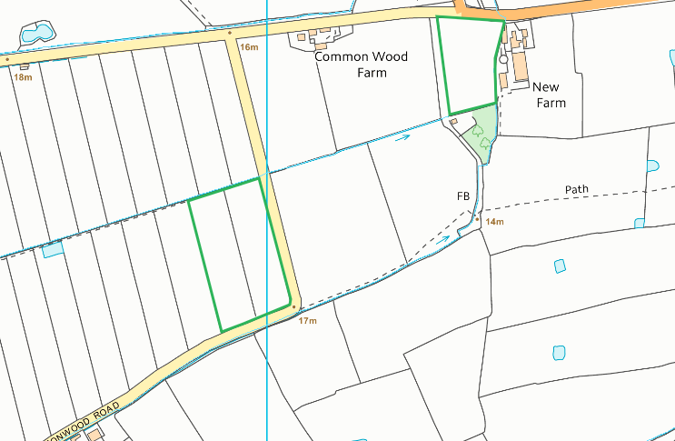
Watercourse to N of 33/35 flowing E, buffer in place.
Watercourse to SE of 43 and 41, NW of 38 flowing SW to NE, buffers in place.
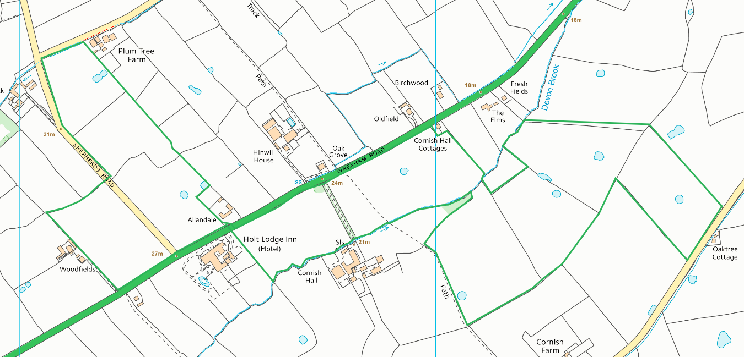
Groundwater protection zones
Area is within SPZ3, no action required.
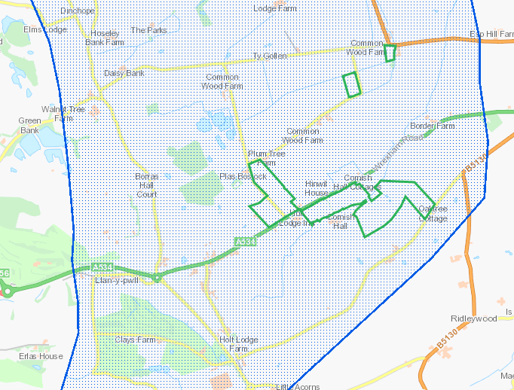

Any well, spring (or issue) or borehole used / not used for the supply of water for human consumption including from a private water supply or supplies within 50m.
Issue within 50m of field 43. Buffer in place on app maps.
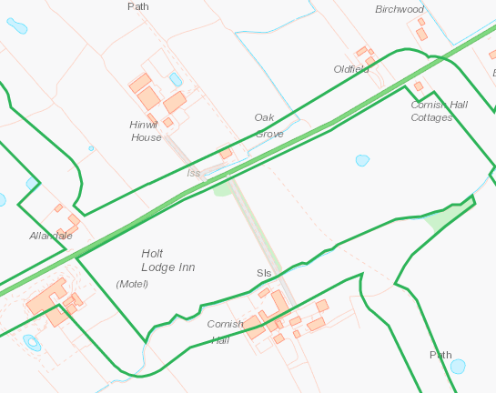

Any well, spring (or issue) or borehole used / not used for the supply of water for human consumption including from a private water supply or supplies within 250m.
NALD Deregulated Abstraction Borehole within 250m W of field 30 and NE fields 31A&B RFI

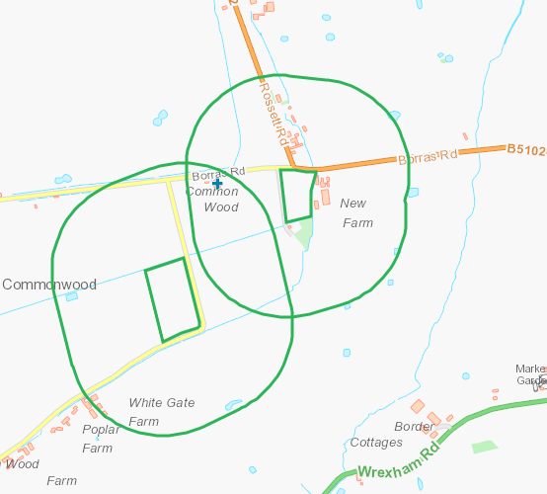

European designated sites- Natura 2000 (SPA, pSPA, SAC or cSAC) or Ramsar- or SSSI within 500m

None
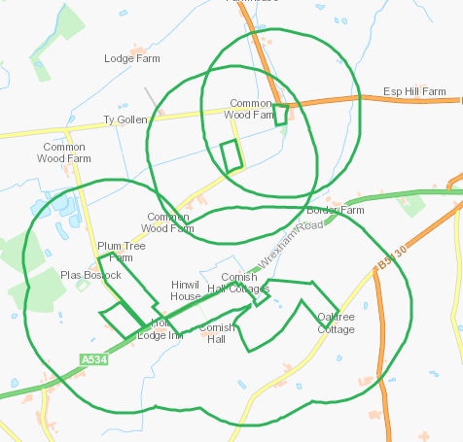

Other protected sites within 500m:
- Protected Species-
- Protected Habitats-
- Scheduled Ancient Monument-
- Local Nature Reserve-
- National Nature Reserve-
- Ancient Woodlands-
- Local Wildlife Sites (SINC)-
- National Park-
- Nitrate Vulnerable Zone (NVZ)-
- Groundwater Safeguard Zone-
- Hedges-
- Ditches-

Purple moor grass and rush pastures, Lowland dry acid grassland and Lowland calcareous grassland. Ancient Semi Natural Woodland and Ancient Woodland Site of Unknown Category.
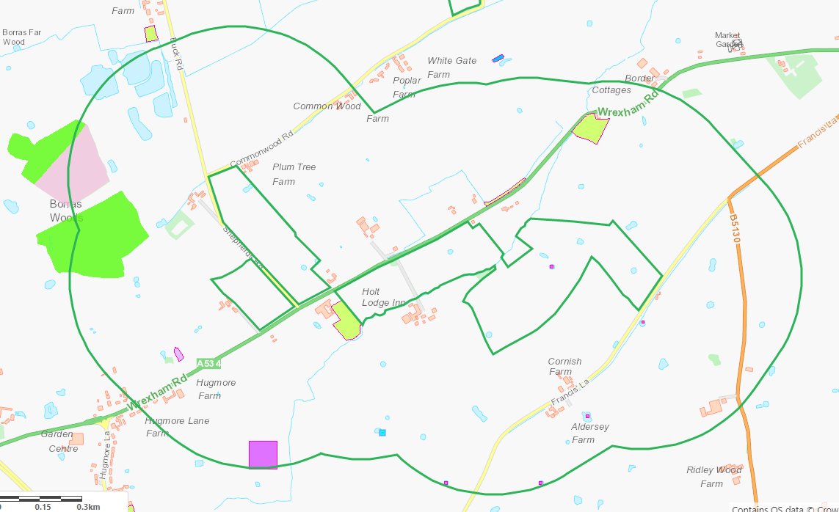

Threatened Bryophyte and Amphibians. Lowland dry acid grassland and Lowland calcareous grassland, Reedbeds

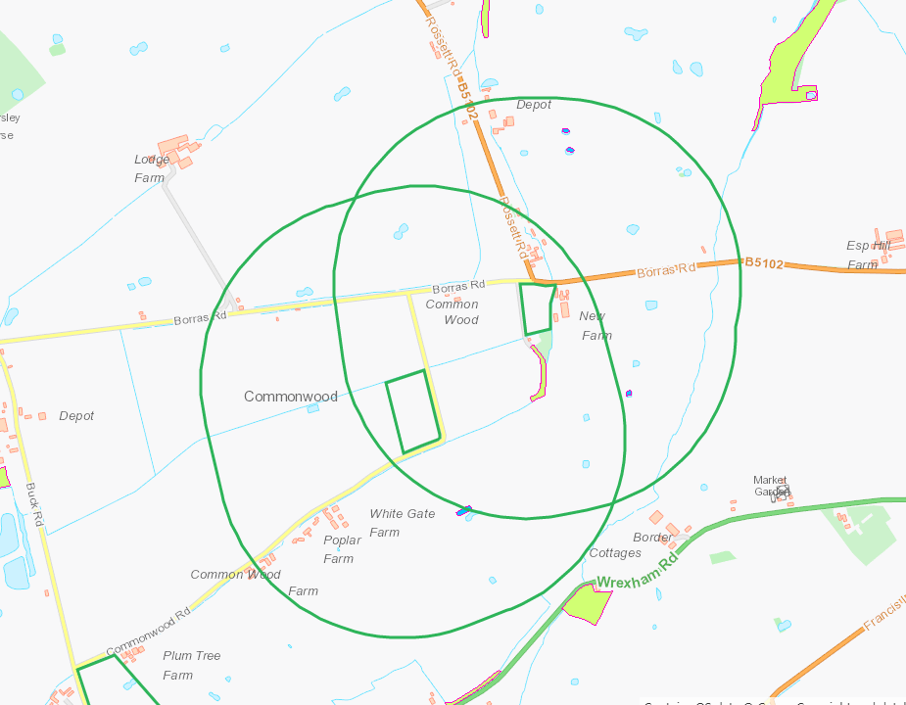

Public rights of way
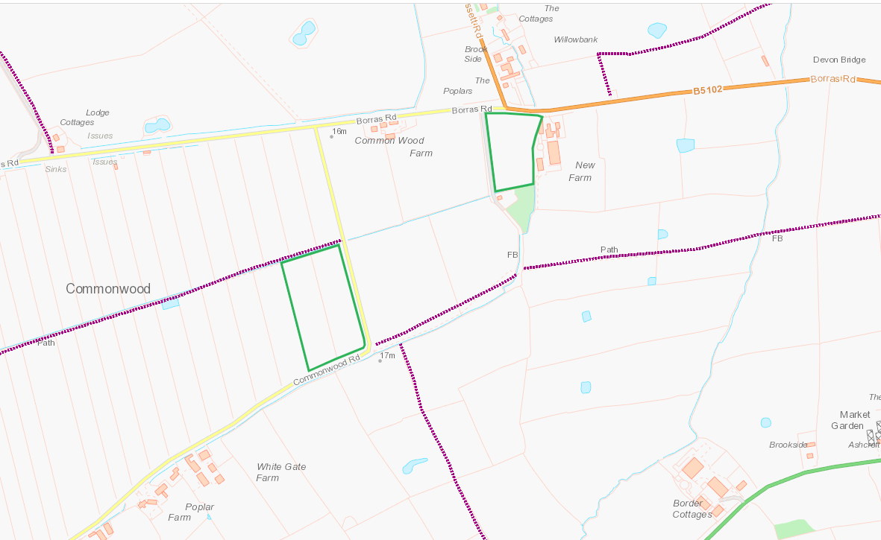

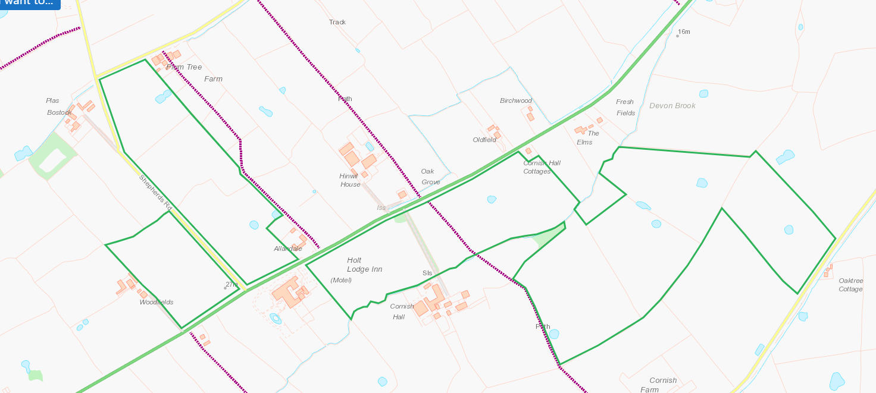
Distance from Main Farm Address
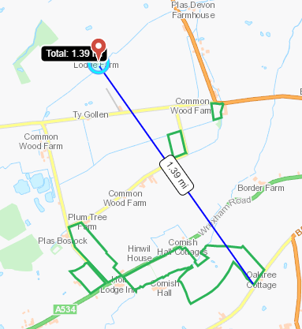

Slope Map

All fields 0-7 degrees
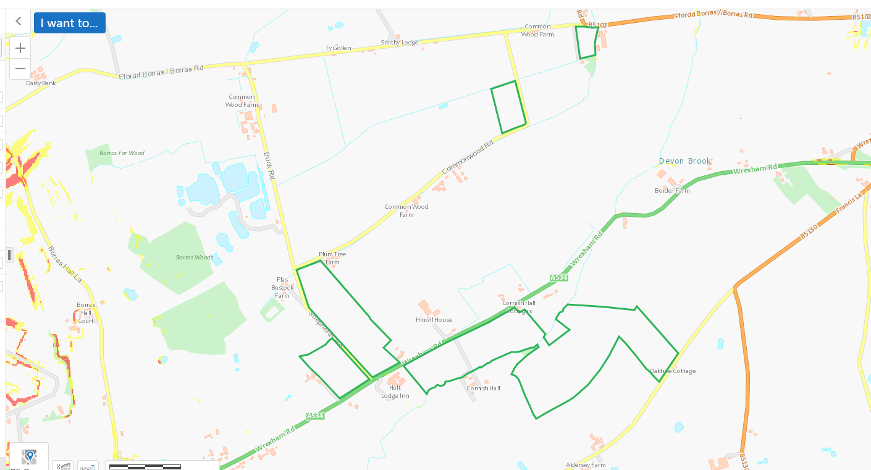
END

