PAN-020614 My Map Report:
Application map
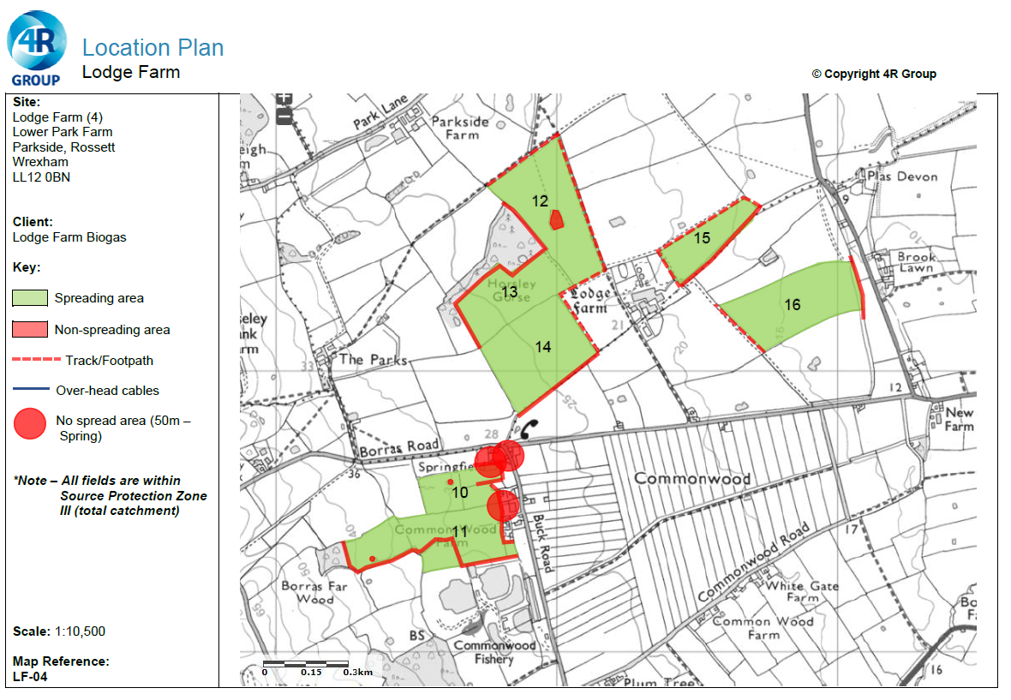
Deployment boundary
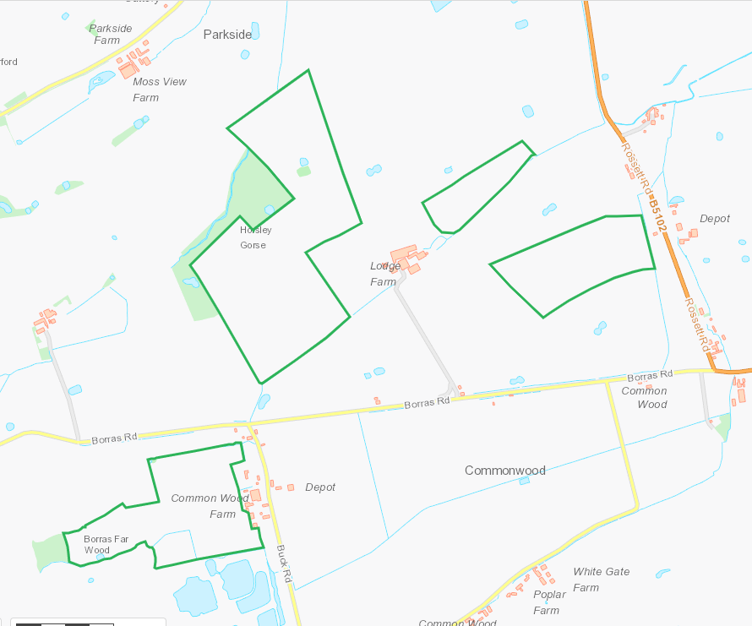
Detailed river network:
Watercourse to the NW of 12 and 13 flowing N, passes underground NW corner of 12 emerging to N of 12 – no buffer in place on point of emergence RFI.
Watercourse adjacent to SE of 14 flowing SW-NE, buffer in place.
Pond central in 12, buffer in place
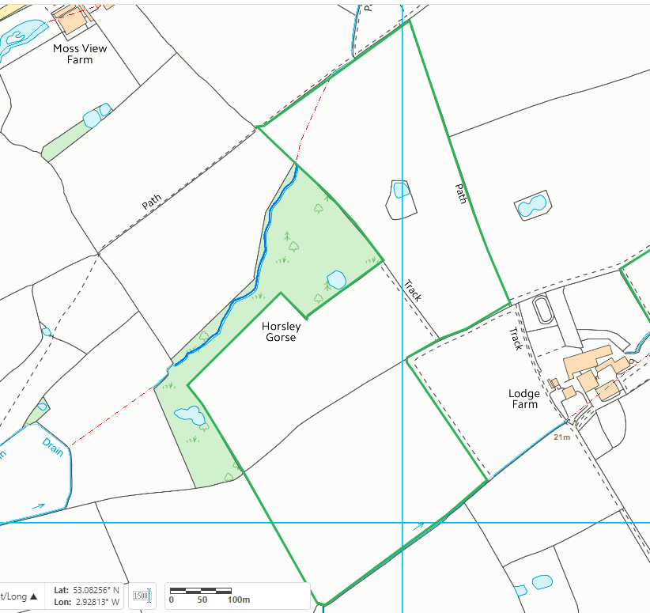
Watercourse adjacent to SE of 15 flowing SW-NE, buffer in place.
Watercourse adjacent to E of 16 flowing S-N, buffer in place.
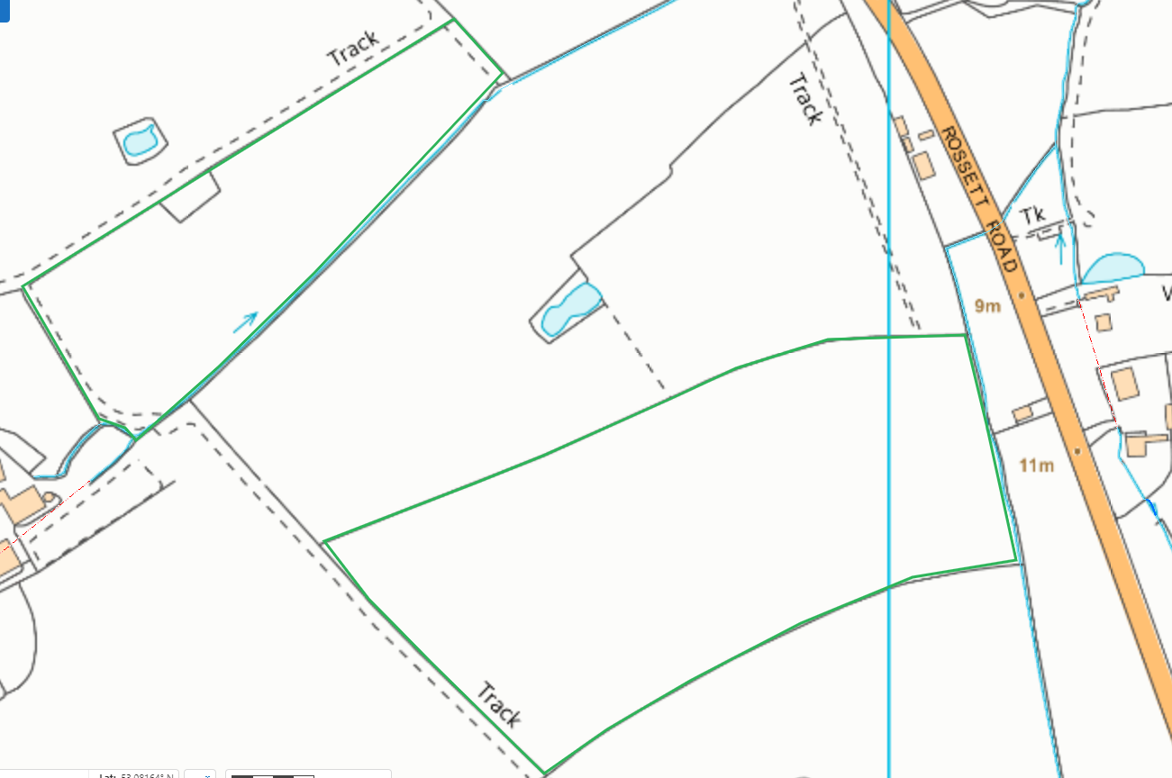
Watercourse adjacent to S of 11 flowing W-E. Drain to E of 10 and 11 flowing S-N, buffers in place.
Pond to NW corner of 10 not identified on application map, buffer not in place. RFI
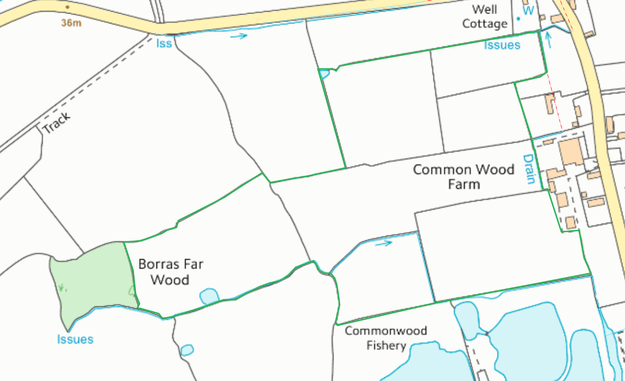

Groundwater protection zones
Deployment area is within SPZ3. No action required.
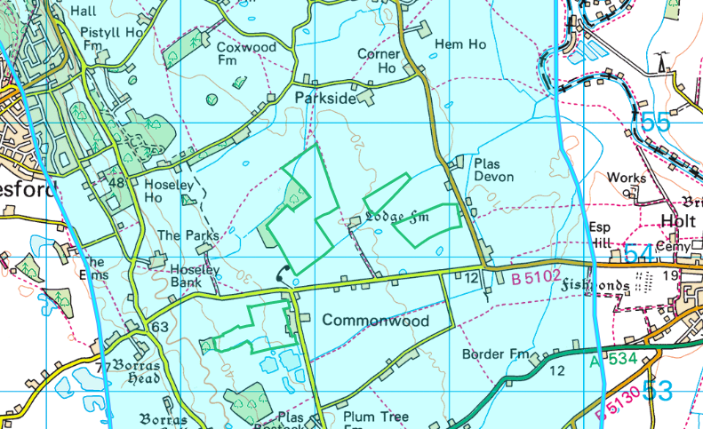

Any well, spring (or issue) or borehole used / not used for the supply of water for human consumption including from a private water supply or supplies within 50m.
Groundwater Borehole to E of 11 - General Farming & Domestic. Issue and well to NE of 10. Buffer in place.
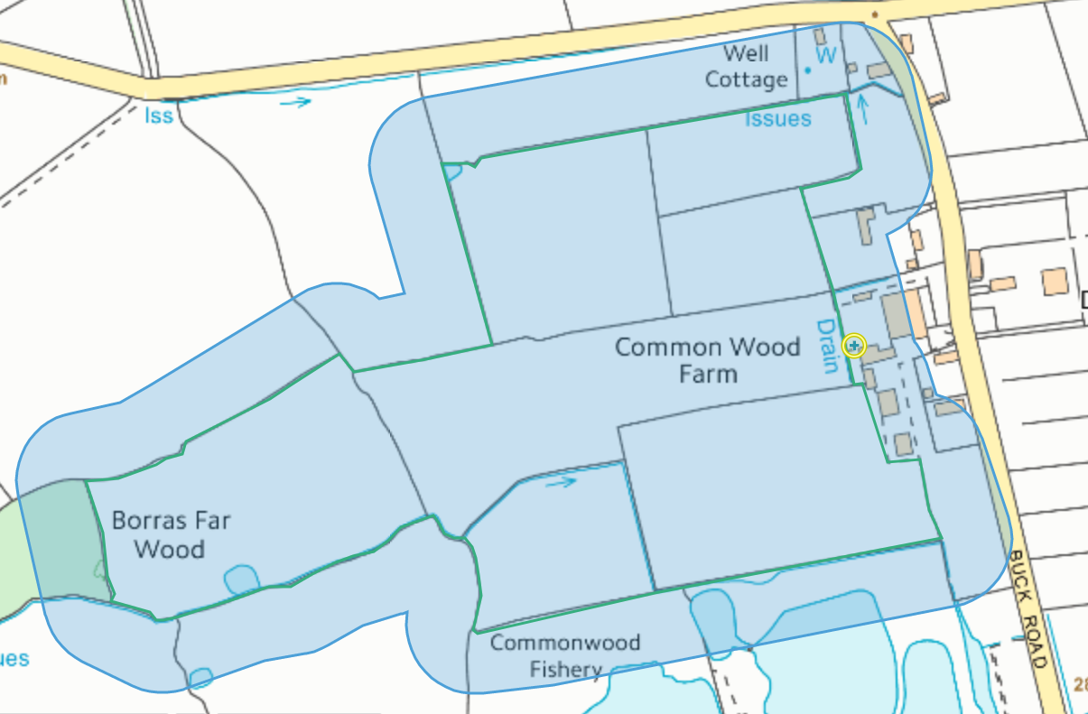
None within range on other fields.
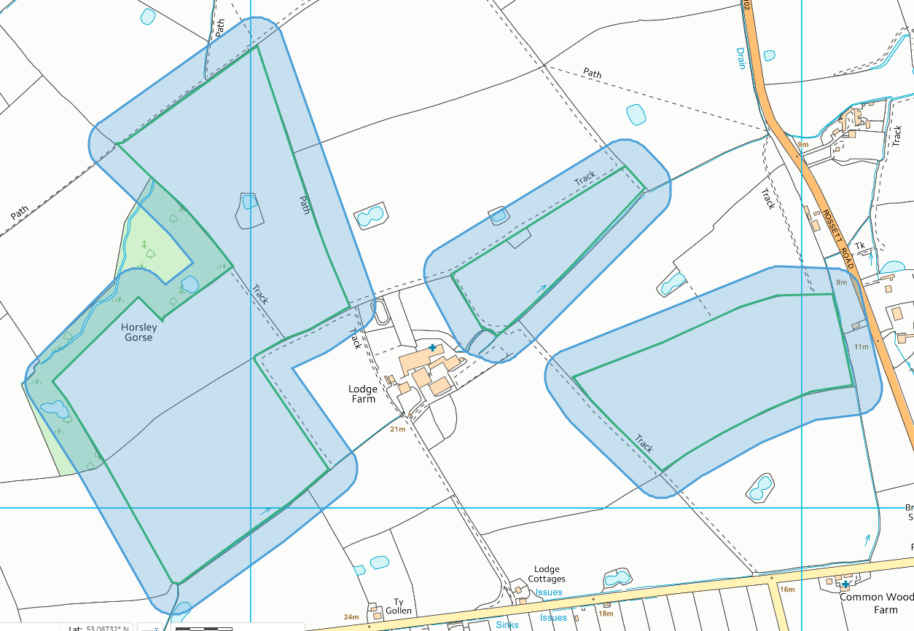
Any well, spring (or issue) or borehole used / not used for the supply of water for human consumption including from a private water supply or supplies within 250m.
10 and 11, none other than mentioned within 50m.
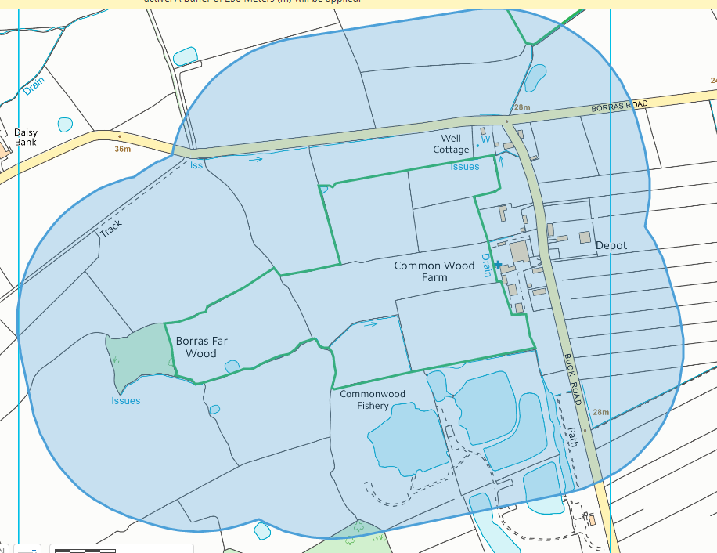
Groundwater Borehole - General Farming & Domestic within 250m centred between 12,13,14,15,16 not identified on application map. RFI
Issue and well to SW of 14. Previously identified within 50m of 10. Buffer in place in 10.

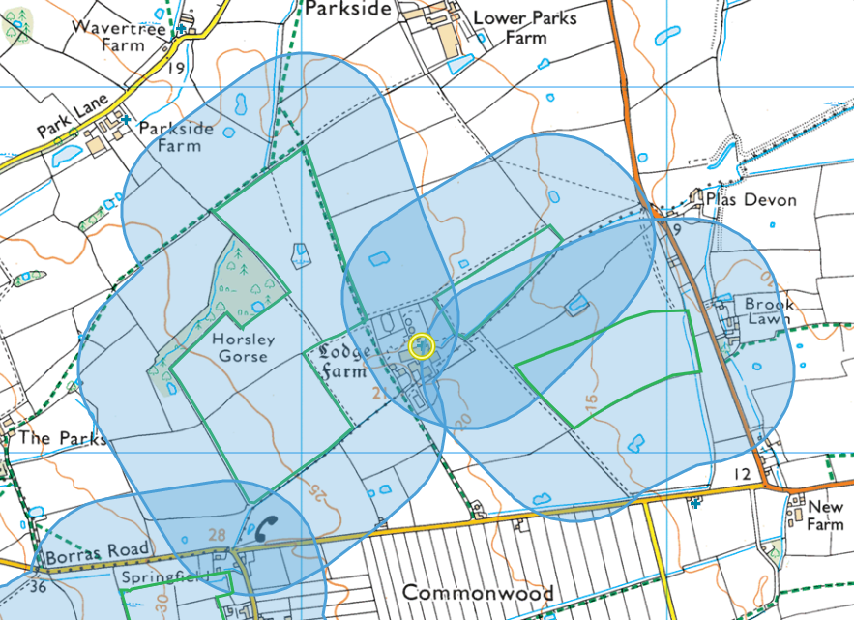

European designated sites- Natura 2000 (SPA, pSPA, SAC or cSAC) or Ramsar- or SSSI within 500m

None
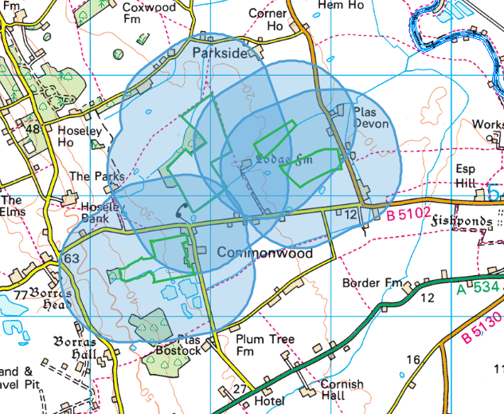

Other protected sites:
- Protected Species-
- Protected Habitats-
- Scheduled Ancient Monument-
- Local Nature Reserve-
- National Nature Reserve-
- Ancient Woodlands-
- Local Wildlife Sites (SINC)-
- National Park-
- Nitrate Vulnerable Zone (NVZ)-
- Groundwater Safeguard Zone-
- Hedges-
- Ditches-

Local wildlife site and Lowland dry acid grassland and Lowland calcareous grassland to NE of 15 and 16. Reedbeds E of 16.
Lowland dry acid grassland and Lowland calcareous grassland N of 12.
Ancient Semi Natural Woodland immediately W of 11 – buffer in place - and ancient woodland over marshy ground. The majority of the site has been planted up with poplars. Beneath this is a ground flora dominated by marshy species, including early purple orchid S of 11.
Lowland dry acid grassland and Lowland calcareous grassland at within SE corner of 11
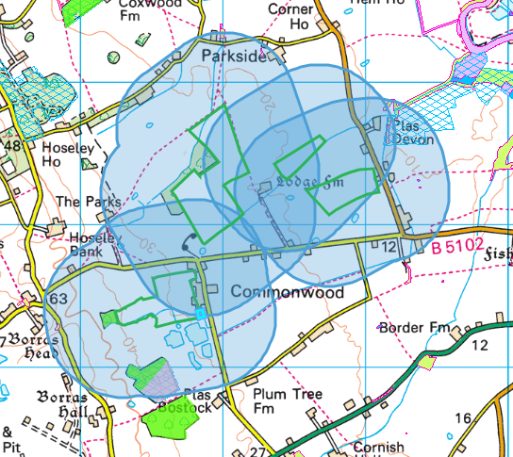
Public rights of way
Public rights of way to NE and NW adjacent to field 12. Application map also marks tracks but these are not designated as public rights of way on MyMaps
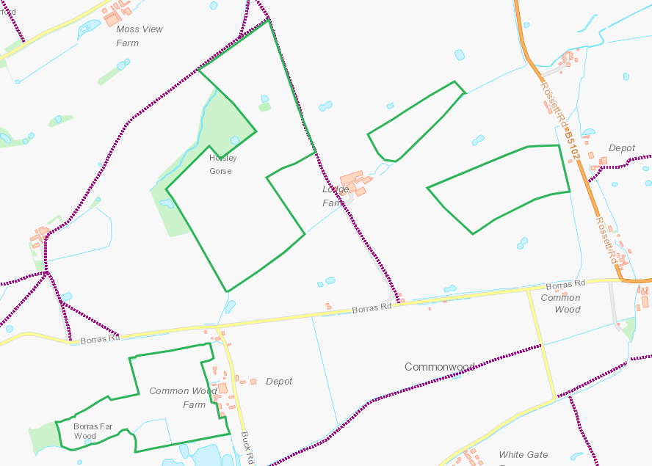
Distance from main farm
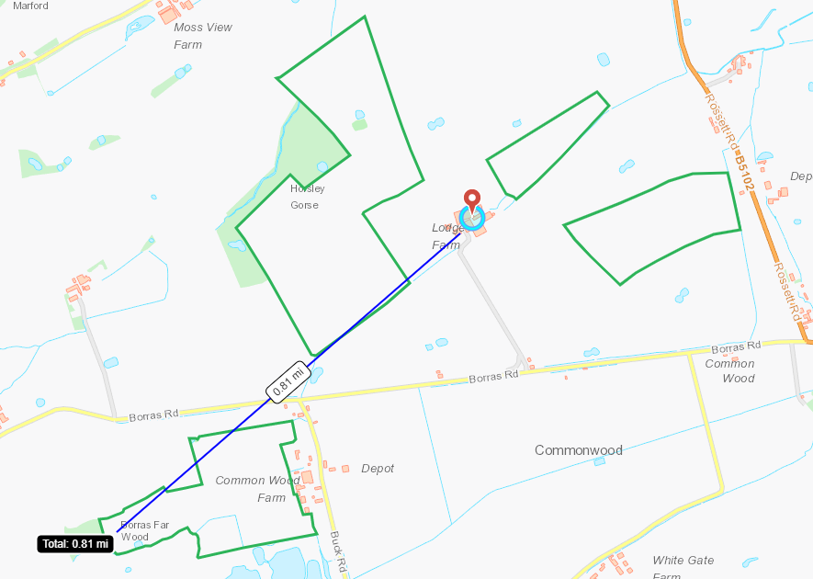

Slope Map
All fields 0-7 degrees


