PAN-020613 My Map Report:
Application map
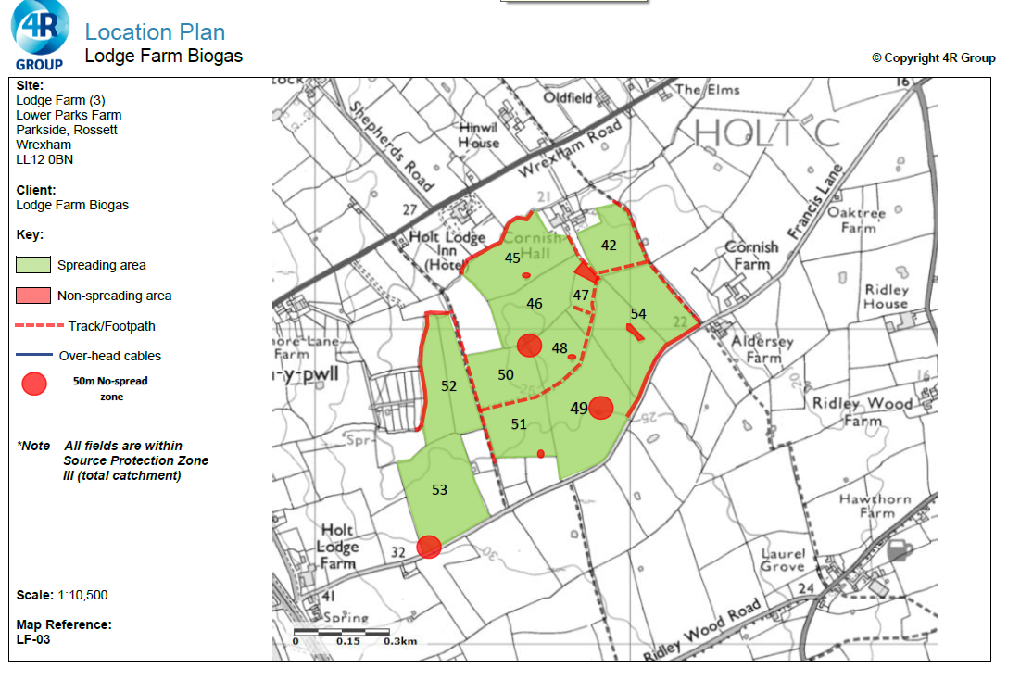

Deployment boundary
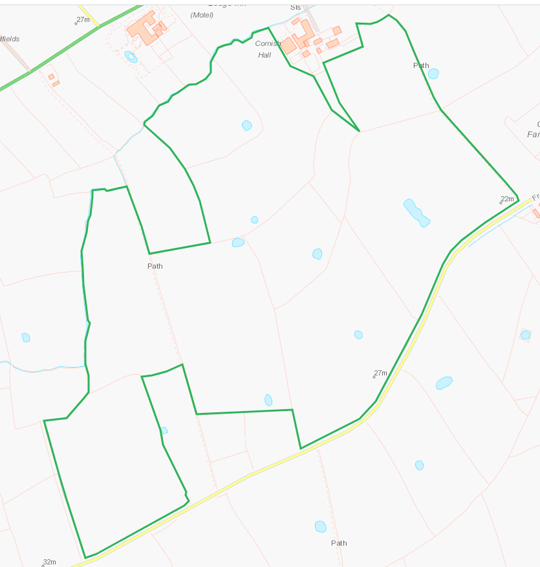

Detailed river network:
Watercourses to the N, NW and SE of the deployment area. Buffers in place on application maps.
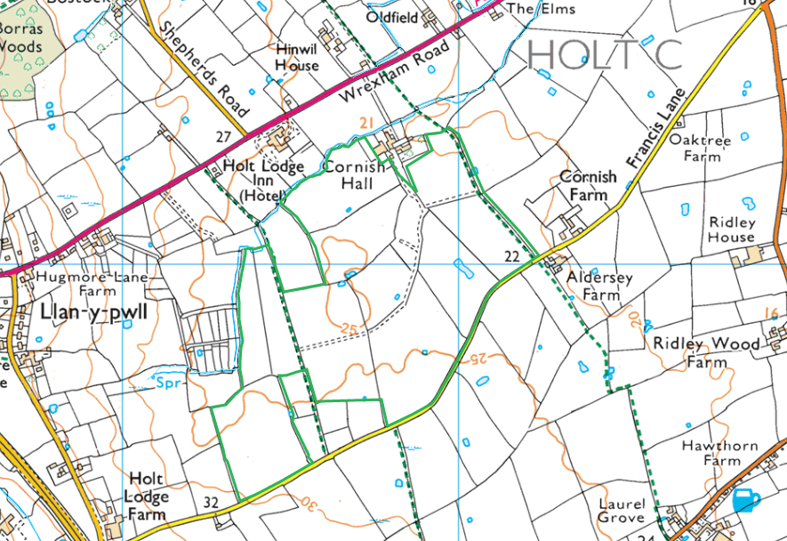
Field 53 has a pond to the E boundary which does not appear on the application map and does not have a buffer. There is a spring at 91.58m (approx) to the SW, not indicated on the application map. RFI
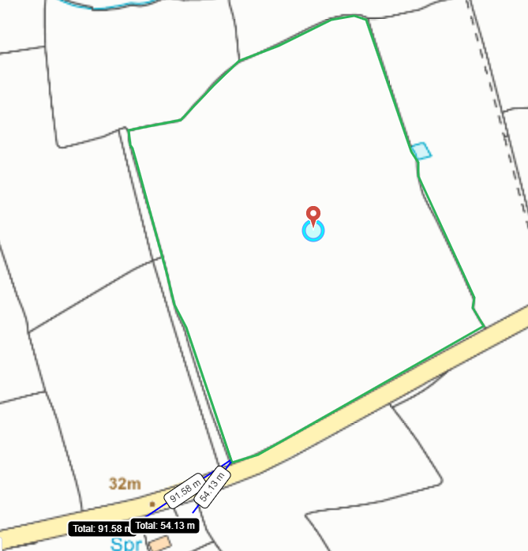

Groundwater protection zones
Area is within a SPZ3. No action required.
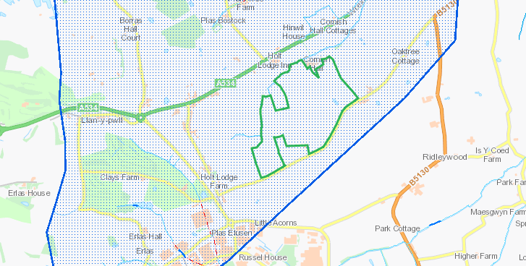

Any well, spring (or issue) or borehole used / not used for the supply of water for human consumption including from a private water supply or supplies within 50m.
None within range
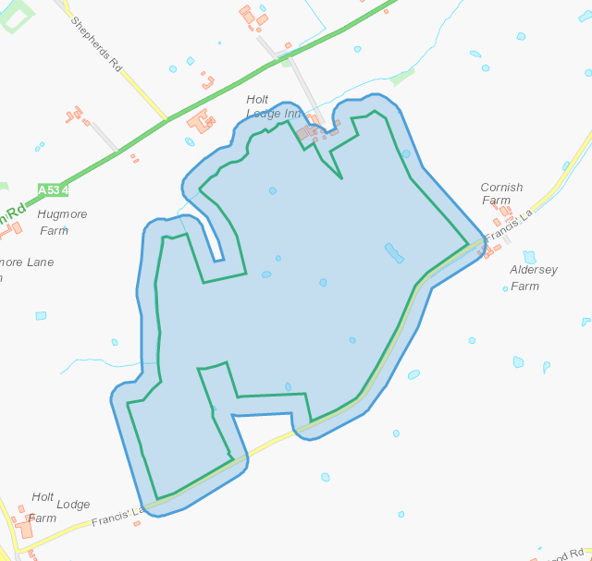

Any well, spring (or issue) or borehole used / not used for the supply of water for human consumption including from a private water supply or supplies within 250m.
Spring W of field 52 noted on application map, Spring to SW of field 53 not noted on application map. Issue N of field 45 not noted on application map RFI.
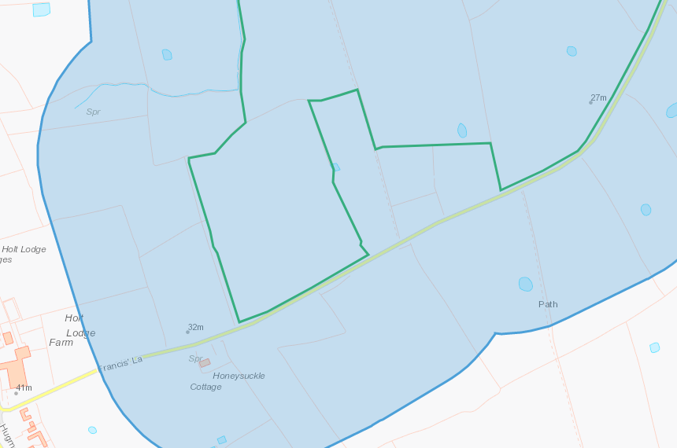
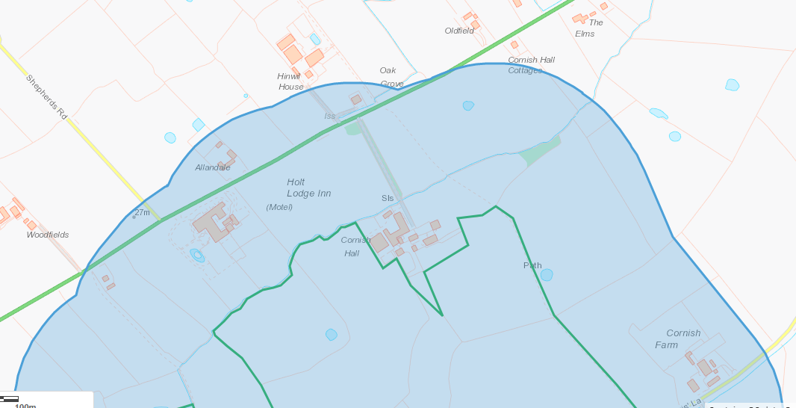

European designated sites- Natura 2000 (SPA, pSPA, SAC or cSAC) or Ramsar- or SSSI within 500m

None in range
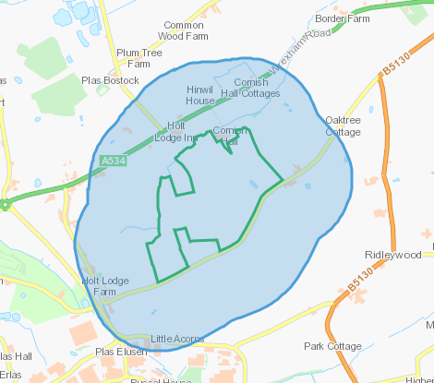
Other protected sites within 500m:
- Protected Species-
- Protected Habitats-
- Scheduled Ancient Monument-
- Local Nature Reserve-
- National Nature Reserve-
- Ancient Woodlands-
- Local Wildlife Sites (SINC)-
- National Park-
- Nitrate Vulnerable Zone (NVZ)-
- Groundwater Safeguard Zone-
- Hedges-
- Ditches-

Lowland dry acid grassland and Lowland calcareous grassland, Purple moor grass and rush pastures.

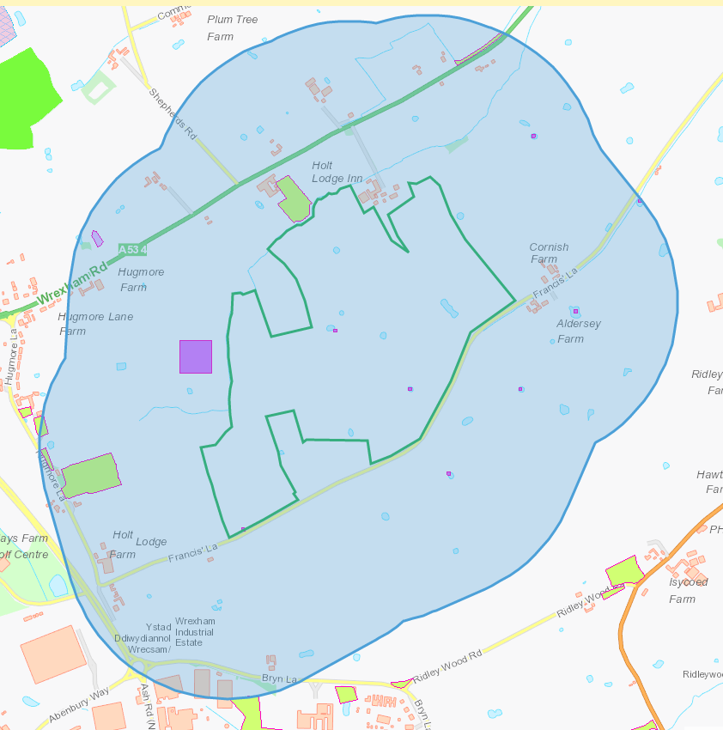

Groundwater safeguard zones
None
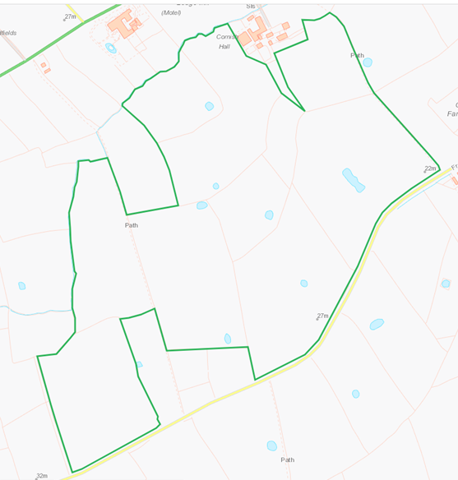

Public rights of way
Public right of way crossing between 50,51 and 52. Also NE of 42 and 54.
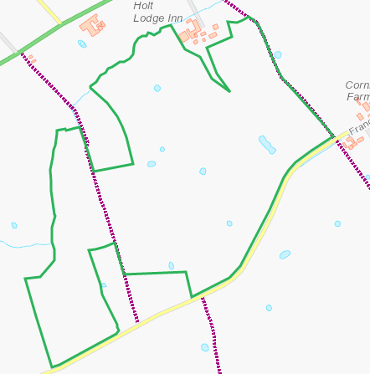
The application map also identifies a track crossing the main deployment area although MyMaps does not identify this track as a public right of way.
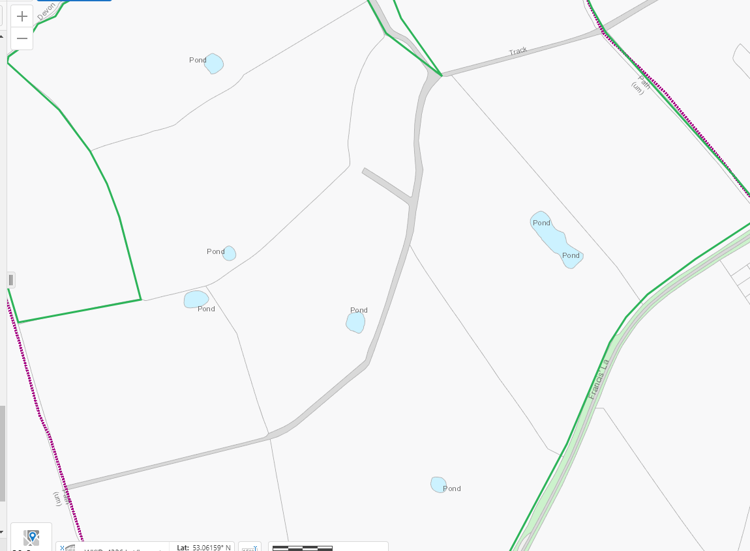
Distance from main farm address
Incorrect grid reference for farm address provided – RFI Map below shows distance from Lower Parks Farm which is the main farm for this application..
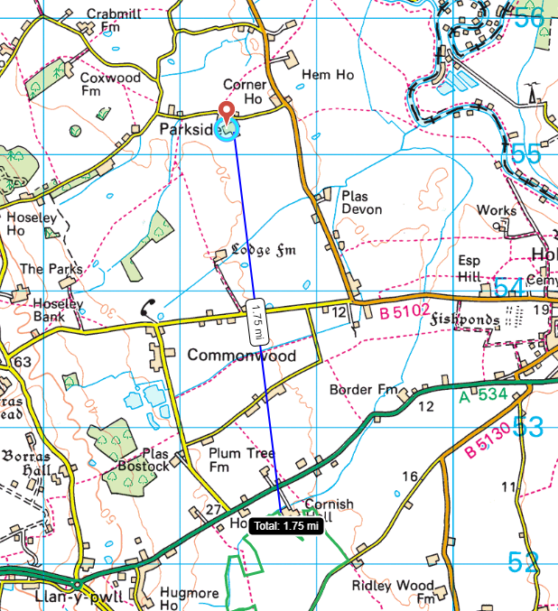

Slope Map
All fields 0-7


