CG0381901 Benllech WWTW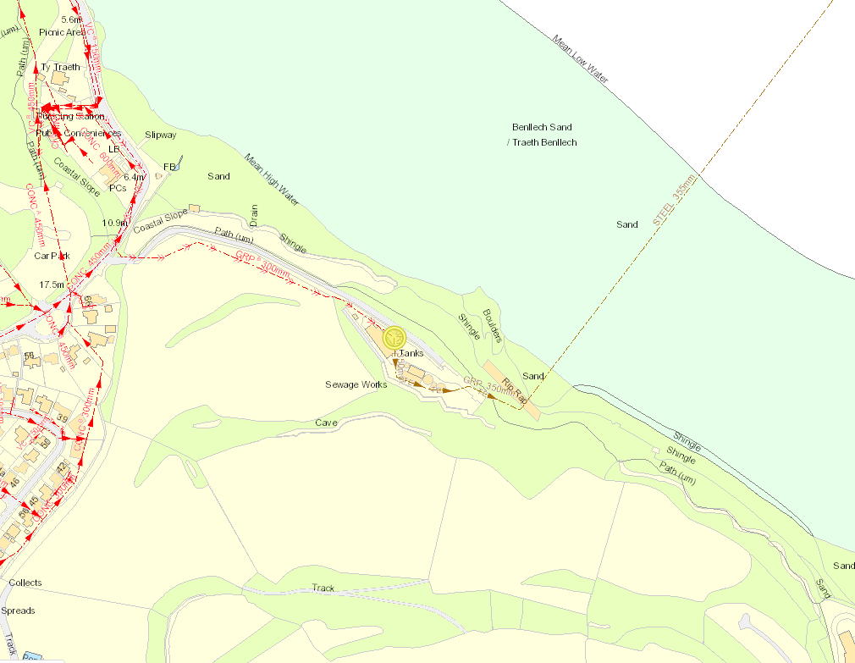
EDM to storm monitoring point
PFF Monitor
Discharge point
Storm sample point
EDM to Env Monitoring point

