CRoW Appendix 4 (140_10_SD02)  CRoW Act 2000: Natural Resources Wales application for permission - Formal Notice |  | 
Natural Resources Wales Formal Notice.
Requirements of Section 28I of the Wildlife & Countryside Act 1981 as amended by the Countryside and Rights of Way Act (CRoW) 2000.
Duty in relation to granting any consent, licence or permit for activities likely to damage Sites of Special Scientific Interest (SSSI).
Guide to filling in this form for Natural Resources Wales staff:
To be completed by Permitting Officers for any applications for a permission which the Natural Resources Wales has considered under S28G duties to protect and enhance SSSIs. This applies to all proposed permissions within a SSSI, and to operations outside the SSSI boundary which are likely to damage its special features.
Refer to OI 140_10 ‘Applying the Countryside and Rights of Way (CRoW) Act 2000 to applications for permits with potential for impact on Sites of Special Scientific Interest (SSSI)’, including the flowchart in Appendix 2.
Ensure you have completed all sections.
- Natural Resources Wales area/region/NPS hub: | Wales, Cardiff, Ty Cambria
- Name of SSSI: | Montgomery Canal (SJ 220058)  Hollybush Pastures (SO 153956)
- Type of permission: | Environmental Permit: New bespoke permit for a free-range layer poultry unit at Upper Bryn, Abermule, Montgomery, SY15 6JW
- Date for Natural Resources Wales permit determination: | 06/06/2019
- Predicted 28 day date for response from NRW conservation/ecology (under S28 I(4)): | For information only
- Natural Resources Wales reference no: | PAN-004244
- National grid reference: | SO 16908 94424  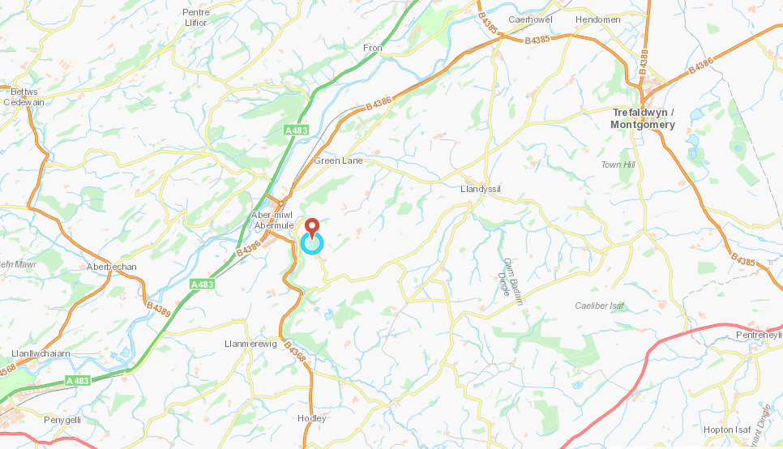
- Description of proposal: | This permit application is for the housing of 64,000 free range egg-laying birds at Upper Bryn, Abermule, Montgomery, Powys, SY15 6JW and is proposed by Irene Lloyd and Tom Hamer trading as WL Hamer.  The proposal is to expand the existing 32,000 bird poultry unit erected in 2018 to accommodate a further 32,000 birds in a second adjoining poultry unit. The total maximum capacity will be 64,000.  The surrounding land is exclusively agricultural.  Settlements surrounding the site include Abermule and Mongtomery. The site is classed as open countryside in the Powys County Council Local Plan.
- Is the proposed activity within (wholly or partially) the SSSI boundary? | No  Montgomery Canal SSSI: Approximately 1km northwest  Hollybush Pastures SSSI: Approximately 1.8km northwest  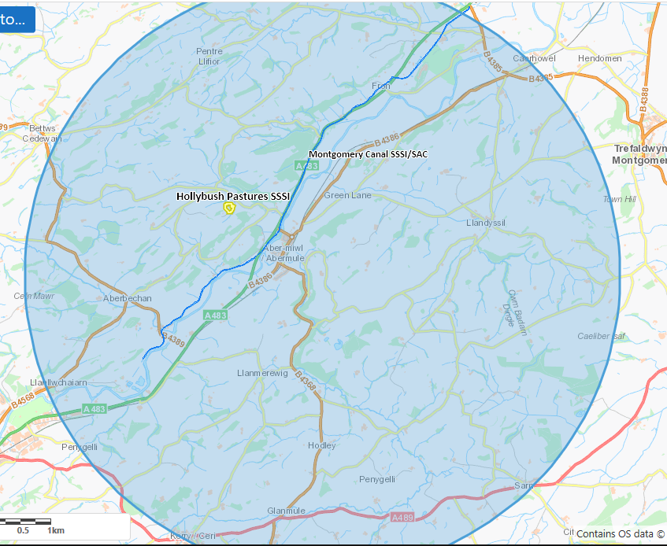
- Has there been any pre-application discussion or correspondence with NRW conservation/ecology | No
- What aspect(s) of the proposed permission may damage the features which are of special interest for the SSSI?
The following ‘Operations Requiring Consent’ (or other activities associated with the permission) that may cause damage) are relevant to the proposed permission:
Emissions from the housing of poultry

The following SSSI features and mechanisms of impact have been considered to assess the likelihood of damage:
Potential for increased ammonia concentration and potential increase in nitrogen deposition
- Decision

The applicant used ADMS 5.0 modelling software and meteorological data to predict the plume and ground level concentrations and deposition rates of pollutants. They then compared them to the critical levels and loads. The process contribution from the installation has been calculated and compared against the minimum and maximum critical loads for each habitat type found within the SSSI’s.

Comparison against Critical Loads:
The applicant has presented a detailed assessment of ammonia concentration and nitrogen deposition as part of the application. The process contribution from the installation has been calculated and compared against the minimum and maximum critical loads for each habitat type found within the SSSI’s. There are no bryophytes or lichens listed at this site, so the assumed critical level for ammonia is 3µg/m3.

Where the Process Contribution (PC) is at or below 1% of the appropriate ammonia critical level / nitrogen critical load, no further assessment is required. As in line with OGN041 and GN020, where the livestock unit’s process contribution, either alone or in combination with other sources (where they exist), is between 1 – 8 % or above 8% it needs to be considered in the context of background ammonia concentration and nitrogen deposition at the sensitive receptor. This is termed the predicted environmental concentration (PEC) and includes the addition of the PC of the unit being assessed with other sources (sumPCs) and with background levels.

Ammonia concentration:
- Montgomery Canal SSSI/SAC: maximum process contribution to ammonia concentrations exceeds NRW’s lower threshold percentage of 1% of the Critical Level of 3µg/m³ by a small margin (0.032 µg/m3 or 1.1% of critical level).
When looked at in-combination with background ammonia levels and PCs of other poultry units within 5km (Belan Newydd, Black Hall, Black Wood, Brynrorin, Cloddiau), the total PEC is 2.045µg/m³, which is below the Cle of 3 µg/m³.

- Hollybush Pastures SSSI: maximum process contribution is 0.01 µg/m³ which is 0.3% of the critical level of 3ug/m³ so screens out

Conclusion:
The proposed permission is not likely to damage any of the flora, fauna or geological or physiological features which are of special interest.

Natural Resources Wales is minded to issue the permission

- Name and job title of Natural Resources Wales officer: | Danielle Carey  Permitting Officer (Regulated Industry)
- Date form sent to NRW conservation/ecology | 13/02/2019
For Natural Resources Wales use only, once NRW conservation/ecology response received
- NRW conservation/ecology comment on assessment: | Provided the in-combination calculations are correct, we are satisfied with the conclusion of the HRA and have no further comments.
- Name and job title of NRW conservation/ecology officer: | Catherine Blower, NRM Montgomeryshire
- Date of receipt of NRW conservation/ecology response: | 18/02/2019

