

Repair of Damaged
Sewer Overflow Pipe,
Penrhyndeudraeth

Preliminary Ecological
Appraisal

CPF8443

Document Control Sheet

Document Title: | Repair of Damaged Sewer Overflow Pipe Penrhyndeudraeth, Preliminary Ecological Appraisal
Document Author(s): | Bethan Moseley
Project Ref / Title: | CPF8443
Project Manager: | Bethan Moseley

Revision History
Date | Version No. | Summary of Changes
16/02/2023 | Draft | Initial draft version
 | V1 | Final version

Reviews
Name | Title | Date | Version
Rhys Meilyr Thomas | Senior Environment Officer | 16/02/2023 | Draft

Approvals
Name | Title | Date | Version

Distribution
Name | Title | Date | Version
Peter Jones | Contracts Coordinator (Alun Griffiths Contractors) |  | V1

© 2023 Gwynedd Council / YGC. All Rights Reserved.  Copyright in any or all of this documentation belongs to Gwynedd Council / YGC of Council Offices, Shire Hall Street, Caernarfon, Gwynedd, LL55 1SH (the 'Owner') and may not be used, sold, transferred, copied or reproduced in whole or in part, in any manner of form or on any media to any person other than in accordance with the terms of the Owner's agreement or otherwise without the prior written consent of the Owner. | 

Contents

- Introduction . . . . . . . . . 4
1.1 Background and Purpose of the Report . . . . . 4

- Planning Policy and Legislation . . . . . . . 5
2.1 Policy . . . . . . . . . 5
2.2 Legislation . . . . . . . . 5

- Methodology . . . . . . . . . 6
  - Desk Study . . . . . . . . 6
  - Field Survey . . . . . . . . 6

- Baseline Ecological Conditions . . . . . . . 7 - 19
  - Designated Sites . . . . . . . 7 - 16
  - Habitats . . . . . . . . 16 – 19
  - Species . . . . . . . . . 19

- Ecological Constraints and Opportunities. . . . . . 29
  - Designated Sites . . . . . . . 30
  - Habitats . . . . . . . . 31
  - Species . . . . . . . . . 31
- Enhancement and Compensation . . . . . . 31

- Conclusions . . . . . . . . . 31

8.0 References . . . . . . . . . 34

Appendices
Method of works and Drawings . . . . . . . 35-44
Cofnod . . . . . . . . . . 46

- Introduction
YGC were commissioned to undertake a Preliminary Ecological Appraisal (PEA) of the proposed repairs of a damaged sewer pipe at Penrhyndeudraeth, Gwynedd (Grid Reference SH261819 38363). The work includes to shorten the damaged exposed 450mm diameter Penrhyndeudraeth WWTW Outfall pipe by approx. 5m and construct a concrete Headwall (see teal figure 1 below). The works will be completed during dry weather at low tide and over pumping will not be necessary.

Works are expected to commence in Summer 2023 during a period of extreme low tide to allow enough time between the abiding tide to complete each part of the works. Details of proposals and location are shown in the method statement contained in Appendix A of this document.
The appraisal includes a desk study and site habitat survey. The survey area and land in the area of the damaged sewer mostly comprises of a sandflat.
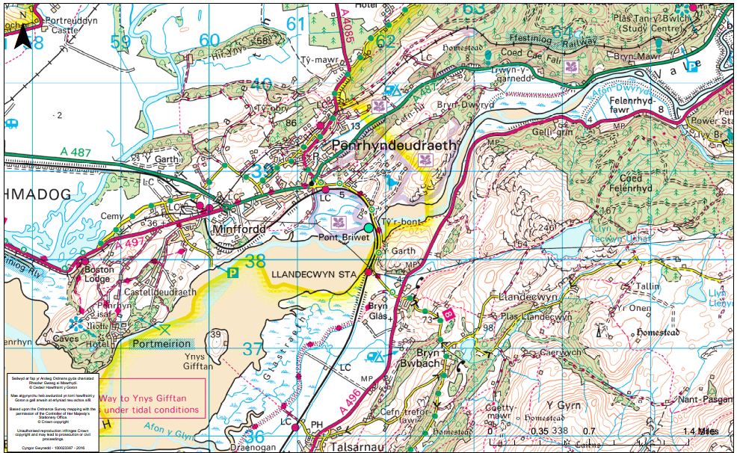
Figure 1 – Penrhyndeudraeth Damaged Sewer Pipe
(Area of works shown with the teal spot)
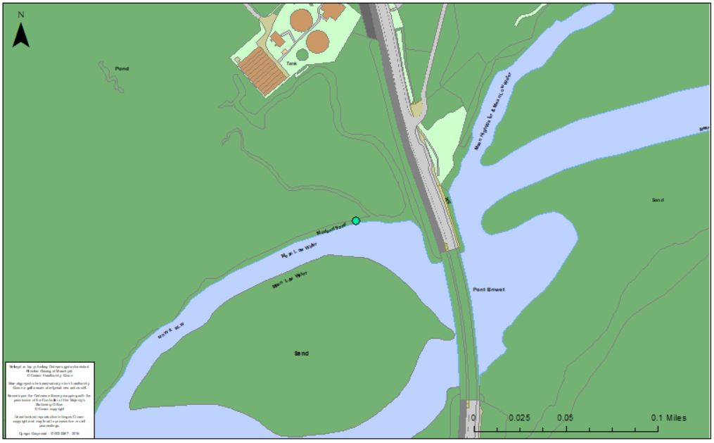
Figure 2 – Map area of the works shown in the teal spot

1.1 Background and Purpose of the Report
The work is to repair existing damaged sewer pipe (the Method Statement can be seen in the Appendix 1). This report will identify protected habitats and species on site, which could be affected by the works.

As a PEA, the purpose of this report is as follows:
- to identify key ecological constraints to the proposal;
- to allow significant ecological effects to be avoided or minimised wherever possible;
- to allow further ecological surveys needed to inform an ecological impact assessment to be identified and appropriately designed;
- to inform the development of potential mitigation and/or compensation measures; and
- to form a basis for the scope of an ecological impact assessment if required.

- Planning Policy and Legislation

2.1 Policy
The national and local policy described below may be relevant to the proposal.

Technical Advice Note (TAN) 5: Nature Conservation and Planning (2009)

TAN 5 provides advice to local planning authorities on the application of the law relating to planning and nature conservation and its impact within the land use planning system. The most recent revision of TAN 5 brings it in line with the strategic policy in Planning Policy Wales (PPW) 2016 and advises how planning policy with regard to ecology needs to be interpreted to comply with Planning Policy Wales. It provides advice on the following:
- Positive planning for nature conservation;
- Nature conservation and Local Development Plans;
- Nature conservation in development management procedures;
- Development affecting protected internationally and nationally designated sites and habitats;
- Development affecting protected and priority habitats and species.

Wales Environment Strategy (2006 to 2026)
The Environment Strategy is the Welsh Government’s long-term strategy for the environment of Wales setting the strategic direction for the next 20 years. The strategy has five main themes:
  - Addressing climate change;
  - Sustainable resource use;
  - Distinctive biodiversity, landscape and seascapes;
  - Our local environment; and
  - Environmental hazards.

Local Biodiversity Action Plans (LBAPs)

In 1992, the UK signed the Convention on Biological Diversity at the Rio Earth Summit pledging to develop national strategies for the conservation and sustainable use of biological diversity. The UK Government subsequently produced Biodiversity: The UK Biodiversity Action Plan in 1994 that described the biological resources of the UK as a whole and in turn led to the production of Biodiversity Action Plans for individual habitats and species. Biodiversity: The UK Biodiversity Steering Group Report was published in 1995. This recognised that to successfully implement the UKBAP at a local level and translate national policy into action, it would be necessary to produce Local Biodiversity Action Plans across the UK. In response to this, local authorities throughout the UK produced LBAPs; Gwynedd LBAP is of relevance to the proposed works and the species and habitats included within it have been considered and included within this assessment where relevant.

2.2 Legislation
The following legislation is likely to be relevant to the proposal:

Environment (Wales) Act (2016)
This Act became law in Wales on 21st March 2016 and includes legislation that supersedes the Natural Environment and Rural Communities (NERC) Act 2006. Part 1 of the Act sets out Wales’ approach to planning and managing natural resources at a national and local level with a general purpose linked to statutory ‘principles of sustainable management of natural resources’ defined within the Act.

Section 6 of the Act places a duty on public authorities to ‘seek to maintain and enhance biodiversity’ so far as it is consistent with the proper exercise of those functions. In doing so, public authorities must also seek to ‘promote the resilience of ecosystems.’ Public authorities will be required to report on the actions they are taking to improve biodiversity and promote ecosystem resilience.

Section 7 replaces the duty in Section 42 of the NERC Act 2006. The Welsh Ministers will publish, review and revise lists of living organisms and types of habitats in Wales, which they consider are of principle importance for the conservation and enhancement of biodiversity in Wales. The Welsh Ministers must also take all reasonable steps to maintain and enhance the living organisms and habitats included in any list published under this section and encourage others to take such steps. A number of habitats and species included under Section 7 of this act have been recorded near the Scheme and are therefore considered in the assessment.

Conservation of Habitats and Species Regulations (Amended) EU Exit) Regulations 2019
Conservation of Habitats and Species Regulations (Amended) (EU Exit) Regulations 2019 transpose Council Directive 92/43/EEC on the conservation of natural habitats and of wild fauna and flora (the EC Habitats Directive) into national law. The Regulations provide for the designation and protection of European sites and the protection of European protected species and habitats as listed in the EC Habitats Directive and EC Birds Directive (Council Directive 2009/147/EC). The regulations provide guidance on undertaking assessment of impacts on European and Protected Sites (Special Areas of Conservation - SACs, Special Protection Areas – SPAs and Ramsar sites) through the Assessment of Implications on European Sites (AIES) process. Two SPAs are located within 1km of the survey area and therefore needs to be considered under this legislation. The survey area also provides potential habitat for foraging bats and otters, which are European protected species, protected under this legislation.

Wildlife and Countryside Act (1981, as amended)

The Wildlife and Countryside Act (WCA) governs the designation and protection of Sites of Special Scientific Interest (SSSI) and National Nature Reserves (NNR), and protection of various plant and animal species. Schedule 1 of the Act lists protected bird species, Schedule 5 lists other protected animal species, and Schedule 8 lists protected plant species. Schedule 9 of the Act lists invasive alien species that it is an offence to introduce or allow to spread in the wild. There are SSSIs located within 1km of the survey area and bats and otters have full protection under Schedule 5 and have previously been recorded within 1km of the survey area.

- Methodology

  - Desk Study

A desktop study was undertaken to inform the baseline conditions, impact assessment and scoping process, including data from the following sources:
  - A search of biodiversity records held by the North Wales Environmental Information Service (Cofnod) was undertaken in February 2023, providing records of sites, habitats and priority species within a 1km buffer of the survey area;
  - Gwynedd Council’s GIS system (Map Gwynedd) provided information on statutory and non-statutory designated sites (within a 1km buffer);
  - Detailed information about protected sites was obtained from the JNCC (Joint Nature Conservation Committee) and NRW websites; and
  - Information about drainage and watercourses was obtained from Map Gwynedd.

  - Field Survey

A phase 1 habitat survey of the site was undertaken on 06th February 2023 by YGC Environment Officer Bethan Moseley BSc (hons) PIEMA, in order to identify the habitats present and search for any signs of protected species within the survey area. Target notes were used to describe and highlight features of interest with regard to habitat types, protected species and invasive plant species on the Phase 1 Habitat Plan provided in figure 7 and 8 below and a species list was compiled of species recorded during the survey can be found in section 4.2 below. Habitat survey methodology and mapping was based on the standard Phase 1 methodology provided in the Nature Conservancy Council’s ‘Handbook for Phase 1 Habitat Survey (2010). With respect to legally protected species, the following characteristics were specifically searched for:

• Suitable habitat for roosting bats including buildings and/or trees with cracks, crevices, holes and/or substantial growth of ivy that may potentially provide roosting locations and field signs of roosting bats (e.g., droppings, fur oil and urine staining, scratch marks and feeding remains);
• Suitable habitat for and field signs of otter Lutra lutra activity (e.g., holts, resting places, spraints, tracks, feeding remains, runs and pathways);
• Suitable habitat for and field signs of water vole Arvicola amphibious activity (e.g., burrows, latrines, feeding stations, tracks, runs and pathways);
- Suitable habitat for and field signs of reptile and amphibian species such as great crested newt Triturus cristatus (GCN), common lizard Lacerta vivipara, slow worm Anguis fragilis, grass snake Natrix natrix, adder Vipera berus, common toad Bufo bufo and common frog Rana temporaria;
- Suitable habitat for and field signs of badger Meles meles (e.g., setts, footprints, trapped hairs, dung-pits/latrines, foraging scrapes, runs and pathways).

In addition to the protected species mentioned above and in accordance with the guidelines of the Chartered Institute of Ecology and Environmental Management (CIEEM), evidence of any other protected, priority and/or invasive species found during the course of the survey has been highlighted in this report.

The weather on 06th February 2023 was dry and sunny with temperatures between lows of 1ºC and highs of 6ºC. These conditions imposed no limitations on the survey.

- Baseline Ecological Conditions

  - Designated Sites

4.1.1 Internationally Designated Sites
Internationally designated sites (as protected under the Conservation of Habitats and Species Regulations (Amended) (EU Exit) Regulations 2019) considered to be potentially affected by the proposal include all those within 10km of the survey area boundary.

SACs sometimes require consideration within a larger buffer distance such as 25km for bats and 30km for otters. The internationally protected sites considered within this assessment are therefore listed in Table 1 and shown in Figure 2 below.

Table 1: Internationally designated site within 10km of the proposed works

European site | Distance | Qualifying features
Pen Llyn a’r Sarnau Special Area of Conservation SAC | Pen Llyn a’r Sarnau SAC is on site at the damaged sewer pipe and proposed access route to the works. | Annex I habitats that are a primary reason for selection of this site  - Sandbanks which are slightly covered by sea water all the time  - Estuaries  - Coastal lagoons * Priority feature  - Large shallow inlets and bays  - Reefs  Annex I habitats present as a qualifying feature, but not a primary reason for selection of this site  - Mudflats and sandflats not covered by seawater at low tide  - Salicornia and other annuals colonizing mud and sand  - Atlantic salt meadows Glauco-Puccinellietalia maritimae  - Submerged or partially submerged sea caves  Annex II species that are a primary reason for selection of this site  - Not Applicable  Annex II species present as a qualifying feature, but not a primary reason for site selection Bottlenose dolphin Tursiops truncates  - Otter Lutra lutra  - Grey seal Halichoerus grypus
Coedydd Derw a Safleoedd Ystlumod Meirion Special Area of Conservation SAC | Coedydd Derw a Safleoedd Ystlumod Meirion SAC is 370m north at its closest point of the works at Penrhyndeudraeth. | Annex I habitats that are a primary reason for selection of this site  Old sessile oak woods with Ilex and Blechnum in the British Isles  Alluvial forests with Alnus glutinosa and Fraxinus excelsior (Alno-Padion, Alnion incanae, Salicion albae) * Priority feature  Annex I habitats present as a qualifying feature, but not a primary reason for selection of this site:  - Water courses of plain to montane levels with the Ranunculion fluitantis and Callitricho-Batrachion vegetation  - Northern Atlantic wet heaths with Erica tetralix  - European dry heaths  - Tilio-Acerion forests of slopes, screes and ravines * Priority feature  - Bog woodland * Priority feature  Annex II species that are a primary reason for selection of this site  - Lesser horseshoe bat Rhinolophus hipposideros
Rhinog Special Area of Conservation (SAC) | Rhinog (SAC) is 5km southeast from the proposed works. | Annex I habitats that are a primary reason for selection of this site:  - European dry heaths  - Old sessile oak woods with Ilex and Blechnum in the British Isles  Annex I habitats present as a qualifying feature, but not a primary reason for selection of this site  - Oligotrophic to mesotrophic standing waters with vegetation of the Littorelletea uniflorae and/or of the Isoëto-Nanojuncetea  - Northern Atlantic wet heaths with Erica tetralix  - Alpine and Boreal heaths  - Blanket bogs (* if active bog) * Priority feature  - Depressions on peat substrates of the Rhynchosporion  Annex II species present as a qualifying feature, but not a primary reason for site selection  - Floating water-plantain Luronium natans
Migneint Arenig Dduallt Special Area of Conservation (SAC) | Migneint Arenig Dduallt (SAC) is 9km east of the proposed works. | Annex I habitats that are a primary reason for selection of this site  - European dry heaths  - Blanket bogs (* if active bog) * Priority feature  Annex I habitats present as a qualifying feature, but not a primary reason for selection of this site  - Oligotrophic to mesotrophic standing waters with vegetation of the Littorelletea uniflorae and/or of the Isoëto-Nanojuncetea  - Natural dystrophic lakes and ponds  - Northern Atlantic wet heaths with Erica tetralix  - Old sessile oak woods with Ilex and Blechnum in the British Isles
Afon Eden Cors Goch Trawsfynydd Special Area of Conservation (SAC) | Afon Eden Cors Goch Trawsfynydd (SAC) is approximately 9km southeast from the damaged sewer pipe. | Annex I habitats that are a primary reason for selection of this site  Not Applicable  Annex I habitats present as a qualifying feature, but not a primary reason for selection of this site  - Active raised bogs * Priority feature  Annex II species that are a primary reason for selection of this site  - Freshwater pearl mussel Margaritifera margaritifera  - Floating water-plantain Luronium natans
Morfa Harlech a Morfa Dyffryn Special Area of Conservation (SAC) | Morfa Harlech a Morfa Dyffryn (SAC) is 4.9km southeast from the proposed works. | Annex I habitats that are a primary reason for selection of this site  - Embryonic shifting dunes  - "Shifting dunes along the shoreline with Ammophila arenaria ("white dunes")"  - Dunes with Salix repens ssp. argentea Salicion arenariae  - Humid dune slacks  Annex II species that are a primary reason for selection of this site  - Petalwort Petalophyllum ralfsii
Gogledd Bae Ceredigion Special Protected Area (SPA) | Gogledd Bae Ceredigion (SPA) is 5km southwest of the proposed works at Penrhyndeudraeth. | Gogledd Bae Ceredigion SPA is located off the coast of Wales, from the Llŷn peninsula in the north, to Pembrokeshire in the south-west, and has been identified as an area of importance for  Red-throated diver Gavia stellat.

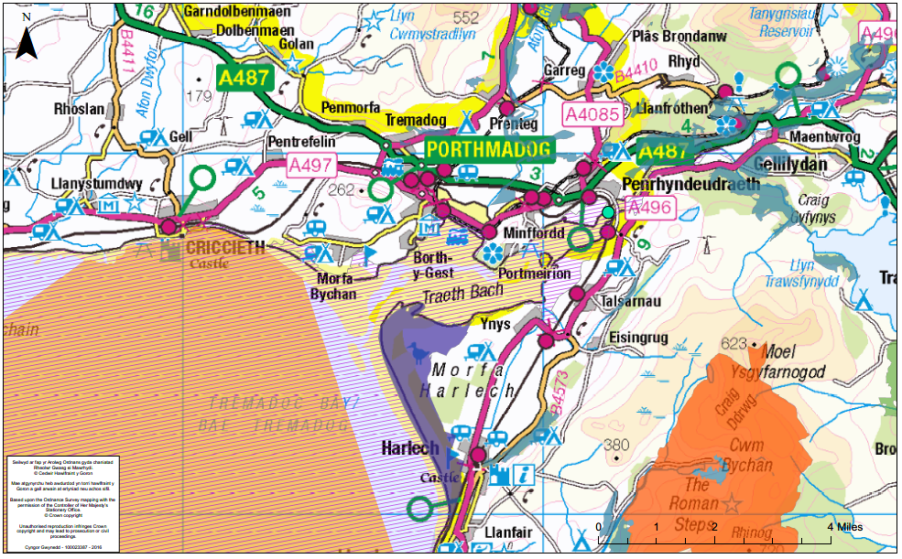

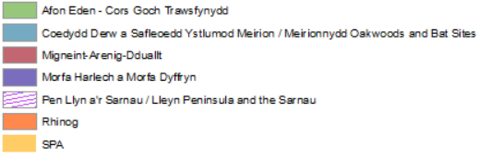

Figure 3. Survey area (call out) in relation to Protected Sites.
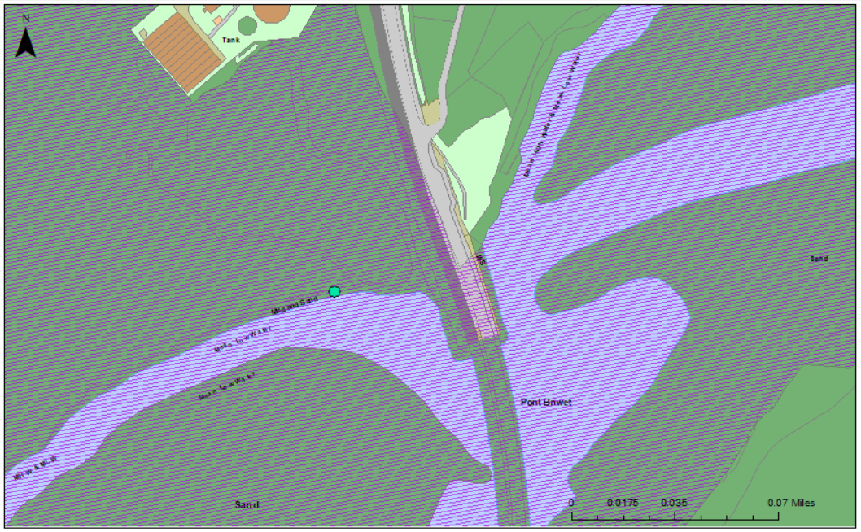
Figure 4 – Pen Llyn a’r Sarnau SAC (purple stripes) in relation to the works area shown in teal spot.

There is direct connectivity between Pen Llyn a’r Sarnau SAC and Gogledd Bae Ceredigion SPA and the works at Penrhyndeudraeth (see figure 3 and 4 above). Effects on these protected sites cannot be ruled out and a Habitats Regulations Assessment is required. The site compound will be on existing hard standing near the sewer pumping station and it will not be near any of the protected sites.
There is no direct connectivity between Coedydd Derw a Safleoedd Ystlumod Meirion SAC, Rhinog (SAC), Migneint Arenig Dduallt (SAC), also there is no tree removal that could affect LHS bats flight paths therefore these sites are ruled out at stage 1. No impacts are predicted on Morfa Harlech a Morfa Dyffryn (SAC) and Gogledd Bae Ceredigion (SPA) because of the distance from the site and these sites are also therefore ruled out at stage 1.

4.1.2 Nationally Designated Sites
Nationally designated sites (as protected under the Wildlife and Countryside Act 1981) considered to be potentially affected by the proposal include all those within 1km of the survey area boundary, as it is not anticipated that the proposal would have any significant effects on sites located further away. Morfa Harlech Site of Special Scientific Interest (SSSI) is on site at the damaged sewer (see figure 5 below:) Coedydd Dyffryn Ffestiniog Site of Special Scientific Interest (SSSI) is 370m north from the proposed works. There is direct connectivity between this protected site and the proposed works at Penrhyndeudraeth Damaged Sewer Pipe. Currently, sewerage discharges during periods of extreme flood events from the damage sewer to near the SSSI, access to the damaged sewer will be improved. The works are not expected to have any effect on Coedydd Dyffryn Ffestiniog SSSI designation as no tree removal is expected.
If works are planned which may affect a Site of Special Scientific Interest (SSSI) then you must first notify NRW and ask for assent under section 28H of the Wildlife and Countryside Act 1981. You will need to notify NRW what you propose to do and give details about where, when and how you intend to carry out the works.
Attach any plans, photographs, method statements or maps that will help NRW to assess the potential impact of the activity. NRW are required to respond to you within 28 days. If they do not respond within that time, you must assume that NRW do not assent. NRW may give the assent with or without conditions or time limits. If you are happy to follow its terms, you can proceed once the assent is received. More details can be found on NRW’s website (see 8 References below:).
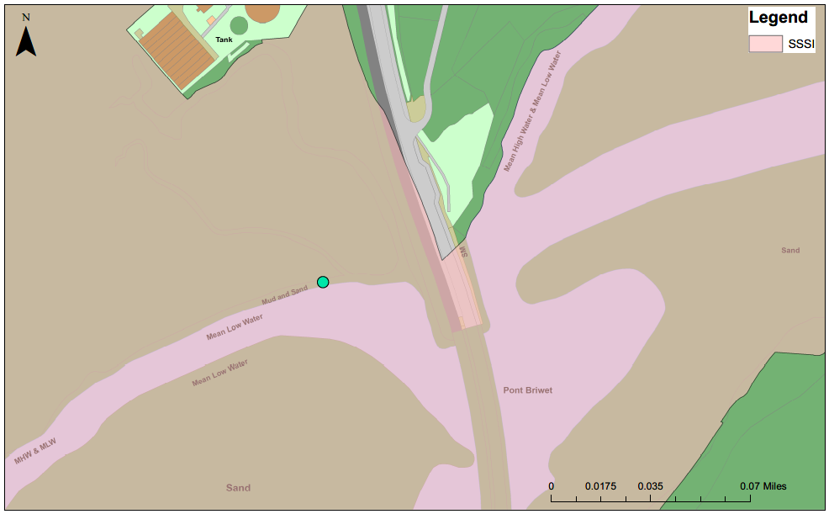
Figure 5 - Nationally designated sites within 1km of the proposed works Morfa Harlech – (Pink shaded area)

4.1.3 Other Sites
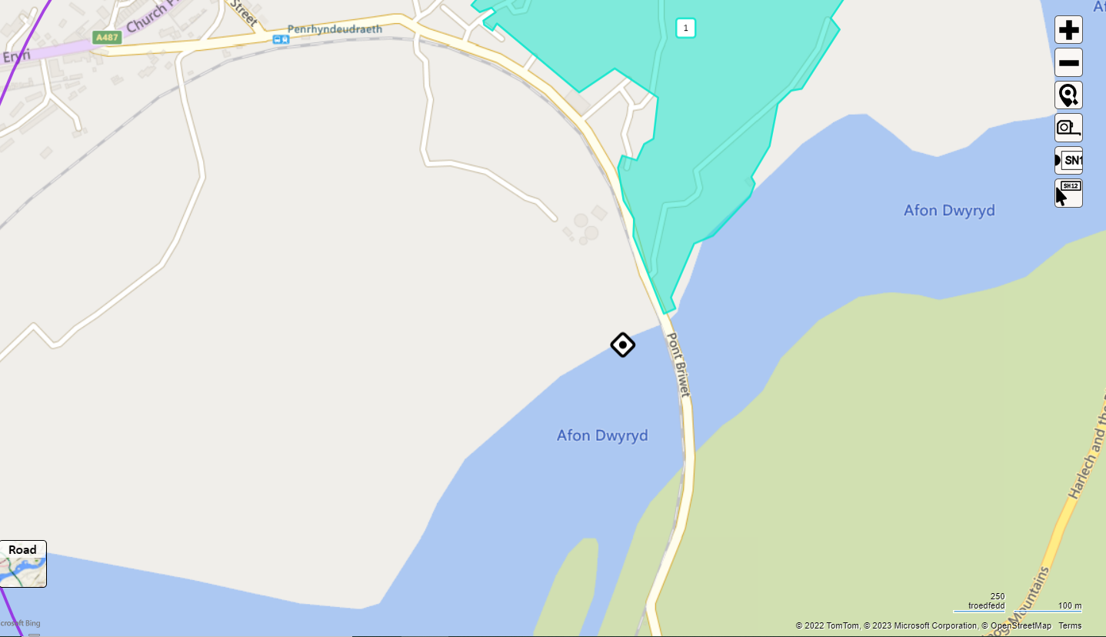
Figure 6 – Gwaith Powdwr - North Wales Wildlife Trust Site
Gwaith Powdwr is located 76m northeast of the proposed works, the works are localised to the sewer pipe only an no effects are expected on Gwaith Powdwr.

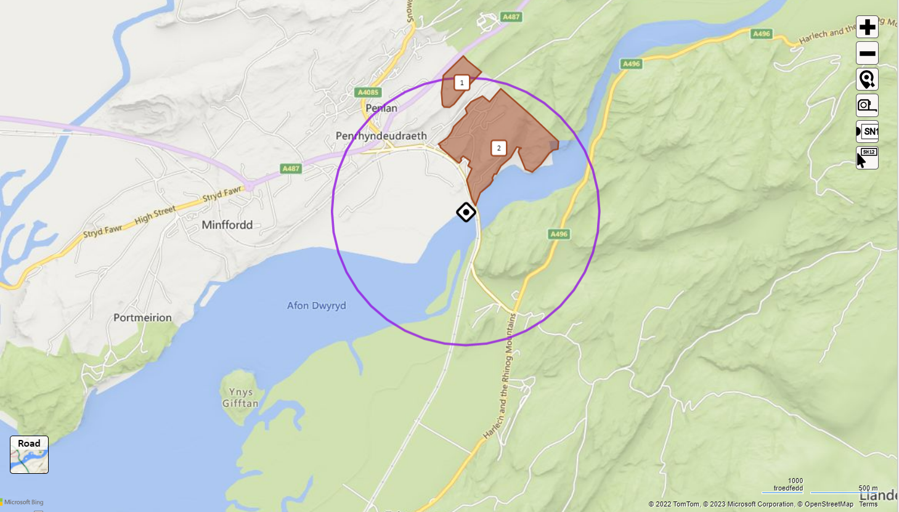
Figure 6 – Maes y Coed Woods (1) and Gwaith Powdwr (2) Local Wildlife Sites (brown shaded areas)

Maes y Coed Woods is approximately 778m and Gwaith Powdwr (candidate site) is 80m north of the damaged sewer at Penrhyndeudraeth (see figure 6 above). The works of repairing the damaged sewer is not expected to have any effect on the Local Wildlife Sites status.

  - Habitats
The phase 1 habitat survey conducted on the 06th of February 2023 found the area of the damaged sewer pipe area mostly comprising of dense continuous saltmarsh (H.2.6), intertidal mud/sand (H.1.1) and Running Water (G2) (see site photos 1 – 4 below).

The area of the works was surveyed for signs of protected species and habitats by Bethan Moseley Licenced otter, bat, dormouse and badger ecologist at YGC. The site was surveyed for signs of otter, including spraint, footprint, feeding remains and resting sites including holts and couches.

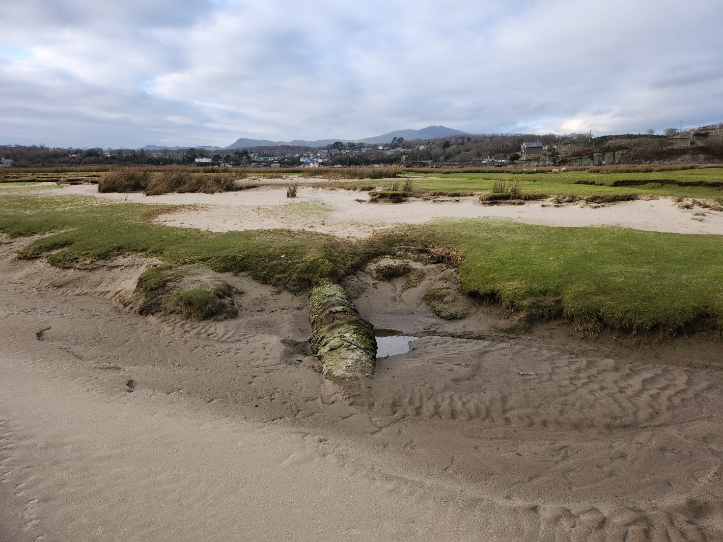
Site Photograph No 1 – The damaged sewer pipe has been covered by intertidal mud and sand
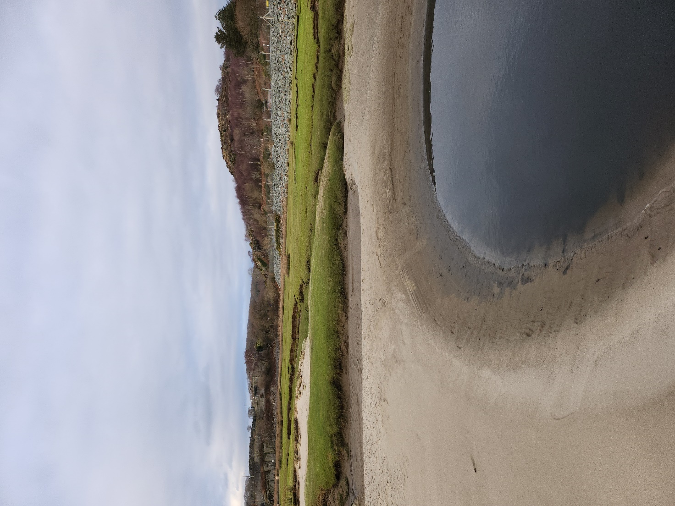
Site Photograph No 2 – The damaged pipe is 9m from this point where the outlet discharges in this deep pool (end of the sewer pipe).

The habitats present within the survey area that either are of importance to nature conservation locally or on a wider geographical scale, are described below.

4.2.1. Dense continuous saltmarsh
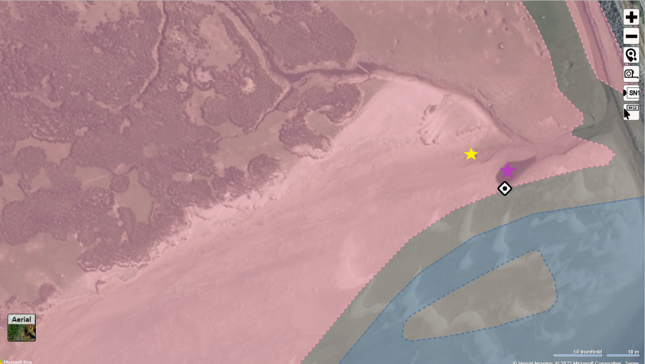
Figure 7 – The Cofnod phase 1 habitat map has identified the area as H.2.6. Dense Continuous Saltmarsh (pink shaded area) and H.1.1 Intertidal mud/sand (green shaded area) and G2 Running water (Blue shaded area)
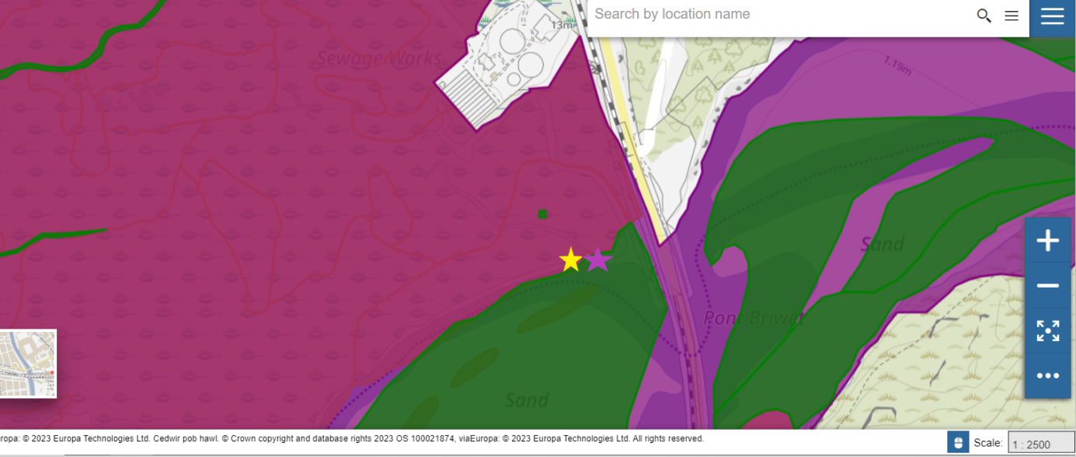
Figure 8 – Data Map Wales identifies the biotype on site as: pink area to the left Open Sea and tidal area, Traeth Bach (Glaslyn and Dwryryd) estuaries. Green is Mudflats & sandflats not covered by seawater at low tide and a biotype of sand.

The littoral sediment habitat on site consists of intertidal mudflats and sandflats that are submerged at high tide and exposed at low tide. They form a major component of Estuaries. The physical structure of the intertidal flats ranges from mobile, coarse-sand beaches on wave-exposed coasts to stable, fine-sediment mudflats in estuaries and other marine inlets. This habitat type can be divided into three broad categories (clean sands, muddy sands and muds), although in practice there is a continuous gradation between them. Within this range the plant and animal communities present vary according to the type of sediment, its stability and the salinity of the water.

The clean sands are present on site. These occur particularly on open coast beaches and in bays around the UK where wave action or strong tidal currents prevent the deposition of finer silt. Owing to the mobility of the sediment and consequent abrasion, species that inhabit clean sands tend to be robust and include amphipod crustaceans, such as sandhoppers Bathyporeia spp., some polychaete worms and certain bivalve molluscs(source JNCC).

Intertidal Mudflats and Sandflats are listed on Schedule 7 priority Habitat, Section 7 priority marine habitat – list of the habitats of principal importance for the purpose of maintaining and enhancing biodiversity in relation to Wales. Environment (Wales) Act 2016 and are an Annex I habitats present as a qualifying feature, but not a primary reason for selection of Pen Llyn a’r Sarnau SAC.
Atlantic Salt Meadows and Costal Saltmarsh is listed on Schedule 7 priority habitat under The Environment (Wales) Act 2016 a list of the habitats of principal importance for the purpose of maintaining and enhancing biodiversity in relation to Wales.

4.2.2 Rivers, streams and intertidal zone
The Main River Afon Dwyryd runs out to sea at Penrhyndeudraeth, but the works will be completed under a marine licence and a FRAP or OWC will not be required.
Intertidal sedimentary habitats are extremely important National and Local Biodiversity Action Plan habitats created and deposited in estuaries and coastal areas as well as providing a habitat for otters. Intertidal zones are of great importance to both habitats and species, which are listed on Schedule 7 priority habitat.

Intertidal zones are listed on Gwynedd biodiversity Action Plan they provide main Links/ Common Interest with Other HAPs and SAPs:
- Otter
Intertidal habitats are at risk from:
- Coastal development works
- Bait collection
- Fisheries - commercial fishing
- Sewage
- Invasive non-native species
- Human disturbance
- Coastal processes

NRW has statutory responsibility for the Marine Environment and a Marine Licence must be obtained from the Marine Licence Team.

4.3 Species

4.3.1 Mammals
Otter
There were many Cofnod local records of otter within the area search area the nearest 32m east of the damaged sewer pipe at Penrhyndeudraeth. No otter spraint or signs of otter was found in the area of the works, but fresh otter spraint was found on the top of the embankment under Pont Briwat approximately 55m from the works area during the survey on 06th February 2023.
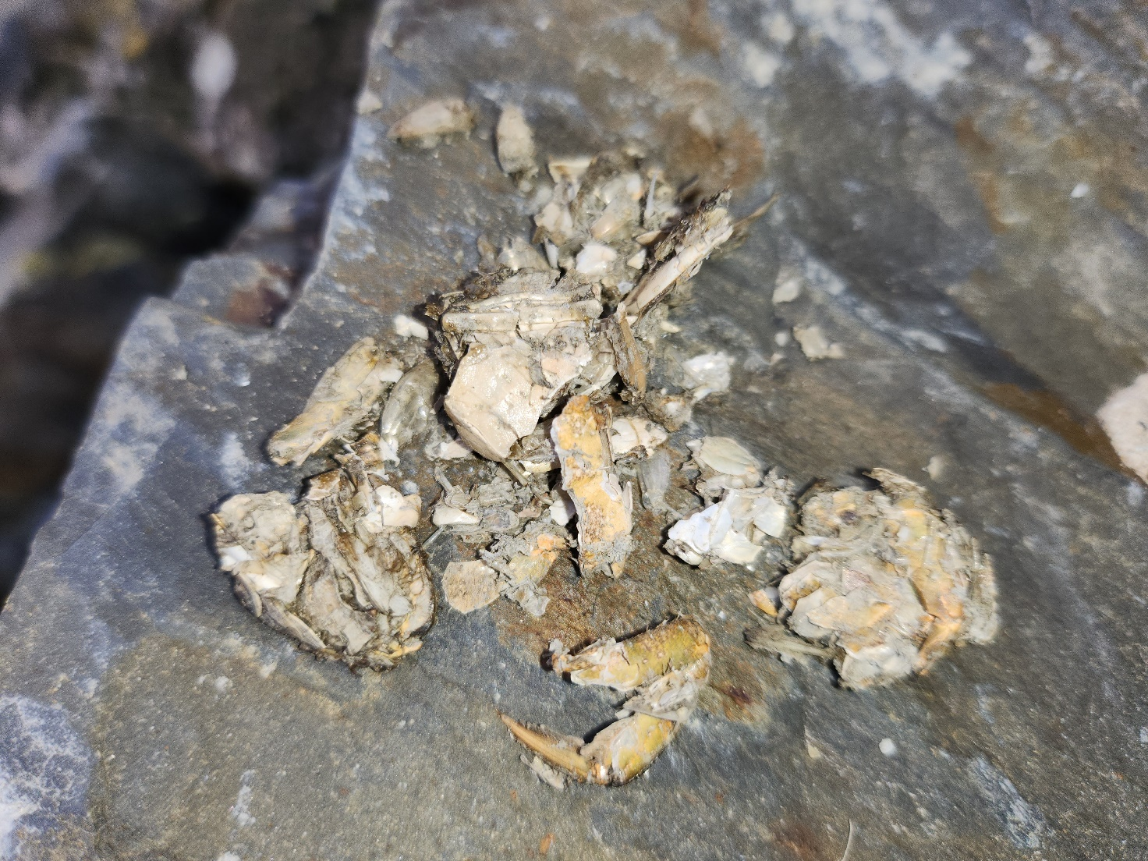
Site Photograph No 3 - Otter spraint Penrhyndeudraeth
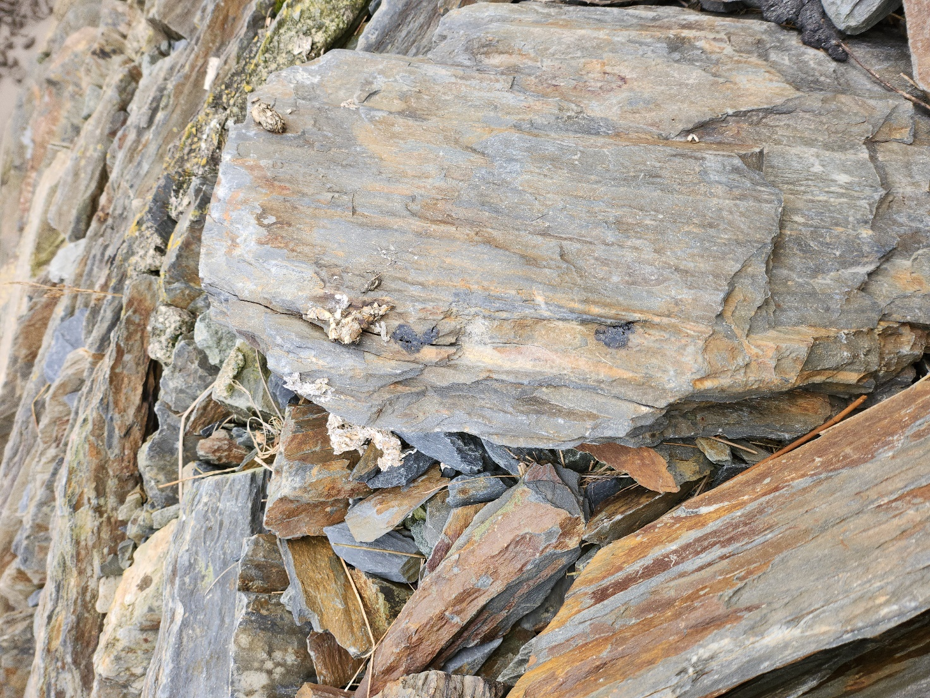
Site photograph No4 – Otter spraint on the top of the embankment beneath Pont Briwat
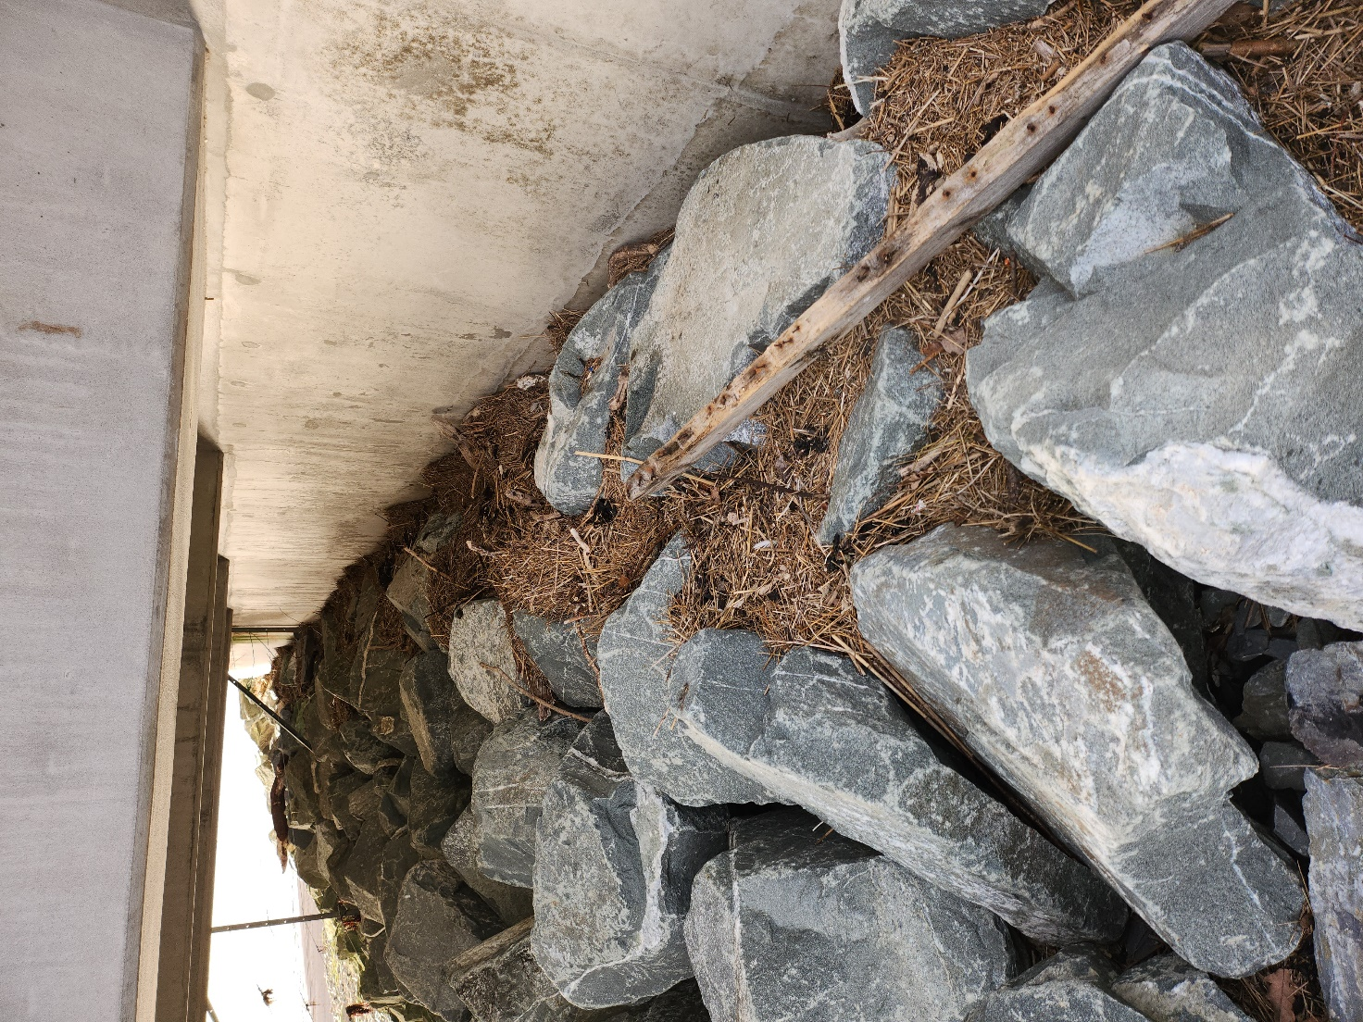
Site Photograph No 5 – Flood line at beneath Pont Briwat.

Otter holts give a more precise estimate of otter population numbers. Maternal holts are used to give birth to around two cubs per year; otters give birth and raise their young in these maternal holts and are usually found in areas of undisturbed land with dense scrub or in the voids in tree root systems. Otters can give birth at any time of the year but mainly during November to January. The otter cubs generally stay with their mother until approximately 8 months old but have been known to stay much longer (Chanin 2003).
Otters are likely to use the coastal area for commuting and foraging but are unlikely to be present during day light hours. All the works are expected to take place during daylight hours and no effects on otters are expected.

Bats (Order: Chiroptera)
There was no suitable habitat for bats on site and as all the works will be completed during the day, no impacts are expected on bats.

Other Mammals
The following additional mammal species of importance to nature conservation have also previously been recorded within the 1km search area according to the Cofnod data:
- American mink Neovision vison 132m east of the site
- Badger Meles 497m north of the damaged sewer
- Hedgehog Erinaceus europaeus 1011m northwest of the site
- Polecat Mustela putorius 332m northeast of the site
- Stoat mustela erminea 425m north
- Water vole Arvicola amphibius 697m north (records from 1978)
- Weasel Mustela nivalis 610m north
Bethan Moseley completed a badger survey on 06th February 2023, there were badger snuff holes near the sewer treatment plant, but no badger sett was seen in the area of the works or in the surrounding habitat.
There was no suitable habitat for land mammals in the area of the damaged sewer and there were no local Cofnod Records of marine mammals on site at Penrhyndeudraeth. Harbour porpoise and seals could be present near the area of the works during a high tide but are unlikely to be present during low tide and when the works are proposed to take place. Seals have extremely sensitive ears and noisy works such as grinding of metalwork could have a significant effect on a seals hearing.
There were no signs of any of the other species on site at Penrhyndeudraeth during the survey on 6th of February 2023.

4.3.2 Birds
Schedule 1 Species
There were bird footprints in the sand near the damaged sewer pipe, but no birds were present during the survey on the 6th of February 2023. There are also numerous Cofnod records within the 1km search area.
Schedule 1 of the Wildlife and Countryside Act (1981) provides protection for certain bird species while they are nesting, including intentional or reckless disturbance while they are building a nest or are in, on or near a nest containing eggs or young; and also, the intentional or reckless disturbance of dependent young of such a species. Schedule 1 birds previously recorded within 1km of the survey area according to the Cofnod data, are listed in Table 3 below:

Section 7 and LBAP Species
Numerous bird species listed on Section 7 of the Environment (Wales) Act 2016 and on the Gwynedd LBAPs have also been recorded within the 1km search area according to the Cofnod data, and these are also included in Table 3 below.

Table 3: Schedule 1, Section 7 and LBAP bird species that have previously been recorded within 300m of the survey area (Cofnod data or during the field survey for this report) (these species recorded between 300m and 1km from the works can be seen in the Appendix).

Distance | Scientific Name | English Name | Welsh Name | Lists
207 | Tringa ochropus | Green Sandpiper | Pibydd Gwyrdd | Bern2, Bonn2, LBAP-C, RL-EN, UKBA, WCA1.1
207 | Troglodytes troglodytes | Wren | Dryw | BAP, BDir1, Bern2, UKBA
236 | Caprimulgus europaeus | Nightjar | Troellwr Mawr | BAP, BDir1, Bern2, LBAP-C, LBAP-D, LBAP-F, LBAP-G, LBAP-S, S7, UKBA, WBA
254 | Caprimulgus europaeus | Nightjar | Troellwr Mawr | BAP, BDir1, Bern2, LBAP-C, LBAP-D, LBAP-F, LBAP-G, LBAP-S, S7, UKBA, WBA
258 | Tringa ochropus | Green Sandpiper | Pibydd Gwyrdd | Bern2, Bonn2, LBAP-C, RL-EN, UKBA, WCA1.1
297 | Troglodytes troglodytes | Wren | Dryw | BAP, BDir1, Bern2, UKBA
Breeding birds are not likely to be present in the area of the damaged sewer pipe because of the intertidal nature of the site.
There were no Cofnod records of birds within the area of the works.

There was no suitable nesting habitat for breeding birds on site at Penrhyndeudraeth, but overwintering birds are likely to be present during spring 2023.

All bird species are protected from intentional killing, injuring or taking and intentional taking, damaging or destruction of an active nest or eggs under the Wildlife and Countryside Act (1981). The sea shore and sandflat area provide feeding and roosting habitat for overwintering birds. A check for overwintering birds should be completed before the works start. If birds are found the works could be delayed until the birds have moved away.

4.3.3 Reptiles and Amphibians
There were no Cofnod records of reptiles or amphibians on site. The nearest records are listed. No suitable habitat for reptiles or amphibians was found on site during the survey and they are unlikely to be present in the area of the damaged sewer pipe.
Reptiles and amphibians recorded on the Cofnod local records database include those listed below in Table 4:
Table 4 - Reptiles and amphibians
Distance | Scientific Name | English Name |  | Welsh Name List

146 | Anguis fragilis | Slow-worm | Neidr Ddefaid | BAP, Bern3, LBAP-A, LBAP-C, LBAP-D, LBAP-F, LBAP-G, LBAP-S, LBAP-T, S7, WCA5
146 | Natrix helvetica | Grass Snake | Neidr y Gwair | BAP, Bern3, LBAP-A, LBAP-C, LBAP-D, LBAP-F, LBAP-G, LBAP-S, LBAP-T, S7, WCA5
146 | Zootoca vivipara | Common Lizard | Madfall | BAP, Bern3, LBAP-A, LBAP-C, LBAP-D, LBAP-F, LBAP-G, LBAP-S, LBAP-T, S7, WCA5
150 | Anguis fragilis | Slow-worm | Neidr Ddefaid | BAP, Bern3, LBAP-A, LBAP-C, LBAP-D, LBAP-F, LBAP-G, LBAP-S, LBAP-T, S7, WCA5
154 | Anguis fragilis | Slow-worm | Neidr Ddefaid | BAP, Bern3, LBAP-A, LBAP-C, LBAP-D, LBAP-F, LBAP-G, LBAP-S, LBAP-T, S7, WCA5
155 | Anguis fragilis | Slow-worm | Neidr Ddefaid | BAP, Bern3, LBAP-A, LBAP-C, LBAP-D, LBAP-F, LBAP-G, LBAP-S, LBAP-T, S7, WCA5
158 | Zootoca vivipara | Common Lizard | Madfall | BAP, Bern3, LBAP-A, LBAP-C, LBAP-D, LBAP-F, LBAP-G, LBAP-S, LBAP-T, S7, WCA5
186 | Anguis fragilis | Slow-worm | Neidr Ddefaid | BAP, Bern3, LBAP-A, LBAP-C, LBAP-D, LBAP-F, LBAP-G, LBAP-S, LBAP-T, S7, WCA5
186 | Anguis fragilis | Slow-worm | Neidr Ddefaid | BAP, Bern3, LBAP-A, LBAP-C, LBAP-D, LBAP-F, LBAP-G, LBAP-S, LBAP-T, S7, WCA5
199 | Natrix helvetica | Grass Snake | Neidr y Gwair | BAP, Bern3, LBAP-A, LBAP-C, LBAP-D, LBAP-F, LBAP-G, LBAP-S, LBAP-T, S7, WCA5

4.3.4 Invertebrates
There were no Cofnod Local Records of Invertebrates on site. The nearest record was of a Knot Grass moth 236m from the site. These moth’s larva feed on herbaceous plant and is not likely to be affected by the works because the host plant was not present at the damaged sewer pipe, no impact is expected on invertebrates.
The works of repairing the damaged sewer is unlikely to have any negative effects on invertebrate species.
Distance | Scientific Name | English Name | Welsh Name | Species Group | Lists
236 | Sympetrum striolatum | Common Darter | Gwäell Gyffredin | Insect - Dragonfly (Odonata) | LBAP-S, RL-DD
350 | Haematopota grandis | Long-horned Cleg |  | Insect - True Fly (Diptera) | RDB-NS
350 | Sympetrum striolatum | Common Darter | Gwäell Gyffredin | Insect - Dragonfly (Odonata) | LBAP-S, RL-DD
494 | Sympetrum striolatum | Common Darter | Gwäell Gyffredin | Insect - Dragonfly (Odonata) | LBAP-S, RL-DD
350 | Aeshna cyanea | Southern Hawker | Gwas Neidr y De | Insect - Dragonfly (Odonata) | LBAP-S
350 | Aeshna mixta | Migrant Hawker | Gwas Neidr Mudol | Insect - Dragonfly (Odonata) | LBAP-S
350 | Enallagma cyathigerum | Common Blue Damselfly | Mursen Las Gyffredin | Insect - Dragonfly (Odonata) | LBAP-S
350 | Ischnura elegans | Blue-tailed Damselfly | Mursen Dinlas Gyffredin | Insect - Dragonfly (Odonata) | LBAP-S
Table 5 – Category 1 Invertebrates

4.3.5 Plants
Plants recorded on the Cofnod local records database include those listed below:
Distance | Scientific name | English name | Welsh Name | List
258 | Eleocharis parvula | Dwarf Spike-rush | Ysbigfrwynen Fach | LBAP-G, LI-48[LS], LI-49[LR], RDB-NR, WCA8, WRL-VP[VU]
298 | Hyacinthoides non-scripta | Bluebell | Clychau'r Gog | LBAP-A, LBAP-C, LBAP-F, LBAP-S, LBAP-T, WCA8
340 | Eleocharis parvula | Dwarf Spike-rush | Ysbigfrwynen Fach | LBAP-G, LI-48[LS], LI-49[LR], RDB-NR, WCA8, WRL-VP[VU]
350 | Asplenium trichomanes | Maidenhair Spleenwort | Duegredynen Gwallt y Forwyn | S7
350 | Cerastium fontanum | Common Mouse-ear | Clust-y-Llygoden Gulddail | BAP
350 | Hyacinthoides non-scripta | Bluebell | Clychau'r Gog | LBAP-A, LBAP-C, LBAP-F, LBAP-S, LBAP-T, WCA8
Table 6 – Plants and Ferns Plants recorded on site include:
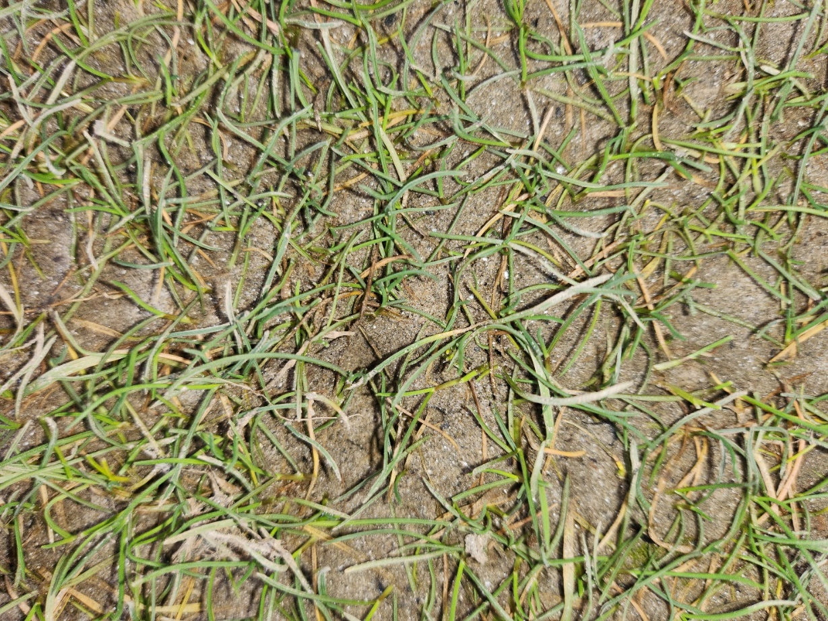
Site Photograph No 5 Sea plantain plantago maritima
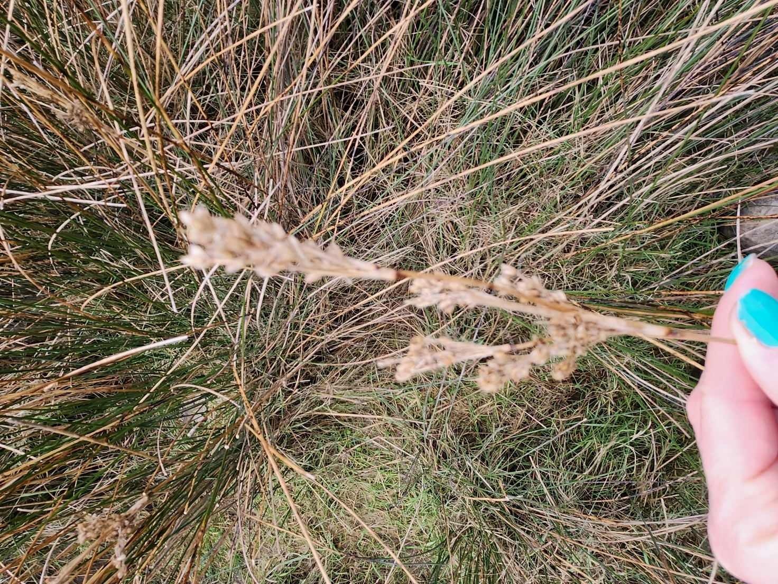
Site Photograph No 6 – Sea rush Junctus maritima

4.3.6 Non-Native Invasive Species
Plants
There are no Cofnod records of invasive non-native species at Penrhyndeudraeth Damaged Sewer Pipe. The nearest invasive-non-native species Americal mink Neovison vison was found 132m east. No invasive non-native species were found in the area of the damaged sewer pipe during the survey. Mink is not likely to be affected by the works.

4.3.7 Butterflies and Moths
There were no Cofnod records of butterflies and moths at the damaged sewer at Penrhyndeudraeth and it is unlikely that there would be any butterflies or moths in the area of the damaged sewer pipe.
Distance | Scientific name | English name | Welsh name | Group | List
236 | Acronicta rumicis | Knot Grass | Bidog Tafol | Insect - Moth | BAP, LBAP-G, S7
236 | Apamea remissa | Dusky Brocade | Brithyn Llwydolau | Insect - Moth | BAP, LBAP-G, S7
236 | Orthonama vittata | Oblique Carpet | Brychan Lletraws | Insect - Moth | BAP, S7
236 | Perizoma albulata | Grass Rivulet | Gwregys y Gwair | Insect - Moth | BAP, S7
236 | Spilosoma lubricipeda | White Ermine | Ermin Gwyn | Insect - Moth | BAP, LBAP-G, S7
236 | Tyria jacobaeae | Cinnabar | Teigr y Benfelen | Insect - Moth | BAP, LBAP-G, S7
236 | Watsonalla binaria | Oak Hook-tip | Bachadain y Deri | Insect - Moth | BAP, LBAP-G, S7
350 | Coenonympha pamphilus | Small Heath | Gweirlöyn Bach y Waun | Insect - Butterfly | BAP, LBAP-G, RL-NT, S7
350 | Hipparchia semele | Grayling | Gweirlöyn Llwyd | Insect - Butterfly | BAP, LBAP-G, RL-VU, S7
350 | Lasiommata megera | Wall | Gweirlöyn y Cloddiau | Insect - Butterfly | BAP, LBAP-G, RL-NT, S7
236 | Favonius quercus | Purple Hairstreak | Brithribin Porffor | Insect - Butterfly | LBAP-C
350 | Celastrina argiolus | Holly Blue | Glesyn Celyn | Insect - Butterfly | LBAP-C
350 | Speyeria aglaja | Dark Green Fritillary | Britheg Werdd | Insect - Butterfly | LBAP-F, LBAP-G
397 | Speyeria aglaja | Dark Green Fritillary | Britheg Werdd | Insect - Butterfly | LBAP-F, LBAP-G

5.0 Ecological Constraints and Opportunities
5.1 Habitat Recommendations
Pen Llyn a’r Sarnau SAC is located on site at the damaged sewer pipe, and mudflats & sandflats not covered by seawater at low tide and a biotype of sand is present on site (see figure 7 below:) this habitat is listed as Annex I habitats present as a qualifying feature, but not a primary reason for selection of this site. A Habitats Regulations Assessment (HRA) will be completed to identify if the works are likely to have a significant effect on the features of Pen Llyn a’r Sarnau (SAC).
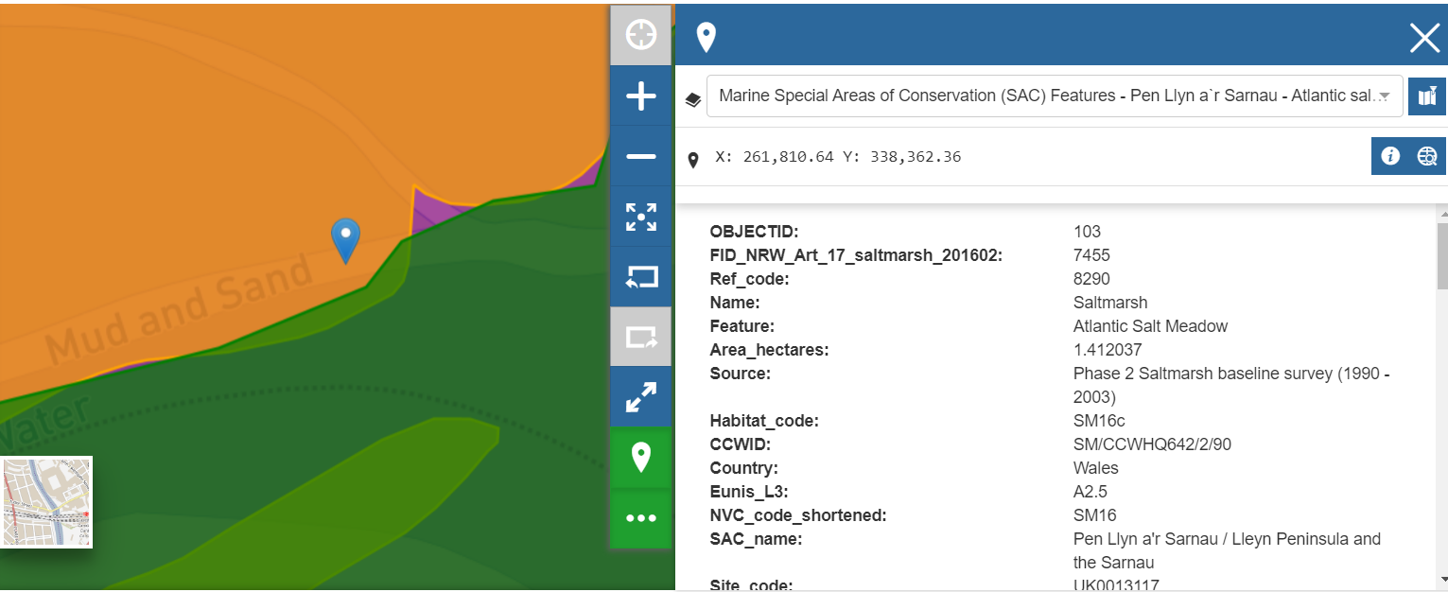
Figure 7 – NRW map of Pen Llyn a’r Sarnau SAC features Phase 2 Saltmarsh

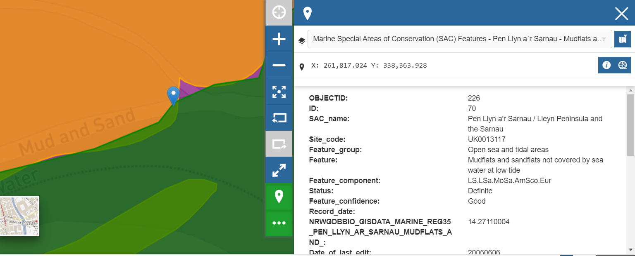
Figure 8 – Mudflats and sandflats not covered by sea water at low tide.

The Figure 7 and 8 maps above identifies muddy sandy shore intertidal mudflats in the area of the damaged sewer pipe. These mudflats are an important feature of the Pen Llyn a’r Sarnau (SAC).
The contractor will adhere to GPP 5 works and maintenance in or near water to lower any impacts on the coastal habitat and species. Mitigation measures will need to be put in place to ensure that the works do not impact any of these sensitive features on site, this will be covered in detail in the HRA.
There will be work on the damaged sewer pipe and the construction will be in the intertidal mudflats at low tide. The sand covering the damaged pipe will be excavated until the damaged pipe is exposed. Any materials removed off site should be disposed of in accordance with the relevant waste regulations and guidance.
The work will only be completed during dry weather to reduce any runoff to issues within the marine environment.
The construction work at Penrhyndeudraeth damaged sewer pipe is temporary in nature, but the new pipe will then be a permanent feature that will improve environmental and ecological conditions on site.

5.1.1 Mitigation
The following mitigation measures should be undertaken to avoid/minimise potential impacts on the intertidal mudflats and reefs area:
• A range of measures will be introduced to ensure working practices and good environmental
site management are secured, minimising the risk of pollution or other incidents.
• These would include the adoption of best practice guidelines including GPP and CIRIA guidance,
particularly GPP 5: Works and maintenance in or near water for construction or maintenance
works near, in or over water.
Typical examples would comprise ensuring the use of spill kits and refuelling in designated areas away from the intertidal area and ensuring an Emergency Pollution Response Plan is put in place;
• Arisings from the works to be collected and disposed of in accordance with the relevant waste regulations.
• No storage of materials or equipment within the intertidal area.
• Materials stored on site shall be located more than 10m away from watercourses at all times.
• No waste/debris is to be placed around the intertidal area likely to be used by otters. The upper layer of sediment that contains invertebrates and plants should be kept segregated for reinstatement at the end of the works.
• Access to site would be via the designated access route only;
• Silt curtains are to be used during excavation to prevent silt from entering the surrounding water/marine environment;
• The contractor is to be aware of tidal conditions and work around the tide;
• Pollution spill kits to be readily available on site at all times, with staff suitably trained in how to deploy;
• No refuelling within 30m of Protected Sites or waterbodies;
• Contractor to have an emergency incident response procedure in place in the case of a spillage; and
• Should watercourses become discoloured works will cease and working practices reviewed.

5.1.2 Habitat opportunities for enhancement
The replacement pipe will provide new habitat that will help retain moisture and shade and have the greatest impact on the richness of species such as fish (Strain et al., 2018). There will be no increase in discharge from the sewer pipe on completion of the works, but the discharge will be carried out further into the sea improving the ecological conditions on site. The client should consider a cast on/bolt on or drill on feature on to the new pipe to provide additional intertidal habitat for marine animals. Living seawall panels or similar should be attached to the new headwall to create habitat for various intertidal animals.

5.2 Species Recommendations

5.2.1 Bats
No impacts are expected on bats species.

    - Other Mammals and Marine Mammals
Otters are likely to use the coastal area for commuting and foraging but are unlikely to be present during day light hours. All the works are expected to take place during daylight hours and no effects on otters are expected.
Otter mitigation
• Night works to be avoided.
• Any excavations should have a mammal ladder or battered back sides to allow any trapped mammals to escape.
• A full toolbox talk should be given to all operatives regarding otters, and other protected species and habitats, before works commence.
• No waste/debris is to be placed around the intertidal area likely to be used by otters.

Otter spraint was present on the top of the embankment beneath Pont Briwat and all excavations should have a safe route of escape in case of entrapment of mammals.
Of the other mammal species of nature conservation importance recorded within the search area (Cofnod data), it is considered that American mink, Badger, Hedgehog, Polecat, Stoat, Water vole and Weasel are unlikely to be affected by the works on the damaged sewer pipe because there was no suitable habitat for them on site. Based on their geographical distribution and abundance, it is considered that these species are of importance locally, and that any proposals likely to arise from this study are unlikely to have a significant effect on the conservation status of these species at either a local or a broader geographical scale.

Harbour Porpoise and Seal
Harbour porpoise and seals could be present near the area of the works during high tide but are unlikely to be present during extreme low tide conditions when the works are proposed to take place.
Seals have extremely sensitive ears and noisy works such as grinding of metalwork could have a significant effect on a seals hearing. Grey seals breed from September to December around British shores. The female gives birth to a single pup on a shore (known as a rookery) crowded with hundreds of other seals. At birth the baby is covered with a thick, creamy-white coat, but this is replaced by a greyish juvenile coat after about three weeks. No breeding seals are likely to be in the area of the damaged sewer pipe at Penrhyndeudraeth during spring/summer when the works are expected to start. It is recommended that the ecologist should check the sea area for seals and porpoise before any noisy activities take place.

Harbour porpoise and seal mitigation
Ecologist to check seaward 100m for porpoise and seals before any noisy work (grinding metal pipe) takes place. No works to take place within the water column.

5.2.4 Birds
A number of Schedule 1, Section 7, Gwynedd LBAP and other bird species have been recorded within 1km of the survey area (See Table 3 above).
There was no suitable habitat for breeding birds within the intertidal area. However, coastal sites like this one are popular habitat for overwintering birds.

Overwintering birds
• Works are to be completed spring/summer 2023 when the marine licence is received during a period of low tide, this will enable any overwintering birds to move away from the area of the damaged sewer pipe to avoid any adverse effects from disturbance on the over-wintering bird species;
• Access to, and within, the works area will be via the designated access route only;
• Works to be supervised by an Environmental Manager or Environmental Clerk of Works as appropriate;
• Site personnel will follow good practice guidelines and be briefed with a toolbox talk on the ecological issues relevant to the site to ensure they comply with environmental protocols;
• Works to be completed with as little ‘downtime’ as possible to ensure works are not prolonged more than necessary.

    - Reptiles and Amphibians
No suitable habitat for reptiles or amphibians found on site during the survey and they are unlikely to be present in the area of the damaged sewer pipe. There were no Cofnod records of reptiles or amphibians on site.

5.2.6 Invertebrates
There were no records of notable invertebrates within the survey area and no notable invertebrates were found during the survey.

5.2.7 Plants
There were no Cofnod Local Records of plants on site. There were no records of notable plants on site.

5.2.8 Non-Native Invasive Species
There were no non-native invasive species on site. As a precaution not to introduce any invasive non-native species on to the site, biosecurity measures should be implemented for machines and personnel.

    - Butterflies and Moths
There were no records of butterflies and moths within the survey area and no butterflies and moths were found during the survey.

To stop any impacts on habitats and species, pollution prevention measures are to be put in place to avoid siltation entering the sandflat area, the contractor should use silt fencing (or equivalent) and adhere to GPP5 works and maintenance in or near water.

All mitigation described above needs to be incorporated into a CEMP for approval prior to commencement.

6. Enhancement and Compensation
The replacement pipe will provide new habitat that will help retain moisture and shade and have the greatest impact on the richness of species such as fish (Shanin et al 2018). There will be no increase in discharge from the sewer pipe on completion of the works, but the discharge will be carried out further into the sea improving the ecological conditions on site. The client should consider a cast on/bolt on or drill on feature on to the new pipe to provide additional habitat for marine animals.

7.0 Conclusions
With the recommendations above and mitigation measures listed below in place it is considered that the risk from pollution or disturbance is reduced to the extent that there would be no adverse effect on the integrity of the Pen Llyn a’r Sarnau SAC, with no residual effects on any of the conservation objectives of the features of these sites.
- Access to site would be via the designated access route only;
- Emergency Pollution Response Plan is put in place;
- Silt curtains are to be used during excavation to prevent silt from entering the surrounding water/marine environment;
- Arisings from the works to be collected and disposed of in accordance with the relevant waste regulations;
- No storage of materials or equipment within the intertidal area;
- Materials stored on site shall be located more than 10m away from waterbodies at all times;
- No waste/debris is to be placed around the intertidal area likely to be used by otters;
- The upper layer of sediment that contains invertebrates and plants should be kept segregated for reinstatement at the end of the works;
- The contractor is to be aware of tidal conditions and work around the tide;
- Pollution spill kits to be readily available on site at all times, with staff suitably trained in how to deploy;
- No refuelling within 30m of Protected Sites or waterbodies;
- Arisings from the works should be collected and disposed of in accordance with the relevant waste regulations;
- Contractor to have an emergency incident response procedure in place in the case of a spillage; and
- Should watercourses become discoloured works will cease and working practices reviewed.
- Night works to be avoided;
- Any excavations should have a mammal ladder or battered back sides to allow any trapped mammals to escape;
- A full toolbox talk should be given to all operatives regarding otters, and other protected species and habitats, before works commence;
- No waste/debris is to be placed around the intertidal area likely to be used by otters;
- Ecologist to check seaward 100m for porpoise and seals before any noisy work (grinding metal pipe) takes place;
- Works are to be completed spring or summer during a period of low tide. This will also provide a maximum habitat area for roosting and feeding overwintering birds (should they be present);
- Access to, and within, the works area will be via the designated access route only;
- Works to be supervised by an Environmental Manager or Environmental Clerk of Works as appropriate;
- Site personnel will follow good practice guidelines and be briefed with a toolbox talk on the ecological issues relevant to the site to ensure they comply with environmental protocols;
- Works to be completed with as little ‘downtime’ as possible to ensure works are not prolonged more than necessary;
- As a precaution not to introduce any invasive non-native species on to the site, biosecurity measures should be implemented for machines and personnel;
- To stop any impacts on habitats and species, pollution prevention measures are to be put in place to avoid siltation entering the sandflat area, the contractor should use silt fencing (or equivalent) and adhere to GPP5 works and maintenance in or near water;
- All mitigation described above needs to be incorporated into a CEMP for approval prior to commencement.

8.0 References
JNCC - Adviser to Government on Nature Conservation accessed 02/03/2023
Cofnod Biodiversity Records Centre. 2022. eMapper.
Joint Nature Conservation Committee (JNCC). 2010. Handbook for Phase 1 Habitat Survey. JNCC.
Natural Resources Wales (NRW). 2022. Designated Sites. NRW. Available from: https://naturalresources.wales/guidance-and-advice/environmental-topics/wildlife-and-biodiversity/find-protected-areas-of-land-and-seas/designated-sites/?lang=en
Rose, F. 2006. The Wildflower Key
Wales Biodiversity Partnership (WBP). 2017. Section 7 Lists. WBP. Available from: https://www.biodiversitywales.org.uk/Environment-Wales-Bill
Paul Chanin 2003 Ecology of the European Otter, Conserving Natura 2000 Rivers Ecology Series No 10.
NRW SSSI Assent https://naturalresources.wales/guidance-and-advice/environmental-topics/wildlife-and-biodiversity/protected-areas-of-land-and-seas/sites-of-special-scientific-interest-responsibilities-of-owners-and-occupiers/?lang=en Accessed 14/02/2023.
Gwynedd LBAP: https://www.gwynedd.llyw.cymru/en/Council/Documents---Council/Strategies-and-policies/Environment-and-planning/Planning-policy/Unitary-Development-Plan/SPG-Wildlife-sites.pdf accessed 14/02/2023
Bat Surveys for Professional Ecologists: Good Practice Guidelines 3rd edition - Guidance for professionals - Bat Conservation Trust 2016 review
Strain, E., Olabarria, C., Mayer-Pinto, M., Cumbo, V., Morris, R., Bugnot, A., Dafforn, K., Heery, E., Firth, L., Brooks, P. and Bishop, M., 2018. Eco-engineering urban infrastructure for marine and coastal biodiversity: Which interventions have the greatest ecological benefit? Journal of Applied Ecology, 55(1), pp.426-441.

APPENDIX I: Works Details Method of Works

ALUN GRIFFITHS CONTRACTORS LTD



Dwr Cymru / Welsh Water
Wastewater Network R & M Framework

Penrhyndeudraeth WWTW - Outfall Pipe and Headwall

METHOD STATEMENT NO – MS 01

SUBJECT:

Penrhyndeudraeth WWTW – Repairs to Outfall

Pipe and Construct Headwall

Originated by:  P Jones  Date: 24/11/2022 | Construction Approval:  John P Evans  Date: 24.11.2022 |  |  |  | Environmental Approval:  Date: |  |  | Works-Supervisor Approval:  Date:
P.M. Acceptance:  Date: |  |  |  |  | Work to commence Approval:  Date:
Revision | Date | Change |  |  | Revision |  | Date |  | Change
Distribution: | John Evans  Project Manager | Keith Wilkes site Agent / Works Manager | Site Copy | DCWW |  |  |  |  |  |  |  | H&S FILE
 | 1 | 1 | 1 | 1 |  |  |  |  |  |  |  | 1

- Introduction.

This method statement relates to the work required to shorten the damaged exposed 450mm dia. Penrhyndeudraeth WWTW Outfall pipe by approx. 5m and construct a concrete Headwall. This method statement should be read in conjunction with the Scope Plans enclosed.

2.0 Responsibilities.

Name | Position | Emergency contact No.
Mike Davies | Site Agent | 07966 318732
Keith Wilkes | Works Supervisor | 07866 912004
Peter Jones | Co-ordinator | 07812 003023

- Method/Procedure.

Prior to commencing work.

- Review information relating to any environmental requirement, or restriction identified within the information provided by the Client.
- Review information on any existing statutory undertaker’s apparatus which may be present within the confines of the site. CAT scan the area of excavation and clearly mark out all existing services, (above and below ground) where there is a possibility of interface, these services shall be protected if necessary.
- Carry out risk assessments of all identified work activities.
- Use risk assessments to produce written safe methods of working.
- Site induction of all personnel employed in the construction of the works.
- Give a method statement explanation to all employees associated with the work.
- Assess the area of work and where access may pose a risk to the work force, working adjacent to the river / sea, which is tidal and time constraints minimal,(work to be carried out on suitable low tides only), animals or the public, temporary fencing of an appropriate type will need to be erected.
- Obtain a permit to excavate from the Works Supervisor.
- Ensure any consents required from the NRW are obtained and current before work proceeds and ensure a copy of the SSSI Assent is to hand at all times.
- Ensure that the necessary land entry permissions are in place with the landowners.
- Monitor weather conditions and Tidal influences for the next few days following the proposed start day to ensure that a dry weather period is forecast.
- Confirm tidal conditions are suitable prior to any excavation.

Method of working

- The designated access route to the working area and to the banks of the river will be agreed with both the NRW and the landowners, who will have been consulted and have confirmed to have no objection to the works being carried out. The route will be marked out and explained to the workforce prior to commencement.
- Access to the working area will be via Penrhyndeudraeth Wastewater Treatment Works LL48 6LT
- Ensure Network Rail Instructions are followed at all times prior to opening the gates and travelling over the railway crossing and along the access road to the WWTW. (Ensure tidal influences are checked before accessing the concrete road due to the access road being liable to flooding at times)
- Erect temporary warning signs to pedestrians using the marsh area of the presence of heavy plant and equipment and brief all site personnel of the need for extra vigilance when travelling to the working area.
- Complete a Certificate of Isolation for flows through the outfall pipe.(Isolation by DCWW Operators)
- To gain access to the Outfall location the proposed route from the WWTW requires a ‘seaward channel’ to be temporarily filled in with a 3m length of a Perforated 600mm dia. Twin Wall Drainage pipe and brought to the surface with suitable clean gravel, with a Bog Mat placed over the surface of the gravel. The pipe and gravel to be laid on a suitable geotextile membrane.
- Once all known services have been located, the excavation around the damaged end of the existing outfall pipe will be carried out.
- Excavate and expose the damaged and collapsed pipe and determine where a neat saw cut for the end of the pipe can be carried out, casting the excavated material to one side prior to re using as re fill around the pipe and new concrete headwall once constructed.
- Suitable timbers to be used for preparing and shuttering around the end of the pipe for the headwall construction. The excavation below the pipe at this point to be to be lined with a ‘Vis queen’ and filled with lean mix concrete. (Concrete to contain an additive of silica fume type).
- A dry concrete mixture is to be collected and delivered to site with a ‘pick up type’ lorry and transported to the working area with a dumper.
- A concrete aggregate mixture of low water / cement ratio (Blue Circle Sulfa crete cement) to be mixed on site with a suitable additive (Silica) added for rapid setting and prevent any tidal washout and utilising the excavator’s bucket placed carefully into the temporary timber shuttered construction to the required level. Ensure volume of concrete is suitable to prevent any spillages. (It is anticipated that this operation can be carried out during one shift)
- The new headwall construction is to be allowed to ‘cure’ for two days prior to removal of the temporary shuttering.
- Large diameter (300mm to 500mm) clean stone to be placed on a geotextile liner in front of the new headwall to act as a flow diffuser to aid dispersal and around the sides of the headwall for protection.
- The damaged length of pipe to be removed and transported to the WWTW.
- Remove all the Temporary shuttering timbers and backfill up against its sides by means of previously excavated material.
- Make good and reinstate the surrounding ground and disturbed areas, remove the geotextile membrane, temporary gravel and DI pipe, remove all plant, equipment and tidy up.

4.0 Principal Equipment.

- 2 No.360º Excavators – 5t and 8t (rubber tracked)
- 1 No. 3t dumper (tracked)
- 1 No. Transit Type Van & Trailer
- 1 No. Transit Pick up
- 1 No. mixer
- 1 No. Cable Avoidance Tool
- 1 No. pipe stopper
- Stihl saw and small hand tools.
- Bog Mats
- Hiab Lorry-24t
- Confined space entry equipment
- Buoyancy aids
- Lifesaving equipment
- Welfare Unit
- Spill Kits

5.0 Environmental Considerations

- Erect localised site fencing to prevent unauthorised entry onto the work site by unauthorised personnel, animals or the general public, where necessary.
- Site access and egress to be kept clear at all times.
- Refuelling of plant is to be carried out away from the place of work, where a risk of inadvertent spillage to the watercourse, marsh land or drainage system exists, carried out to the procedures in the Control of Pollution (Oil Storage) Regulations 2001
- Daily checks on plant, hoses and any pumping equipment to be undertaken and recorded
- Noise levels to be minimised where possible and within site working hours
- Disturbance to the bed of the marsh area to be kept to an absolute minimum.
- Contact DCWW to ensure WWTW and SPS are operating efficiently to avoid any premature discharge through the outfall pipe.

6.0 COSHH

- Sewage,
- Diesel,
- Petrol
- Pipe Grease.
- River water (risk of Weil’s Disease)
- Concrete
- Aggregate

7.0 Specific Requirements for Risk Assessment

- All main contractor activities.
- Environmental considerations.

8.0 P.P.E. Requirements

- Hard hats.
- Safety footwear.
- High visibility clothing.
- Impervious Gloves.
- Safety Glasses
- Light Eye protection / Goggles
- Ear Defenders
- Dust Protection
- Life jackets

9.0 Communication and liaison

9.1 Identity of specific contacts
Refer to CTR B and C for details of specific contacts within DCWW.

Emergency plans

9.2 Contact phone numbers (in order)

Keith Wilkes | 07866 912004
Mike Davies  Peter Wyn Jones | 07966 318732  07812 003023
Bodelwyddan Office  NRW | 01745 405904  03000 653000

10.0 Appendices

Appendix A Construction Risk assessment
Appendix B Scope Plans
Appendix C Method Statement Explanation Form

Appendix A

Construction Risk Assessment

Appendix B

Scope Plan

Appendix C

Method Statement Explanation Form

ALUN GRIFFITHS CONTRACTORS LTD

Dwr Cymru / Welsh Water
Wastewater Network R & M Framework

Penrhyndeudraeth WWTW Outfall Pipe

METHOD STATEMENT EXPLANATION FORM

Method statement | Penrhyndeudraeth WWTW – Outfall Pipe and Headwall
Method Statement No. | 01
Date of explanation
Explanation given by
Topics covered: | Method statement explanation including toolbox talks on:- Environmental and Ecological Constraints, Contamination of watercourses.

No. | Attendee | Signature | No. | Attendee | Signature
1 |  |  | 14
2 |  |  | 15
3 |  |  | 16
4 |  |  | 17
5 |  |  | 18
6 |  |  | 19
7 |  |  | 20
8 |  |  | 21
9 |  |  | 22
10 |  |  | 23
11 |  |  | 24
12 |  |  | 25
13 |  |  | 26

Signature of person giving explanation: ………………………………………………

Signature of attendee confirms understanding of explanation given

For comments/questions raised during explanation please refer to back of form

Cofnod Data – Birds Category 1 over 300m
Distance | Scientific name | English name | Welsh name | List
304 | Emberiza schoeniclus | Reed Bunting | Bras y Cyrs | BAP, Bern2, LBAP-C, LBAP-D, LBAP-F, LBAP-G, S7, UKBA, WBA
304 | Tringa ochropus | Green Sandpiper | Pibydd Gwyrdd | Bern2, Bonn2, LBAP-C, RL-EN, UKBA, WCA1.1
324 | Caprimulgus europaeus | Nightjar | Troellwr Mawr | BAP, BDir1, Bern2, LBAP-C, LBAP-D, LBAP-F, LBAP-G, LBAP-S, S7, UKBA, WBA
350 | Acanthis cabaret | Lesser Redpoll |  | BAP, LBAP-C, LBAP-D, S7, WBR
350 | Alauda arvensis | Skylark | Ehedydd | BAP, BDir2.2, LBAP-A, LBAP-C, LBAP-D, LBAP-F, LBAP-G, LBAP-S, S7, UKBR, WBA
350 | Alcedo atthis | Kingfisher | Glas y Dorlan | BDir1, Bern2, LBAP-C, LBAP-D, LBAP-F, LBAP-G, LBAP-T, WBA, WCA1.1
350 | Anthus trivialis | Tree Pipit | Corhedydd y Coed | BAP, Bern2, LBAP-C, LBAP-D, LBAP-F, LBAP-G, S7, UKBR, WBA
350 | Caprimulgus europaeus | Nightjar | Troellwr Mawr | BAP, BDir1, Bern2, LBAP-C, LBAP-D, LBAP-F, LBAP-G, LBAP-S, S7, UKBA, WBA
350 | Chroicocephalus ridibundus | Black-headed Gull | Gwylan Benddu | BDir2.2, LBAP-G, RL-VU, S7, UKBA, WBR
350 | Cuculus canorus | Cuckoo | Cog | BAP, LBAP-C, LBAP-D, LBAP-F, LBAP-G, RL-VU, S7, UKBR, WBR
350 | Emberiza schoeniclus | Reed Bunting | Bras y Cyrs | BAP, Bern2, LBAP-C, LBAP-D, LBAP-F, LBAP-G, S7, UKBA, WBA
350 | Falco columbarius | Merlin | Cudyll Bach | BDir1, Bern2, Bonn2, CITES-A, LBAP-C, LBAP-D, LBAP-F, LBAP-G, RL-EN, UKBR, WBA, WCA1.1
350 | Falco peregrinus | Peregrine | Hebog Tramor | BDir1, Bern2, Bonn2, CITES-A, GBNNSIP, LBAP-A, LBAP-C, LBAP-G, WCA1.1
350 | Ficedula hypoleuca | Pied Flycatcher | Gwybedog Brith | Bonn2, LBAP-C, LBAP-G, LBAP-S, RL-VU, S7, UKBA, WBR
350 | Larus argentatus | Herring Gull | Gwylan y Penwaig | BAP, BDir2.2, LBAP-C, LBAP-G, RL-DD, RL-EN, S7, UKBR, WBR
350 | Linaria cannabina | Linnet | Llinos | BAP, Bern2, LBAP-A, LBAP-C, LBAP-D, LBAP-F, LBAP-G, RL-NT, S7, UKBR, WBR
350 | Milvus milvus | Red Kite | Barcud | BDir1, Bonn2, CITES-A, LBAP-C, LBAP-G, WBA, WCA1.1, WCA9
350 | Motacilla flava | Yellow Wagtail |  | BAP, Bern2, LBAP-C, LBAP-D, LBAP-F, LBAP-T, RL-NT, S7, UKBR, WBR
350 | Numenius arquata | Curlew | Gylfinir | BAP, BDir2.2, Bonn2, LBAP-A, LBAP-C, LBAP-D, LBAP-F, LBAP-G, LBAP-S, RL-EN, S7, UKBR, WBR
350 | Pandion haliaetus | Osprey | Gwalch y Pysgod | BDir1, Bonn2, CITES-A, LBAP-G, RL-NT, UKBA, WBA, WCA1.1
350 | Passer domesticus | House Sparrow | Aderyn y To | BAP, LBAP-C, LBAP-F, LBAP-G, S7, UKBR, WBA
350 | Phylloscopus sibilatrix | Wood Warbler | Telor y Coed | BAP, LBAP-C, LBAP-G, LBAP-S, RL-VU, S7, UKBR, WBR
350 | Prunella modularis | Dunnock | Llwyd y Gwrych | BAP, Bern2, LBAP-C, S7, UKBA
350 | Pyrrhula pyrrhula | Bullfinch | Coch y Berllan | BAP, LBAP-C, LBAP-D, LBAP-F, LBAP-G, S7, UKBA, WBR
350 | Regulus ignicapilla | Firecrest | Dryw Penfflamgoch | Bern2, LBAP-C, LBAP-G, WBA, WCA1.1
350 | Sturnus vulgaris | Starling | Drudwen | BAP, BDir2.2, LBAP-C, LBAP-F, LBAP-G, RL-VU, S7, UKBR, WBR
350 | Tringa ochropus | Green Sandpiper | Pibydd Gwyrdd | Bern2, Bonn2, LBAP-C, RL-EN, UKBA, WCA1.1
350 | Troglodytes troglodytes | Wren | Dryw | BAP, BDir1, Bern2, UKBA
350 | Turdus philomelos | Song Thrush | Bronfraith | BAP, BDir2.2, LBAP-A, LBAP-C, LBAP-D, LBAP-F, LBAP-G, LBAP-S, LBAP-W, S7, UKBA, WBA
362 | Caprimulgus europaeus | Nightjar | Troellwr Mawr | BAP, BDir1, Bern2, LBAP-C, LBAP-D, LBAP-F, LBAP-G, LBAP-S, S7, UKBA, WBA
390 | Linaria cannabina | Linnet | Llinos | BAP, Bern2, LBAP-A, LBAP-C, LBAP-D, LBAP-F, LBAP-G, RL-NT, S7, UKBR, WBR
411 | Prunella modularis | Dunnock | Llwyd y Gwrych | BAP, Bern2, LBAP-C, S7, UKBA
435 | Tyto alba | Barn Owl | Tylluan Wen | Bern2, CITES-A, LBAP-A, LBAP-C, LBAP-D, LBAP-F, LBAP-G, LBAP-S, LBAP-T, LBAP-W, WBA, WCA1.1, WCA9
451 | Passer domesticus | House Sparrow | Aderyn y To | BAP, LBAP-C, LBAP-F, LBAP-G, S7, UKBR, WBA
459 | Caprimulgus europaeus | Nightjar | Troellwr Mawr | BAP, BDir1, Bern2, LBAP-C, LBAP-D, LBAP-F, LBAP-G, LBAP-S, S7, UKBA, WBA
478 | Caprimulgus europaeus | Nightjar | Troellwr Mawr | BAP, BDir1, Bern2, LBAP-C, LBAP-D, LBAP-F, LBAP-G, LBAP-S, S7, UKBA, WBA
505 | Linaria cannabina | Linnet | Llinos | BAP, Bern2, LBAP-A, LBAP-C, LBAP-D, LBAP-F, LBAP-G, RL-NT, S7, UKBR, WBR
513 | Acanthis cabaret | Lesser Redpoll |  | BAP, LBAP-C, LBAP-D, S7, WBR
513 | Anthus trivialis | Tree Pipit | Corhedydd y Coed | BAP, Bern2, LBAP-C, LBAP-D, LBAP-F, LBAP-G, S7, UKBR, WBA
513 | Cuculus canorus | Cuckoo | Cog | BAP, LBAP-C, LBAP-D, LBAP-F, LBAP-G, RL-VU, S7, UKBR, WBR
513 | Emberiza schoeniclus | Reed Bunting | Bras y Cyrs | BAP, Bern2, LBAP-C, LBAP-D, LBAP-F, LBAP-G, S7, UKBA, WBA
513 | Ficedula hypoleuca | Pied Flycatcher | Gwybedog Brith | Bonn2, LBAP-C, LBAP-G, LBAP-S, RL-VU, S7, UKBA, WBR
513 | Larus argentatus | Herring Gull | Gwylan y Penwaig | BAP, BDir2.2, LBAP-C, LBAP-G, RL-DD, RL-EN, S7, UKBR, WBR
513 | Linaria cannabina | Linnet | Llinos | BAP, Bern2, LBAP-A, LBAP-C, LBAP-D, LBAP-F, LBAP-G, RL-NT, S7, UKBR, WBR
513 | Milvus milvus | Red Kite | Barcud | BDir1, Bonn2, CITES-A, LBAP-C, LBAP-G, WBA, WCA1.1, WCA9
513 | Pandion haliaetus | Osprey | Gwalch y Pysgod | BDir1, Bonn2, CITES-A, LBAP-G, RL-NT, UKBA, WBA, WCA1.1
513 | Passer domesticus | House Sparrow | Aderyn y To | BAP, LBAP-C, LBAP-F, LBAP-G, S7, UKBR, WBA
513 | Phylloscopus sibilatrix | Wood Warbler | Telor y Coed | BAP, LBAP-C, LBAP-G, LBAP-S, RL-VU, S7, UKBR, WBR
513 | Prunella modularis | Dunnock | Llwyd y Gwrych | BAP, Bern2, LBAP-C, S7, UKBA
513 | Pyrrhula pyrrhula | Bullfinch | Coch y Berllan | BAP, LBAP-C, LBAP-D, LBAP-F, LBAP-G, S7, UKBA, WBR
513 | Troglodytes troglodytes | Wren | Dryw | BAP, BDir1, Bern2, UKBA
513 | Turdus philomelos | Song Thrush | Bronfraith | BAP, BDir2.2, LBAP-A, LBAP-C, LBAP-D, LBAP-F, LBAP-G, LBAP-S, LBAP-W, S7, UKBA, WBA
517 | Caprimulgus europaeus | Nightjar | Troellwr Mawr | BAP, BDir1, Bern2, LBAP-C, LBAP-D, LBAP-F, LBAP-G, LBAP-S, S7, UKBA, WBA
532 | Caprimulgus europaeus | Nightjar | Troellwr Mawr | BAP, BDir1, Bern2, LBAP-C, LBAP-D, LBAP-F, LBAP-G, LBAP-S, S7, UKBA, WBA
535 | Troglodytes troglodytes | Wren | Dryw | BAP, BDir1, Bern2, UKBA
563 | Turdus philomelos | Song Thrush | Bronfraith | BAP, BDir2.2, LBAP-A, LBAP-C, LBAP-D, LBAP-F, LBAP-G, LBAP-S, LBAP-W, S7, UKBA, WBA
568 | Anthus trivialis | Tree Pipit | Corhedydd y Coed | BAP, Bern2, LBAP-C, LBAP-D, LBAP-F, LBAP-G, S7, UKBR, WBA
569 | Troglodytes troglodytes | Wren | Dryw | BAP, BDir1, Bern2, UKBA
570 | Caprimulgus europaeus | Nightjar | Troellwr Mawr | BAP, BDir1, Bern2, LBAP-C, LBAP-D, LBAP-F, LBAP-G, LBAP-S, S7, UKBA, WBA
574 | Prunella modularis | Dunnock | Llwyd y Gwrych | BAP, Bern2, LBAP-C, S7, UKBA
586 | Tyto alba | Barn Owl | Tylluan Wen | Bern2, CITES-A, LBAP-A, LBAP-C, LBAP-D, LBAP-F, LBAP-G, LBAP-S, LBAP-T, LBAP-W, WBA, WCA1.1, WCA9
597 | Caprimulgus europaeus | Nightjar | Troellwr Mawr | BAP, BDir1, Bern2, LBAP-C, LBAP-D, LBAP-F, LBAP-G, LBAP-S, S7, UKBA, WBA
597 | Ficedula hypoleuca | Pied Flycatcher | Gwybedog Brith | Bonn2, LBAP-C, LBAP-G, LBAP-S, RL-VU, S7, UKBA, WBR
599 | Anthus trivialis | Tree Pipit | Corhedydd y Coed | BAP, Bern2, LBAP-C, LBAP-D, LBAP-F, LBAP-G, S7, UKBR, WBA
610 | Caprimulgus europaeus | Nightjar | Troellwr Mawr | BAP, BDir1, Bern2, LBAP-C, LBAP-D, LBAP-F, LBAP-G, LBAP-S, S7, UKBA, WBA
610 | Chroicocephalus ridibundus | Black-headed Gull | Gwylan Benddu | BDir2.2, LBAP-G, RL-VU, S7, UKBA, WBR
610 | Falco tinnunculus | Kestrel | Cudyll Coch | Bern2, Bonn2, CITES-A, LBAP-A, LBAP-C, LBAP-D, LBAP-F, LBAP-G, RL-VU, S7, UKBA, WBR
610 | Ficedula hypoleuca | Pied Flycatcher | Gwybedog Brith | Bonn2, LBAP-C, LBAP-G, LBAP-S, RL-VU, S7, UKBA, WBR
610 | Larus argentatus | Herring Gull | Gwylan y Penwaig | BAP, BDir2.2, LBAP-C, LBAP-G, RL-DD, RL-EN, S7, UKBR, WBR
610 | Linaria cannabina | Linnet | Llinos | BAP, Bern2, LBAP-A, LBAP-C, LBAP-D, LBAP-F, LBAP-G, RL-NT, S7, UKBR, WBR
610 | Passer domesticus | House Sparrow | Aderyn y To | BAP, LBAP-C, LBAP-F, LBAP-G, S7, UKBR, WBA
610 | Prunella modularis | Dunnock | Llwyd y Gwrych | BAP, Bern2, LBAP-C, S7, UKBA
610 | Pyrrhula pyrrhula | Bullfinch | Coch y Berllan | BAP, LBAP-C, LBAP-D, LBAP-F, LBAP-G, S7, UKBA, WBR
610 | Sturnus vulgaris | Starling | Drudwen | BAP, BDir2.2, LBAP-C, LBAP-F, LBAP-G, RL-VU, S7, UKBR, WBR
610 | Troglodytes troglodytes | Wren | Dryw | BAP, BDir1, Bern2, UKBA
610 | Turdus philomelos | Song Thrush | Bronfraith | BAP, BDir2.2, LBAP-A, LBAP-C, LBAP-D, LBAP-F, LBAP-G, LBAP-S, LBAP-W, S7, UKBA, WBA
610 | Tyto alba | Barn Owl | Tylluan Wen | Bern2, CITES-A, LBAP-A, LBAP-C, LBAP-D, LBAP-F, LBAP-G, LBAP-S, LBAP-T, LBAP-W, WBA, WCA1.1, WCA9
613 | Caprimulgus europaeus | Nightjar | Troellwr Mawr | BAP, BDir1, Bern2, LBAP-C, LBAP-D, LBAP-F, LBAP-G, LBAP-S, S7, UKBA, WBA
613 | Linaria cannabina | Linnet | Llinos | BAP, Bern2, LBAP-A, LBAP-C, LBAP-D, LBAP-F, LBAP-G, RL-NT, S7, UKBR, WBR
614 | Prunella modularis | Dunnock | Llwyd y Gwrych | BAP, Bern2, LBAP-C, S7, UKBA
621 | Prunella modularis | Dunnock | Llwyd y Gwrych | BAP, Bern2, LBAP-C, S7, UKBA
655 | Turdus philomelos | Song Thrush | Bronfraith | BAP, BDir2.2, LBAP-A, LBAP-C, LBAP-D, LBAP-F, LBAP-G, LBAP-S, LBAP-W, S7, UKBA, WBA
658 | Caprimulgus europaeus | Nightjar | Troellwr Mawr | BAP, BDir1, Bern2, LBAP-C, LBAP-D, LBAP-F, LBAP-G, LBAP-S, S7, UKBA, WBA
662 | Troglodytes troglodytes | Wren | Dryw | BAP, BDir1, Bern2, UKBA
664 | Falco tinnunculus | Kestrel | Cudyll Coch | Bern2, Bonn2, CITES-A, LBAP-A, LBAP-C, LBAP-D, LBAP-F, LBAP-G, RL-VU, S7, UKBA, WBR
671 | Ficedula hypoleuca | Pied Flycatcher | Gwybedog Brith | Bonn2, LBAP-C, LBAP-G, LBAP-S, RL-VU, S7, UKBA, WBR
682 | Caprimulgus europaeus | Nightjar | Troellwr Mawr | BAP, BDir1, Bern2, LBAP-C, LBAP-D, LBAP-F, LBAP-G, LBAP-S, S7, UKBA, WBA
682 | Tyto alba | Barn Owl | Tylluan Wen | Bern2, CITES-A, LBAP-A, LBAP-C, LBAP-D, LBAP-F, LBAP-G, LBAP-S, LBAP-T, LBAP-W, WBA, WCA1.1, WCA9
697 | Acanthis cabaret | Lesser Redpoll |  | BAP, LBAP-C, LBAP-D, S7, WBR
697 | Caprimulgus europaeus | Nightjar | Troellwr Mawr | BAP, BDir1, Bern2, LBAP-C, LBAP-D, LBAP-F, LBAP-G, LBAP-S, S7, UKBA, WBA
697 | Chlidonias niger | Black Tern | Cors-Wennol Ddu | BDir1, Bern2, RL-RE, WBA, WCA1.1
697 | Chroicocephalus ridibundus | Black-headed Gull | Gwylan Benddu | BDir2.2, LBAP-G, RL-VU, S7, UKBA, WBR
697 | Emberiza citrinella | Yellowhammer | Bras Melyn | BAP, Bern2, LBAP-A, LBAP-C, LBAP-D, LBAP-F, LBAP-G, LBAP-S, S7, UKBR, WBR
697 | Falco peregrinus | Peregrine | Hebog Tramor | BDir1, Bern2, Bonn2, CITES-A, GBNNSIP, LBAP-A, LBAP-C, LBAP-G, WCA1.1
697 | Hydrocoloeus minutus | Little Gull | Gwylan Fechan | BDir1, Bern2, LBAP-C, WBA, WCA1.1
697 | Larus argentatus | Herring Gull | Gwylan y Penwaig | BAP, BDir2.2, LBAP-C, LBAP-G, RL-DD, RL-EN, S7, UKBR, WBR
697 | Linaria cannabina | Linnet | Llinos | BAP, Bern2, LBAP-A, LBAP-C, LBAP-D, LBAP-F, LBAP-G, RL-NT, S7, UKBR, WBR
697 | Pandion haliaetus | Osprey | Gwalch y Pysgod | BDir1, Bonn2, CITES-A, LBAP-G, RL-NT, UKBA, WBA, WCA1.1
697 | Phylloscopus sibilatrix | Wood Warbler | Telor y Coed | BAP, LBAP-C, LBAP-G, LBAP-S, RL-VU, S7, UKBR, WBR
697 | Pyrrhula pyrrhula | Bullfinch | Coch y Berllan | BAP, LBAP-C, LBAP-D, LBAP-F, LBAP-G, S7, UKBA, WBR
697 | Turdus iliacus | Redwing | Coch Dan Adain | BDir2.2, LBAP-C, RL-CR, UKBA, WBA, WCA1.1
697 | Turdus pilaris | Fieldfare | Socan Eira | BDir2.2, LBAP-C, RL-PX, UKBR, WBA, WCA1.1
708 | Ficedula hypoleuca | Pied Flycatcher | Gwybedog Brith | Bonn2, LBAP-C, LBAP-G, LBAP-S, RL-VU, S7, UKBA, WBR
727 | Caprimulgus europaeus | Nightjar | Troellwr Mawr | BAP, BDir1, Bern2, LBAP-C, LBAP-D, LBAP-F, LBAP-G, LBAP-S, S7, UKBA, WBA
734 | Caprimulgus europaeus | Nightjar | Troellwr Mawr | BAP, BDir1, Bern2, LBAP-C, LBAP-D, LBAP-F, LBAP-G, LBAP-S, S7, UKBA, WBA
736 | Caprimulgus europaeus | Nightjar | Troellwr Mawr | BAP, BDir1, Bern2, LBAP-C, LBAP-D, LBAP-F, LBAP-G, LBAP-S, S7, UKBA, WBA
736 | Cuculus canorus | Cuckoo | Cog | BAP, LBAP-C, LBAP-D, LBAP-F, LBAP-G, RL-VU, S7, UKBR, WBR
738 | Troglodytes troglodytes | Wren | Dryw | BAP, BDir1, Bern2, UKBA
747 | Troglodytes troglodytes | Wren | Dryw | BAP, BDir1, Bern2, UKBA
754 | Linaria cannabina | Linnet | Llinos | BAP, Bern2, LBAP-A, LBAP-C, LBAP-D, LBAP-F, LBAP-G, RL-NT, S7, UKBR, WBR
764 | Linaria cannabina | Linnet | Llinos | BAP, Bern2, LBAP-A, LBAP-C, LBAP-D, LBAP-F, LBAP-G, RL-NT, S7, UKBR, WBR
777 | Emberiza schoeniclus | Reed Bunting | Bras y Cyrs | BAP, Bern2, LBAP-C, LBAP-D, LBAP-F, LBAP-G, S7, UKBA, WBA
791 | Phylloscopus sibilatrix | Wood Warbler | Telor y Coed | BAP, LBAP-C, LBAP-G, LBAP-S, RL-VU, S7, UKBR, WBR
799 | Caprimulgus europaeus | Nightjar | Troellwr Mawr | BAP, BDir1, Bern2, LBAP-C, LBAP-D, LBAP-F, LBAP-G, LBAP-S, S7, UKBA, WBA
799 | Cuculus canorus | Cuckoo | Cog | BAP, LBAP-C, LBAP-D, LBAP-F, LBAP-G, RL-VU, S7, UKBR, WBR
799 | Tyto alba | Barn Owl | Tylluan Wen | Bern2, CITES-A, LBAP-A, LBAP-C, LBAP-D, LBAP-F, LBAP-G, LBAP-S, LBAP-T, LBAP-W, WBA, WCA1.1, WCA9
803 | Caprimulgus europaeus | Nightjar | Troellwr Mawr | BAP, BDir1, Bern2, LBAP-C, LBAP-D, LBAP-F, LBAP-G, LBAP-S, S7, UKBA, WBA
807 | Turdus iliacus | Redwing | Coch Dan Adain | BDir2.2, LBAP-C, RL-CR, UKBA, WBA, WCA1.1
814 | Tyto alba | Barn Owl | Tylluan Wen | Bern2, CITES-A, LBAP-A, LBAP-C, LBAP-D, LBAP-F, LBAP-G, LBAP-S, LBAP-T, LBAP-W, WBA, WCA1.1, WCA9
818 | Troglodytes troglodytes | Wren | Dryw | BAP, BDir1, Bern2, UKBA
826 | Emberiza citrinella | Yellowhammer | Bras Melyn | BAP, Bern2, LBAP-A, LBAP-C, LBAP-D, LBAP-F, LBAP-G, LBAP-S, S7, UKBR, WBR
826 | Milvus milvus | Red Kite | Barcud | BDir1, Bonn2, CITES-A, LBAP-C, LBAP-G, WBA, WCA1.1, WCA9
829 | Caprimulgus europaeus | Nightjar | Troellwr Mawr | BAP, BDir1, Bern2, LBAP-C, LBAP-D, LBAP-F, LBAP-G, LBAP-S, S7, UKBA, WBA
868 | Muscicapa striata | Spotted Flycatcher | Gwybedog Mannog | BAP, Bern2, Bonn2, LBAP-C, LBAP-D, LBAP-F, LBAP-G, S7, UKBR, WBR
868 | Prunella modularis | Dunnock | Llwyd y Gwrych | BAP, Bern2, LBAP-C, S7, UKBA
868 | Pyrrhula pyrrhula | Bullfinch | Coch y Berllan | BAP, LBAP-C, LBAP-D, LBAP-F, LBAP-G, S7, UKBA, WBR
868 | Turdus philomelos | Song Thrush | Bronfraith | BAP, BDir2.2, LBAP-A, LBAP-C, LBAP-D, LBAP-F, LBAP-G, LBAP-S, LBAP-W, S7, UKBA, WBA
869 | Caprimulgus europaeus | Nightjar | Troellwr Mawr | BAP, BDir1, Bern2, LBAP-C, LBAP-D, LBAP-F, LBAP-G, LBAP-S, S7, UKBA, WBA
869 | Cuculus canorus | Cuckoo | Cog | BAP, LBAP-C, LBAP-D, LBAP-F, LBAP-G, RL-VU, S7, UKBR, WBR
876 | Caprimulgus europaeus | Nightjar | Troellwr Mawr | BAP, BDir1, Bern2, LBAP-C, LBAP-D, LBAP-F, LBAP-G, LBAP-S, S7, UKBA, WBA
884 | Caprimulgus europaeus | Nightjar | Troellwr Mawr | BAP, BDir1, Bern2, LBAP-C, LBAP-D, LBAP-F, LBAP-G, LBAP-S, S7, UKBA, WBA
906 | Ficedula hypoleuca | Pied Flycatcher | Gwybedog Brith | Bonn2, LBAP-C, LBAP-G, LBAP-S, RL-VU, S7, UKBA, WBR
906 | Phylloscopus sibilatrix | Wood Warbler | Telor y Coed | BAP, LBAP-C, LBAP-G, LBAP-S, RL-VU, S7, UKBR, WBR
940 | Caprimulgus europaeus | Nightjar | Troellwr Mawr | BAP, BDir1, Bern2, LBAP-C, LBAP-D, LBAP-F, LBAP-G, LBAP-S, S7, UKBA, WBA
995 | Caprimulgus europaeus | Nightjar | Troellwr Mawr | BAP, BDir1, Bern2, LBAP-C, LBAP-D, LBAP-F, LBAP-G, LBAP-S, S7, UKBA, WBA
995 | Cuculus canorus | Cuckoo | Cog | BAP, LBAP-C, LBAP-D, LBAP-F, LBAP-G, RL-VU, S7, UKBR, WBR
998 | Cuculus canorus | Cuckoo | Cog | BAP, LBAP-C, LBAP-D, LBAP-F, LBAP-G, RL-VU, S7, UKBR, WBR
Category 2 | Over
Distance | Scientific name | English name | Welsh name | List
180 | Phylloscopus trochilus | Willow Warbler | Telor yr Helyg | LBAP-C, UKBA, WBR
207 | Ardea cinerea | Grey Heron | Crëyr Glas | RL-NT
207 | Regulus regulus | Goldcrest | Dryw Eurben | Bern2, LBAP-C, WBA
219 | Aegithalos caudatus | Long-tailed Tit | Titw Cynffon-Hir | WBA
264 | Phalacrocorax carbo | Cormorant | Mulfran | LBAP-C, LBAP-G, RL-NT, WBA
350 | Accipiter nisus | Sparrowhawk | Gwalch Glas | Bonn2, CITES-A, LBAP-C, RL-NT, UKBA
350 | Actitis hypoleucos | Common Sandpiper | Pibydd y Dorlan | Bonn2, RL-VU, UKBA, WBA
350 | Aegithalos caudatus | Long-tailed Tit | Titw Cynffon-Hir | WBA
350 | Anas platyrhynchos | Mallard | Hwyaden Wyllt | BDir2.1, Bonn2, LBAP-C, LBAP-G, RL-NT, UKBA, WBA
350 | Anthus pratensis | Meadow Pipit | Corhedydd y Waun | Bern2, LBAP-C, UKBA, WBA
350 | Anthus spinoletta | Water Pipit | Corhedydd y Dwr | Bern2, RL-VU, UKBA
350 | Ardea cinerea | Grey Heron | Crëyr Glas | RL-NT
350 | Aythya ferina | Pochard | Hwyaden Bengoch | BDir2.1, Bonn2, GBNNSIP, LBAP-C, RL-EN, UKBR, WBR
350 | Bucephala clangula | Goldeneye | Hwyaden Lygad-Aur | BDir2.2, Bonn2, LBAP-C, RL-VU, UKBR, WCA1.2
350 | Curruca communis | Whitethroat | Llwydfron | LBAP-C, UKBA, WBA
350 | Delichon urbicum | House Martin | Gwennol y Bondo | Bern2, LBAP-C, RL-VU, UKBR, WBA
350 | Gallinago gallinago | Snipe | Gïach Cyffredin | BDir2.1, Bonn2, LBAP-A, LBAP-C, LBAP-D, LBAP-F, LBAP-G, RL-NT, UKBA, WBA
350 | Haematopus ostralegus | Oystercatcher | Pioden Fôr | BDir2.2, LBAP-C, LBAP-G, UKBA, WBA
350 | Hirundo rustica | Swallow | Gwennol | Bern2, LBAP-A, LBAP-C, LBAP-G, WBA
350 | Larus fuscus | Lesser Black-backed Gull | Gwylan Gefnddu Leiaf | BDir2.2, LBAP-C, LBAP-G, LBAP-S, RL-DD, UKBA, WBA
350 | Larus marinus | Great Black-backed Gull | Gwylan Gefnddu Fwyaf | BDir2.2, RL-EN, UKBA, WBR
350 | Mergus serrator | Red-breasted Merganser | Hwyaden Frongoch | BDir2.2, Bonn2, LBAP-C, RL-VU, UKBA, WBA
350 | Motacilla cinerea | Grey Wagtail | Siglen Iwyd | Bern2, LBAP-C, LBAP-T, RL-NT, UKBA
350 | Oenanthe oenanthe | Wheatear | Tinwen y Garn | Bern2, LBAP-C, UKBA, WBA
350 | Periparus ater | Coal Tit | Titw Penddu | Bern2, LBAP-C, WBA
350 | Phalacrocorax carbo | Cormorant | Mulfran | LBAP-C, LBAP-G, RL-NT, WBA
350 | Phoenicurus phoenicurus | Redstart | Tingoch | Bern2, LBAP-C, LBAP-G, LBAP-S, UKBA, WBA
350 | Phylloscopus trochilus | Willow Warbler | Telor yr Helyg | LBAP-C, UKBA, WBR
350 | Picus viridis | Green Woodpecker | Cnocell Werdd | Bern2, LBAP-C, LBAP-D, LBAP-F, LBAP-G, LBAP-S, WBA
350 | Regulus regulus | Goldcrest | Dryw Eurben | Bern2, LBAP-C, WBA
350 | Riparia riparia | Sand Martin | Gwennol y Glennydd | Bern2, LBAP-C, LBAP-D, LBAP-F, LBAP-G, WBA
350 | Streptopelia decaocto | Collared Dove | Turtur Dorchog | BDir2.2, GBNNSIP, RL-NT
350 | Strix aluco | Tawny Owl | Tylluan Frech | Bern2, CITES-A, LBAP-C, RL-NT, UKBA
350 | Sylvia borin | Garden Warbler | Telor yr Ardd | LBAP-C, WBA
350 | Tadorna tadorna | Shelduck | Hwyaden yr Eithin | Bern2, Bonn2, LBAP-C, LBAP-G, RL-EN, UKBA, WBA
350 | Tringa totanus | Redshank | Pibydd Coesgoch | BDir2.2, Bonn2, LBAP-A, LBAP-C, LBAP-G, RL-NT, RL-VU, UKBA, WBA
350 | Turdus viscivorus | Mistle Thrush | Brych y Coed | BDir2.2, RL-VU, UKBR
386 | Apus apus | Swift | Gwennol Ddu | RL-EN, UKBR, WBA
397 | Picus viridis | Green Woodpecker | Cnocell Werdd | Bern2, LBAP-C, LBAP-D, LBAP-F, LBAP-G, LBAP-S, WBA
477 | Oenanthe oenanthe | Wheatear | Tinwen y Garn | Bern2, LBAP-C, UKBA, WBA
501 | Hirundo rustica | Swallow | Gwennol | Bern2, LBAP-A, LBAP-C, LBAP-G, WBA
502 | Chloris chloris | Greenfinch | Llinos Werdd | Bern2, LBAP-C, RL-EN, UKBR
513 | Actitis hypoleucos | Common Sandpiper | Pibydd y Dorlan | Bonn2, RL-VU, UKBA, WBA
513 | Aegithalos caudatus | Long-tailed Tit | Titw Cynffon-Hir | WBA
513 | Anas platyrhynchos | Mallard | Hwyaden Wyllt | BDir2.1, Bonn2, LBAP-C, LBAP-G, RL-NT, UKBA, WBA
513 | Anthus pratensis | Meadow Pipit | Corhedydd y Waun | Bern2, LBAP-C, UKBA, WBA
513 | Apus apus | Swift | Gwennol Ddu | RL-EN, UKBR, WBA
513 | Ardea cinerea | Grey Heron | Crëyr Glas | RL-NT
513 | Chloris chloris | Greenfinch | Llinos Werdd | Bern2, LBAP-C, RL-EN, UKBR
513 | Curruca communis | Whitethroat | Llwydfron | LBAP-C, UKBA, WBA
513 | Cygnus olor | Mute Swan | Alarch Dof | BDir2.2, Bonn2, GBNNSIP, LBAP-C, WBA
513 | Delichon urbicum | House Martin | Gwennol y Bondo | Bern2, LBAP-C, RL-VU, UKBR, WBA
513 | Haematopus ostralegus | Oystercatcher | Pioden Fôr | BDir2.2, LBAP-C, LBAP-G, UKBA, WBA
513 | Hirundo rustica | Swallow | Gwennol | Bern2, LBAP-A, LBAP-C, LBAP-G, WBA
513 | Larus fuscus | Lesser Black-backed Gull | Gwylan Gefnddu Leiaf | BDir2.2, LBAP-C, LBAP-G, LBAP-S, RL-DD, UKBA, WBA
513 | Larus marinus | Great Black-backed Gull | Gwylan Gefnddu Fwyaf | BDir2.2, RL-EN, UKBA, WBR
513 | Mergus serrator | Red-breasted Merganser | Hwyaden Frongoch | BDir2.2, Bonn2, LBAP-C, RL-VU, UKBA, WBA
513 | Motacilla cinerea | Grey Wagtail | Siglen Iwyd | Bern2, LBAP-C, LBAP-T, RL-NT, UKBA
513 | Oenanthe oenanthe | Wheatear | Tinwen y Garn | Bern2, LBAP-C, UKBA, WBA
513 | Periparus ater | Coal Tit | Titw Penddu | Bern2, LBAP-C, WBA
513 | Phalacrocorax carbo | Cormorant | Mulfran | LBAP-C, LBAP-G, RL-NT, WBA
513 | Phoenicurus phoenicurus | Redstart | Tingoch | Bern2, LBAP-C, LBAP-G, LBAP-S, UKBA, WBA
513 | Phylloscopus trochilus | Willow Warbler | Telor yr Helyg | LBAP-C, UKBA, WBR
513 | Regulus regulus | Goldcrest | Dryw Eurben | Bern2, LBAP-C, WBA
513 | Streptopelia decaocto | Collared Dove | Turtur Dorchog | BDir2.2, GBNNSIP, RL-NT
513 | Sylvia borin | Garden Warbler | Telor yr Ardd | LBAP-C, WBA
513 | Tadorna tadorna | Shelduck | Hwyaden yr Eithin | Bern2, Bonn2, LBAP-C, LBAP-G, RL-EN, UKBA, WBA
561 | Turdus viscivorus | Mistle Thrush | Brych y Coed | BDir2.2, RL-VU, UKBR
573 | Phylloscopus trochilus | Willow Warbler | Telor yr Helyg | LBAP-C, UKBA, WBR
581 | Phylloscopus trochilus | Willow Warbler | Telor yr Helyg | LBAP-C, UKBA, WBR
594 | Phylloscopus trochilus | Willow Warbler | Telor yr Helyg | LBAP-C, UKBA, WBR
595 | Turdus viscivorus | Mistle Thrush | Brych y Coed | BDir2.2, RL-VU, UKBR
601 | Aegithalos caudatus | Long-tailed Tit | Titw Cynffon-Hir | WBA
610 | Aegithalos caudatus | Long-tailed Tit | Titw Cynffon-Hir | WBA
610 | Anas platyrhynchos | Mallard | Hwyaden Wyllt | BDir2.1, Bonn2, LBAP-C, LBAP-G, RL-NT, UKBA, WBA
610 | Ardea cinerea | Grey Heron | Crëyr Glas | RL-NT
610 | Chloris chloris | Greenfinch | Llinos Werdd | Bern2, LBAP-C, RL-EN, UKBR
610 | Curruca communis | Whitethroat | Llwydfron | LBAP-C, UKBA, WBA
610 | Delichon urbicum | House Martin | Gwennol y Bondo | Bern2, LBAP-C, RL-VU, UKBR, WBA
610 | Hirundo rustica | Swallow | Gwennol | Bern2, LBAP-A, LBAP-C, LBAP-G, WBA
610 | Larus fuscus | Lesser Black-backed Gull | Gwylan Gefnddu Leiaf | BDir2.2, LBAP-C, LBAP-G, LBAP-S, RL-DD, UKBA, WBA
610 | Periparus ater | Coal Tit | Titw Penddu | Bern2, LBAP-C, WBA
610 | Phoenicurus phoenicurus | Redstart | Tingoch | Bern2, LBAP-C, LBAP-G, LBAP-S, UKBA, WBA
610 | Phylloscopus trochilus | Willow Warbler | Telor yr Helyg | LBAP-C, UKBA, WBR
610 | Regulus regulus | Goldcrest | Dryw Eurben | Bern2, LBAP-C, WBA
610 | Scolopax rusticola | Woodcock | Cyffylog | BDir2.1, Bonn2, LBAP-C, LBAP-D, LBAP-F, LBAP-G, RL-VU, UKBR, WBA
610 | Streptopelia decaocto | Collared Dove | Turtur Dorchog | BDir2.2, GBNNSIP, RL-NT
610 | Strix aluco | Tawny Owl | Tylluan Frech | Bern2, CITES-A, LBAP-C, RL-NT, UKBA
610 | Tadorna tadorna | Shelduck | Hwyaden yr Eithin | Bern2, Bonn2, LBAP-C, LBAP-G, RL-EN, UKBA, WBA
610 | Turdus viscivorus | Mistle Thrush | Brych y Coed | BDir2.2, RL-VU, UKBR
611 | Phylloscopus trochilus | Willow Warbler | Telor yr Helyg | LBAP-C, UKBA, WBR
634 | Phylloscopus trochilus | Willow Warbler | Telor yr Helyg | LBAP-C, UKBA, WBR
642 | Phylloscopus trochilus | Willow Warbler | Telor yr Helyg | LBAP-C, UKBA, WBR
658 | Strix aluco | Tawny Owl | Tylluan Frech | Bern2, CITES-A, LBAP-C, RL-NT, UKBA
692 | Apus apus | Swift | Gwennol Ddu | RL-EN, UKBR, WBA
697 | Actitis hypoleucos | Common Sandpiper | Pibydd y Dorlan | Bonn2, RL-VU, UKBA, WBA
697 | Hirundo rustica | Swallow | Gwennol | Bern2, LBAP-A, LBAP-C, LBAP-G, WBA
697 | Motacilla cinerea | Grey Wagtail | Siglen Iwyd | Bern2, LBAP-C, LBAP-T, RL-NT, UKBA
697 | Periparus ater | Coal Tit | Titw Penddu | Bern2, LBAP-C, WBA
697 | Phoenicurus phoenicurus | Redstart | Tingoch | Bern2, LBAP-C, LBAP-G, LBAP-S, UKBA, WBA
697 | Picus viridis | Green Woodpecker | Cnocell Werdd | Bern2, LBAP-C, LBAP-D, LBAP-F, LBAP-G, LBAP-S, WBA
697 | Scolopax rusticola | Woodcock | Cyffylog | BDir2.1, Bonn2, LBAP-C, LBAP-D, LBAP-F, LBAP-G, RL-VU, UKBR, WBA
697 | Somateria mollissima | Eider | Hwyaden Fwythblu | BDir2.2, Bonn2, LBAP-C, LBAP-G, RL-VU, UKBA, WBA
697 | Sylvia borin | Garden Warbler | Telor yr Ardd | LBAP-C, WBA
706 | Anthus pratensis | Meadow Pipit | Corhedydd y Waun | Bern2, LBAP-C, UKBA, WBA
760 | Phylloscopus trochilus | Willow Warbler | Telor yr Helyg | LBAP-C, UKBA, WBR
775 | Regulus regulus | Goldcrest | Dryw Eurben | Bern2, LBAP-C, WBA
777 | Ardea cinerea | Grey Heron | Crëyr Glas | RL-NT
797 | Picus viridis | Green Woodpecker | Cnocell Werdd | Bern2, LBAP-C, LBAP-D, LBAP-F, LBAP-G, LBAP-S, WBA
807 | Regulus regulus | Goldcrest | Dryw Eurben | Bern2, LBAP-C, WBA
823 | Apus apus | Swift | Gwennol Ddu | RL-EN, UKBR, WBA
823 | Delichon urbicum | House Martin | Gwennol y Bondo | Bern2, LBAP-C, RL-VU, UKBR, WBA
850 | Phylloscopus trochilus | Willow Warbler | Telor yr Helyg | LBAP-C, UKBA, WBR
852 | Apus apus | Swift | Gwennol Ddu | RL-EN, UKBR, WBA
867 | Apus apus | Swift | Gwennol Ddu | RL-EN, UKBR, WBA
868 | Chloris chloris | Greenfinch | Llinos Werdd | Bern2, LBAP-C, RL-EN, UKBR
890 | Turdus viscivorus | Mistle Thrush | Brych y Coed | BDir2.2, RL-VU, UKBR
895 | Apus apus | Swift | Gwennol Ddu | RL-EN, UKBR, WBA
898 | Apus apus | Swift | Gwennol Ddu | RL-EN, UKBR, WBA
911 | Anas crecca | Teal | Corhwyaden | BDir2.1, Bonn2, CITES-C, LBAP-A, LBAP-C, LBAP-D, LBAP-F, LBAP-G, UKBA, WBA
911 | Corvus frugilegus | Rook | Ydfran | BDir2.2, RL-NT, UKBA
911 | Mareca strepera | Gadwall | Hwyaden Lwyd | BDir2.1, Bonn2, GBNNSIP, LBAP-C, LBAP-G, UKBA, WBA
911 | Phalacrocorax carbo | Cormorant | Mulfran | LBAP-C, LBAP-G, RL-NT, WBA
914 | Apus apus | Swift | Gwennol Ddu | RL-EN, UKBR, WBA
916 | Apus apus | Swift | Gwennol Ddu | RL-EN, UKBR, WBA
919 | Apus apus | Swift | Gwennol Ddu | RL-EN, UKBR, WBA
984 | Scolopax rusticola | Woodcock | Cyffylog | BDir2.1, Bonn2, LBAP-C, LBAP-D, LBAP-F, LBAP-G, RL-VU, UKBR, WBA

Statutory sites data originally sourced from NRW
Watercourse data originally sourced from NRW

