BP0324601 Llangwm STW SPS Plan

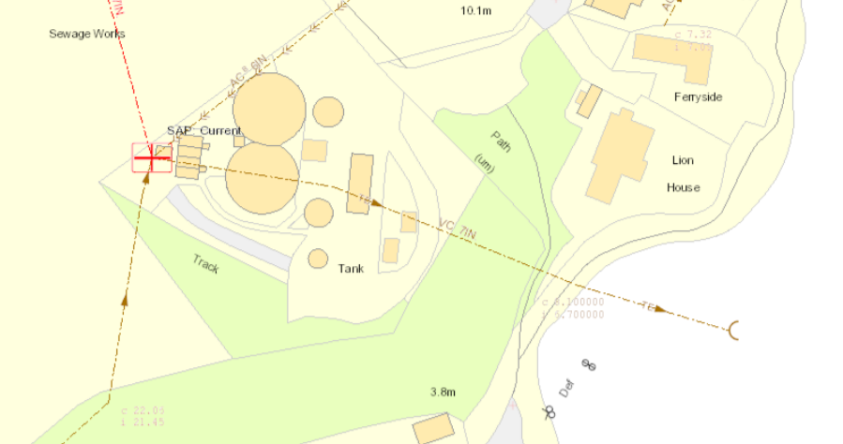
POINT OF DISCHARGE
Effluent sampling point
POINT OF OVERFLOW

