BW1403601 Blaenau Chicken farm CSO Plan

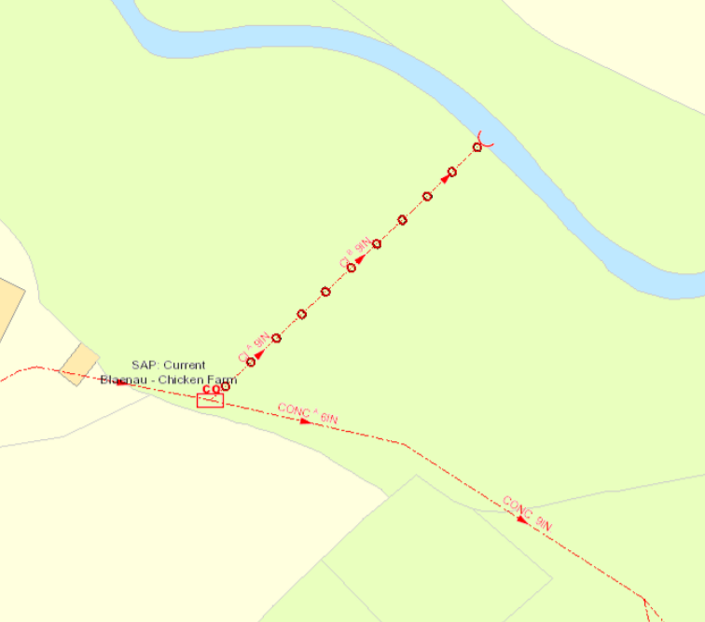
POINT OF OVERFLOW
POINT OF DISCHARGE

