PAN-021080 My Map Report:
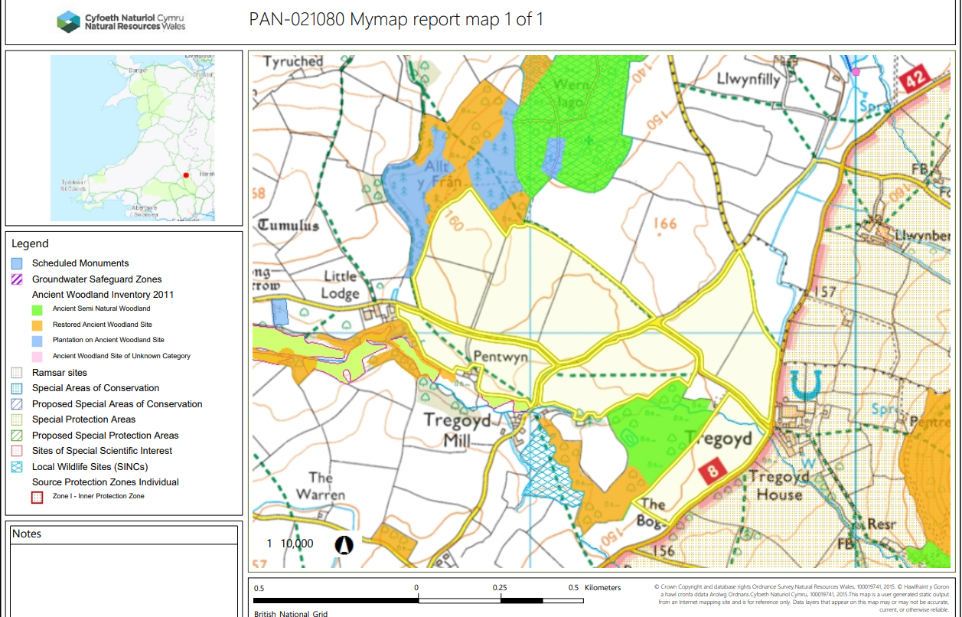

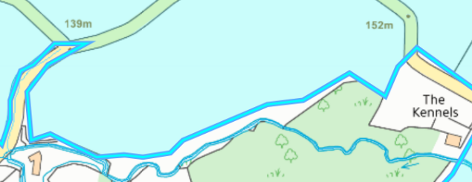
Detailed river network:
A
B
Fields A , B and E border a stream. There is a 10 m no spread buffer zone in place to prevent nutrients entering the water course.
Groundwater protection zones
None in range.

Wells, springs or boreholes used for the supply of water for human consumption including from a private water supply or supplies
None in range.
any springs wells or boreholes not used to supply water for domestic or food production purposes within 50m

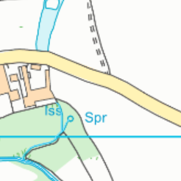

Lodge

Field lodge contains a spring. This area has been buffered by 50 meters and complies with the SRP.

European designated sites- Natura 2000 (SPA, pSPA, SAC or cSAC) or Ramsar- or SSSI within 500m

None in range.

Other protected sites:
- Protected Species- None in range.

- Protected Habitats-

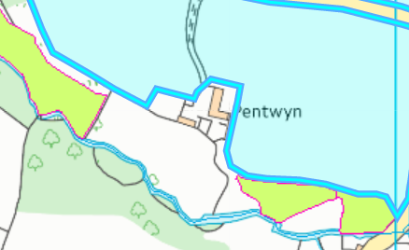
Pentwyn
corner
Lodge
The protected habitats are located outside of the spreading area. It is unlikely determent from this land spreading activity will occur to these sites as long as landspreading takes place in line with the submitted application i.e. agricultural benefit statement. No action needed.

- Scheduled Ancient Monument- None in range.

- Local Nature Reserve- None in range.

- National Nature Reserve- None in range.

- Ancient Woodlands-
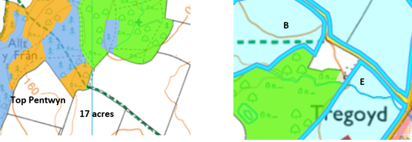
Fields Top Pentwyn , 17 acres, B and E border ancient woodlands. Theses areas have been identified on the site plan. The ABS also states the mitigation measures in place to protect these areas such as implementation of 10 meter no spread buffer zones.
In the request for information it has been requested these are displayed on the site plan and the mitigation measures in place to prevent determent to these areas in the ABS.

- Local Wildlife Sites (SINC)-

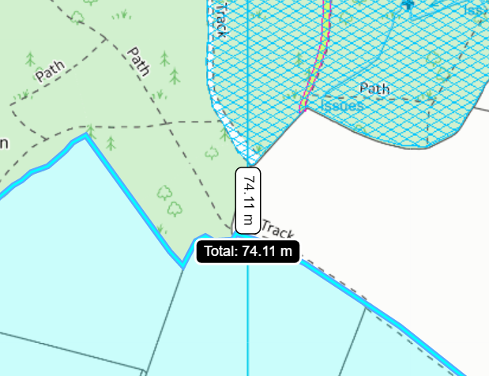
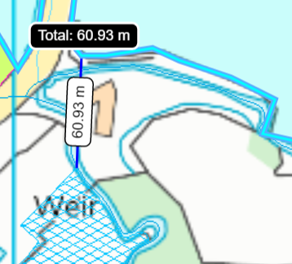
A
Top Pentwyn
16 acres
17 acres

Two SINC sites are located 60 m – 75 meters from field A and 17 acres. The sites have been identified on the site plan. It is unlikely determent to these areas will result from this deployment due to the distance the sites are from the fields.

- National Park-

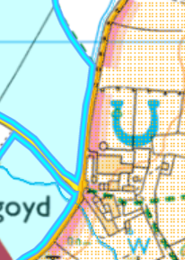
Fields D and E are located 10 meters from the Brecon beacons national park. The national park has been displayed on the site plan. There is a road in between the fields and the national park as of this it is highly unlikely detriment to the national park will occur from this deployment.
E
D
- Groundwater Safeguard Zone- None in range.

- Hedges- Nothing of concern.

- Ditches- Nothing of concern.

Slope Map
Top Pentwyn
Bottom Pentwyn
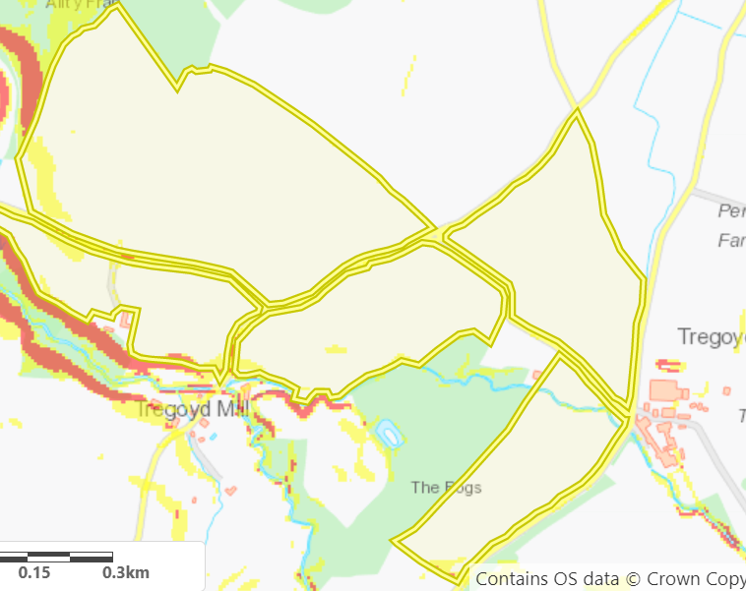
E
Field Bottom Pentwyn is partially on moderately sloping land. This area contains a no spread buffer zone to mitigate the risk of surface runoff of the non-stackable sludges.
The rests of the fields are located on flat to gently sloping land and do not pose a surface runoff risk.

D
C
17 acres
B
A
Pentwyn
corner
Lodge
16 acres

