PAN-021637 My Map Report:
Application map
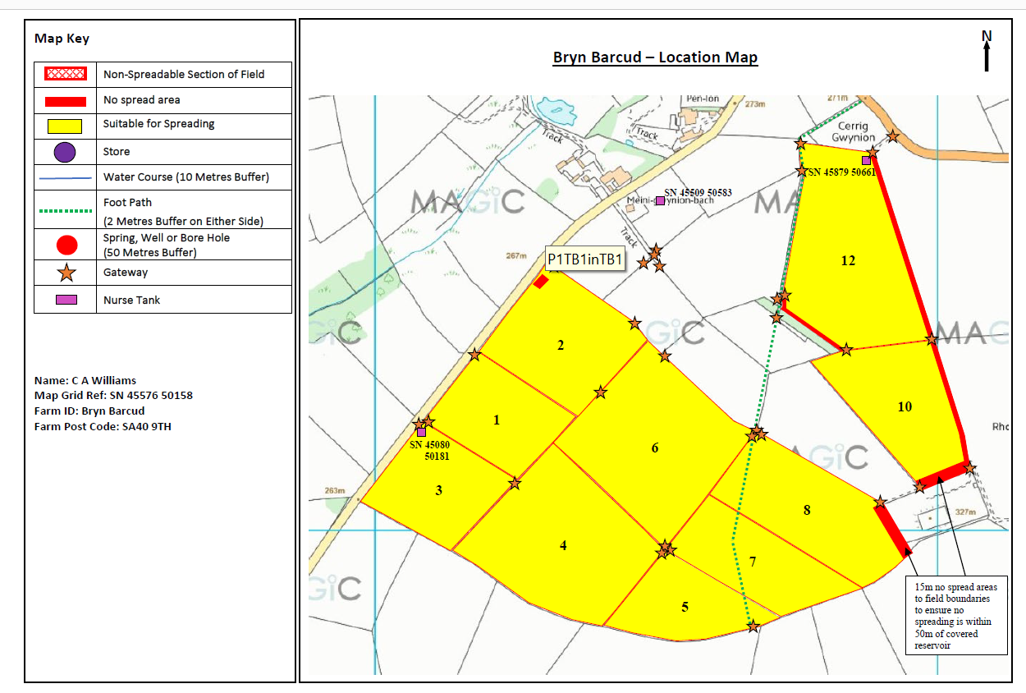
Deployment Boundaries and Storage
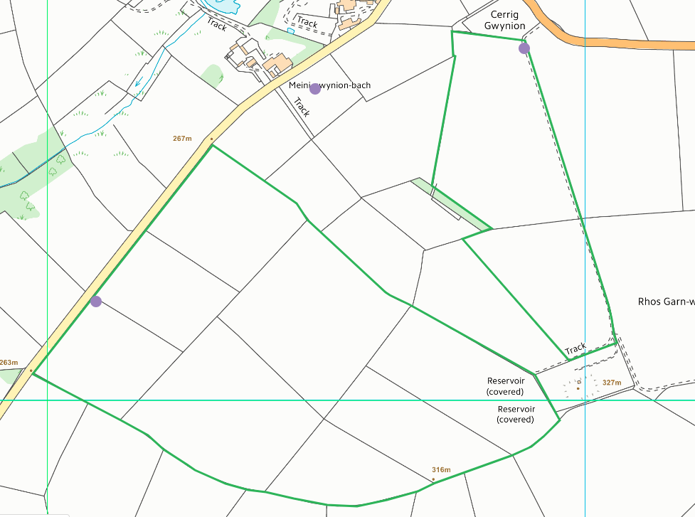
Detailed river network:
None within range
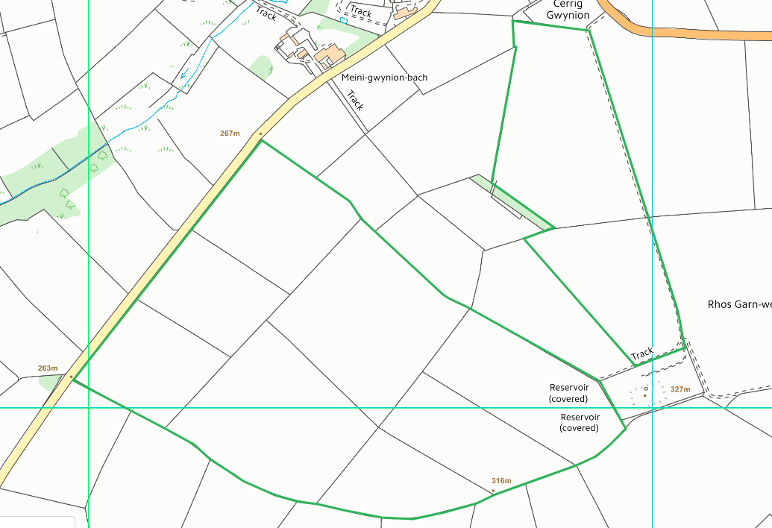

Groundwater protection zones
None within range
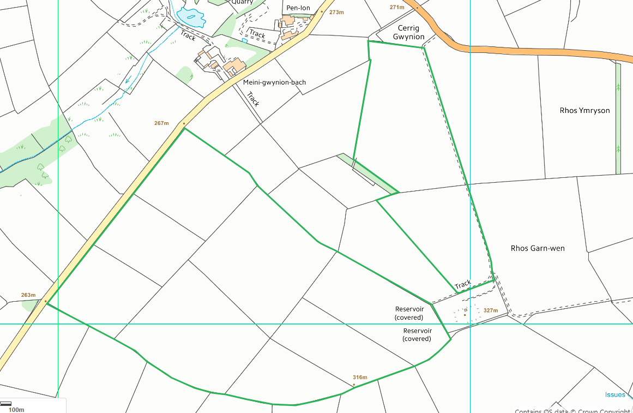
Any well, spring (or issue) or borehole used / not used for the supply of water for human consumption including from a private water supply or supplies within 50m.
Covered reservoir to SE, identified on application maps and buffers in place
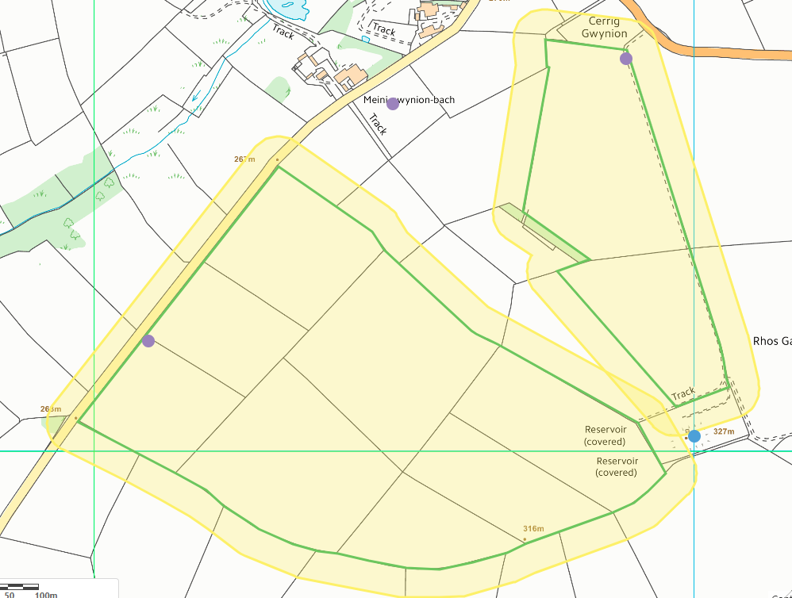
Any well, spring (or issue) or borehole used / not used for the supply of water for human consumption including from a private water supply or supplies within 250m.
Pond N of field 2, identified on application map
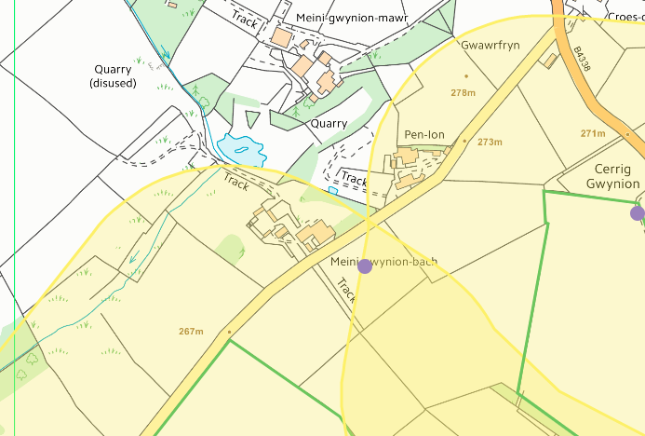

European designated sites- Natura 2000 (SPA, pSPA, SAC or cSAC) or Ramsar- or SSSI within 500m
None
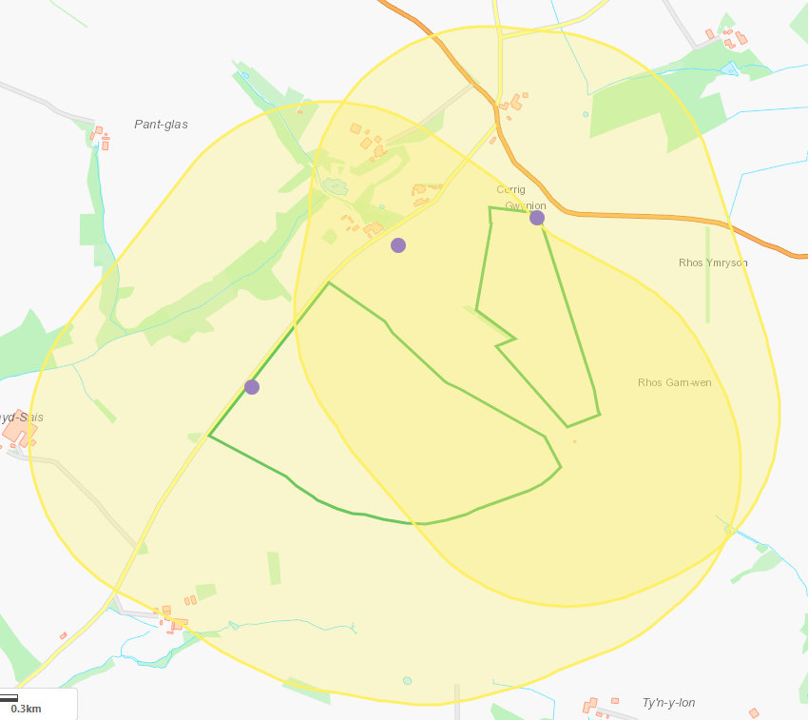
Other protected sites within 500m:
- Protected Species-
- Protected Habitats-
- Scheduled Ancient Monument-
- Local Nature Reserve-
- National Nature Reserve-
- Ancient Woodlands-
- Local Wildlife Sites (SINC)-
- National Park-
- Nitrate Vulnerable Zone (NVZ)-
- Groundwater Safeguard Zone-
- Hedges-
- Ditches-

Lowland dry acid grassland and Lowland calcareous grassland NE of field 12
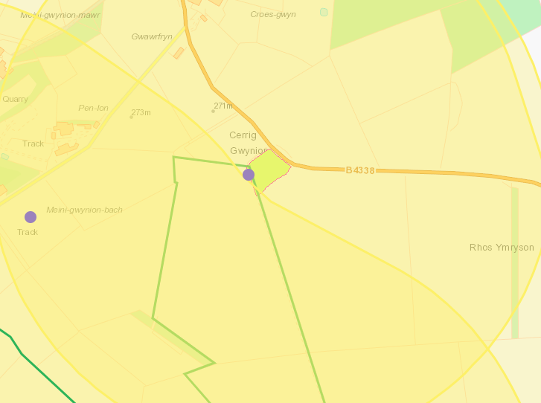

Lowland dry acid grassland and Lowland calcareous grassland, Purple moor grass and rush pastures N and W of field 2.
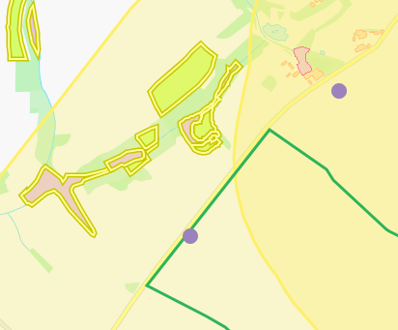
Public rights of way
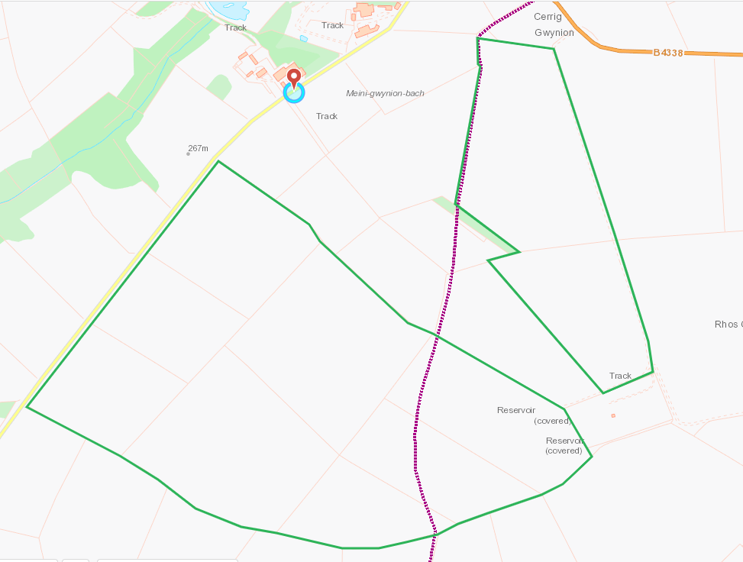
Distance from Main Farm Address
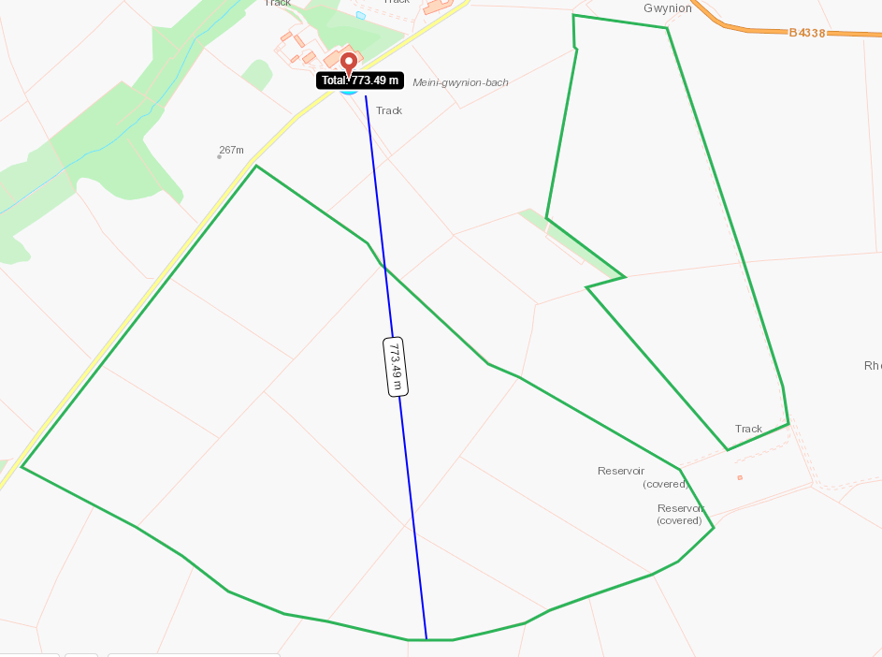

Slope Map
All fields 0-7 degrees
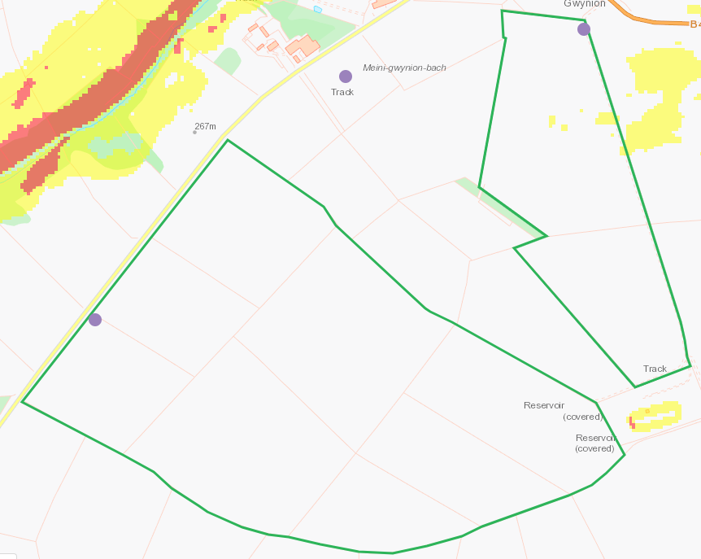

END

