PAN-021429 My Map Report:
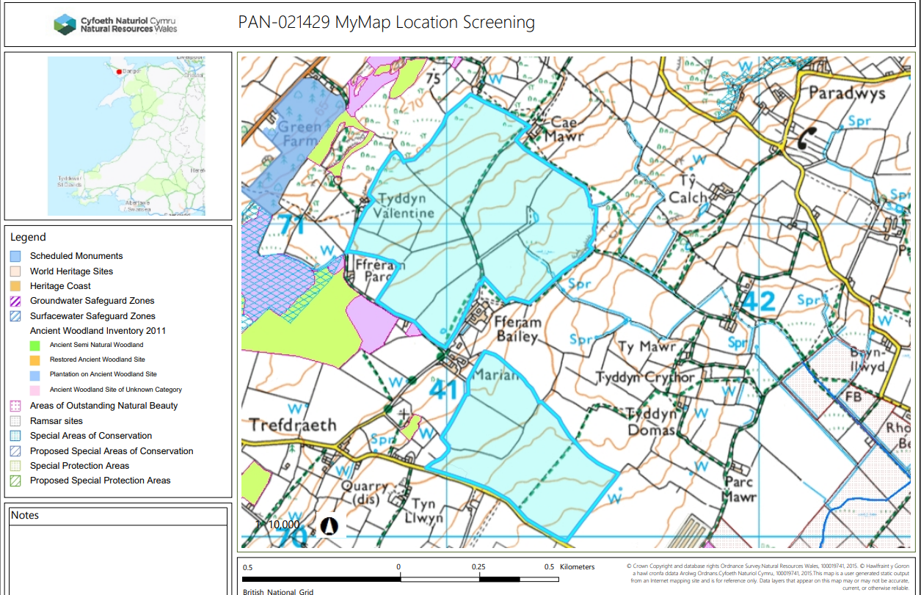

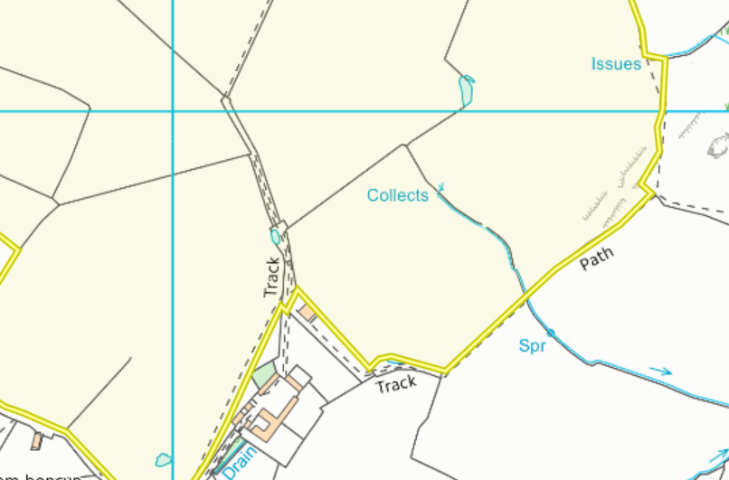
Detailed river network:
11
10

Field 11 contains a pond which has been buffered by 10 meters. Field 10 contains a pond which has been buffered in the request for information 2 response.
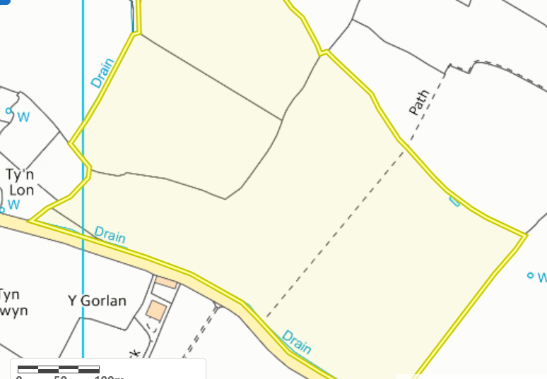
19
18
Fields 18 & 19 contain land drains. These have been buffered by 10 meters and complies with SR2010No4. Field 19 also contains a pond which has been buffered the request for information 2 response.
Groundwater protection zones
None in range.

Wells, springs or boreholes used for the supply of water for human consumption including from a private water supply or supplies
Field 19 is located 37 meters from a well. This has been buffered by 50 meters and complies with the SRP.
19
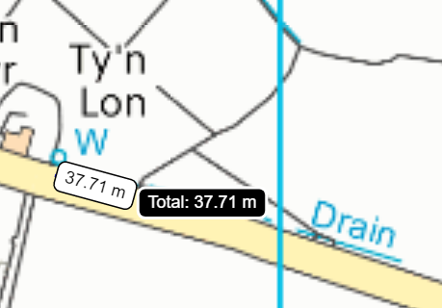
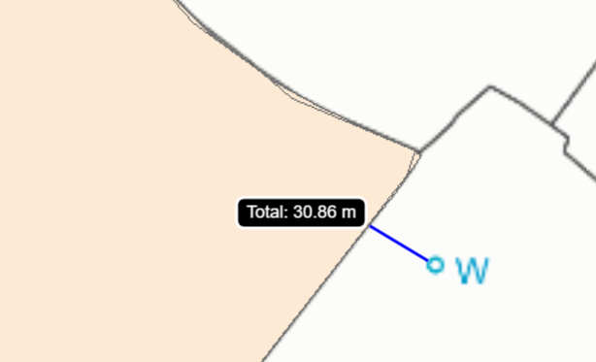
19
Field 19 is located 30 meters from a well. This has been buffered in the request for information 2 response.

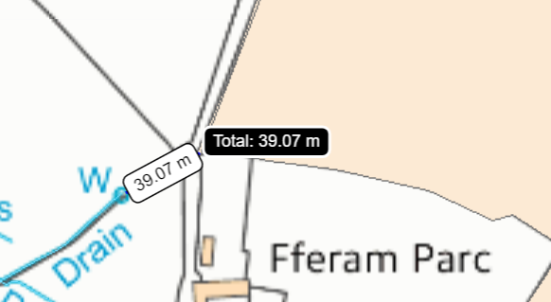
19
Field 19 is located 39 meters from a well. This has been buffered by 50 meters and complies with the SRP.

12
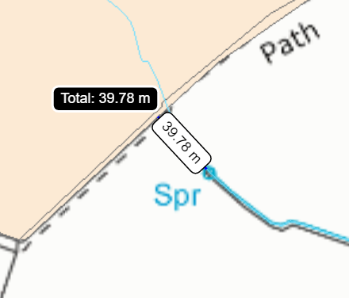
Field 12 is located 40 meters from a spring. This has been buffered in the request for information 2 response.

any springs wells or boreholes not used to supply water for domestic or food production purposes within 50m

None in range.

European designated sites- Natura 2000 (SPA, pSPA, SAC or cSAC) or Ramsar- or SSSI within 500m
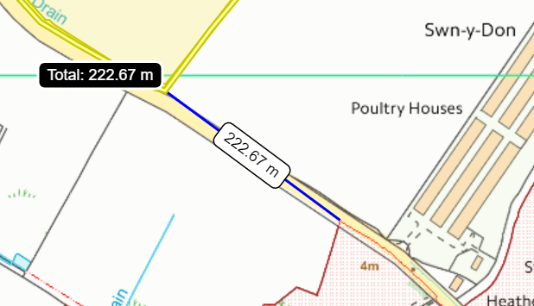
19
Malltraeth Marsh / Cors Ddyga SSSI is located 223 meters from field 19. This has been identified on the site plan and SSRA.

Other protected sites:
- Protected Species- None in range.

- Protected Habitats-

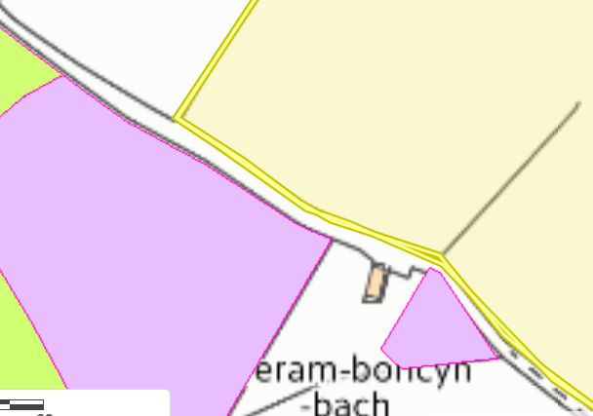
10
Fields 10 is located 10 meter from a protected habitat named: Purple moor grass and rush pastures. As the habitat is 10 meters from the fields it is highly unlikely detriment to this area will occur. No action needed.

- Scheduled Ancient Monument- None in range.

- Local Nature Reserve- None in range.

- National Nature Reserve- None in range.

- Ancient Woodlands- None in range.

- Local Wildlife Sites (SINC)-
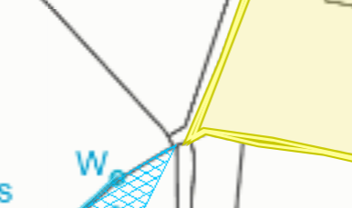
9
Field 9 is located 9 meters from a SINC named: Fferam Parc. This has been displayed on the submitted site plan in the request for information 2 response.

- National Park- None in range.

- Groundwater Safeguard Zone- None in range.

- ANOBs - None in range.

- Heritage coast - None in range.

- World Heritage Sites - None in range.

- Hedges- Nothing of concern.

- Ditches- Nothing of concern.

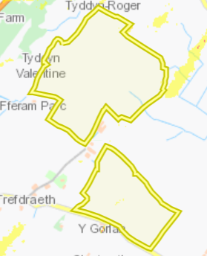
Slope Map
All the fields are located on flat to gently sloping land (0-7º) therefore there is minimal risk of surface runoff.

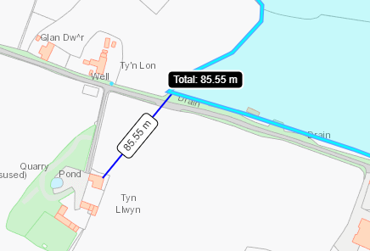
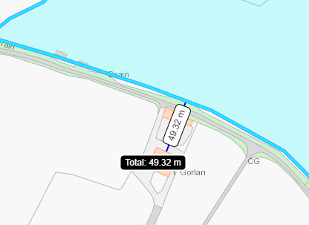
Sensitive Receptors (odour)
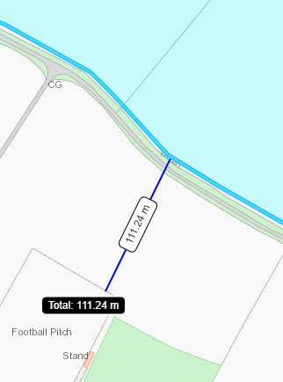
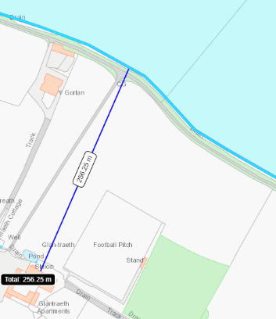
These odour receptors were not originally identified in the application but have been in the request for information 2 response, in section 8 of the ABS.

