CRoW Appendix 4 (140_10_SD02)  CRoW Act 2000: Natural Resources Wales application for permission - Formal Notice |  | 
Natural Resources Wales Formal Notice.
Requirements of Section 28I of the Wildlife & Countryside Act 1981 as amended by the Countryside and Rights of Way Act (CRoW) 2000.
Duty in relation to granting any consent, licence or permit for activities likely to damage Sites of Special Scientific Interest (SSSI).
Guide to filling in this form for Natural Resources Wales staff:
To be completed by Permitting Officers for any applications for a permission which the Natural Resources Wales has considered under S28G duties to protect and enhance SSSIs. This applies to all proposed permissions within a SSSI, and to operations outside the SSSI boundary which are likely to damage its special features.
Refer to OI 140_10 ‘Applying the Countryside and Rights of Way (CRoW) Act 2000 to applications for permits with potential for impact on Sites of Special Scientific Interest (SSSI)’, including the flowchart in Appendix 2.
Pink italic text – drafting notes, to be deleted before completion/consultation.
Blue text – examples, to be replaced with permission-specific information.
Ensure you have completed all sections.
- Natural Resources Wales area/region/NPS hub: | North West Wales
- Name of SSSI: | MALLTRAETH MARSH/CORS DDYGA
- Type of permission: | Land spreading deployment under standard rules permit SR 2010 No4 Mobile plant for land spreading.
- Date for Natural Resources Wales permit determination: | 03/05/2023
5. Predicted 28 day date for response from NRW conservation/ecology (under S28 I(4)): | n/a
6. Natural Resources Wales reference no: | PAN-021429
- National grid reference: | SSSI: SH440710  Farm location: SH 41064 70701  Fields:  8 SH 41060 71230  9 SH 40870 71020  10 SH 40960 70790  11 SH 41180 71080  12 SH 41310 70910  18 SH 41150 70390  19 SH 41300 70200  Storage: n/a
- Description of proposal: | A land spreading application to spread 3 waste streams (EWC 02 05 01 & 02 05 02 at Fferam Bailey farm, Trefdraeth. Wastes are to be spread on 7 fields which contain grass. The application rate of the wastes ranges from 125-200 tonnes per ha, with a total tonnage to spread a maximum of 10,000 tonnes.  The waste will be spread over 50 ha hectares of land within the listed fields at Fferam Bailey. The waste spread under this deployment are composed of non-stackable liquid wastes and will be spread on delivery. The non-stackable liquids will be surface spread via trailing shoe applicator. No more than 250t/ha will be spread within any 12-month period.  Targeted periods of spreading on grass fields include  - 1st application start of April 2023*  - 2nd application end of May 2023  - 3rd application start of July 2023  * the time for this April application had passed due to the deployment being issued on the 03/05/2023.  The wastes may be applied separately or in combination. If the wastes are applied in combination the waste stream with the highest nutrient ‘Potentially Toxic Element (PTE)’ or other limiting parameter will be used as the maximum application rate allowed to be spread.  The land spreading activity will comply with the Code of Good Agricultural Practice guidelines (COGAP).  Documents related to this deployment can be found on the DMS.
9. Is the proposed activity within (wholly or partially) the SSSI boundary? | NO  Field 19 is located 223 meters away from the SSSI. There is no perceivable impact pathway for the waste to reach the SSSI.  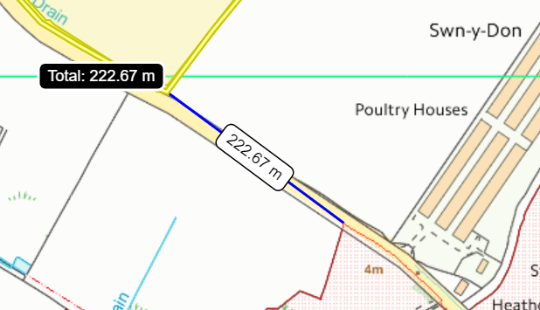
- Has there been any pre-application discussion or correspondence with NRW conservation/ecology | NO
10. What aspect(s) of the proposed permission may damage the features which are of special interest for the SSSI?
The following ‘Operations Requiring Consent’ (or other activities associated with the permission) that may cause damage) are relevant to the proposed permission.

7. Dumping, spreading or discharging of any materials, excluding manure or fertilizers.

The following SSSI features and mechanisms of impact have been considered to assess the likelihood of damage:

- Open water associated with the lowland grazing marsh ditch system and former river meanders with associated plants and animals such as reed canary, grass, water-plantain and branched bur-reed. Club-rush, and reed sweet-grass Submerged plants such as spiked water-milfoil, blunt-leaved pondweed, horned pondweed and uncommon plants such as flowering-rush, water-violet and marsh stitchwort.
- Pillwort – an aquatic fern
- Variable dragonfly
- Water beetle
- Wintering shoveler
- An assemblage of breeding birds of lowland damp grassland such as lapwing, curlew, redshank and snipe.
- An assemblage of breeding birds of open water such as teal, gadwall, and pochard.
- Water vole

- Decision
i) The proposed permission is not likely to damage any of the flora, fauna or geological or physiological features which are of special interest.

- The waste will be applied via trailing shoe application which is an effective way of applying the wastes to the soils directly which improve spreading accuracy, maximising nutrient use and minimising nutrient loss.
- All the fields in this deployment are on flat to gently sloping land (0-7º) therefore do not pose a surface runoff risk.
- All fields under this deployment have a greater overall offtake of phosphate than is being added by the waste, so the overall levels of phosphate in the soils will decrease from their current level within the 12 month period of this deployment. There will be no overall phosphate increase to the land as a result of this application.
- Water courses/springs have been appropriately buffered in accordance with the stand rules permit to prevent nutrients and/or PTEs from entering the water courses/ SSSI.
- All wastes streams are non-stackable liquid sludges, so dust will not be generated during the activity. and as such, no dust from this activity should enter any protected water courses/SSSI.
- A site-specific risk assessment has been provided by the operator to take into account any potential issues and has provided appropriate mitigation measures to protect the SSSI and other sensitive sites from harm.
- Wastes will be spread at appropriate times when the crop will benefit from the nutrients provided (April-July).
- All turns made by the application machinery will be gentle with the intention of preventing wheel slip and excess soil damage in the form of ruts;
- All deliveries to the field will be made during the working day to limit noise/disturbance to nearby sensitive (human) receptors;
- All application machinery is calibrated and regularly checked in order to ensure the stated application rates are maintained.
Natural Resources Wales is minded to: Issue the permission

Name and job title of Natural Resources Wales officer: | Owen Clee  Permitting Officer
Date form sent to NRW conservation/ecology | n/a
For Natural Resources Wales use only, once NRW conservation/ecology response received
NRW conservation/ecology comment on assessment: | Please delete as appropriate:  i) NRW conservation/ecology advise the operation can go ahead  ii) NRW conservation/ecology advise the operation can go ahead with conditions  iii) NRW conservation/ecology advise against permitting the operation  Please ensure that the NRW conservation/ecology response is attached to this Formal Notice.
Name and job title of NRW conservation/ecology officer:
Date of receipt of NRW conservation/ecology response:

