Port of Holyhead
Marine Maintenance Dredging Biosecurity Plan 2023-2028

This plan has been completed as a requirement to support the Port’s dredging licence application and makes use of the ‘Biosecurity Plan Template’ produced by Natural Resources Wales. Where appropriate NRW guidance notes have intentionally been left in the document to assist in reviews.

As indicated in the template guidance notes the template it is “intended to be used by marine maintenance dredging operators and contractors” and therefore as stated in section 1.6 and 9, and at Note 1 Page 4, it must be reviewed for the inclusion of detailed information and re-issued prior any dredging campaign being undertaken.

John Goddard
Harbour Master

This Biosecurity Plan Template is intended to be used by marine maintenance dredging operators and contractors in order to minimise the risks posed by marine invasive non-native species (INNS), particularly related to minimising spread to new areas. It is difficult to directly manage INNS in the marine environment once they are present, therefore, prevention is key which is recognised in the GB Invasive Non-native Species Strategy (2015)

“Where direct management is not feasible, as is often the case in the marine environment, we will seek to reduce the spread of species by improved and targeted biosecurity”.

There are a number of legislative drivers for this work including the Marine Strategy Framework directive (MSFD); EU IAS (Invasive Alien Species) Regulation and the Wildlife and Countryside Act (W&CA) 1981, Schedule 9. Section 14 of the W&CA states that it is an offence to ‘release or allow to escape into the wild any animal which is not ordinarily resident in Great Britain or any species listed in Schedule 9 of the Act’. Schedule 9 of the act lists a number of marine INNS particularly relevant to marine dredging activities, these include the Chinese mitten crab (Eriocheir sinensis), American Oyster Drill (Urosalpinx cinerea) and the American Slipper Limpet (Crepidula fornicata).

With respect to maintenance dredging activities in Wales and in order for the potential risks posed by these species to be managed in the most effective way it is important that NRW obtain as much information as possible. In certain circumstances where the activity is deemed not to contribute to the further geographic spread of those species on Schedule 9 (W&CA), NRW may issue an exemption in the form of a ‘General Species Licence’, however, this will be assessed as part of the licensing process.

- Introduction
Over a period of time sediment accumulates alongside berths, in berthing pockets and in the fairways reducing the navigable depth of water. Periodically the Harbour Authority undertakes maintenance dredging to remove these sediments and return the depth to those marked on navigation charts.

  - Applicant Name:
Stena Line Ports Ltd, Holyhead

  - Marine Licence reference number:
Application DML2278

  - Description of Operation:
Periodic removal of accumulated sediments in given areas of the harbour.

  - Dredge and disposal Site Location(s):
Dredge sites
Disposal

ISO43 Holyhead North
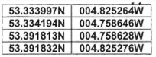
N W

  - Activity period:
At notified times throughout the duration of the dredging licence

  - Biosecurity Manager/Officer:
To be advised prior to the start of a dredging campaign

  - Approval Date: To be completed by NRW Marine Licensing Team

  - Document version number:

- Information related to the Environmental conditions affecting biosecurity
 | Source environment/location | Receiving environment/location
Marine Non-native species known to be present | an alien species of sea squirt had infected Holyhead Marina. The sea squirt is still confined to the Marina area and CCW (now NRW) have undertaken their own programme to eradicate it. No dredging will be undertaken in or near to the Marina. | None known to be present in Holyhead deep

- Vessels & equipment involved in the operation (please list all vessels, barges and equipment to be used as part of the maintenance dredging operation – insert additional rows as necessary)
Vessel name | Photo reference  (Please insert images in the appendix) | Vessel type | Details, Risk factors & Justification  e.g. Pathway, vessel speed, biofouling control, Inspection history, Internal treatment history etc.. | Risk:  (High/Medium/Low)
Unknown at this point. This section will be completed before a program is due to commence by the dredging contractor¹
  - Vessel & Disposal site Proposed activity log
In relation to maintenance dredging activities, marine invasive non-native species typically have three main vectors by which spread can potentially occur from one location to another. These are hull fouling, transfer in vessel ballast water and transfer within marine sediments. In order to better understand the potential risks associated to the current operation it is important to outline a brief history of vessel/equipment movements. This includes information such as vessel/equipment recent activity history (including any periods of inactivity) as well as information on ports visited and dredge/disposal site locations associated to the current licensable activity.

(Please note: a separate row should be inserted for changes in vessel and/or disposal site)
Vessel name | Brief description of vessel activity over the last 12 months | Transit ports (list all ports to be visited on route to the current dredge activity if applicable) | Transit ports arrival and departures |  | Disposal site name & reference
Vessel name | Brief description of vessel activity over the last 12 months |  | Arrival date | Departure date | Disposal site name & reference
Unknown at this point. This section will be completed before a program is due to commence by the dredging contractor | Insert name of all ports and dredge/disposal sites visited in the last 12 months | Port name | Date | Date | Disposal site name and reference no.

- Activities which have a significant risk of introducing or spreading marine invasive non-native species (Please provide as much detail as possible of how each of the activities have the potential to increase the risk of introduction or onward spread of marine invasive non-native species – insert additional rows as necessary)
Activity and brief description | Details of how this could potentially increase the risk of introducing and/or spreading MINNS | Mitigation and Biosecurity measures to be implemented
Movement of a vessel from one port to another in relation to maintenance dredging activities. | Inadequate anti-fouling of vessel may cause transfer of certain MINNS from one port to another  Inadequate biosecurity measures related to the cleaning/flushing of equipment and screens before moving to the next location.Measures would include flushing suction equipment and re-depositing any screen material before leaving the site.  Transfer of ballast and/or hopper water between ports and/or between dredge and disposal sites. | Regular antifouling of vessel demonstrated through up-to-date log book.  Equipment is thoroughly flushed before moving off dredge disposal site in order to minimise the risk of transporting MINNS between sites/ports.  Exchange of ballast/hopper water at sea before reaching the destination port or maintenance dredging site.  *Ideally ballast/hopper water should be exchanged prior to transitioning from one biogeographic area to another and away from the coast.
Crew disposing of international food waste and/or contaminated products overboard | Food stuffs may contain seeps, spores, or eggs which under the right conditions may proliferate | Vessels comply with MARPOL Chapters on disposal of food waste.

- Mitigation & Biosecurity Control Measures – Instructions for staff/contractors/site users (insert additional rows as necessary)
Who | What | Where | When
Vessel owner and/or Skipper | Ensure vessel logbook is up to date and vessel has conformed to best practice under ballast water and hull fouling guidance. Exchange/cycling of hopper water should also be documented in the logbook when vessels are transitioning biogeographic areas. | Vessel logbook | To be kept up to date during normal operations
Vessel owner and/or Skipper | Disposal of garbage and food wastes is to be conducted in accordance with the vessels MARPOL garbage management plan. | Vessels garbage record book | Transiting to and from the port and all times in-between.

- Operational surveillance and reporting procedure
The vessel is to be vigilant in the surveillance and reporting the presence of INNS or any marine debris present before moving out of the harbour and proceeding to the dumping grounds.

Such reports should be made to the Harbour Master initially by phone, backed up by email, and guidance sought.

- Contingency Plan (i.e. when changes to the plan necessary and have been identified - insert additional rows as necessary)
Action | Responsibility | Location of Equipment
Use of alternative equipment, vessels or methodologies | Delegated to Equipment or Vessel supplier | Any additional equipment or vessels brought on site must conform to the requirements of this RA
Disposal of dredge material should the vessel be incapacitated for any reason (Strike, arrest, breakdown, damage) | Harbour Master | To be agreed between NRW, Insurers and the Port.
- Location of biosecurity logbook
To be maintained abord the dredging vessel with copies made available to the Harbour Master on completion of the campaign.

- Annual Review Date
Every fifth year on application renewal; or, prior to a dredging campaign; or, after a maintenance dredging incident or near miss; – whichever occurs first.

Appendix A

Didemnum vexillum ‘Carpet Sea Squirt’

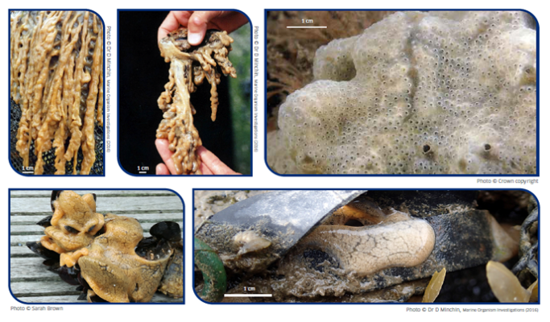

(Source Marine Scotland – Credits at noted)

The licence holder should update and submit a revised plan as a result of any amendments to the list of vessels and/or equipment to be utilised as part of current licence.
There may be instances where such mitigation measures may not be needed due to movement within the same biogeographic region, however, this will be reviewed as part of the assessment.

