Permit boundary
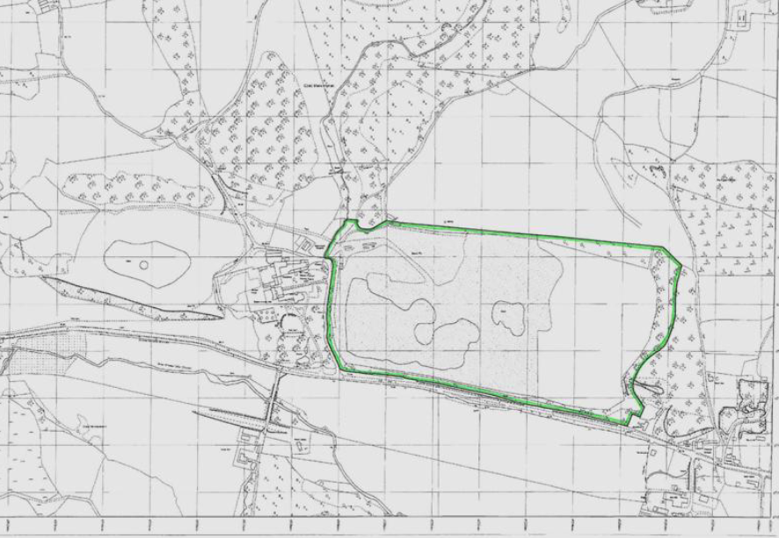
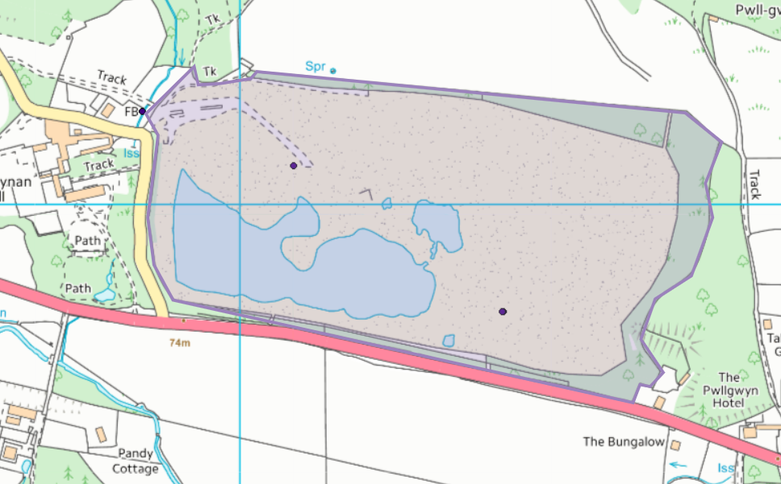
Site location plan supplied in application
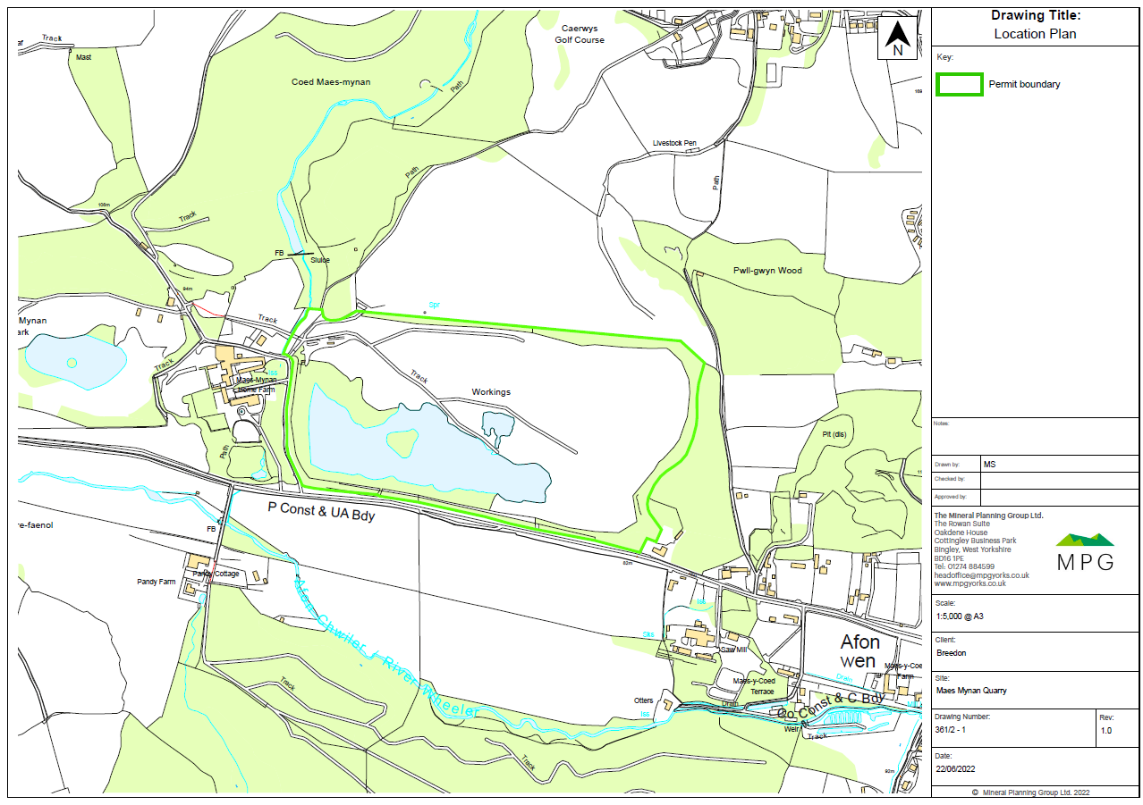
SAC, SPA, Ramsar, SSSI within 2km of the site:
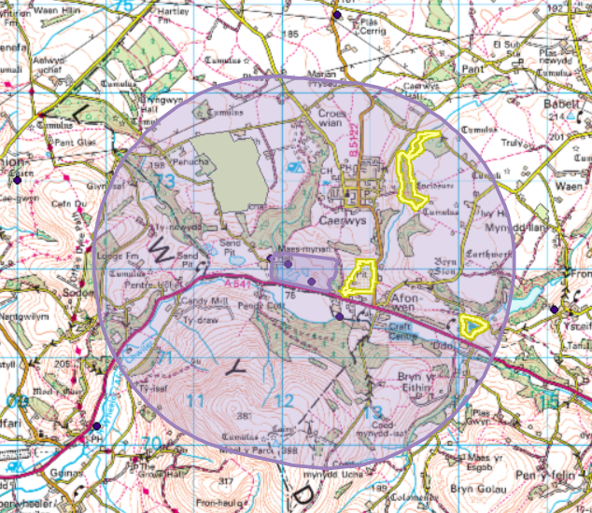
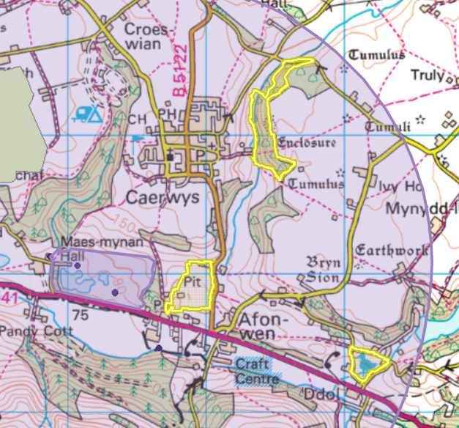
Left: Caerwys Tufa SSSI (approx. 160 meters at nearest points)

Top: Coed Trefraith SSSI (approx. 1,0250 meters at nearest points)

Right: Ddol Uchaf SSSI (approx. 1,530 meters at nearest points)

Aquifer Designation (Superficial)
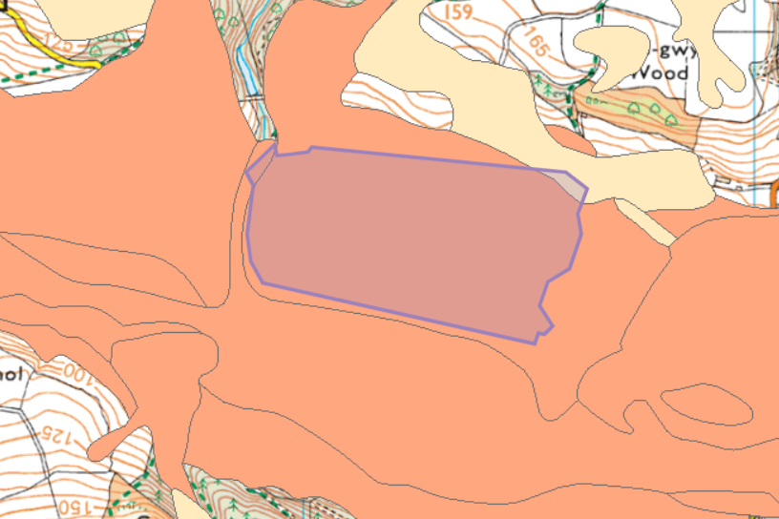
No Source Protection Zone
Aquifer Designation (Bedrock)
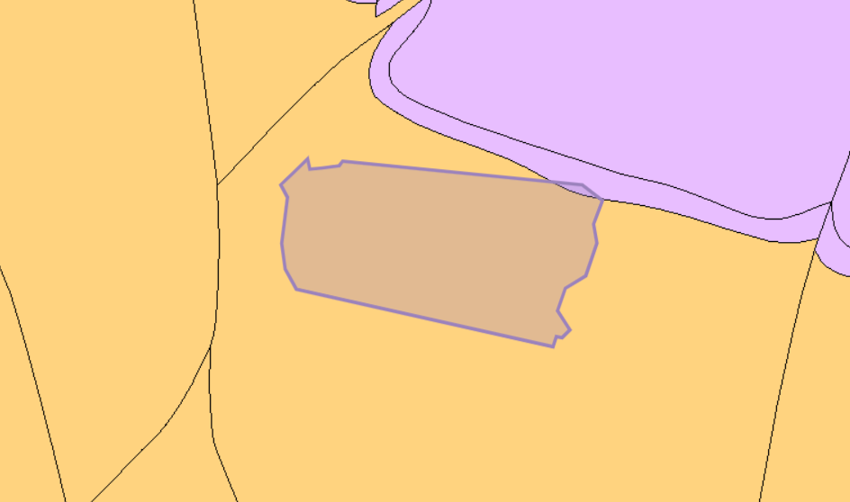
No Source Protection Zone
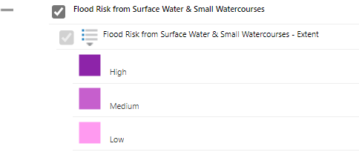
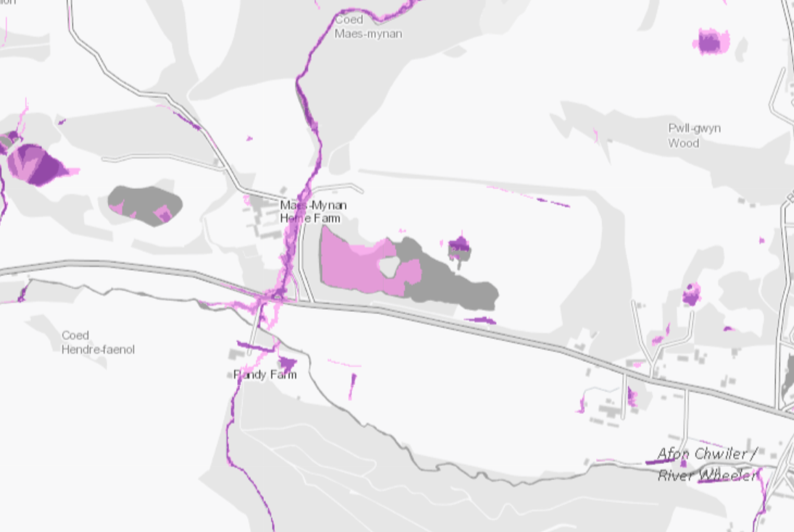
Flood risk

Surface water
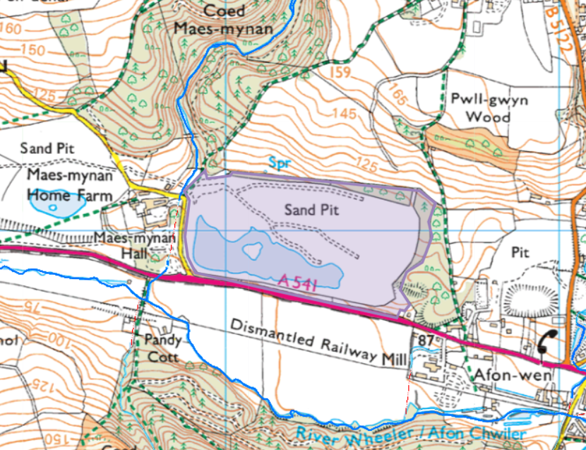
Protected species/habitats
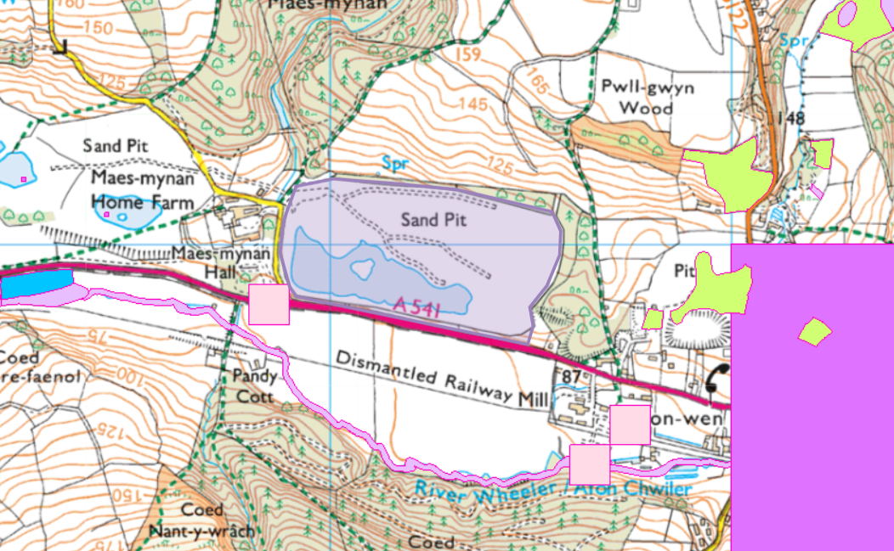

Ancient Woodland Inventory 2011
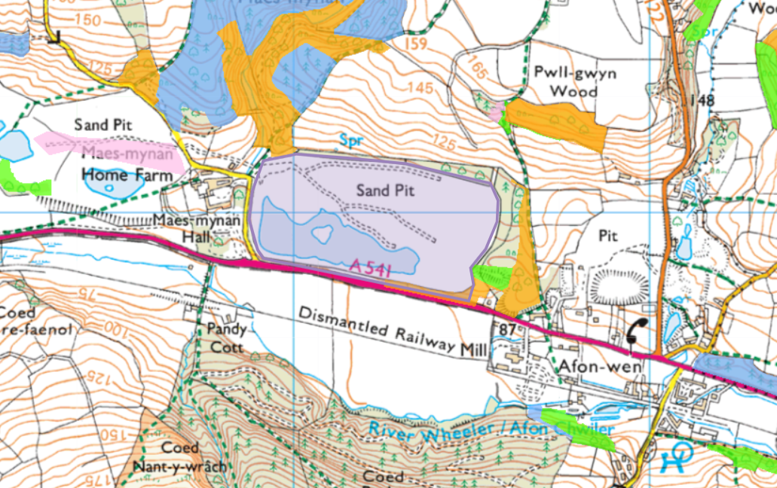
Areas of Outstanding Natural Beauty
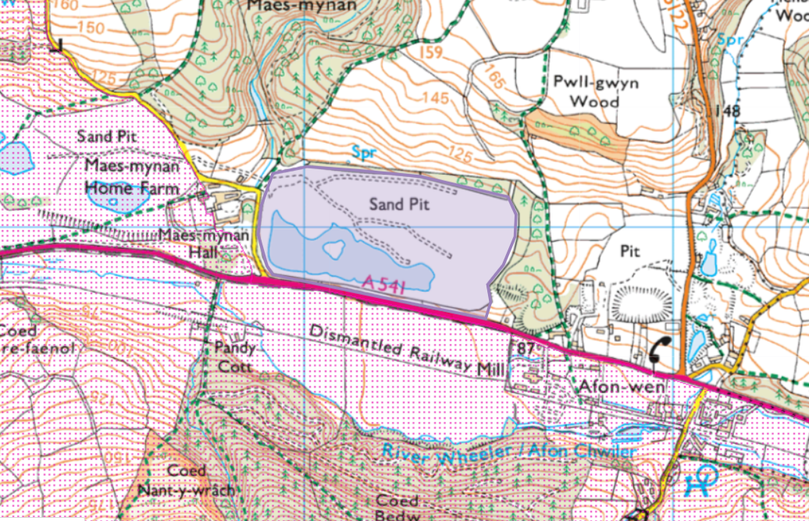
Local Wildlife Sites (SINCs)


