PAN-021796 MyMap Screening Report
Application Map
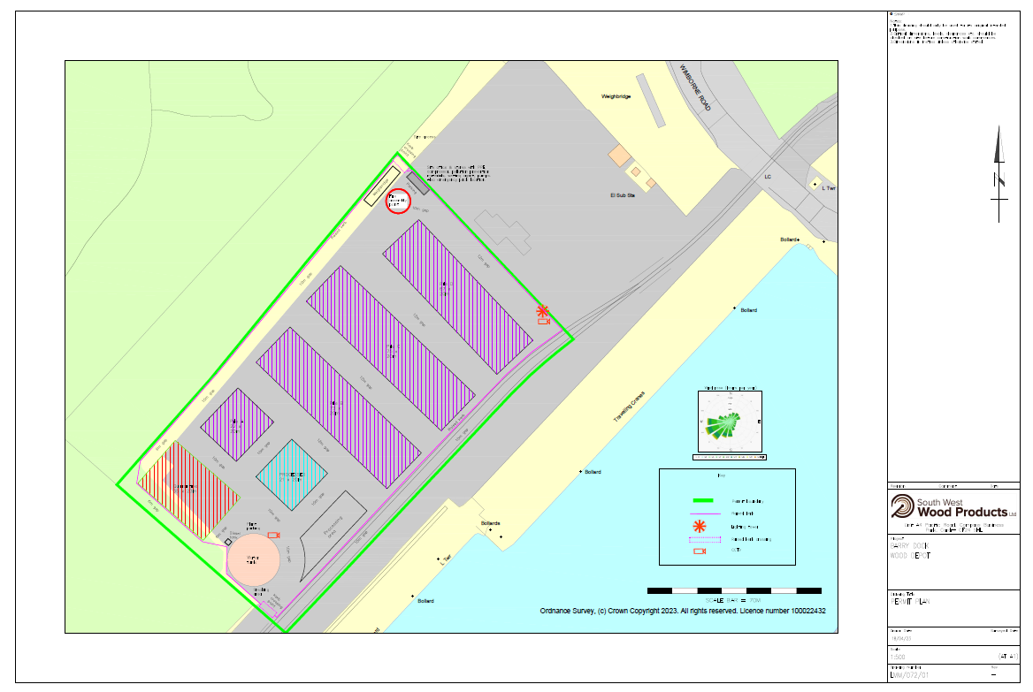

Permit Boundary
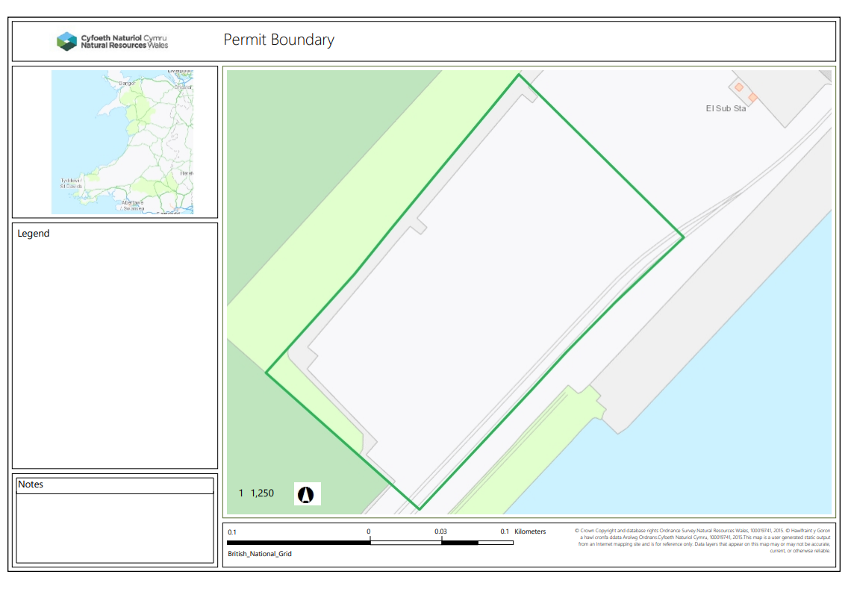
RAMSAR, SSSI - 500m.
None
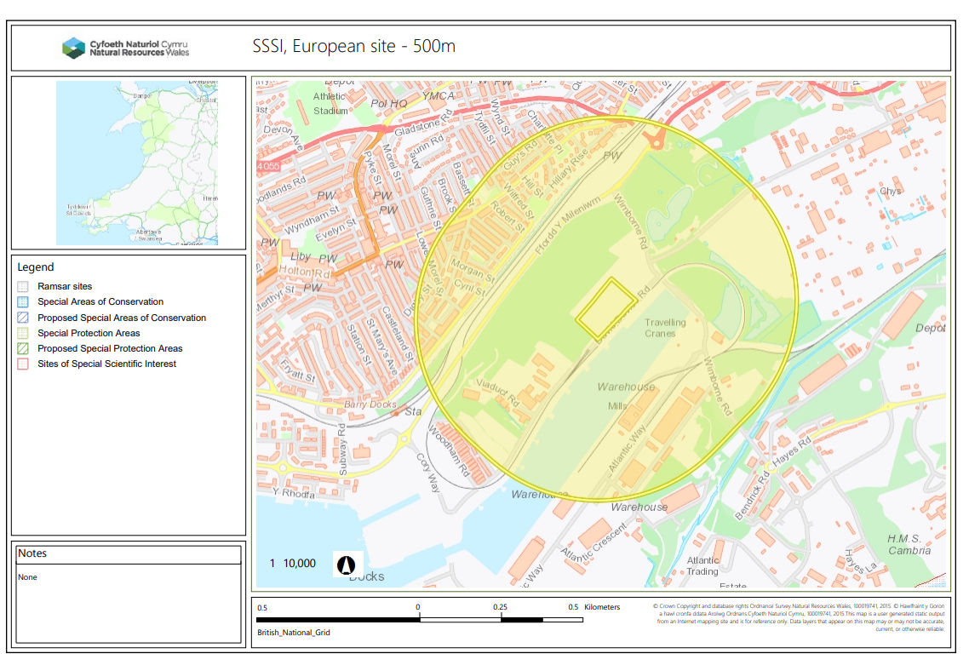

Great crested newts – 250m
none
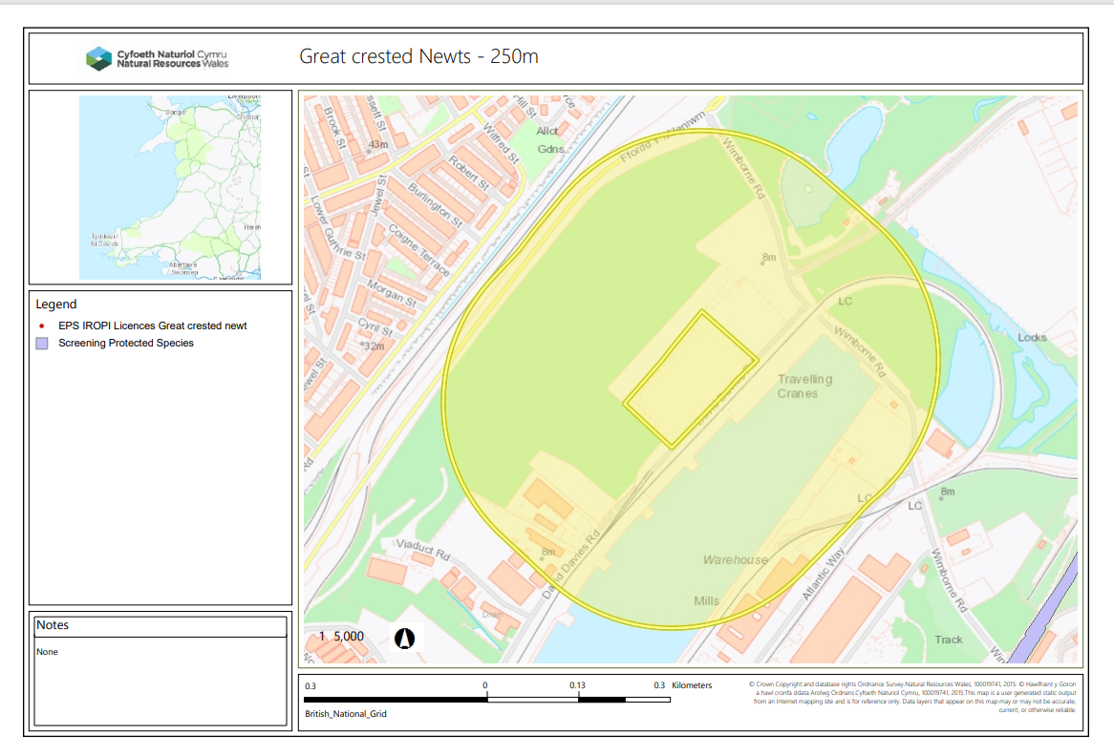
NNR, LNR, LWS, Ancient Woodland, SAM – 50m
None
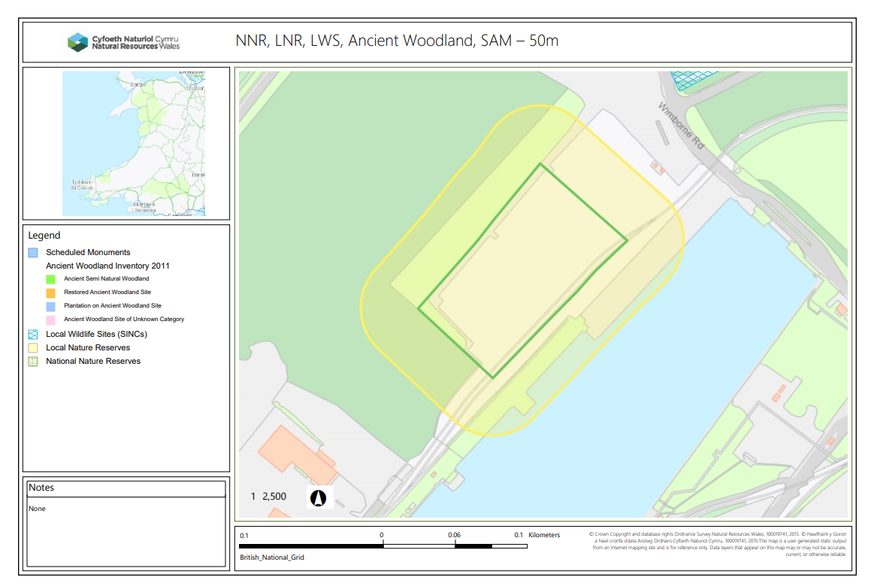
Protected Species, Protected Habitats, 50m
None
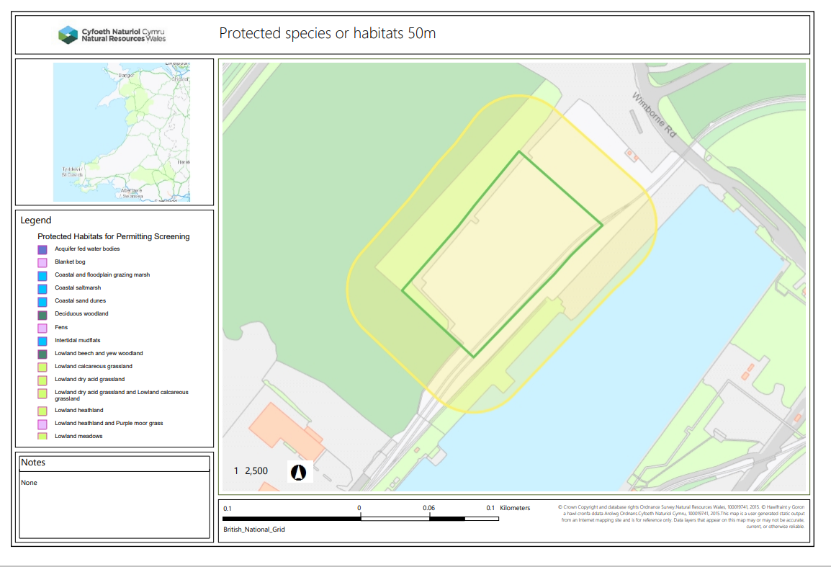
Wells, Springs, Boreholes – 50m
None
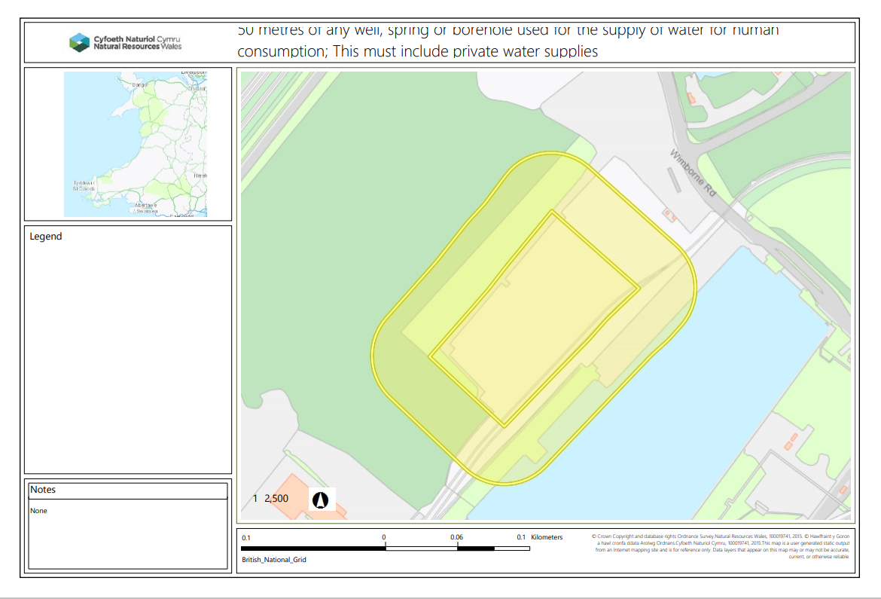
Watercourses – 10m
None
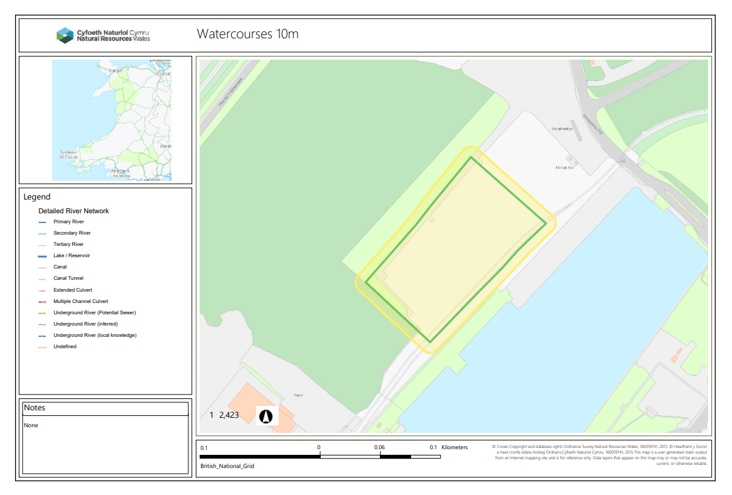
END

