PAN-021193 My Map Report:
Application map
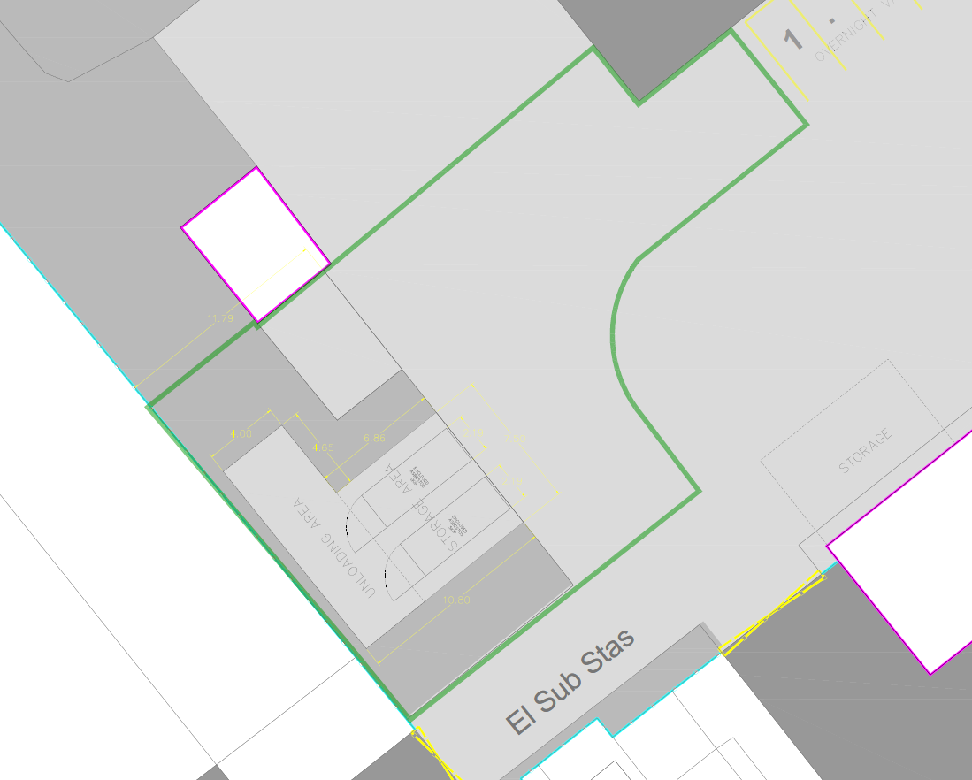
Site Boundary
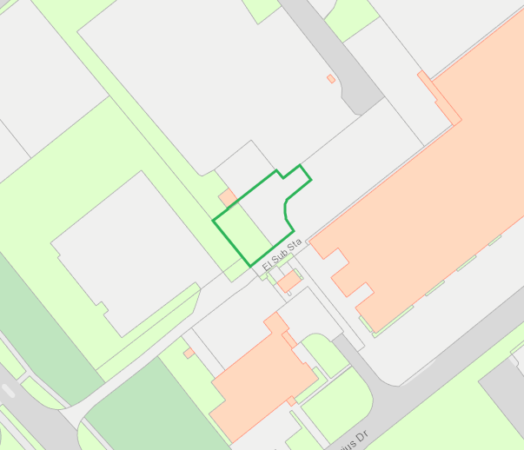

European designated sites- Natura 2000 (SPA, pSPA, SAC or cSAC) or Ramsar- or SSSI on or adjacent to site
None within range
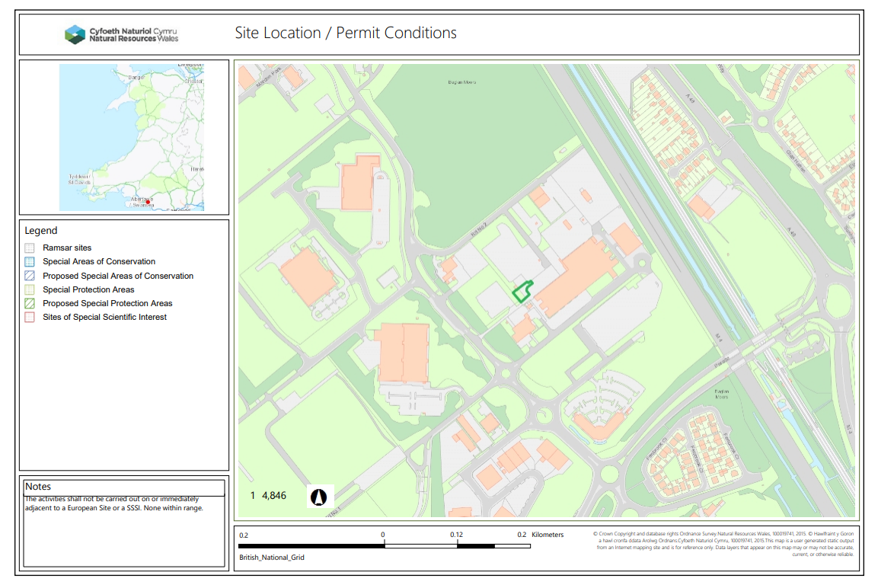

END

