Background Information Note:

Llyn Padarn and Llwyn Y Coed Sites of Special Scientific Interest
Dinorwig to Pentir 400kV buried electricity cable replacement scheme – Dinorwig – Pentir 400kV (A4086 Section)
The purpose of this note is to provide NRW with background information on the Dinorwig to Pentir 400kV buried electricity cable replacement scheme (A4086 Section) that National Grid Electricity Transmission (‘National Grid’) proposes to undertake near to and adjacent to the Llyn Padarn SSSI and Llwyn Y Coed SSSI.
National Grid is a ‘public body’ in respect of Section 28G of the Wildlife and Countryside Act 1981 (as amended). Morgan Sindall therefore have notified Natural Resources Wales of our intention to undertake operations near to and adjacent to Llyn Padarn SSSI and Llwyn Y Coed SSSI that ‘are likely’ to damage its flora or fauna.
Non-Technical Summary
Morgan Sindall on behalf of National Grid are installing a new underground electricity cable to connect the hydroelectric power station at Llanberis to the national grid node at Pentir.
Part of the route for the new cable will be installed within the A4086 along a section between Llanberis and Craig yr Undeb to the north. The road runs alongside Llyn Padarn and Llwyn Y Coed, both sites of special scientific interest. The lake is sensitive to silt.
The need for SSSI Assent is driven by the proximity of the proposed cable routes to the Llyn Padarn and Llwyn y Coed Sites of Special Scientific Interest. As the route proceeds north along the A4244 there are no other designated sites within 50m of the route (Figure 1). Llwyn Y Coed SSSI is designated for its mosses, liverworts and ferns. There are no impact pathways to these features and so this SSSI is not considered further.
Figure: Cable route in proximity to SSSIs
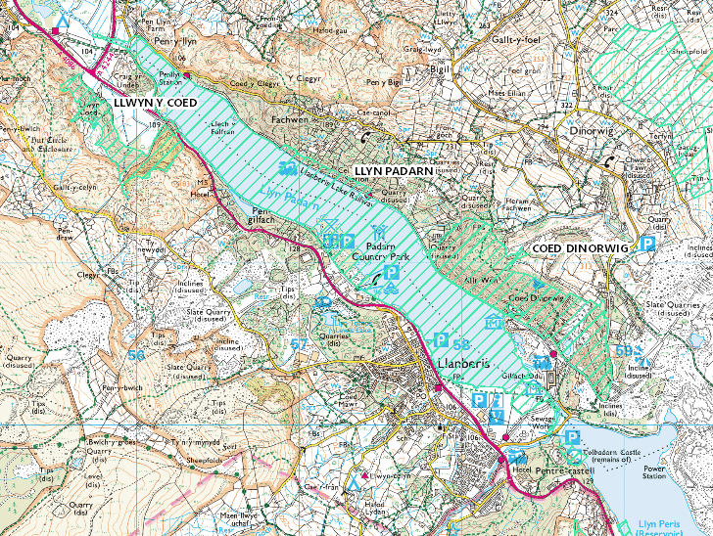
Receptors
Llyn Padarn SSSI
The cable route passes alongside Llyn Padarn. This lake is designated as a site of special scientific interest because of the genetically distinct race of Arctic Char that live in the lake as well as aquatic plants. Arctic Char and other salmonid fish species present within the lake are sensitive to suspended sediment entering the lake. Spawning in Llyn Padarn occurs locally in shallow, marginal waters, notably along Afon y Bala. The lake is also an important amenity to the local community. Llyn Padarn has now been designated as Wales's only freshwater bathing lake and the results of samples taken by Natural Resources Wales there in 2015 have reached the highest "excellent" standard.
Llwyn Y Coed SSSI
The cable route passes adjacent to Llwyn Y Coed near to Craig Yr Undeb . Llwyn Y Coed SSSI is designated for its mosses, liverworts and ferns. There are no impact pathways to these features and so this SSSI is not considered further.
Measures to prevent potential damage to the interests of the SSSIs
The Llyn Padarn SSSI is designated for Arctic charr (lake dwelling), geological interest at the northern lake shore, and aquatic plant species. The cable ducting installation works are not within the SSSI boundary, rather they are approximately 20 - 50m from the nearest lake edge and so will not directly affect aquatic flora or fauna. The field ‘Caer Ddol’ adjacent to where Joint Bay 2/3 is to be located has recently been shown to support a rich assemblage of grassland fungi at a level indicating it would be likely to qualify as SSSI under grassland fungi SSSI selection criteria. Disturbance, compression or pollution of the ground is likely to damage this interest.
Indirect effects will be controlled by following the Guidance for Pollution Prevention Works and maintenance in or near water (GPP5 & PPG6).
Any temporary dewatering activities will be overseen by the Morgan Sindall Environmental Advisor or nominated substitute. Any pumping for dewatering of excavations will be controlled by the issue of a permit to pump and controls put in place to prevent silt entering any nearby water courses. Silt mitigation such as silt curtains and / or straw bales may be required. Morgan Sindall Environmental Advisor to review silt mitigation management prior to and during the works. Inclement weather to be assessed prior to works. Regular weather forecast reviews will be undertaken.
The operation to install the new HV cable joint bays will comprise the following sequence of works:
Due to the nature of the cable route, most of the joint-bays will be in or near the carriageways of the A4086 & A4244. This will constrain the available working area when it comes to installation of joint bays.
There are a number of joint bays that have been positioned in agricultural field parcels along both carriageways including Padarn Country Park.
Each cable is 140mm in diameter and with a 2,500mm2, the cable weighs 37kg per metre.
Each phase needs to be separated from the others to meet the electrical characteristics of the cable system design and therefore the joints cannot be laid near the others.
Therefore, we make the three joints off in a delta-formation in the bay, to maximise separation, whist keeping the bay down to a minimal footprint.
Each bay slab to support the joints will therefore be approximately 15m long and 2.5m wide.
Each side of the bay, we need to “snake” the cables. The reason we do this is to create mechanical “locking bends”. This in turn ensures that the thrust forces generated as the cable expands under load, is not transferred into the joint and in time, causing the joint to fail. Each one of these lead-in sections is approximately 8m long.
As a result of the constraints of the footprint in the highways and Padarn Country Park, we will excavate the bays with vertical walls. We will install a concrete slab to support the joints. A set of hydraulic frames will be installed to prevent collapse. We then install a scaffold tent to enclose the bay, which gives the required working environment for jointing operations to commence.
Another constraint we must manage and mitigate, is that we keep the joint bay both clean and dry. Water ingress into the cables would be catastrophic. We therefore intend to install sumps in each bay and run pumps to remove any water ingress. In extreme cases, we would install a false floor to the bay, significantly increasing the “sump” capacity, to maintain suitable working conditions.
It’s worth noting, the two main sources of water ingress in the joint bay will be from rainwater run-off from the road, or groundwater ingress. The joint-bay slab will be concrete, not CBS and therefore no risk of cementitious leachate to contaminate the collected water.
Each bay will require the following approximate time in the programme:
Excavate, install shoring, pour slab, install earth mats and scaffold – 3 weeks
Install cables – 1 week
Carry out jointing of the cables – 3 weeks
Strike scaffold and remove shoring – 1 week
Backfill and reinstate – 1 week
The joint bays will require dewatering should rainfall start to fill the excavations or groundwater levels are high and excavations beneath the groundwater level are required. Any dewatering will be discharged via the highway drainage system which discharges to the adjacent land via a drainage ditch and then soaks into the surrounding land.
A number of mitigation measures have been developed to reduce the risk of any sediment laden water entering the lake directly:
- Joint bays shall be excavated/constructed using clutched trench sheets to minimise ground/rainwater ingress.
- Base of joint bay shall be cast against trench sheets to minimise groundwater entering excavation.
- Water will be pumped out of the excavations and discharged to the highway drainage system. The highway drainage system discharges to adjacent land and water soaks into the ground. The drainage system has been designed to cope with storm conditions collecting run off from the entire highway surface. The small volumes of water required to be discharged from the excavation will be a small fraction of the capacity of the drainage system. All dewatering activities will be in line with GPP5 and all discharge locations shall be inspected by the supervisor who the nominated person in the work team will be.
- Inspection of the highway gully system has highlighted that the drainage system is completely silted up in places. It is proposed that these gullies will be cleaned and proven using a gully sucker in advance of the works to clear the drainage system. This will maximise the capacity of the highway drainage system to drop any sediment out. In addition, sediment matts may be used to cover gullies to reduce sediment entering the gully network.
- A Green Rhino filtration sock (Hydrocarbon indicator) will be placed over the discharge end of the pipe to trap sand and silt particles prior to it entering the highway drainage system. The pumps will always be manned, and records of all de-watering activities recorded where they will be communicated to the ECoW and / or Morgan Sindall environmental on site at the end of each working day.
- The highway drainage system discharges to ditches which will allow water to infiltrate through the underlying sediments.
- Should any visual evidence of oil or other hydrocarbons be found within any excavation, any dewatering required will be collected and removed from the work site using a licensed waste carrier.
- Should any excavation require dewatering a watching brief will be maintained at the discharge point to ensure that no over land flow can reach the lake shore. If over land flow is seen all pumping activities will stop.
- Sandbags will be used to channel surface water away from the excavation to minimise the volume of dewatering required from open excavations.
- A supply of intermediate bulk containers will be kept on hand in case dewatering to the highway system becomes impossible due to over land flow towards the lake.
- A road bowser will be mobilised to site should this become necessary to cope with large volumes of water.
With these mitigation measures it is considered unlikely that the lake will be adversely affected.
The enclosed Morgan Sindall RAMS provide more detail on the measures to be taken at site during the works.

Plans and photographs to show the location of proposed dewatering discharge locations are given below.
Map Ref | Discharge Location | Location | Comments
Joint Bay 1/2 – Discharge 1 | SH 59042 59934 | Dinorwig Electric Mountain, Llanberis, Gwynedd, Wales, LL55 3EU, United Kingdom | Outside the SSSI. Approximately 75m outside Coed Dinorwig SSSI. Assent may not be required but included for awareness. Bespoke Environmental Permit for dewatering activities tbs to NRW by October 2022.
 |  | 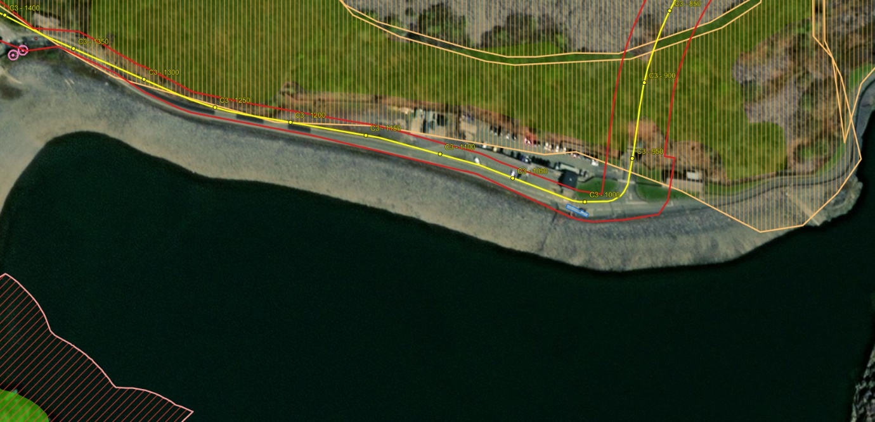
Joint Bay 2/3 – Discharge 2 | SH 58077 60165 | Llanberis Electric Mountain carpark, A4086, Llanberis, Gwynedd, Wales, LL55 4TA, United Kingdom | Outside the SSSI. Approximately 75m outside the Llyn Padarn SSSI. Works are within Caer Ddol.  Assent may not be required but included for awareness. Bespoke Environmental Permit for dewatering activities tbs to NRW by October 2022.
 |  | 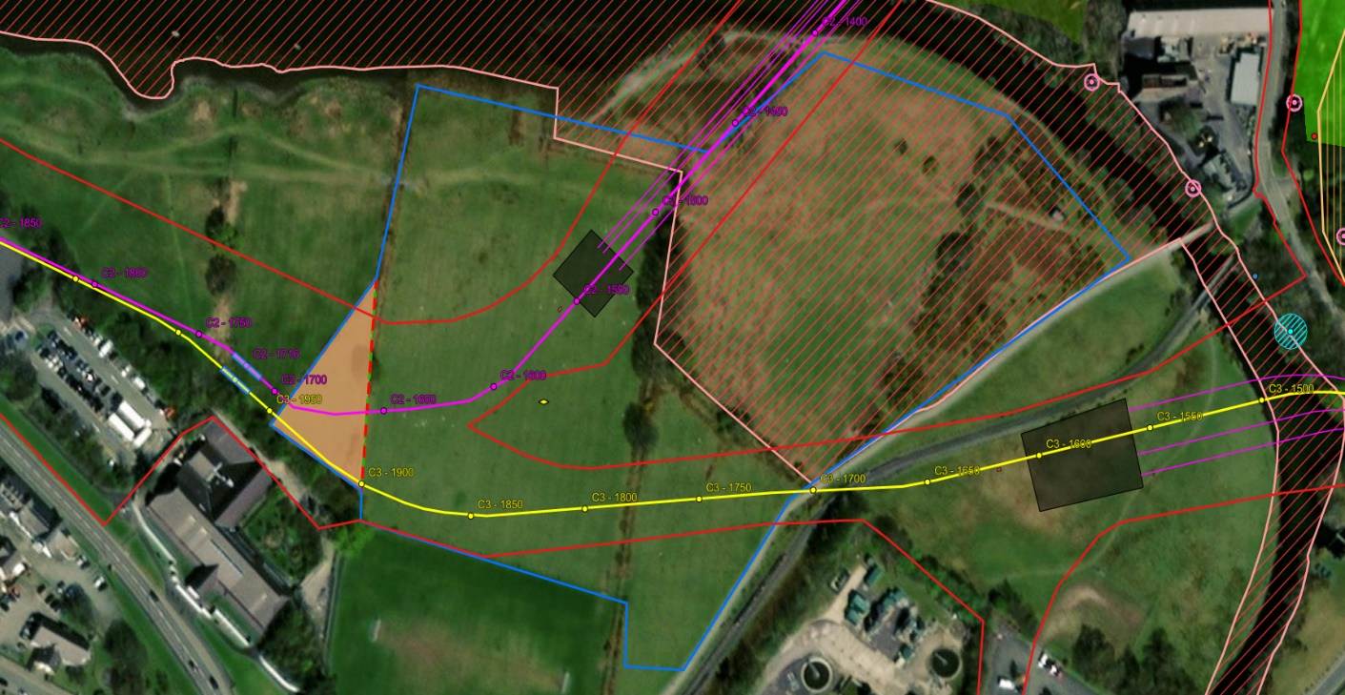
Joint Bay 3/4 – Discharge 3 | SH 57455 60728 | A4086, Clegir, Llanberis, Gwynedd, Wales, LL55 4EL | Outside the SSSI. Approximately 35m outside Coed Doctor LWS. Works are within verge of A4086.  Assent may not be required but included for awareness. Bespoke Environmental Permit for dewatering activities tbs to NRW by October 2022.
 |  | 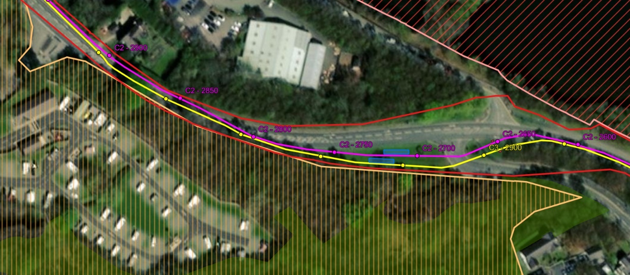
Joint Bay 4/5 – Circuit 3  Discharge 4 | SH 56935 61127 | A4086, Llanberis, Gwynedd, Wales, LL55 4BY, United Kingdom | Outside the SSSI. Approximately 130m outside the Llyn Padarn SSSI. Works are within A4086 between Pen Gilfach LWS & Glyn Rhonwy Quarries Woodland Mosiac LWS.  Assent may not be required but included for awareness. Bespoke Environmental Permit for dewatering activities tbs to NRW by October 2022.
 | 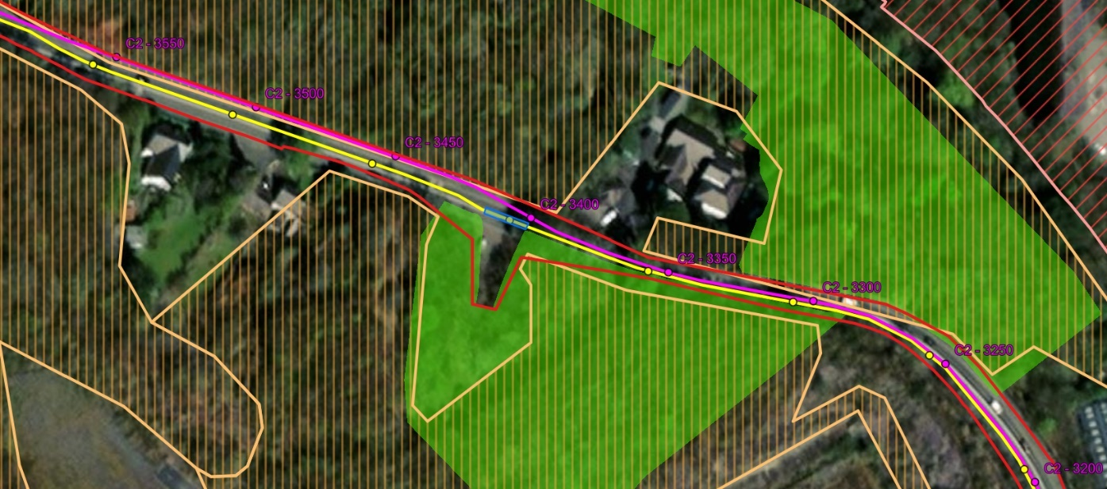
Joint Bay 4/5 – Circuit 2  Discharge 5 | SH 56741 61218 | A4086, Llanberis, Gwynedd, Wales, LL55 4BY, United Kingdom | Outside the SSSI. Approximately 130m outside the Llyn Padarn SSSI. Works are within A4086 between Pen Gilfach LWS & Llwyn Coed Heath LWS.  Assent may not be required but included for awareness. Bespoke Environmental Permit for dewatering activities tbs to NRW by October 2022.
 |  | 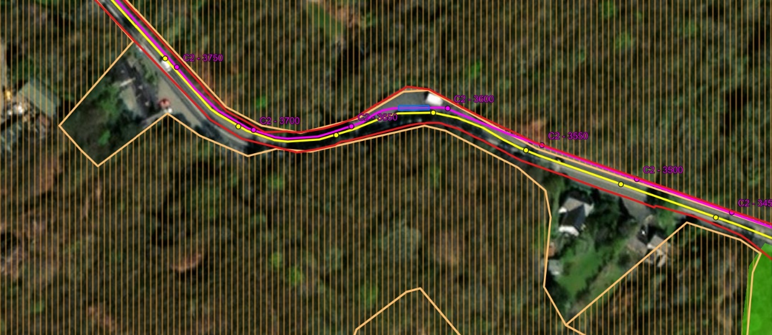
Joint Bay’s 5/6 Circuit 3 – 5/6 Circuit 2  Discharge 6 | SH 56401 61634  SH 56353 61693 | A4086, Llanberis, Gwynedd, Wales, LL55 4BY, United Kingdom | Outside the SSSI. Approximately 130m outside the Llyn Padarn SSSI. Works are within A4086 between Pen Gilfach LWS & Llwyn Coed Heath LWS.  Assent may not be required but included for awareness. Bespoke Environmental Permit for dewatering activities tbs to NRW by October 2022.
 |  | 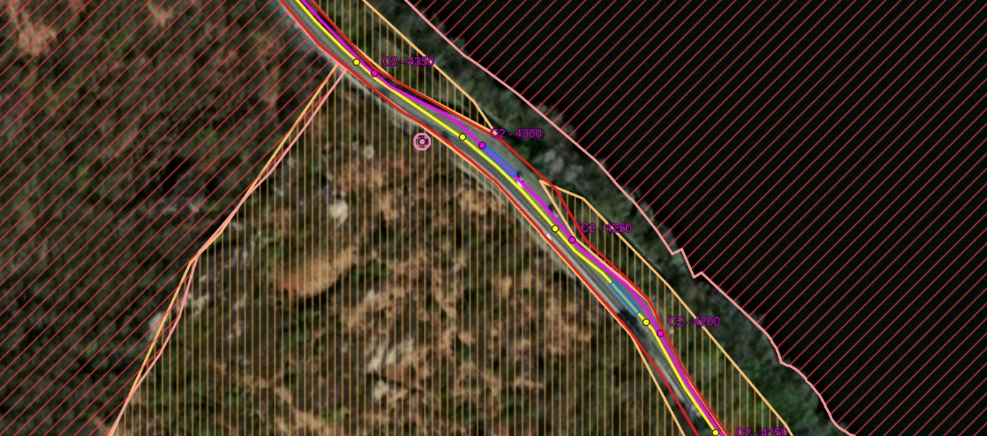
Joint Bay 6/7 – Circuit 3  Discharge 7 | SH 55798 62145 | A4086, Llanberis, Gwynedd, Wales, LL55 4BY, United Kingdom | Outside the SSSI. Approximately 200m outside the Llyn Padarn SSSI & 100m outside Llwyn Y Coed SSSI. Works are within field parcel adjacent to A4086.  Assent may not be required but included for awareness. Bespoke Environmental Permit for dewatering activities tbs to NRW by October 2022.  Discharge location already permitted under previous permit.
 |  |  | 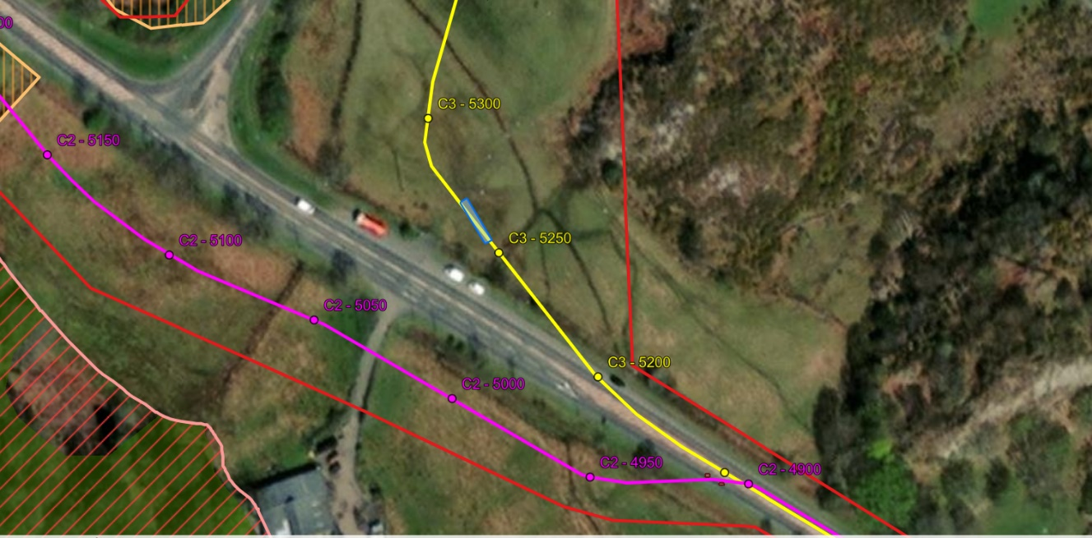
Joint Bay 6/7 – Circuit 2  Discharge 8 | SH 55643 62204 | Hafod Wen, A4086, Clegir, Llanberis, Gwynedd, Wales, LL55 4EL, United Kingdom | Outside the SSSI. Approximately 50m outside Llwyn Y Coed SSSI. Works are within field parcel opposite A4086 between Llwyn Coed Heath LWS & Pen Y Llyn LWS.  Assent may not be required but included for awareness. Bespoke Environmental Permit for dewatering activities tbs to NRW by October 2022.
 |  | 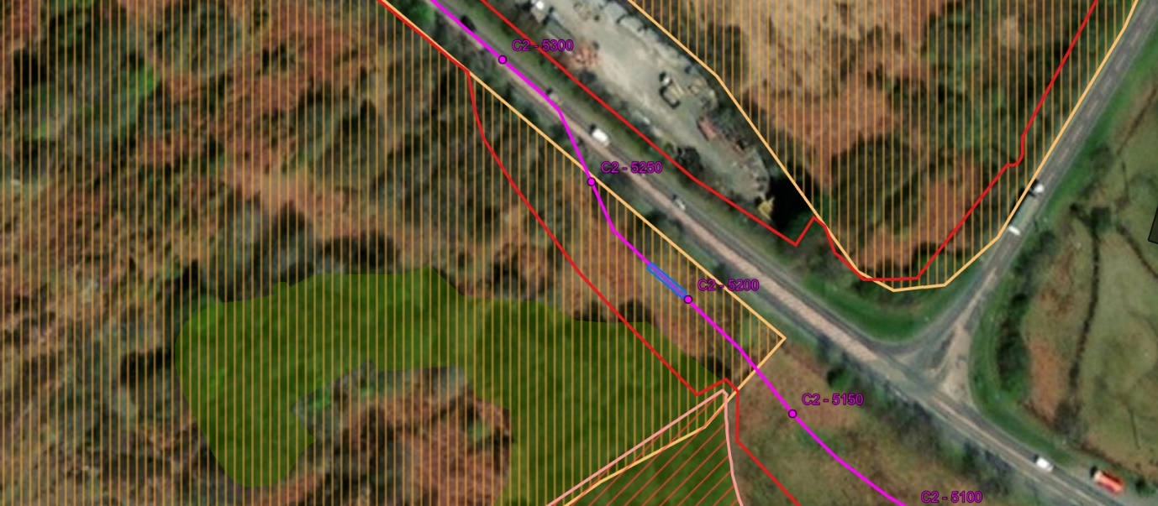
Joint Bay 7/8 – Circuit 2  Discharge 9 | SH 55098 62912 | A4086, Llanrug, Cwm-y-glo, Gwynedd, Wales, LL55 4FD, United Kingdom | Outside the SSSI. Works are within field parcel opposite A4086 between Pen Y Gaer LWS & Afon Rhythallt LWS.  Assent may not be required but included for awareness. Bespoke Environmental Permit for dewatering activities tbs to NRW by October 2022.
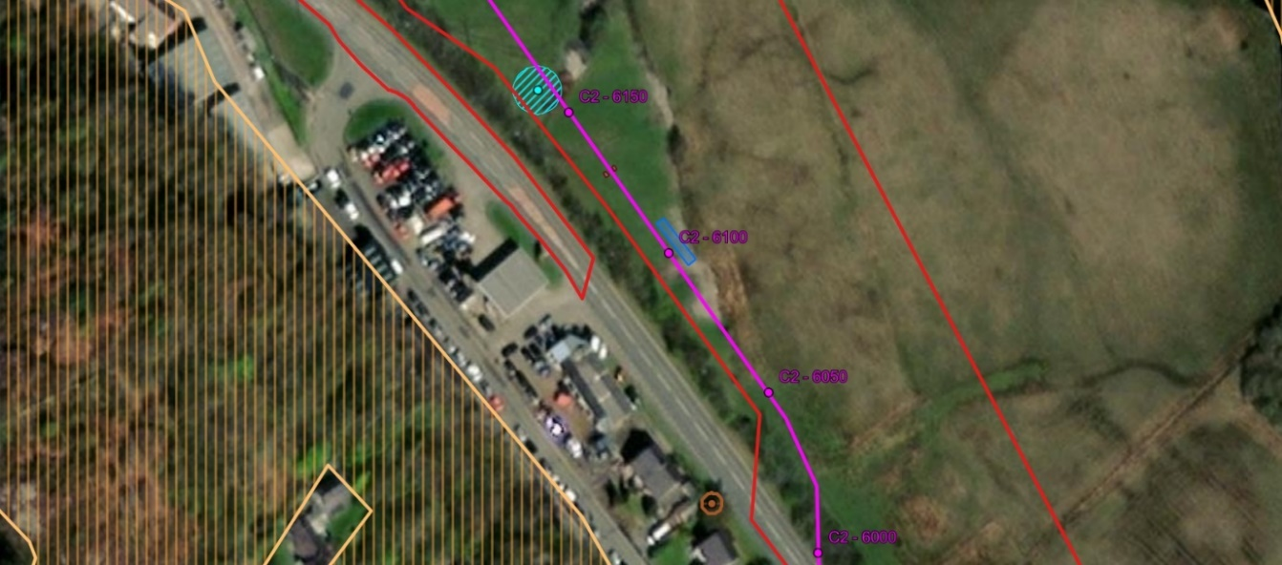

Joint Bay 7/8 – Circuit 3  Discharge 10 | SH 55938 62928 | A4244, Clwt-y-bont, Llanddeiniolen, Brynrefail, Gwynedd, Wales, LL55 3PD | Outside the SSSI. Works are within field parcel opposite A4244 between Clwt y Bont LWS & Afon Rhythallt LWS.  Assent may not be required but included for awareness. Bespoke Environmental Permit for dewatering activities tbs to NRW by October 2022.
 |  | 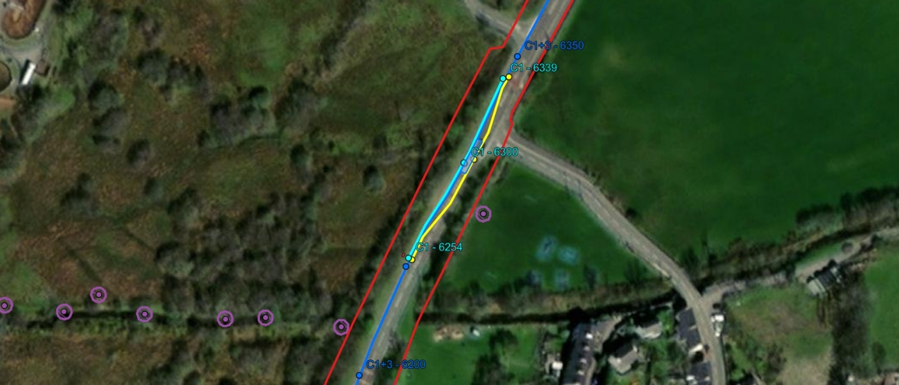
Joint Bay 8/9 – Circuit 3  Discharge 11 | SH 56089 63193 | A4244, Clwt-y-bont, Llanddeiniolen, Brynrefail, Gwynedd, Wales, LL55 3PD, | Outside the SSSI  Clwt Y Bont to the east  Gors LWS to the west
 |  | 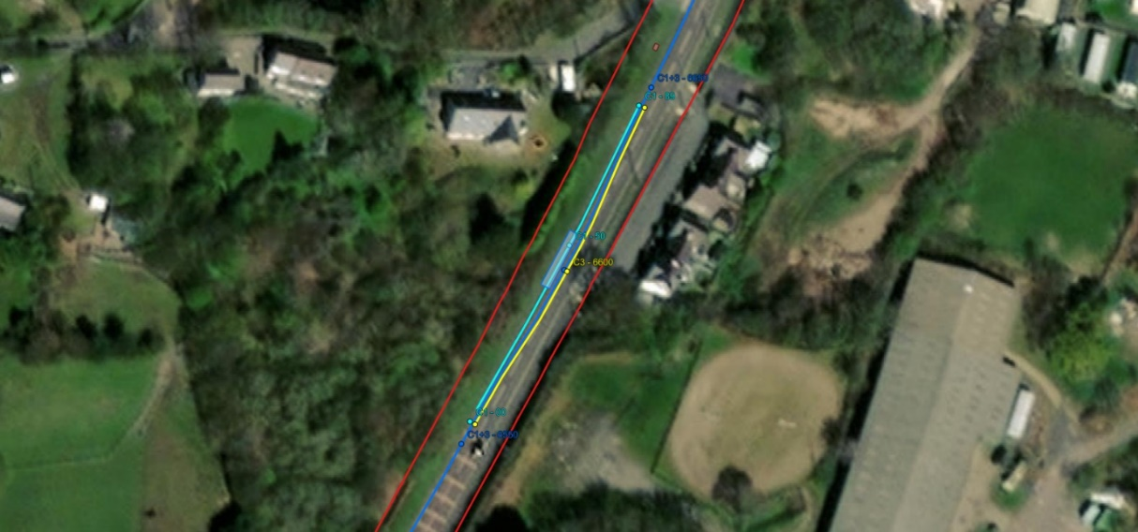
Joint Bay 9/10 – Circuit 3  Discharge 12 | SH 56459 63702 | Cooling Station, A4244, Clwt-y-bont, Llanddeiniolen, Brynrefail, Gwynedd, LL55 3PD | Outside of SSSI  Rhiwen LWS to the east  Deniol House LWS to the west
 |  | 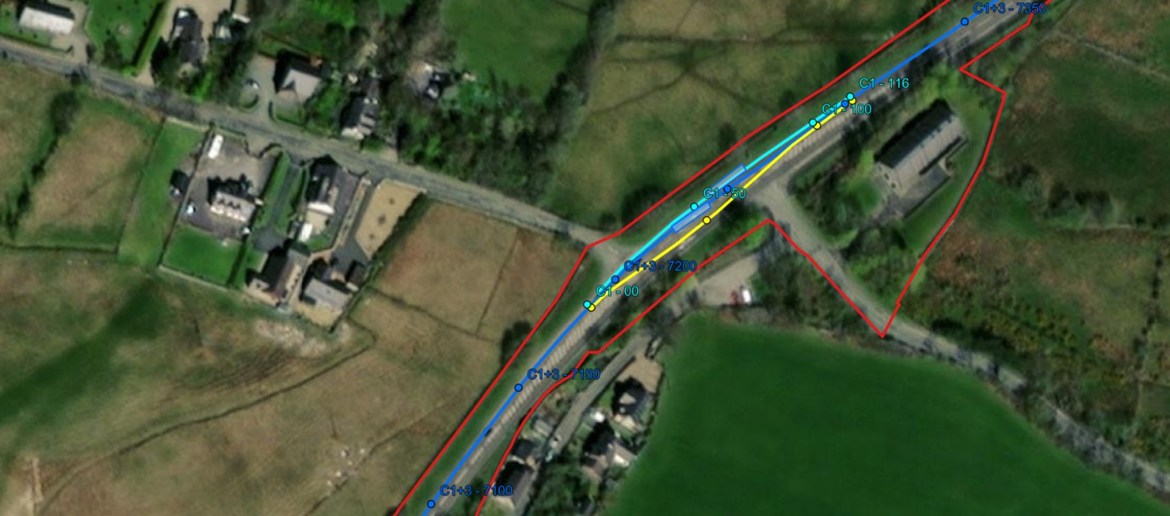
Joint Bay 10/11 – Circuit 3  Discharge 13 | SH 57039 64304 | A4244, Carfan, Llanddeiniolen, Rhiwlas, Gwynedd, Wales, LL57 4EE | Outside SSSI  Ancient woodland on both sides  Eryri SSSI to the east (320m)  Coed Blaen-y-Cae LWS, Glan-y-Gors LWS, Baron Hill LWS and Coed Tyddyn-Hendre LWS to the west
 |  |  | 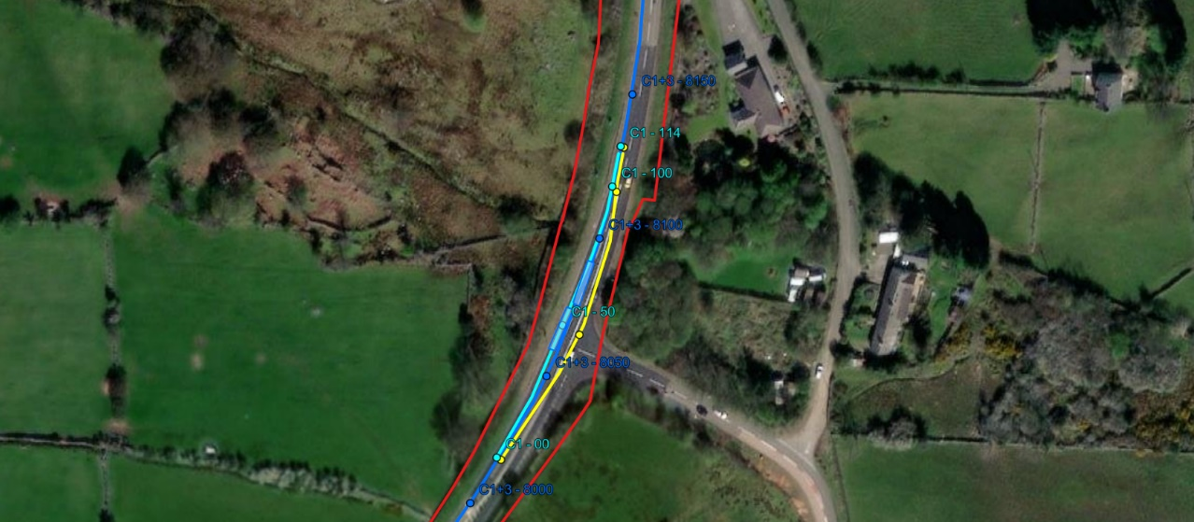
Joint Bay 11/12 – Circuit 3  Discharge 14 | SH 56758 65174 | A4244, Carfan, Llanddeiniolen, Rhiwlas, Gwynedd, Wales, LL57 4EE, | Outside SSSI  Coed Blaen-y-Cae, Glan-y-Gors LWS, Baron Hill LWS and Coed Tyddyn-hendre LWS to the west  Ancient woodland to the east and west  Rhiwlas LWS and Waen Pentir LWS to the east
 | 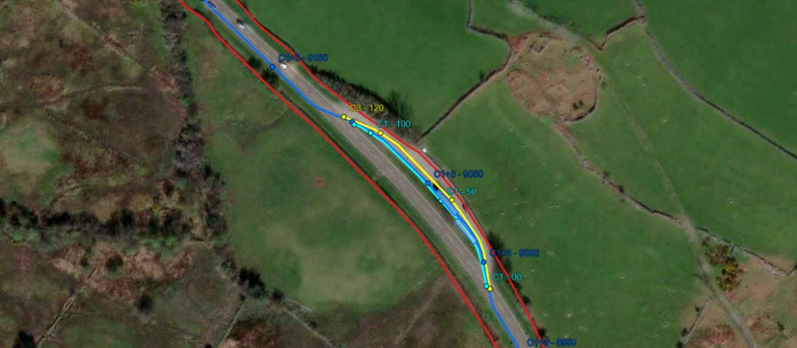
Joint Bay 12/13 – Circuit 3  Discharge 15 | SH 56308 65978 | A4244, Carfan, Llanddeiniolen, Rhiwlas, Gwynedd, Wales, LL57 4EE, | Outside SSSI  Ancient woodland to the West  Bach yr Hilfry LWS and Coed Rhydau to the west  Ynys lago LWS to the East
 |  | 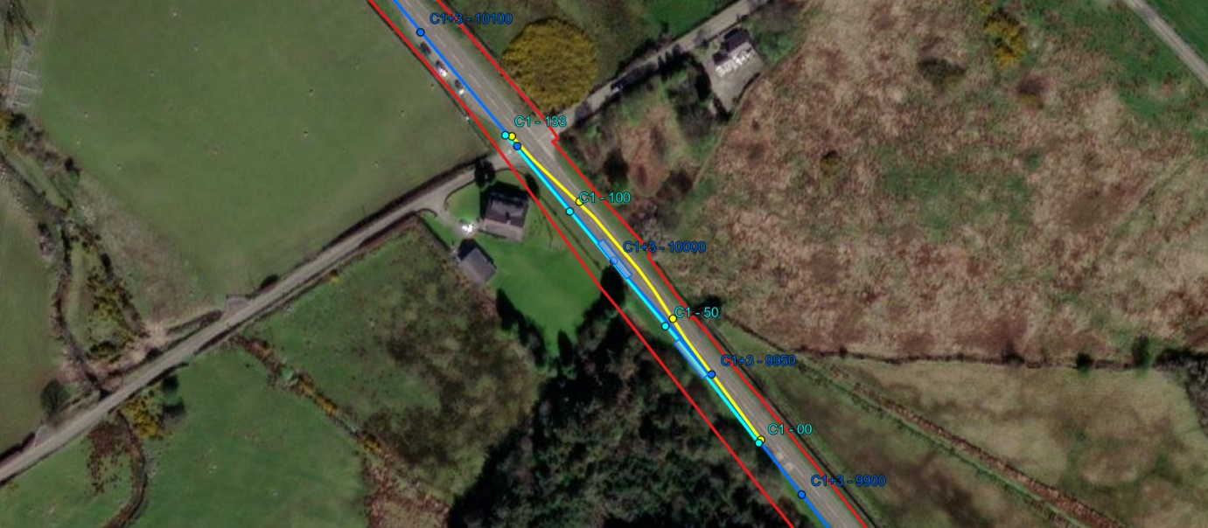
Joint Bay 12/13 – Circuit 3  Discharge 15 | SH 55816 66741 | A4244, Llanddeiniolen, Pentir, Gwynedd, Wales, LL55 3AW | Outside of SSSI  Ancient woodland to the east and west  Coed Tyddyn and water course to the West  Ynysllecharian-bach to the east
 |  | 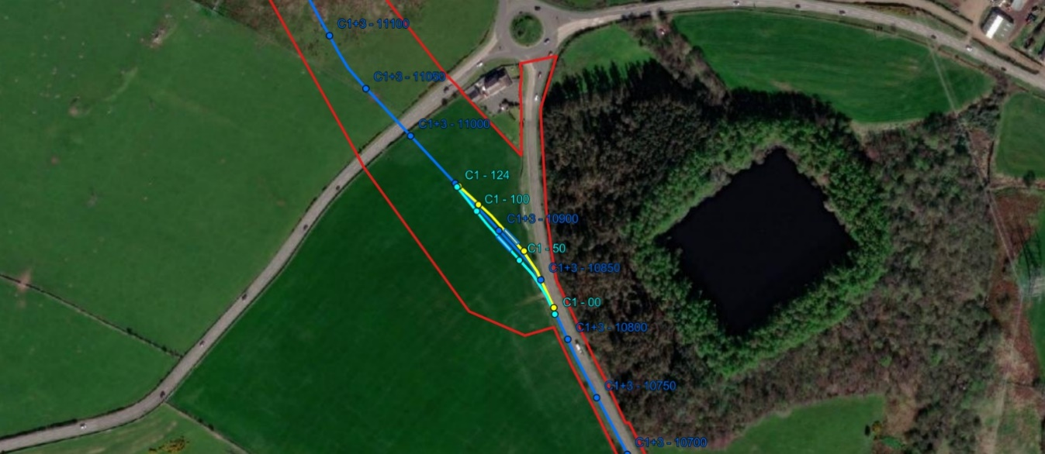
Joint Bay 13/14 – (PointA) Circuit 3  Discharge 15 | SH 55501 67280 | B4547, Seion, Llanddeiniolen, Gwynedd, Wales, LL56 4QU, | Outside of SSSI  Ancient woodland to the east  Near breakers' yard LWS to the west  Coed Ty'n-llwyn LWS to the east
 |  | 

