Background Information Note:

Llyn Padarn and Llwyn Y Coed Sites of Special Scientific Interest
Dinorwig to Pentir 400kV buried electricity cable replacement scheme – Dinorwig – Pentir 400kV (A4086 Section)
The purpose of this note is to provide NRW with background information on the Dinorwig to Pentir 400kV buried electricity cable replacement scheme that National Grid Electricity Transmission (‘National Grid’) proposes to undertake near to and adjacent to the Llyn Padarn SSSI and Llwyn Y Coed SSSI.
National Grid is a ‘public body’ in respect of Section 28G of the Wildlife and Countryside Act 1981 (as amended). Morgan Sindall therefore have notified Natural Resources Wales of our intention to undertake operations near to and adjacent to Llyn Padarn SSSI and Llwyn Y Coed SSSI that ‘are likely’ to damage its flora or fauna.
Non-Technical Summary
Morgan Sindall on behalf of National Grid are installing a new underground electricity cable to connect the hydroelectric power station at Llanberis to the national grid node at Pentir.
Part of the route for the new cable will be installed beneath the Padarn Meadows, Afon Goch Stream and a second, unnamed stream immediately to the east of Llanberis. The route runs alongside Llyn Padarn a Site of Special Scientific Interest. The lake is sensitive to silt.
The need for SSSI Assent is driven by the proximity of the proposed cable routes to the Llyn Padarn Site of Special Scientific Interest. As the route proceeds north along the A4244 there are no other designated sites within 50m of the route (Figure 1). Llwyn Y Coed SSSI is designated for its mosses, liverworts and ferns. There are no impact pathways to these features and so this SSSI is not considered further.
Figure: Working area in proximity to SSSIs
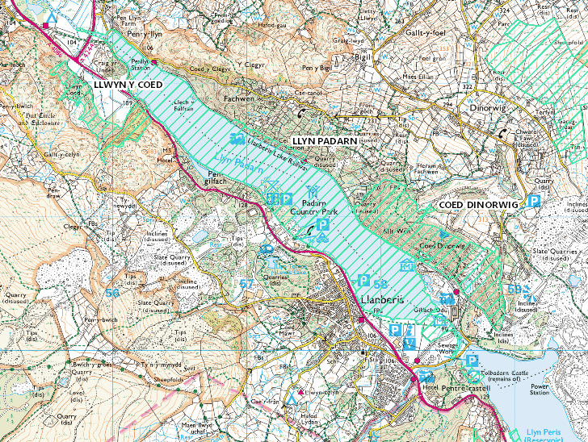
Receptors
Llyn Padarn SSSI
The cable route passes alongside Llyn Padarn. This lake is designated as a site of special scientific interest because of the genetically distinct race of Arctic char that live in the lake as well as aquatic plants. Arctic char and other salmonid fish species present within the lake are sensitive to suspended sediment entering the lake. Spawning in Llyn Padarn occurs locally in shallow, marginal waters, notably along Afon y Bala. The lake is also an important amenity to the local community. Llyn Padarn has now been designated as Wales's only freshwater bathing lake and the results of samples taken by Natural Resources Wales there in 2015 have reached the highest "excellent" standard.
Measures to prevent potential damage to the interests of the SSSIs
The Llyn Padarn SSSI is designated for Arctic char (lake dwelling), geological interest at the northern lake shore, and aquatic plant species. The cable ducting installation works are not within the SSSI boundary, rather they are approximately 20 - 50m from the nearest lake edge and so will not directly affect aquatic flora or fauna.
Indirect effects will be controlled by following the Guidance for Pollution Prevention Works and maintenance in or near water (GPP5 & PPG6).
Any temporary dewatering activities will be overseen by the Morgan Sindall Environmental Advisor or nominated substitute. Any pumping for dewatering of excavations will be controlled by the issue of a permit to pump and controls put in place to prevent silt entering any nearby water courses. Silt mitigation such as silt curtains and / or straw bales may be required. Morgan Sindall Environmental Advisor to review silt mitigation management prior to and during the works. Inclement weather to be assessed prior to works. Regular weather forecast reviews will be undertaken.
The operation to install the new HV cable ducts will comprise the following sequence of works:
- Install temporary footpath diversions.
- Close off pedestrian crossing across A4086.
- Set up lane closure with 2 way traffic lights on A4086 expected duration 3 weeks.
- Set up heras fencing to provide segregation
- Set up surface water, groundwater silt mitigation measures as per sketch. To be agreed with NRW i.e. settlement tank, silt bag, silt fencing in accordance with bespoke environmental permit.
- Specialist to disconnect & remove lighting column.
- Take down gate, wall, fence signs etc., to provide access
- Mobilise large plant to car park area.
- Where applicable, strim and de-veg river bank, under ECoW watching brief, refer to MS Ecology Management Plan – note Himalayan balsam present.
- Install flume pipe 800 dia x 8m long to provide access over watercourse (flume installation methodology detailed below). Flume size to be confirmed via TWD.
- Install ducting as per standard duct installation methods.
- Groundwater to be pumped through silt management system and in line with Bespoke Permit & SSSI assent.
- Install ducting under flumed watercourse and remove flume.
- Reinstate bed of watercourse, with river bed materials
- Reinstate banks of watercourse
- Install ducting through into car park
- Reinstate play park, gate, walls, sign
- Reinstate watercourse sides etc.
- Reinstate kerbs and tarmac to area
- Re-open pedestrian crossing, play park & remove temporary footpath
Each section will take approximately 3-weeks to complete
As the cable ducts need to be installed in the dry to avoid any water coming into contact with the cables the ground around each section ducting will be dewatered. All water removed as part of the dewatering works will be treated prior to discharge to a groundwater dissipation sump as detailed below:
- All pumping to be in accordance with MS permit to pump system, SSSI Assent & bespoke permit conditions.
- Set up silt fencing & straw bales to design.
- Set up settlement tank and silt bag for outlet pipe to discharge into.
- Set up two 6” pumps on bunded drip trays, duty & stand by b& associated agging in a location as least 8m away from water course and Llyn Padarn.
- Carefully excavate sump comprising 450 dia perforated pipe wrapped in non-woven geotextile material & 20mm single size clean stone.
- Offline sumps to be located adjacent and below the low points to effectively de-water the trench bottom to avoid cable ducting coming into contact with groundwater.
- Any small infiltration into the trenches can be pumped into the main sump;
- Flows to pass through settlement tank, silt bag and into groundwater dissipation sump, & silt fencing.
- Monitoring system to be in place to ensure the works are not allowing water contaning seidment from entering the lake.
- Should silty water be found to be entering the lake the works shall cease and additional controls be implemented
- Works to stop & pumping stopped should water become silt lader.
- Should any visual evidence of oil or other hydrocarbons be found within any excavation, any dewatering required will be collected and removed from the work site using a licensed waste carrier.
- Should any excavation require dewatering a watching brief will be maintained at the discharge point to ensure that no over land flow can reach the lake shore. If over land flow is seen all pumping activities will stop.
- Sandbags will be used to channel surface water away from the excavation to minimise the volume of dewatering required from open excavations.
- A road bowser will be mobilised to site should this become necessary to cope with large volumes of water.

An example of the works layout can be found in the figures below.
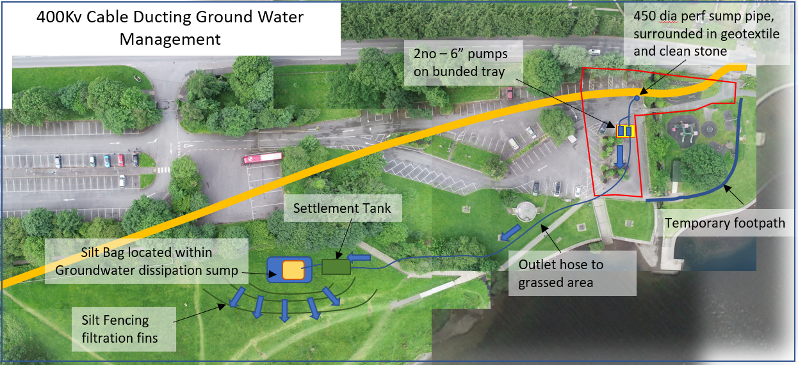
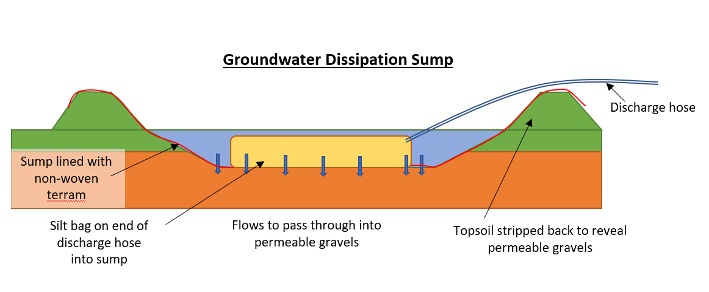
With these mitigation measures it is considered unlikely that the lake will be adversely affected.
The enclosed Morgan Sindall/Waitings RAMS provide more detail on the measures to be taken at site during the works.

