Permit
The Environmental Permitting (England & Wales) Regulations 2016

Artico Environmental Limited

Units 1-3 Sirius Drive,
Seaway Parade Industrial Estate, Baglan Energy Park,
Port Talbot.
SA12 7BR

Permit number

EPR/CB3894CN

Permit
The Environmental Permitting (England and Wales) Regulations 2016
Permit number

EPR/CB3894CN

The Natural Resources Body for Wales (“Natural Resources Wales”) authorises, under regulation 13 of the Environmental Permitting (England and Wales) Regulations 2016

Artico Environmental Limited,

whose registered office is

Tank Farm Road,

Llandarcy,

Neath,

Wales,

SA10 6EN

company registration number 12085491

to operate waste operations at

Artico Environmental Limited

Units 1-3 Sirius Drive,

Seaway Parade Industrial Estate,

Baglan Energy Park,

Port Talbot.

SA12 7BR

to the extent authorised by and subject to the conditions of this permit.

Under regulation 27(2) of the Regulations, standard rules SR2008 No9 are conditions of this permit.

Name | Date
Huw Davies | 17/05/2023

Authorised on behalf of Natural Resources Wales

Schedule 1 - Site plan

This is the plan referred to in the standard rules SR2008 No9

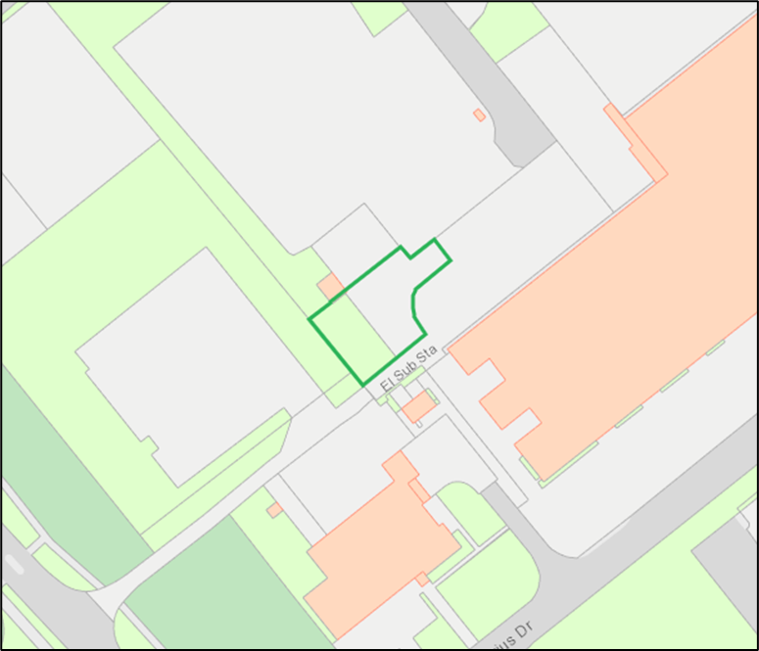

© Crown Copyright and database right 2023. Ordnance Survey licence number 100019741.

END OF PERMIT

