PAN-021568 My Map Report:

Application map
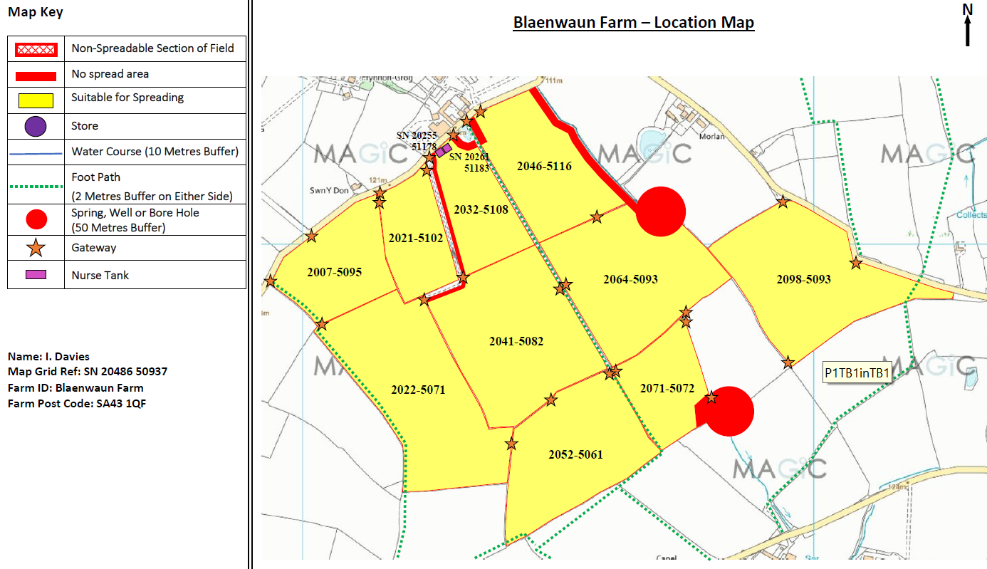
Deployment Boundaries and Storage
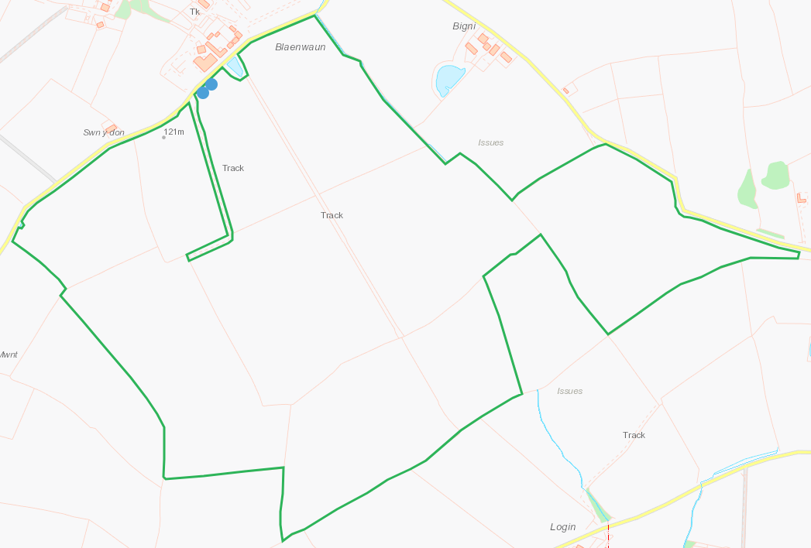
Detailed river network within 10m.
Pond W of field 2007-5095 not identified on application maps, buffers required. RFI
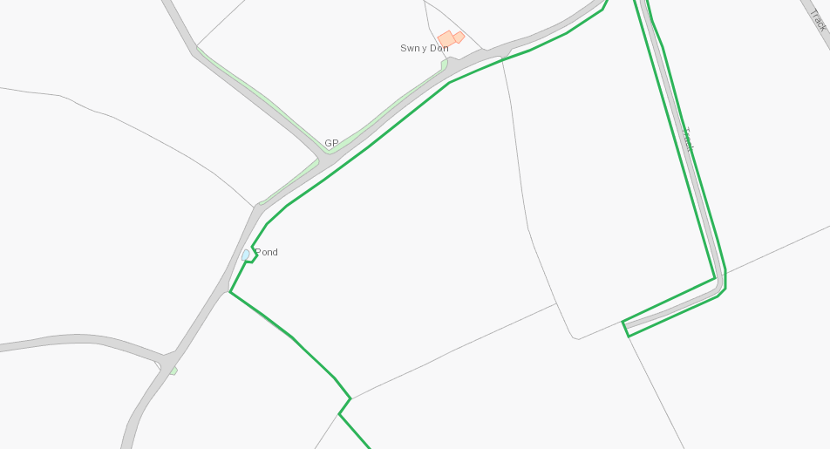

Pond W and watercourse, flowing SE-NW, adjacent NE to field 2046-5116, shown with buffers on application map.
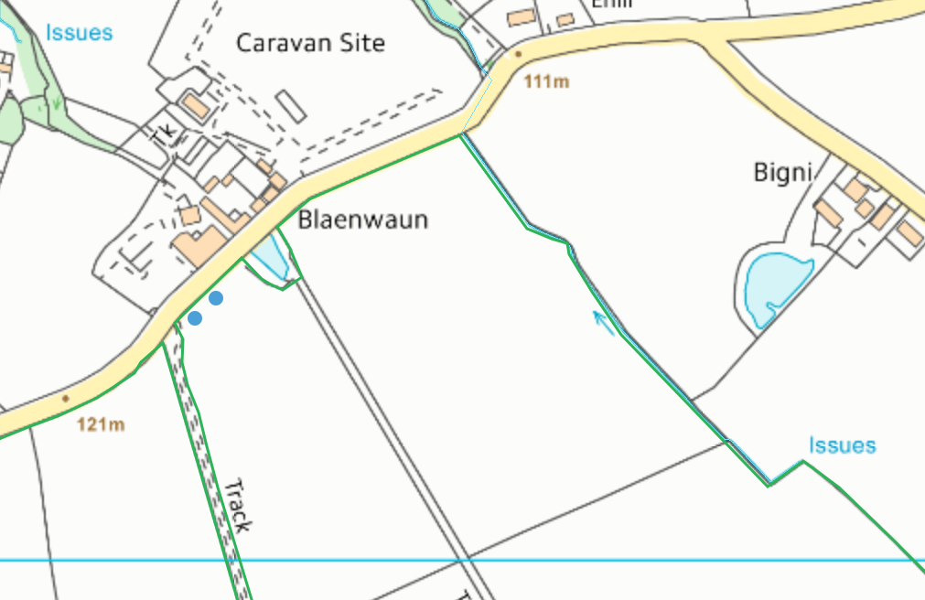
All other fields none
Groundwater protection zones
None
Any well, spring (or issue) or borehole used / not used for the supply of water for human consumption including from a private water supply or supplies within 50m.
Issue NE of field 2064-5093, issue E of field 2071-5072. Shown with buffers on application map.
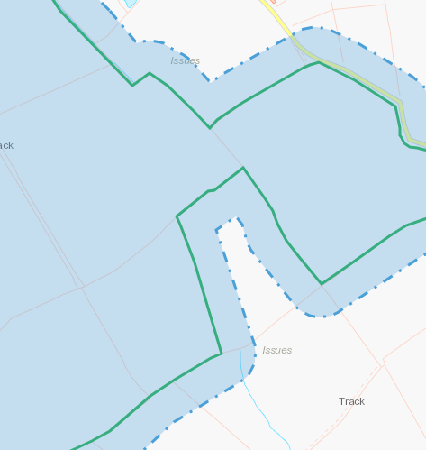
None at other feilds
Any well, spring (or issue) or borehole used / not used for the supply of water for human consumption including from a private water supply or supplies within 250m.
Collects E of field 2098-5093, shown on application map.

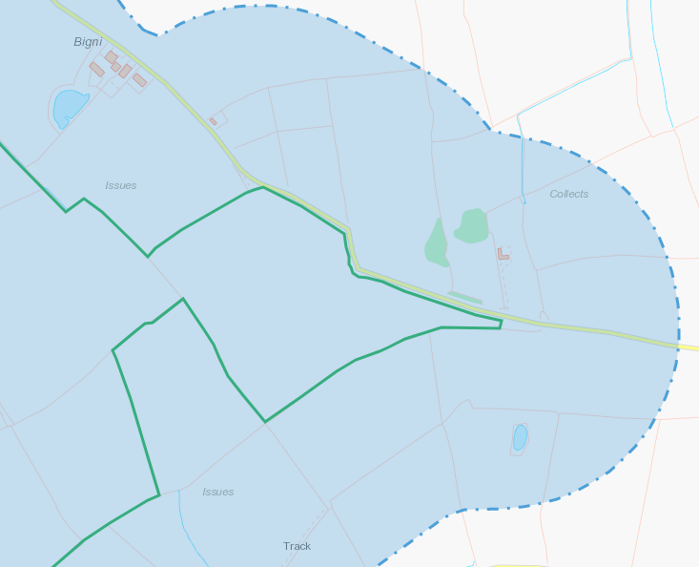
European designated sites- Natura 2000 (SPA, pSPA, SAC or cSAC) or Ramsar- or SSSI within 500m

None
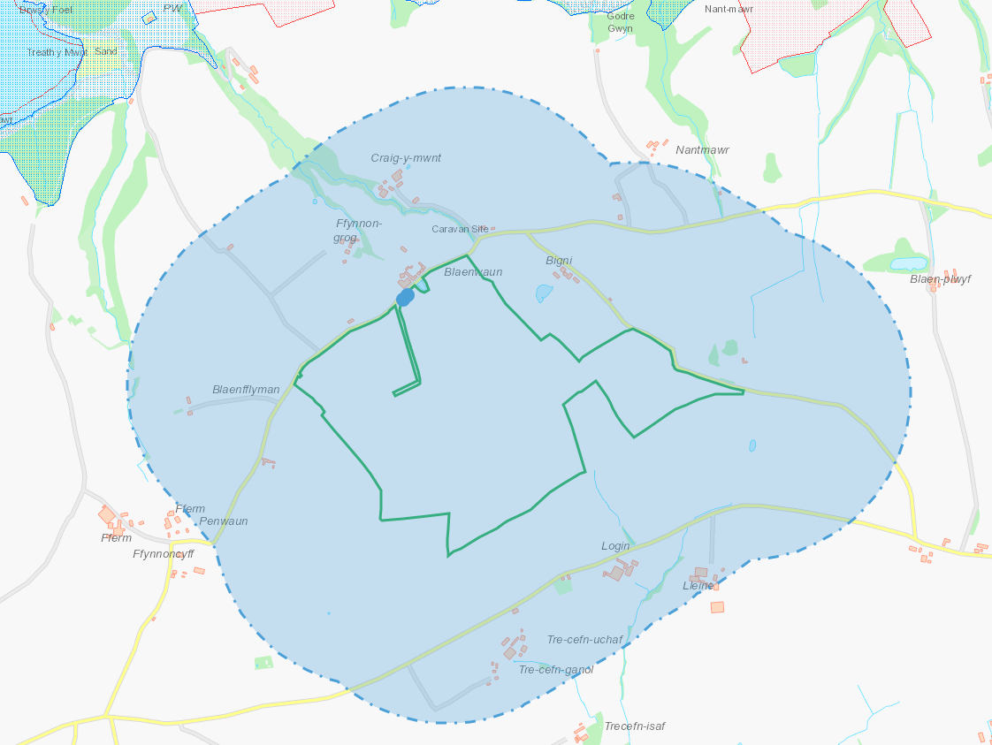
Other protected sites within 500m
- Protected Species-
- Protected Habitats-
- Scheduled Ancient Monument-
- Local Nature Reserve-
- National Nature Reserve-
- Ancient Woodlands-
- Local Wildlife Sites (SINC)-
- National Park-
- Nitrate Vulnerable Zone (NVZ)-
- Groundwater Safeguard Zone-
- Hedges-
- Ditches-

None
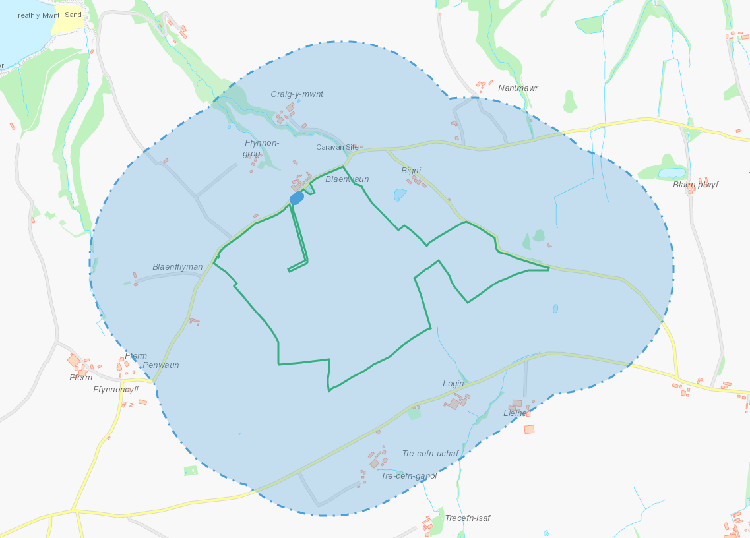
Public rights of way
All shown an application maps
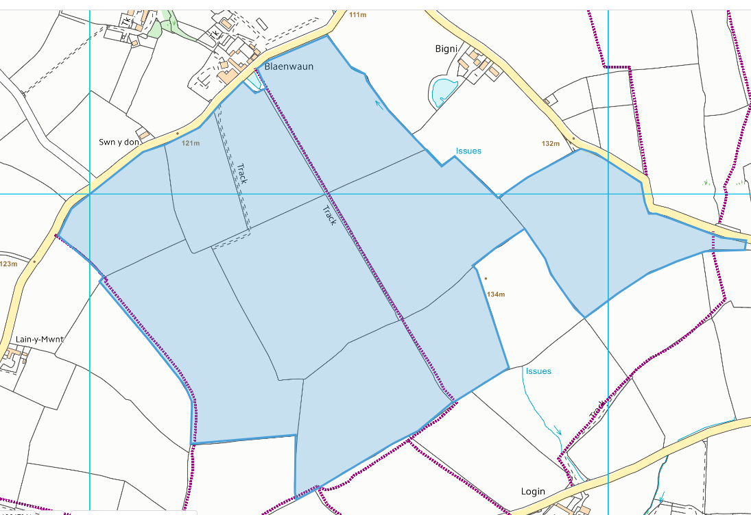
Distance from Main Farm Address
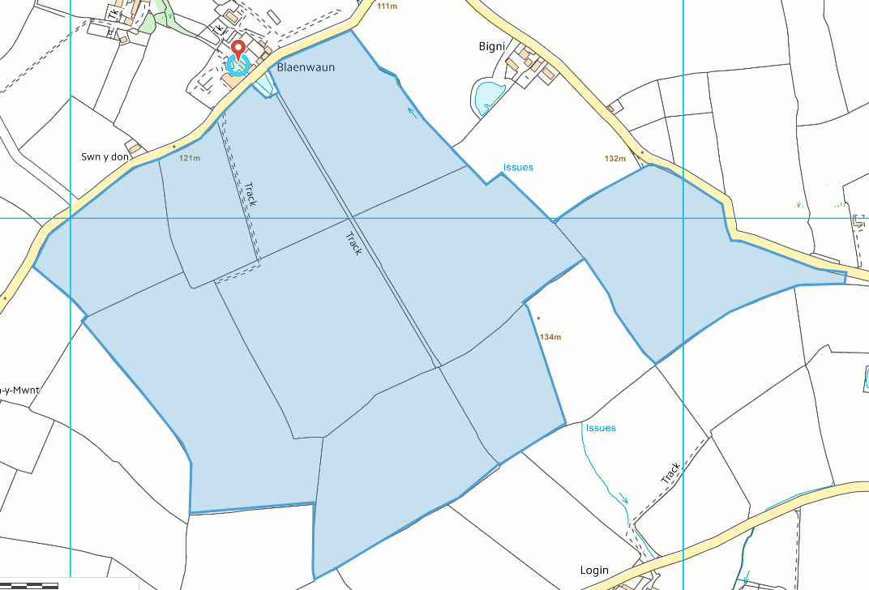
Slope Map
All fields 0-7 degrees
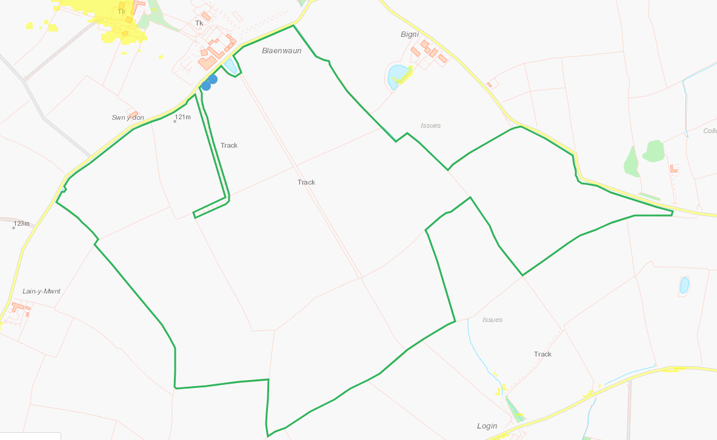

END

