Dinorwig – Pentir 400kV (A4086 Section)
SITE CONDITION REPORT

For full details, see H5 SCR guide for applicants v2.0 4 August 2008

COMPLETE SECTIONS 1-3 AND SUBMIT WITH APPLICATION

DURING THE LIFE OF THE PERMIT: MAINTAIN SECTIONS 4-7

AT SURRENDER: ADD NEW DOC REFERENCE IN 1.0; COMPLETE SECTIONS 8-10; & SUBMIT WITH YOUR SURRENDER APPLICATION.

1.0 SITE DETAILS

Name of the applicant | Morgan Sindall
Activity address | Along A4086 Llanberis
National grid reference | Southern end 257793,360419  Northern end 255803,362108

Document reference and dates for Site Condition Report at permit application and surrender | Permit Application: A4086 Section Site Condition Record P01  Permit Surrender:

Document references for site plans (including location and boundaries) | Site Location Plan  Detailed plans:  16875-MSI-0608-XX-DR-C-010017  16875-MSI-0608-XX-DR-C-010018  16875-MSI-0608-XX-DR-C-010022  16875-MSI-0608-XX-DR-C-010023

Note:
In Part A of the application form you must give us details of the site’s location and provide us with a site plan. We need a detailed site plan (or plans) showing:

- Site location, the area covered by the site condition report, and the location and nature of the activities and/or waste facilities on the site.
- Locations of receptors, sources of emissions/releases, and monitoring points.
- Site drainage.
- Site surfacing.

If this information is not shown on the site plan required by Part A of the application form then you should submit the additional plan or plans with this site condition report.

2.0 Condition of the land at permit issue

Environmental setting including:  - geology  - hydrogeology  - surface waters | There are no superficial deposits recorded along the southern section of the proposed cable routes (along the shores of Llyn Padarn to the Dinorwig Power Station), with the exception of a small area of alluvial fan deposits around Llanberis and beneath the Llanberis Lake railway line on the north bank of Llyn Padarn south east of Cei Llydan Station.  The solid geology comprises the following lithologies from Llanberis northwards:  - Bronllwyd Grit Fm – sandstone  - Llanberis Slates Fm – mudstone, siltstone and sandstone  - Fachwen Fm - sandstone and conglomerate, interbedded  - Padarn Tuff Fm - tuff, felsic  The A4086 is built on imported crushed rock.
Pollution history including:  - pollution incidents that may have affected land  - historical land-uses and associated contaminants  - any visual/olfactory evidence of existing contamination  - evidence of damage to pollution prevention measures | The cable route generally follows the A4086 along the western shore of Llyn Padarn. Any highway related pollution would be intercepted by the drainage system. There is no evidence of any pollution being present in the subsurface.  According to Gwyneth Council the highway drainage system discharges to land adjacent to the road.
Evidence of historic contamination, for example, historical site investigation, assessment, remediation and verification reports (where available) | There are no indications that the sub base beneath the road contains any contaminative materials.
Baseline soil and groundwater reference data | Socotec GI Factual Report F1015-20/ Sep 2020  Socotec GI Factual Report F1004-21/2 June 2021
Supporting information | Socotec GI Factual Report F1015-20/ Sep 2020  Socotec GI Factual Report F1004-21/2 June 2021

3.0 Permitted activities

Permitted activities | Dewatering excavations.
Non-permitted activities undertaken | Excavation of trench and placement of cable ducting, with reinstatement to road surface
Document references for:  - plan showing activity layout; and  - environmental risk assessment. | Site Location Plan shows route of cable  Environmental Risk Assessment (attached to this document)

Note:
In Part B of the application form you must tell us about the activities that you will undertake at the site. You must also give us an environmental risk assessment. This risk assessment must be based on our guidance (Environmental Risk Assessment - EPR H1) or use an equivalent approach.

It is essential that you identify in your environmental risk assessment all the substances used and produced that could pollute the soil or groundwater if there were an accident, or if measures to protect land fail.

These include substances that would be classified as ‘dangerous’ under the Control of Major Accident Hazards (COMAH) regulations and also raw materials, fuels, intermediates, products, wastes and effluents.

If your submitted environmental risk assessment does not adequately address the risks to soil and groundwater we may need to request further information from you or even refuse your permit application.

4.0 Changes to the activity

Have there been any changes to the activity boundary? |  | If yes, provide a plan showing the changes to the activity boundary.
Have there been any changes to the permitted activities? |  | If yes, provide a description of the changes to the permitted activities
Have any ‘dangerous substances’ not identified in the Application Site Condition Report been used or produced as a result of the permitted activities? |  | If yes, list of them
Checklist of supporting information | - Plan showing any changes to the boundary (where relevant)  - Description of the changes to the permitted activities (where relevant)  - List of ‘dangerous substances’ used/produced by the permitted activities that were not identified in the Application Site Condition Report (where relevant)

5.0 Measures taken to protect land

Use records that you collected during the life of the permit to summarise whether pollution prevention measures worked. If you can’t, you need to collect land and/or groundwater data to assess whether the land has deteriorated.

Checklist of supporting information | - Inspection records and summary of findings of inspections for all pollution prevention measures  - Records of maintenance, repair and replacement of pollution prevention measures

6.0 Pollution incidents that may have had an impact on land, and their remediation

Summarise any pollution incidents that may have damaged the land. Describe how you investigated and remedied each one. If you can’t, you need to collect land and /or groundwater reference data to assess whether the land has deteriorated while you’ve been there.

Checklist of supporting information | - Records of pollution incidents that may have impacted on land  - Records of their investigation and remediation

7.0 Soil gas and water quality monitoring (where undertaken)

Provide details of any soil gas and/or water monitoring you did. Include a summary of the findings. Say whether it shows that the land deteriorated as a result of the permitted activities. If it did, outline how you investigated and remedied this.

Checklist of supporting information | - Description of soil gas and/or water monitoring undertaken  - Monitoring results (including graphs)

8.0 Decommissioning and removal of pollution risk

Describe how the site was decommissioned. Demonstrate that all sources of pollution risk have been removed. Describe whether the decommissioning had any impact on the land. Outline how you investigated and remedied this.

Checklist of supporting information | - Site closure plan  - List of potential sources of pollution risk  - Investigation and remediation reports (where relevant)

9.0 Reference data and remediation (where relevant)

Say whether you had to collect land and/or groundwater data. Or say that you didn’t need to because the information from sections 3, 4, 5 and 6 of the Surrender Site Condition Report shows that the land has not deteriorated.

If you did collect land and/or groundwater reference data, summarise what this entailed, and what your data found. Say whether the data shows that the condition of the land has deteriorated, or whether the land at the site is in a “satisfactory state”. If it isn’t, summarise what you did to remedy this. Confirm that the land is now in a “satisfactory state” at surrender.

Checklist of supporting information | - Land and/or groundwater data collected at application (if collected)  - Land and/or groundwater data collected at surrender (where needed)  - Assessment of satisfactory state  - Remediation and verification reports (where undertaken)

10.0 Statement of site condition

Using the information from sections 3 to 7, give a statement about the condition of the land at the site. This should confirm that:

- the permitted activities have stopped
- decommissioning is complete, and the pollution risk has been removed
- the land is in a satisfactory condition.

1.0 Environmental Risk Assessment

1.1 Identification of Risks
The activity which requires an environmental permit is the discharge of rainwater and groundwater from excavations in the A4086 highway. Whilst there is no evidence of contamination within the underlying road subbase it is considered likely that sediment will become entrained within the pumped water unless specific measures are taken to prevent this.

The need for a bespoke permit is driven by the proximity of the proposed cable routes to the Lyn Padarn and Llwyn y Coed Sites of Special Scientific Interest. As the route proceeds north along the A4244 there are no other designated sites within 50m of the route (Figure 1). Llwyn y Coed SSSI is designated for its mosses, liverworts and ferns. There are no impact pathways to these features and so this SSSI is not considered further.

Figure 1: Cable route in proximity to SSSIs
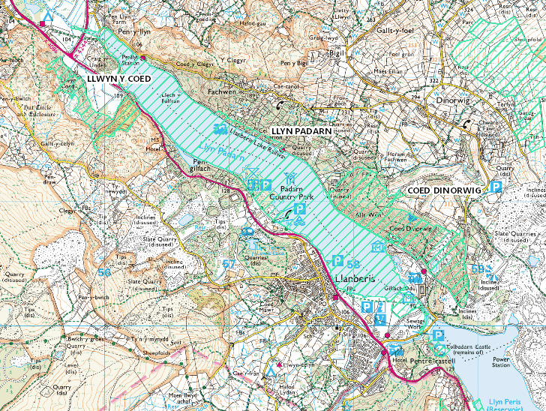
Source: Ordnance Survey © Crown copyright 2020. All rights reserved. Licence number 100026791

The operation to install the new cable ducts will comprise the following sequence of works:
- A 12m long 2.5m wide section of highway surface will be cut with a floor saw
- The macadam road surface will be broken out and disposed off site
- The subbase will be excavated to 1.0m
- The base of the excavation will be laid with cement bound sand. The cement bound sand is mixed off site and brought to the excavation area in the quantities needed.
- Cable ducts are placed onto the cement bound sand and are then covered with more cement bound sand
- Once set, the trench is backfilled and surfaced with macadam.

It is envisaged that a 12m long section can be completed in a working day which minimises the volume of open excavation and so reduces the volume of any water that will need to be pumped out.

This part of the overall project is to lay new cables, there are no existing cables to be removed along the A4086.

The pumping system will comprise a single portable pump which will be used as required to drain the trench during excavation and filling.

1.2 Receptors
The cable route passes alongside Llyn Padarn. This lake is designated as a site of special scientific interest because of the genetically distinct race of Arctic Char that live in the lake as well as aquatic plants. Arctic Char and other salmonid fish species present within the lake are sensitive to suspended sediment entering the lake. The lake is also an important amenity to the local community.

1.3 Proposed Mitigation
The following mitigation measures are proposed to control sediment:
- Water will be pumped out of the excavation and discharged to the highway drainage system. The highway drainage system discharges to adjacent land and water soaks into the ground. The drainage system has been designed to cope with storm conditions collecting run off from the entire highway surface. The small volumes of water required to be discharged from the excavation will be a small fraction of the capacity of the drainage system.
- Inspection of the highway gully system has highlighted that the drainage system is completely silted up in places. It is proposed that these gullies will be cleared using a gully sucker in advance of the works to clear the drainage system. This will maximise the capacity of the highway drainage system to drop any sediment out.
- A filtration sock will be placed over the discharge end of the pipe to trap sand and silt particles prior to it entering the highway drainage system.
- The highway drainage system discharges to ditches which will allow water to infiltrate through the underlying sediments.
- Should any visual evidence of oil or other hydrocarbons be found within any excavation, any dewatering required will be collected and removed from the work site.
- Should any excavation require dewatering a watching brief will be maintained at the discharge point to ensure that no over land flow can reach the lake shore. If over land flow is seen all pumping activities will stop.
- Each open section will be open for 1 working day; should the weather forecast predict unusual rainfall, or a flood warning be issued work can be suspended temporarily.
- Sandbags will be used to channel surface water away from the excavation to minimise the volume of dewatering required.
- A supply of intermediate bulk containers will be kept on hand in case dewatering to the highway system becomes impossible due to over land flow towards the lake.
- A road bowser will be mobilised to site should this become necessary to cope with large volumes of water.

1.4 Discharge Quality
The excavations into the road subbase will be free of contaminants, the subbase is comprised of slate gravel and free from mobile contaminants. The discharge may contain suspended sediment and a proposed limit of 50mg/l suspended solids is proposed to be discharged into the highway drainage system. The water will be subject to further attenuation as it moves through the highway drainage system and into the drainage ditch and ultimately into the underlying soil.

1.5 Conclusion
With the mitigation measures described above it is considered that there will be no adverse risk to water quality within Llyn Padarn.

