PAN-021655 My Map Report:
Application map
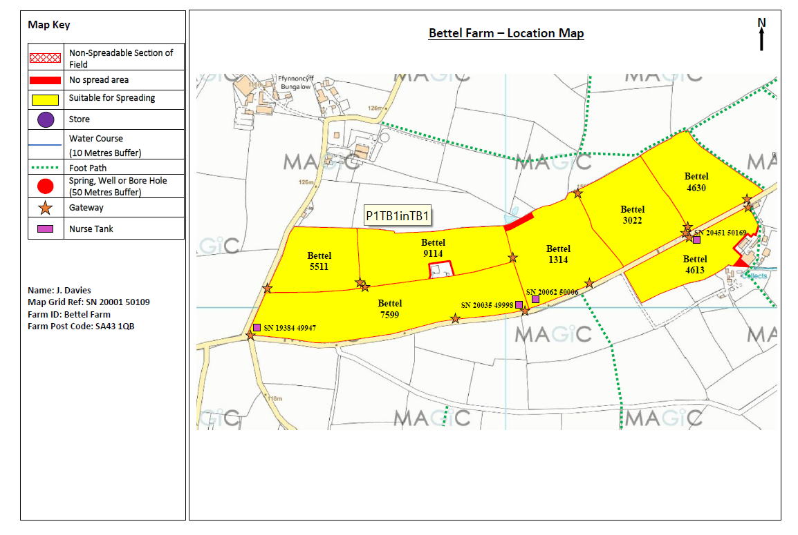
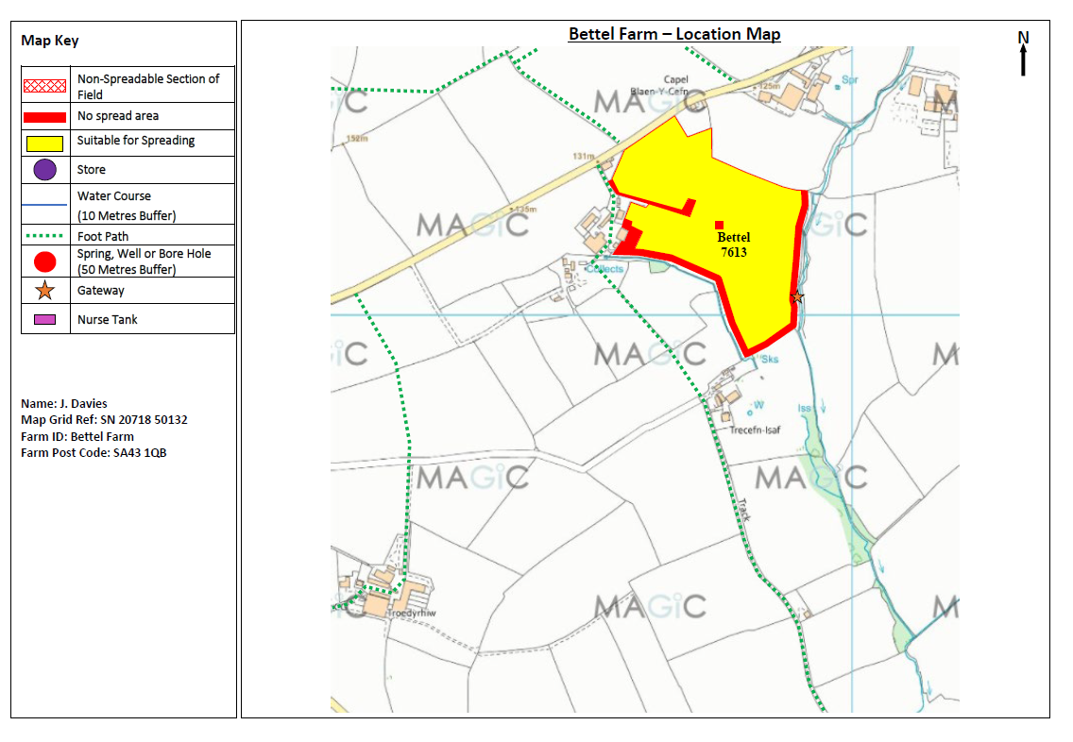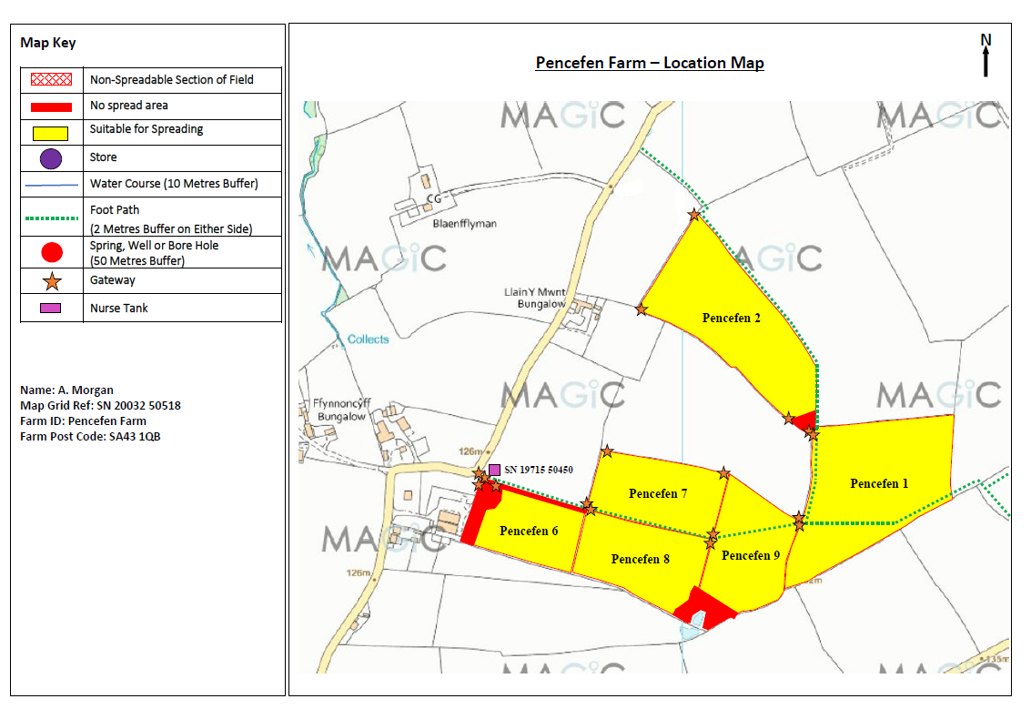
Deployment Boundaries and Storage
Storage nurse tank at SN 19715 50450 is not within the deployment field boundary RFI
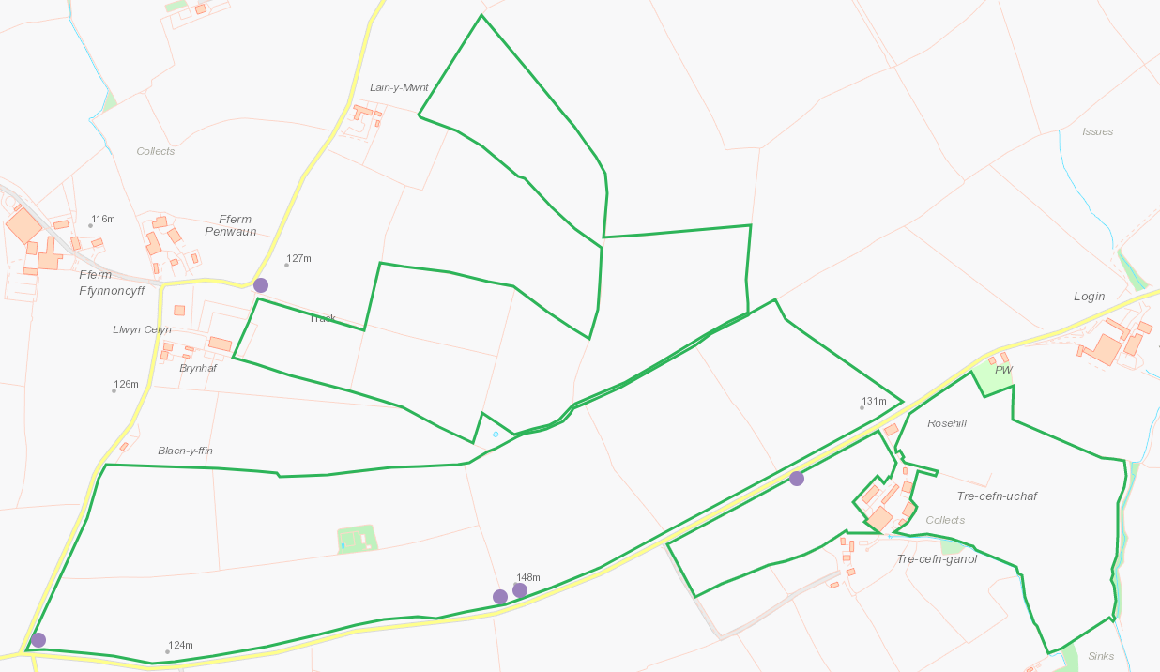
Detailed river network:
Water courses to SW and E of 7613, shown on application maps and buffers applied.
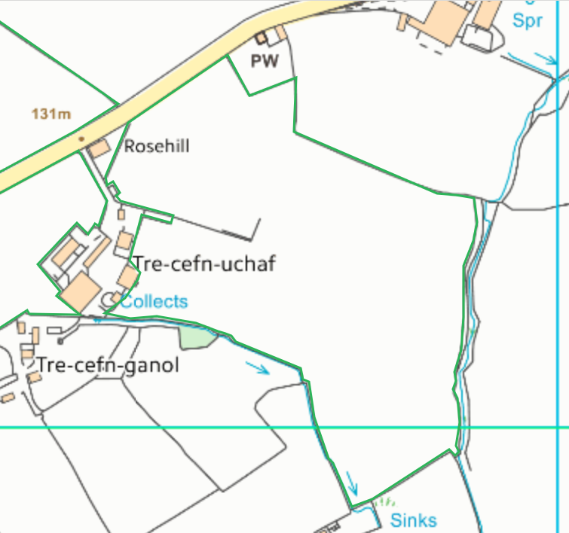
Ponds S of Pencefen 9, shown on application maps and buffers applied.
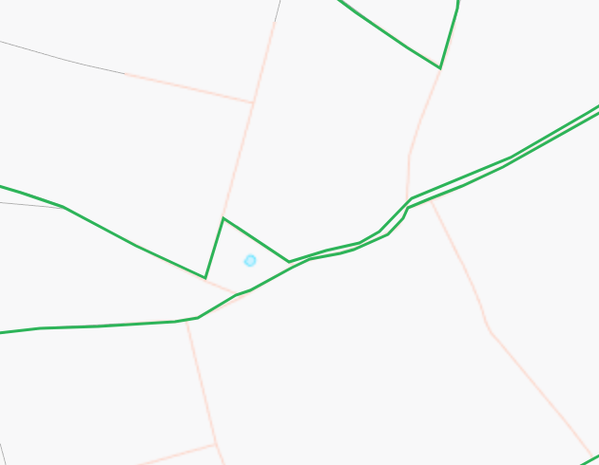
Pond within 9114, shown on application maps and buffers applied.
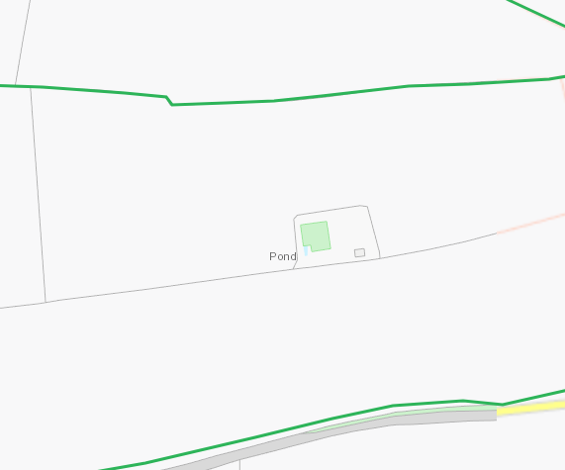
None at other locations.
Groundwater protection zones
None
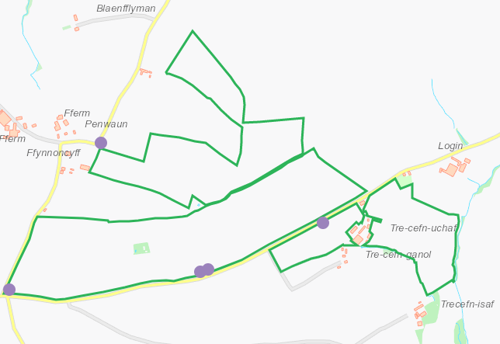
Any well, spring (or issue) or borehole used / not used for the supply of water for human consumption including from a private water supply or supplies within 50m.
7613 - Collects W, sinks S. shown on application maps and buffers applied.
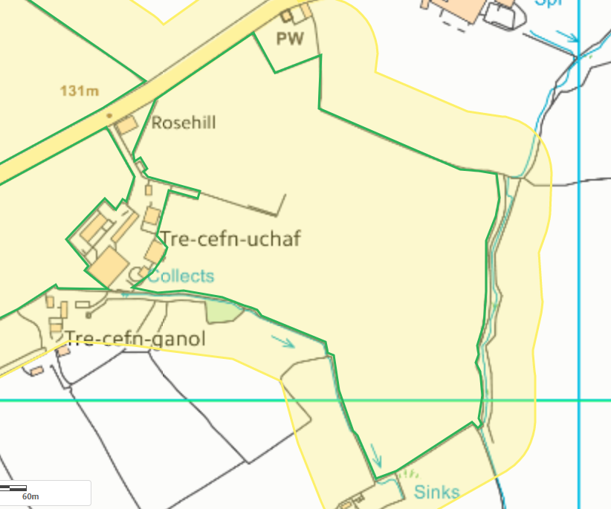
Any well, spring (or issue) or borehole used / not used for the supply of water for human consumption including from a private water supply or supplies within 250m.
7613 - Spring NE, issues S, shown on application maps
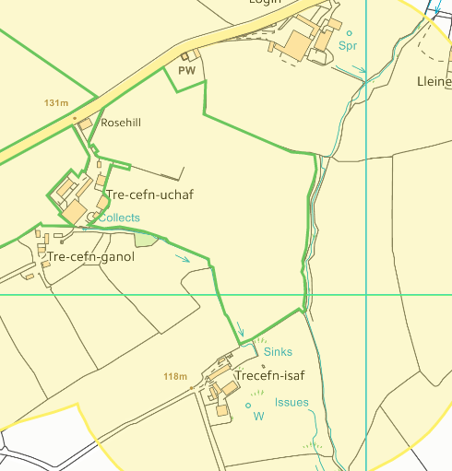
None at other locations.
European designated sites- Natura 2000 (SPA, pSPA, SAC or cSAC) or Ramsar- or SSSI within 500m
None
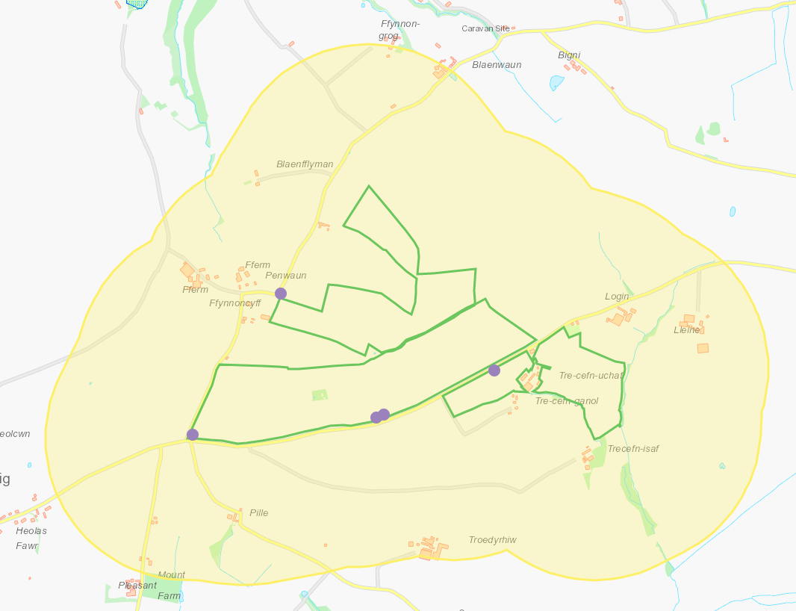

Other protected sites within 500m:
- Protected Species-
- Protected Habitats-
- Scheduled Ancient Monument-
- Local Nature Reserve-
- National Nature Reserve-
- Ancient Woodlands-
- Local Wildlife Sites (SINC)-
- National Park-
- Nitrate Vulnerable Zone (NVZ)-
- Groundwater Safeguard Zone-
- Hedges-
- Ditches-
None
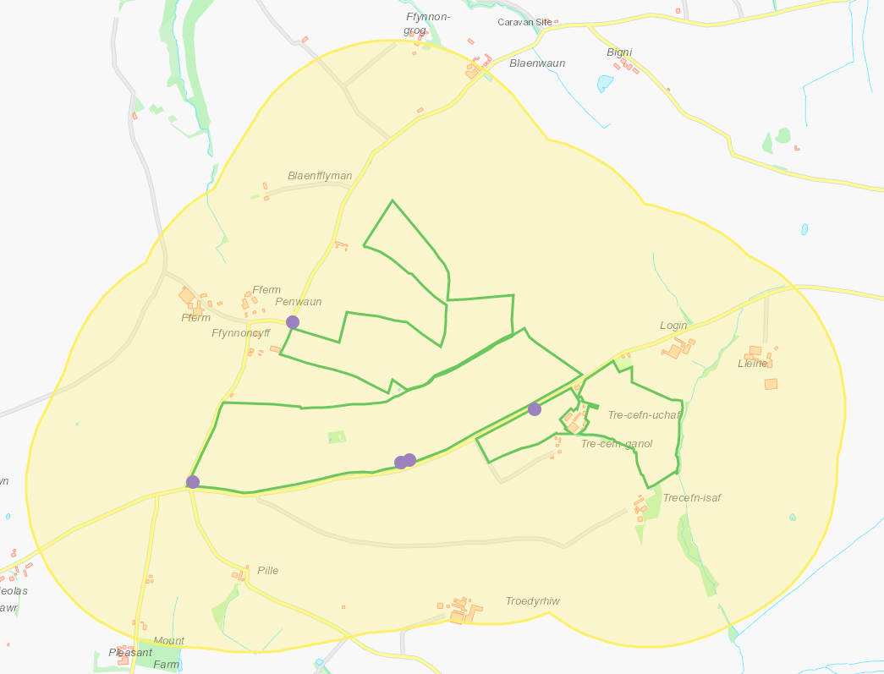

Public rights of way
All shown on application maps
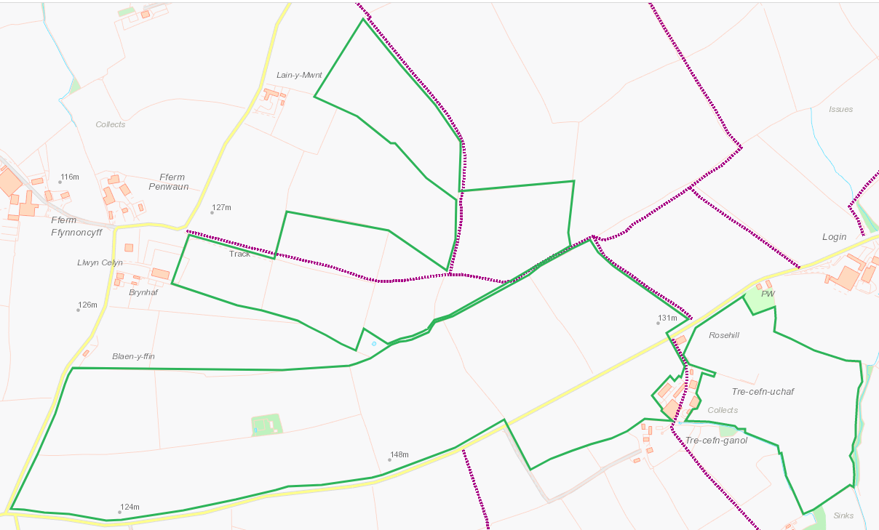

Distance from Main Farm Address
NGR provided in application does not appear to relate to the main farm address. RFI

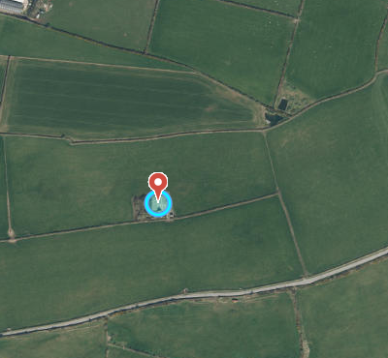
Slope Map
All fields 0-7degrees
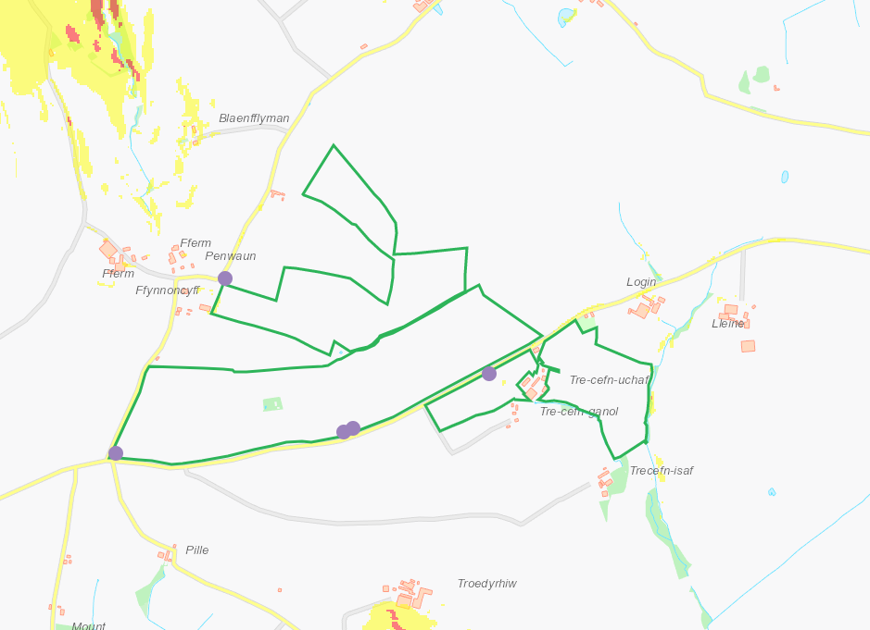

END

