PAN-021494 My Map Report:

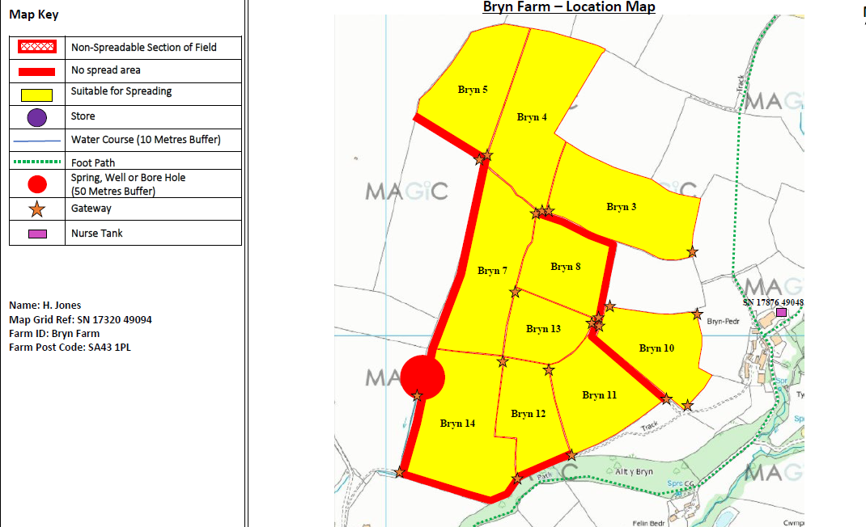
Spreading Maps

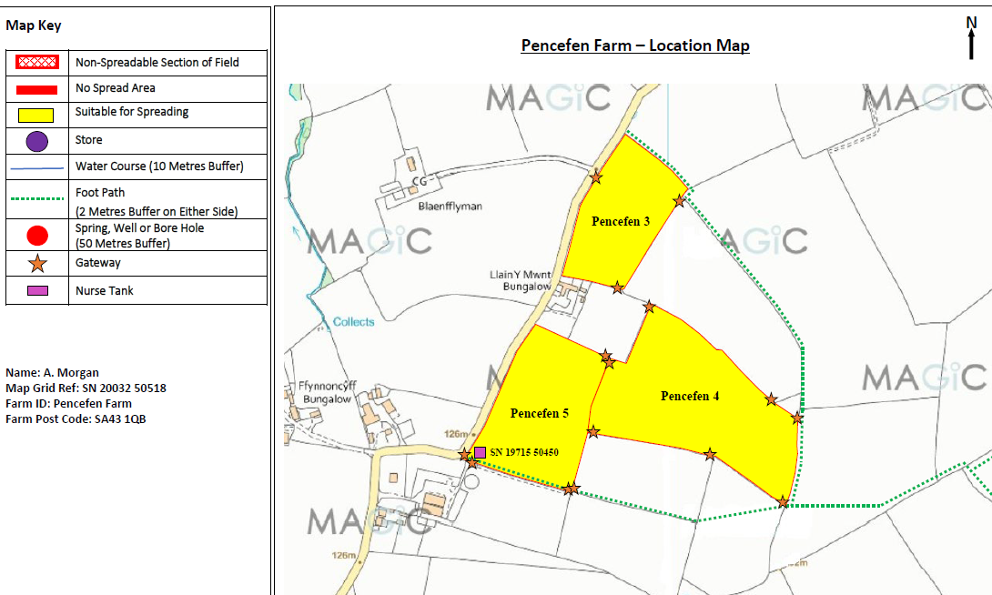
MyMap
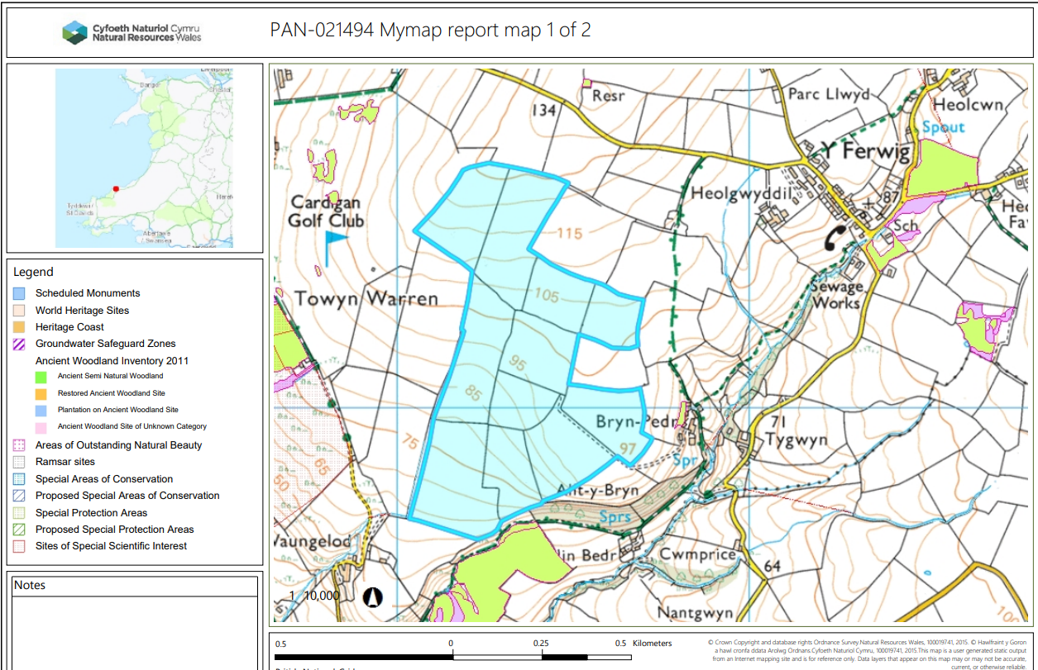

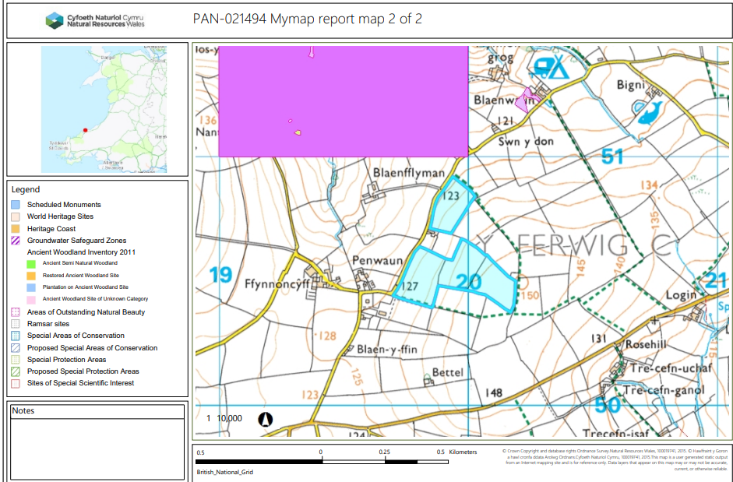
Detailed river network:
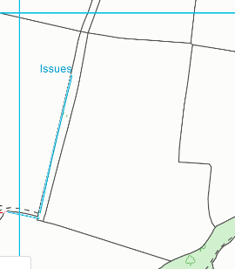
Bryn 14
Field Bryn 14 is located next to a water issue. There is a 10 meter no spread buffer zone in place to prevent nutrients from entering the water course.

Groundwater protection zones – (source)
None in range.

Wells, springs or boreholes used for the supply of water for human consumption including from a private water supply or supplies
None in range.
Any springs wells or boreholes not used to supply water for domestic or food production purposes within 50m

None in range.
European designated sites- Natura 2000 (SPA, pSPA, SAC or cSAC) or Ramsar- or SSSI within 500m
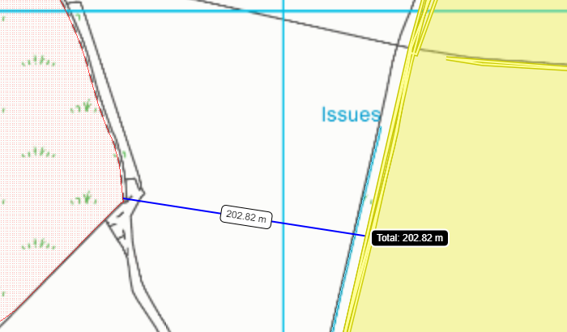
Bryn 7
Field Bryn 7 is located 203 meters from the Aberarth - Carreg Wylan SSSI. There is a 10 meter no spread buffer zone in place on the field border that faces the SSSI.
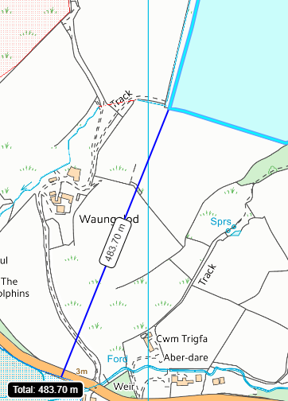
Bryn 14
Field Bryn 14 is located 484 meters from the Afon Teifi SAC and Afon Teifi SSSI.

Other protected sites:
- Protected Species- None in range.

- Protected Habitats- None in range.

- Scheduled Ancient Monument- None in range.

- Local Nature Reserve- None in range.

- National Nature Reserve- None in range.

- Ancient Woodlands-

- Local Wildlife Sites (SINC)- None in range.

- National Park- None in range.

- Groundwater Safeguard Zone- None in range.

- ANOBs - None in range.

- Heritage coast- None in range.

- World Heritage Sites- None in range.

- Hedges- Nothing of concern.

- Ditches- Nothing of concern.

- Local residents

Slope Map
Bryn 14
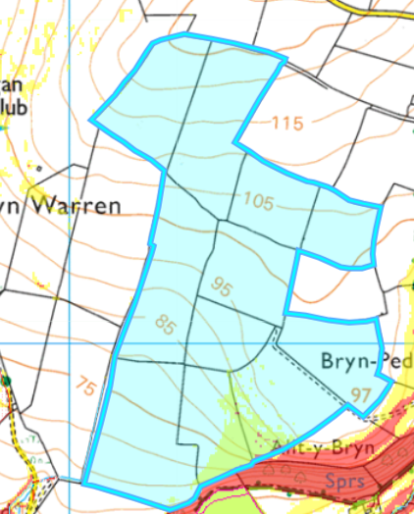
Fields Bryn 12 and 11 are located on moderately sloping land (7-12º). There is a 10 meter no spread buffer zone on the southern border of field Bryn 12 to mitigate the risk of wastes entering the highly sloping area of land outside the field boundary.
The rest of the fields are located on flat to gently sloping land.
Bryn 5
Bryn 4
Bryn 3
Bryn 8
Bryn 7
Bryn 13
Bryn 10
Bryn 11
Bryn 12
2
Bryn 14

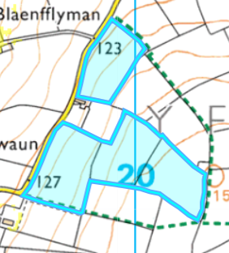
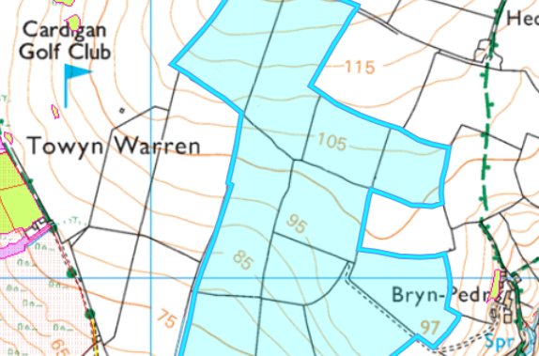
P3
Bryn 5 and 7 are located next to the Cardigan Golf club. Due odorous nature of 02 05 02 an odour management plan was received in the request for information 1 response.
P5
P4
Bryn 7
Bryn 5

