Fields 2991, 3799, 5813 and 5694 (area 1)
Application map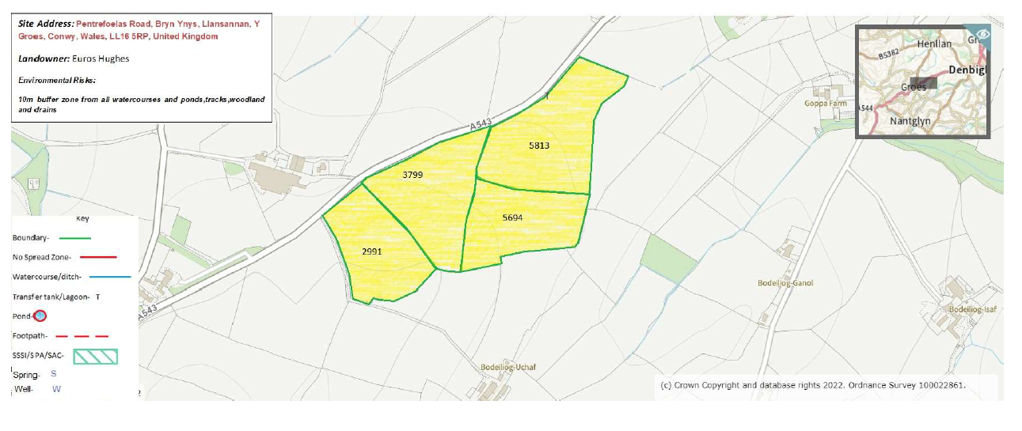

MyMap layer
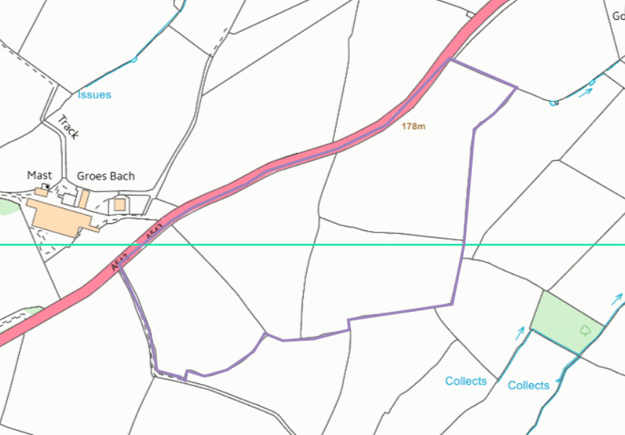

Public Rights of Way
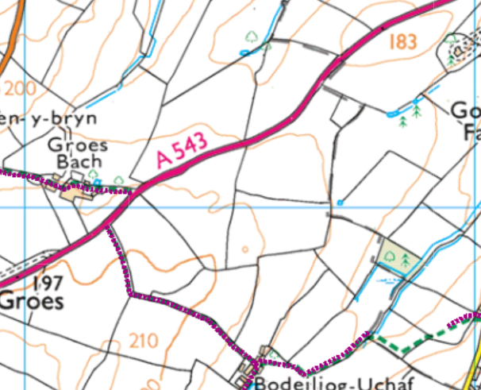

Slope
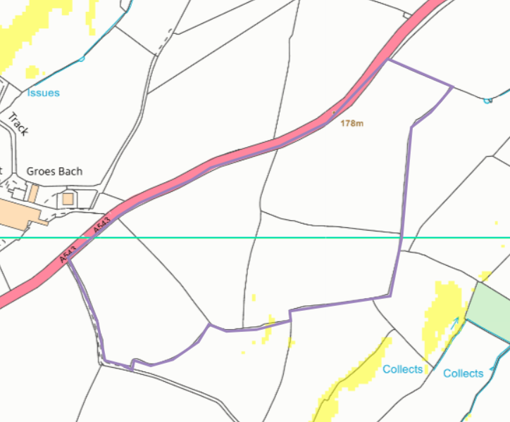

Fields 5905, 4279, 7605, 3851, 6418, 1843, 5974, 5490, 2565, 7887, 2946, 2881, 3398, 1390, 9596, 0716, 2211 (Area 2)
Application map
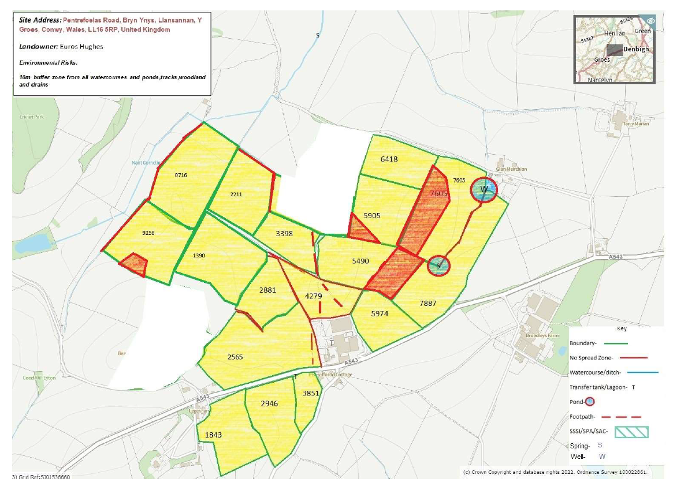
MyMap area
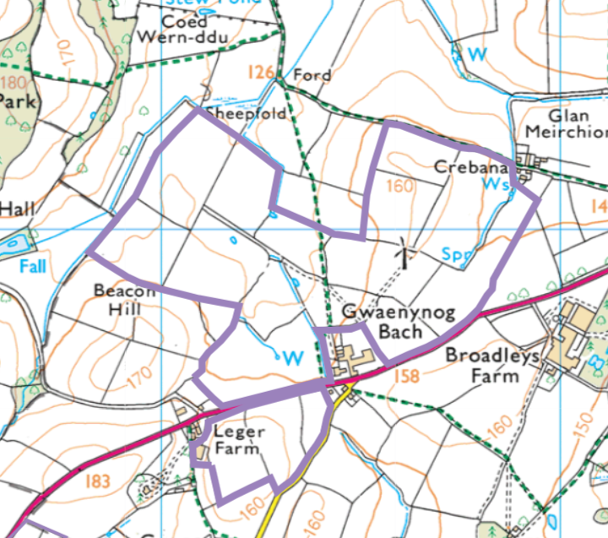

Surface water courses, springs, wells boreholes, issues
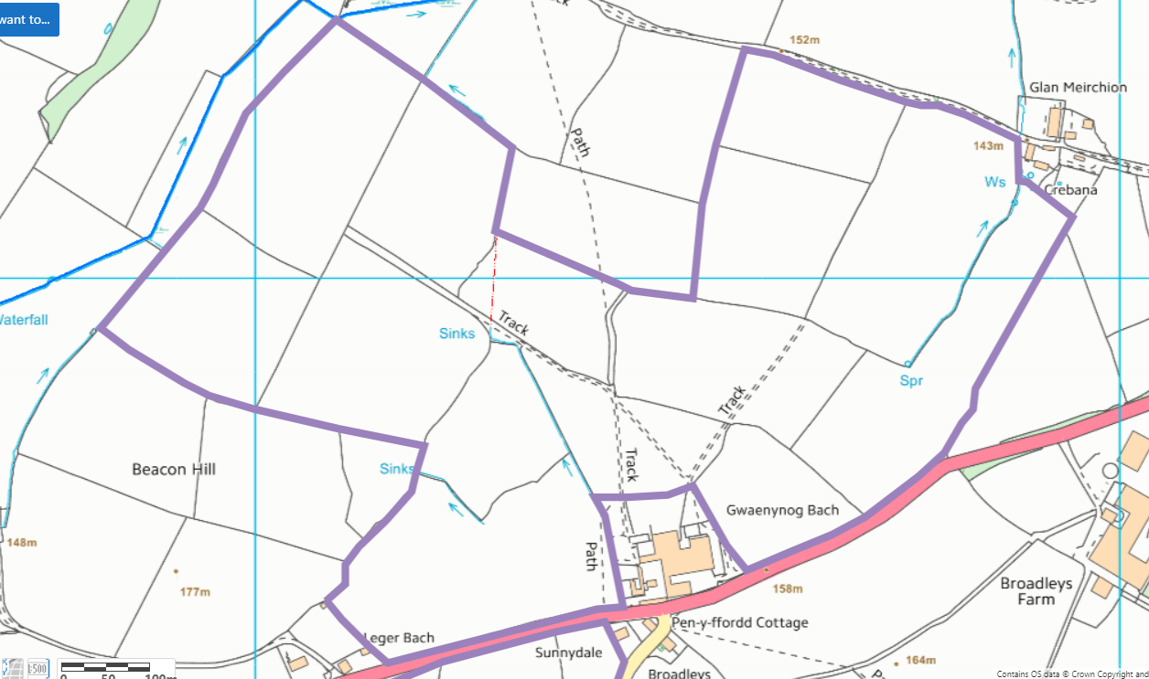
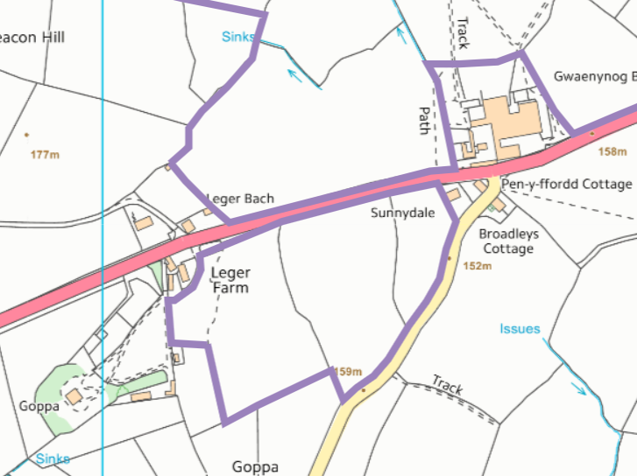

Public rights of way
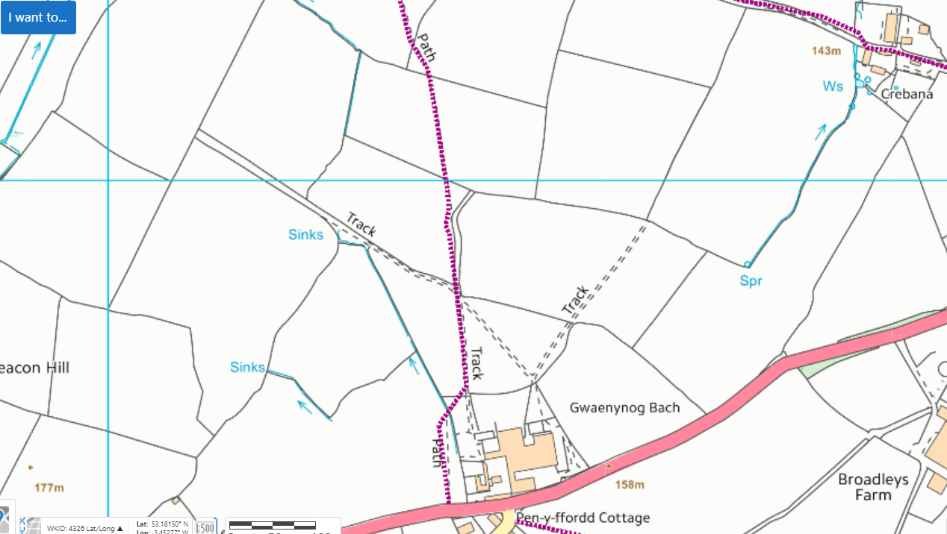
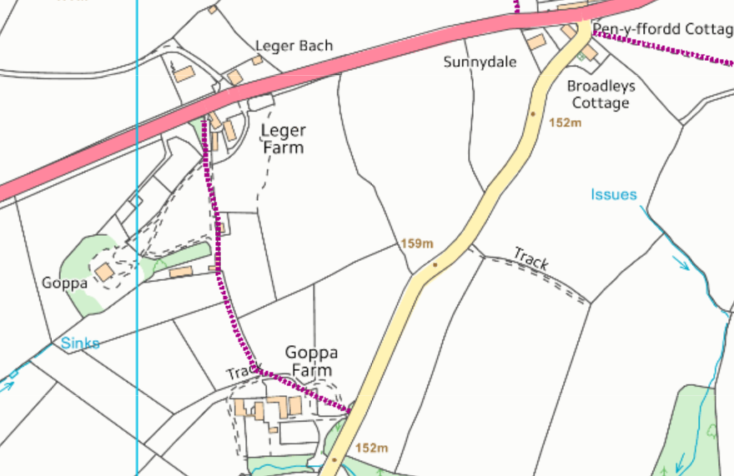

Slope


