PAN-021005 MyMap Screening Report
Application Map
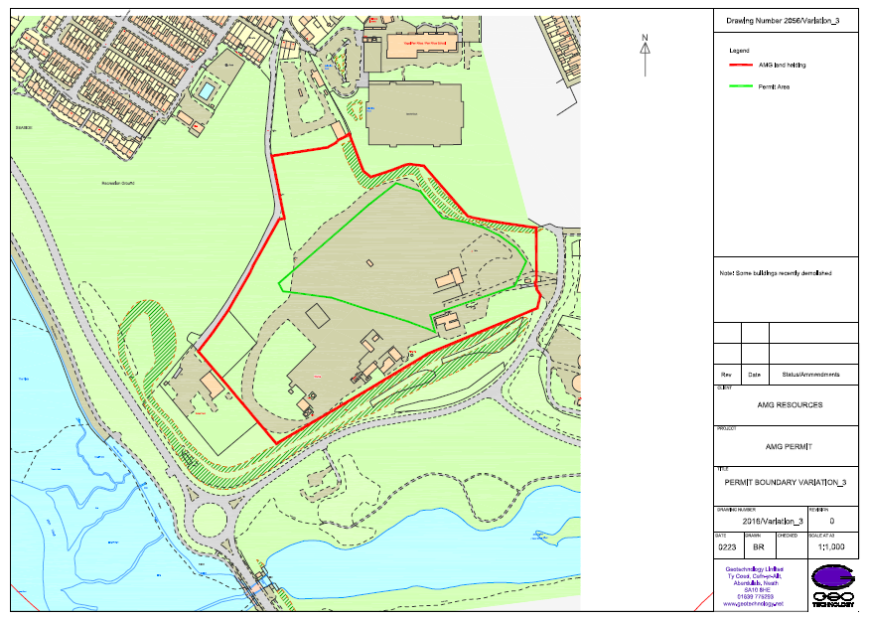
Permit Boundary
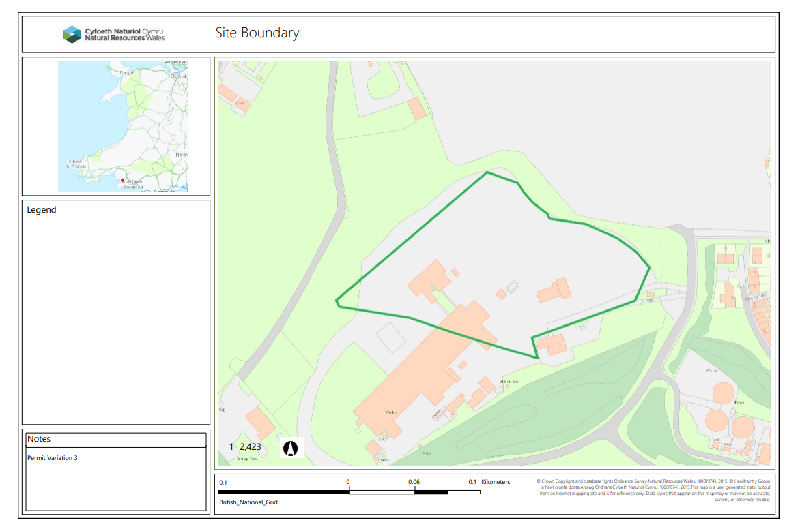
RAMSAR, SSSI - 500m.
None
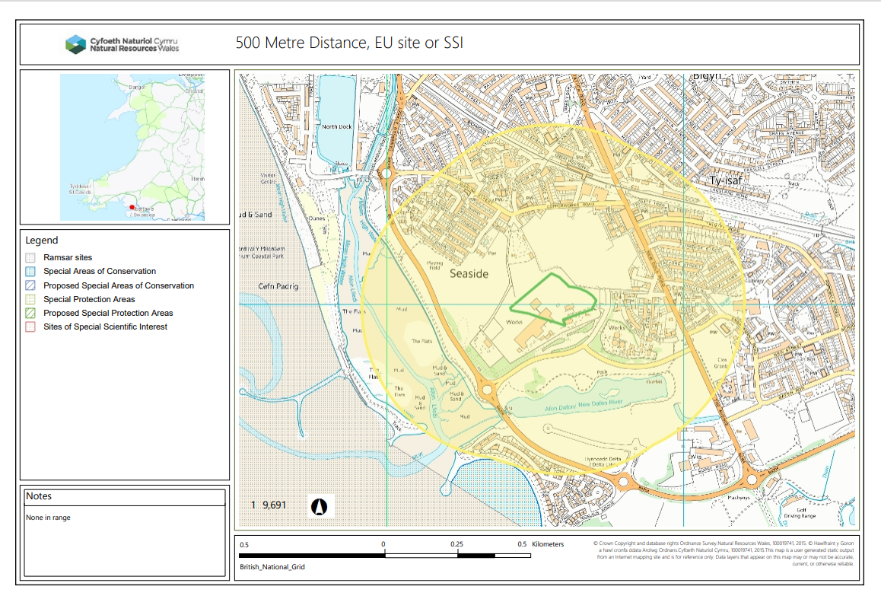
Wells, Springs, Boreholes – 50m
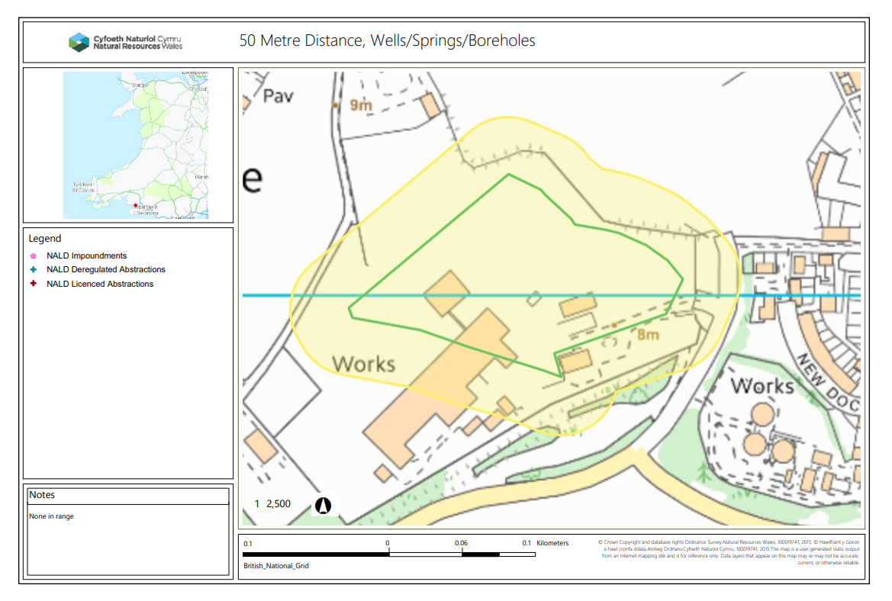
END

