CRoW Appendix 4 (140_10_SD02)  CRoW Act 2000: Natural Resources Wales application for permission - Formal Notice |  | 
Natural Resources Wales Formal Notice.
Requirements of Section 28I of the Wildlife & Countryside Act 1981 as amended by the Countryside and Rights of Way Act (CRoW) 2000.
Duty in relation to granting any consent, licence or permit for activities likely to damage Sites of Special Scientific Interest (SSSI).
Guide to filling in this form for Natural Resources Wales staff:
To be completed by Permitting Officers for any applications for a permission which the Natural Resources Wales has considered under S28G duties to protect and enhance SSSIs. This applies to all proposed permissions within a SSSI, and to operations outside the SSSI boundary which are likely to damage its special features.
Refer to OI 140_10 ‘Applying the Countryside and Rights of Way (CRoW) Act 2000 to applications for permits with potential for impact on Sites of Special Scientific Interest (SSSI)’, including the flowchart in Appendix 2.
Pink italic text – drafting notes, to be deleted before completion/consultation.
Blue text – examples, to be replaced with permission-specific information.
Ensure you have completed all sections.
- Natural Resources Wales area/region/NPS hub: | South East
- Name of SSSI: | Llandegfedd Reservoir
- Type of permission: | Variation to an Environmental Permit for a waste operation: Mixed metal recycling activity including end of life vehicle  de-pollution, and Household, commercial and industrial waste transfer station with treatment
- Date for Natural Resources Wales permit determination:
- Predicted 28 day date for response from NRW conservation/ecology (under S28 I(4)): | N/A – saved for audit only
- Natural Resources Wales reference no: | PAN-016333
- National grid reference: | ST 30123 98691
- Description of proposal: | The variation is to:  - change the permit from a standard rules SR2008 No3 and SR2012 No14 permit to a Tier 3 bespoke permit for a  - mixed metal waste treatment facility, including end-of-life vehicle (ELV) de-pollution; and  - household, commercial and industrial waste transfer station with treatment  This includes a reduction in the number of waste codes accepted, an increase in the annual tonnage and the addition of shredding metals outside.  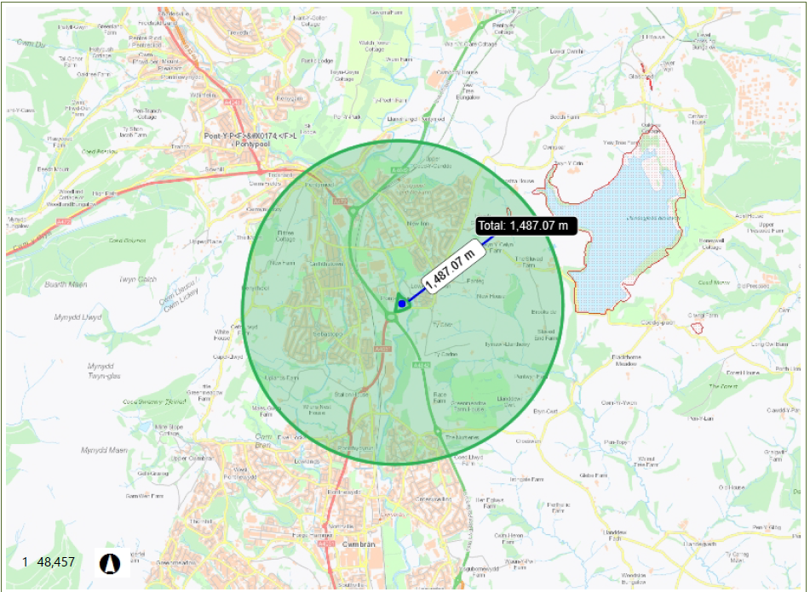
- Is the proposed activity within (wholly or partially) the SSSI boundary? | NO  The SSSI is approx. 1.4km north east of the facility boundary
- Has there been any pre-application discussion or correspondence with NRW conservation/ecology | NO
- What aspect(s) of the proposed permission may damage the features which are of special interest for the SSSI?
The following ‘Operations Requiring Consent’ (or other activities associated with the permission) that may cause damage) are relevant to the proposed permission:

There are no Operations Requiring Consent that are relevant to the proposed permission, no operations are taking place within the boundary of the SSSI’s. The proposed activities include treatment of wastes including manual sorting/separation, cutting, compacting, baling and metal shredding, which have the potential to create dust and noise.

The following SSSI features and mechanisms of impact have been considered to assess the likelihood of damage:
Features include the overwintering wildfowl, and supporting habitat of grassland, woodland and scrub.
Due to the distance from the site boundary there is no pathway for dust or noise emissions to impact upon the SSSI.
All wastes are stored on an impermeable surface that drains to a sealed lagoon and therefore there is no potential impact pathway through contamination of the groundwater affecting the supporting habitat.

- Decision
i) The proposed permission is not likely to damage any of the flora, fauna or geological or physiological features which are of special interest.

There is no pathway for features to be affected.

Natural Resources Wales is minded to:
Issue the permission

- Name and job title of Natural Resources Wales officer: | Anna Palmer  Senior Permitting Officer
- Date form sent to NRW conservation/ecology | N/A

