PAN-022093 MyMap report

“BW” fields
Applicants map
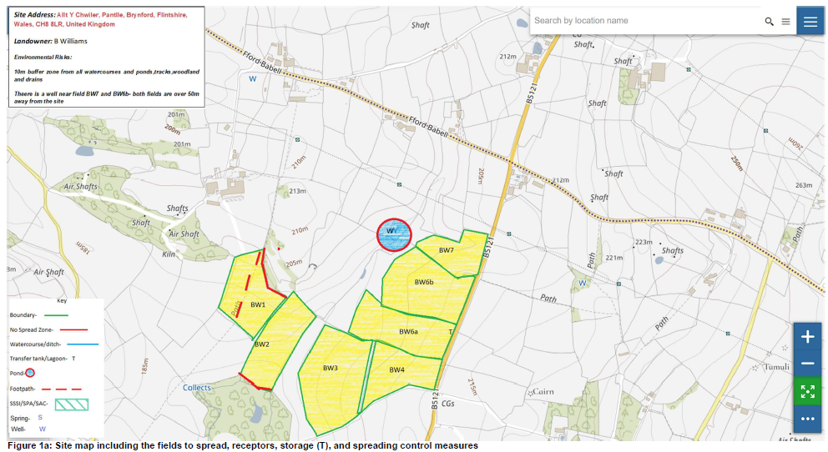

MyMap view
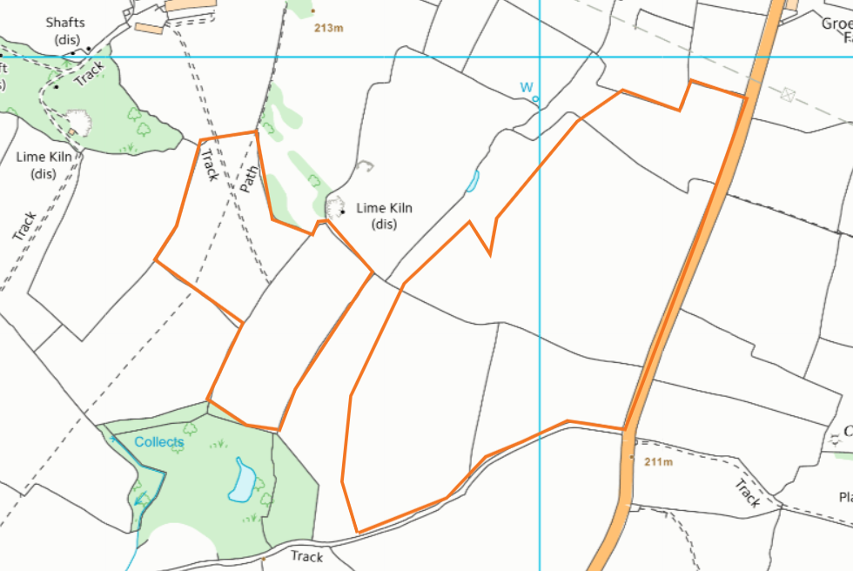

Google earth (22/04/2015)
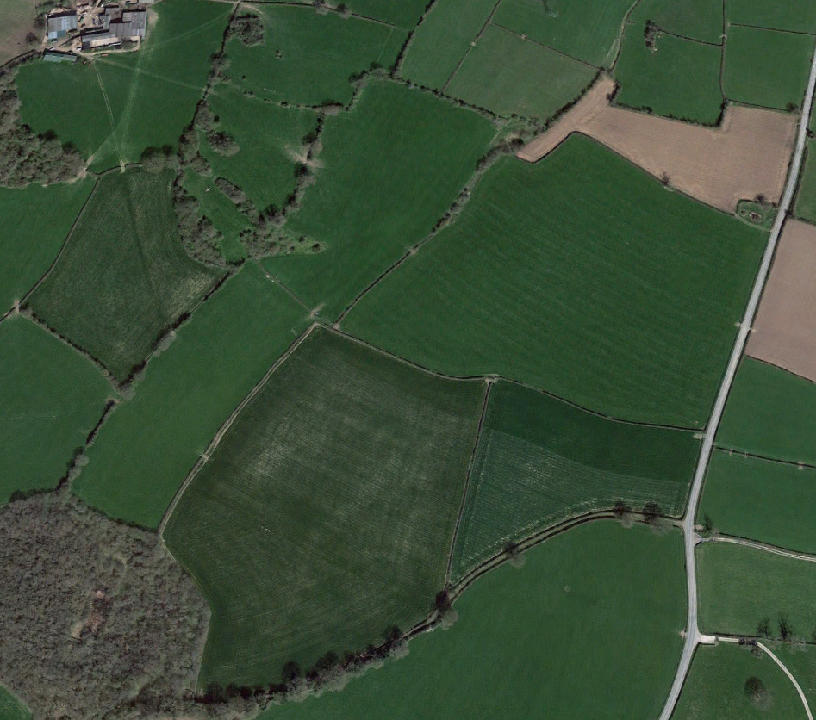

surface water courses- no storage or spreading within 10 meters
- none

groundwater source protection zones- no storage or spreading in SPZ1
- none

well, spring (or issue) or borehole:
- used for the supply of water for human consumption including from a private water supply or supplies- no storage or spreading within 50 meters
- not used to supply water for domestic or food production purposes within 50m
- used to supply water for domestic or food production purposes within 250m
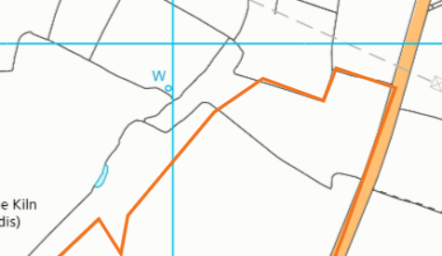
well to the NE of fields- shown on map and buffered

any European designated sites- Natura 2000 (SPA, pSPA, SAC or cSAC) or Ramsar- or SSSI within 500m
- none
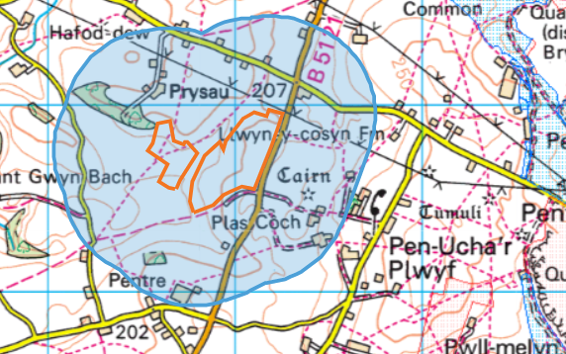

location of any public rights of way
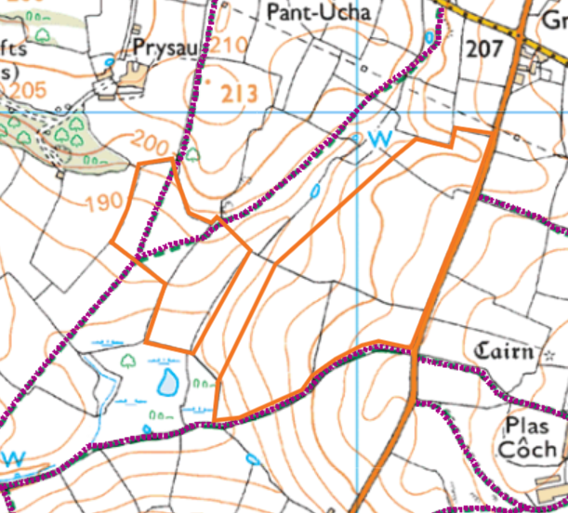
along southern edge of BW3 and BW4, in BW1 and BW2

Within Groundwater Safeguard Zone
- none

Protected Species/Protected Habitats
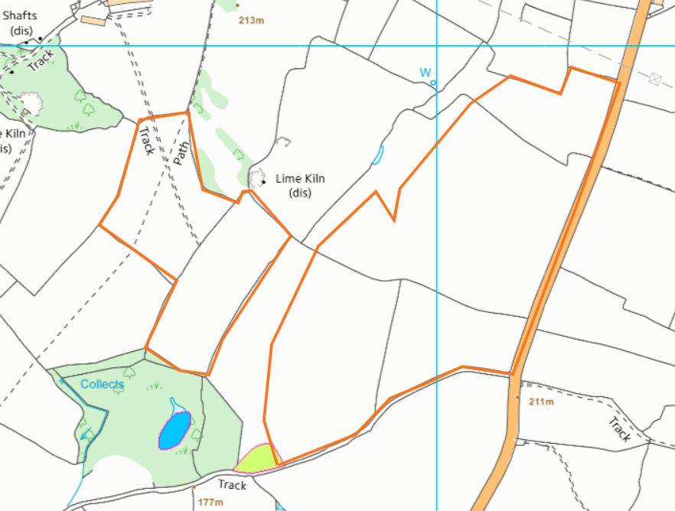
none in fields
Scheduled Monument
none in fields

Local Nature Reserve/National Nature Reserve/Ancient Woodlands/Local Wildlife Sites (SINC)/National Park
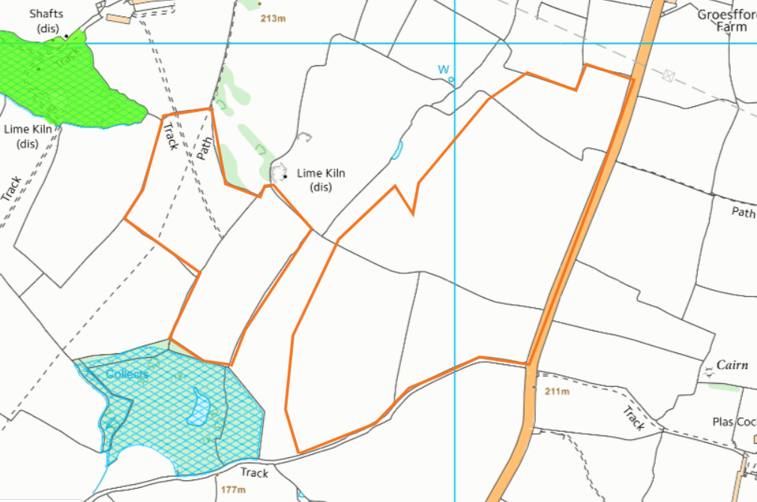
Ancient woodland/local wildlife site to east of field BW1
Local wildlife site to south of field BW2
Field Slope
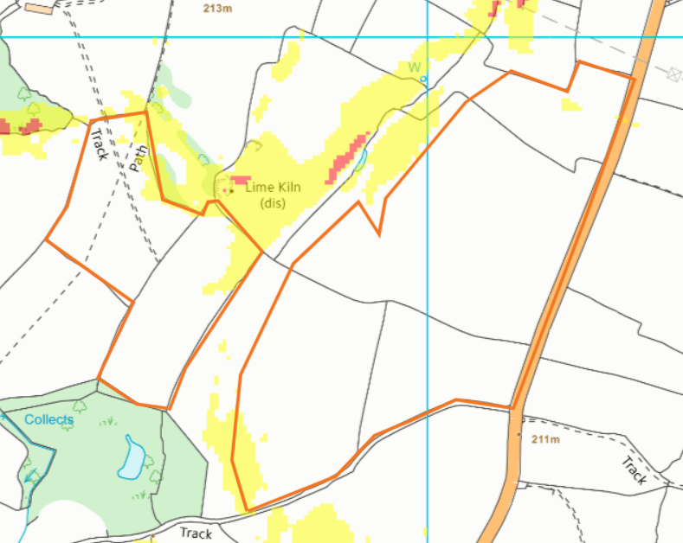
areas of yellow (7-12 degree slope) in fields BW1, BW2 and BW3
“BYC” fields
Applicants map
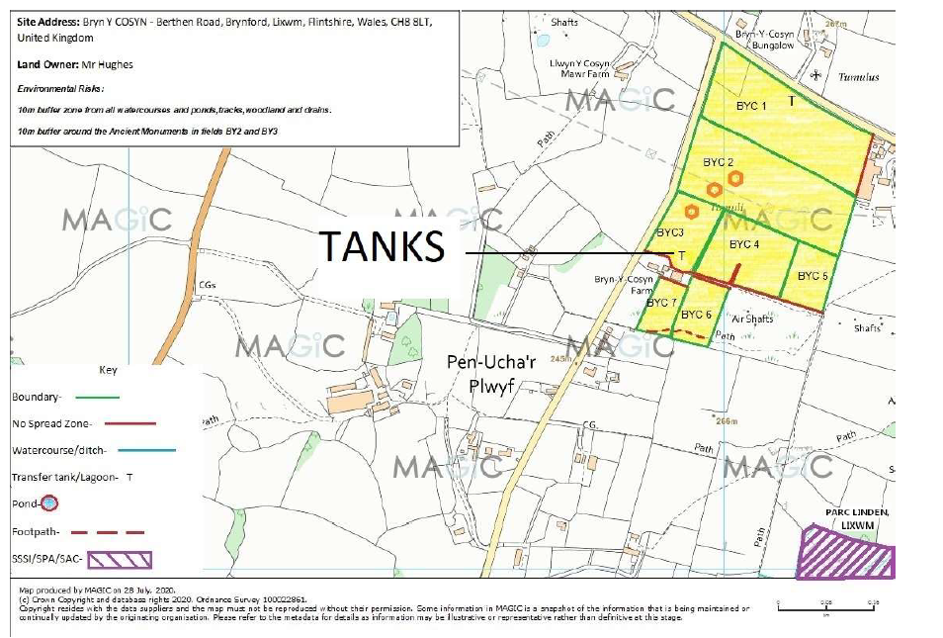

MyMap
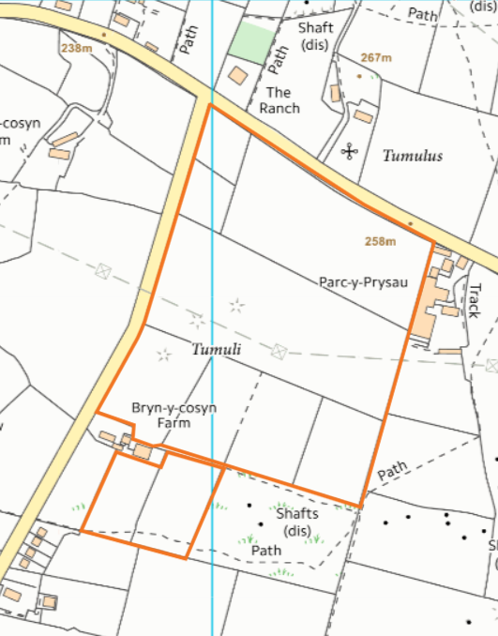

Google earth- 22/04/2021
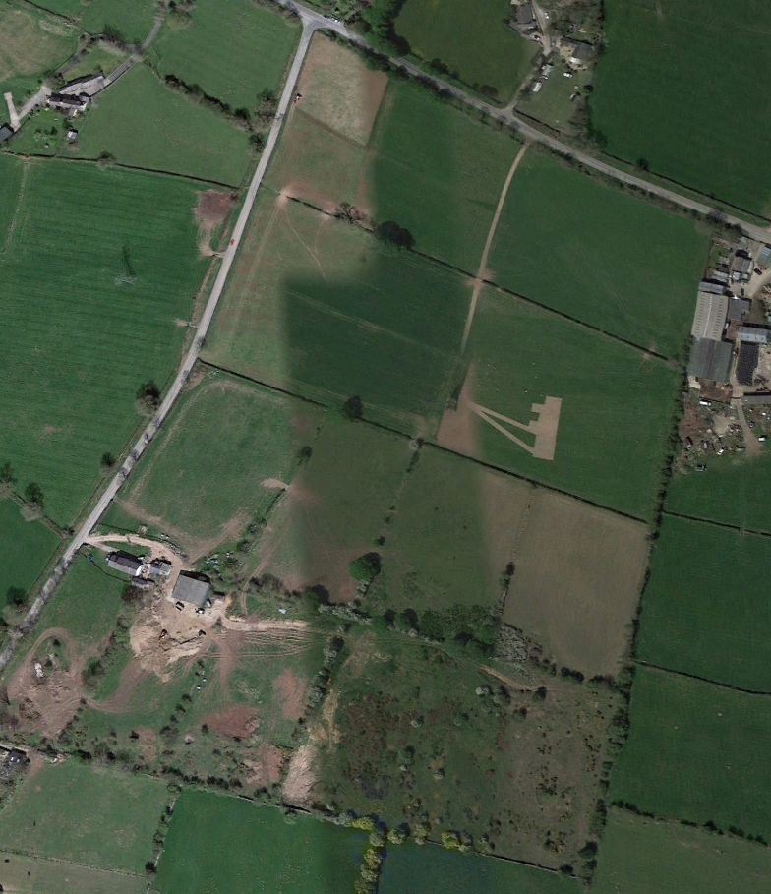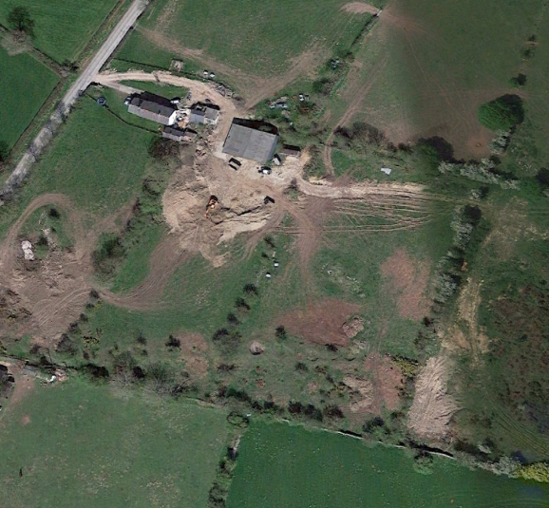

surface water courses- no storage or spreading within 10 meters
- none

groundwater source protection zones- no storage or spreading in SPZ1
- none

well, spring (or issue) or borehole:
- used for the supply of water for human consumption including from a private water supply or supplies- no storage or spreading within 50 meters
- not used to supply water for domestic or food production purposes within 50m
- used to supply water for domestic or food production purposes within 250m
None

any European designated sites- Natura 2000 (SPA, pSPA, SAC or cSAC) or Ramsar- or SSSI within 500m
SAC:
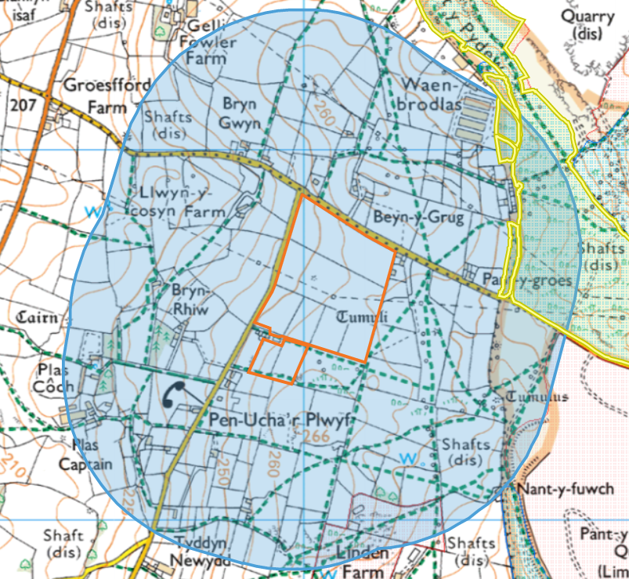

Halkyn Mountain / Mynydd Helygain SAC to the east
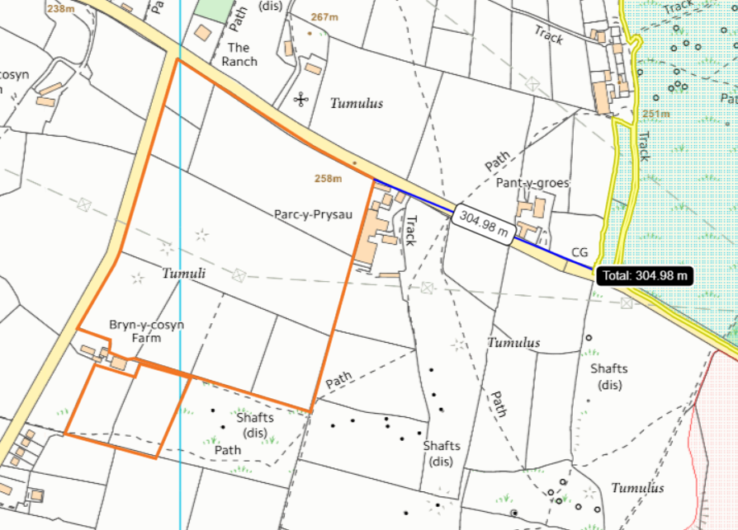
SSSI
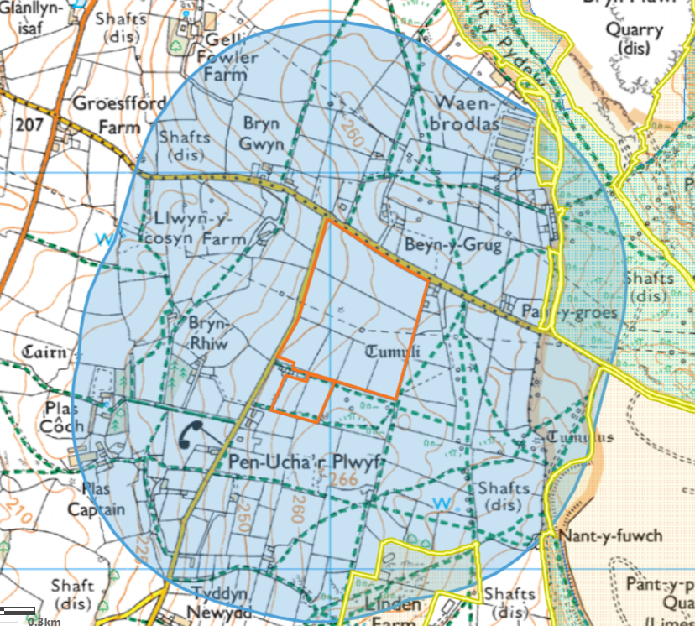
Comin Helygain a Glaswelltiroedd Treffynnon / Halkyn Common and Holywell Grasslands SSSI to the east
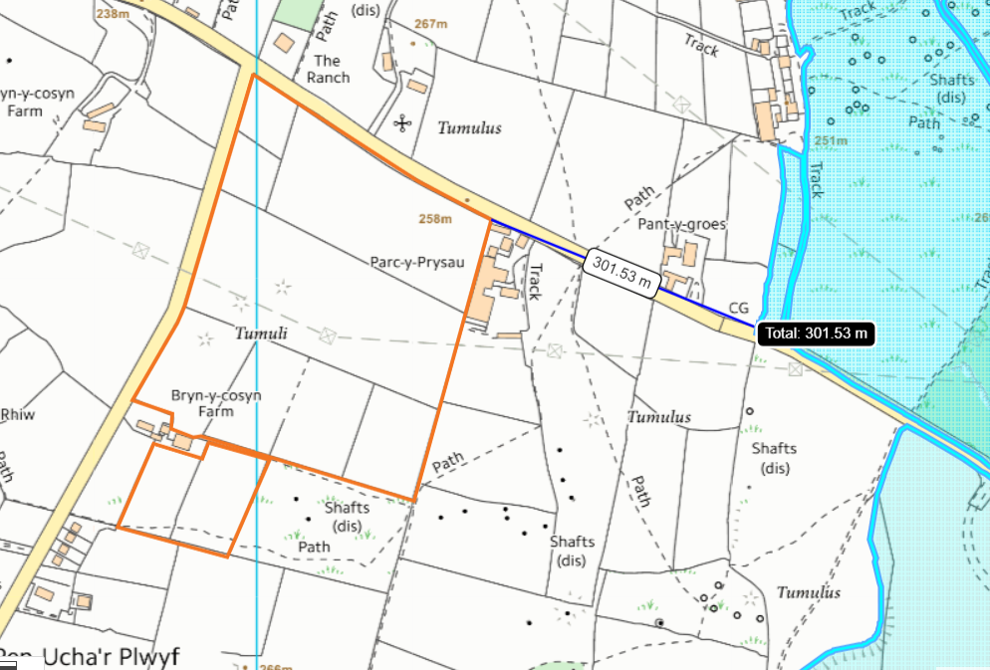

Parc Linden, Lixwm SSSI to the south:
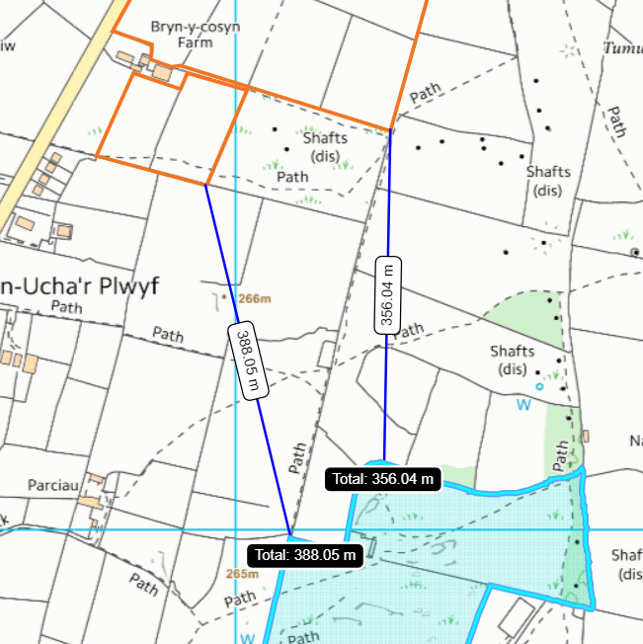
location of any public rights of way
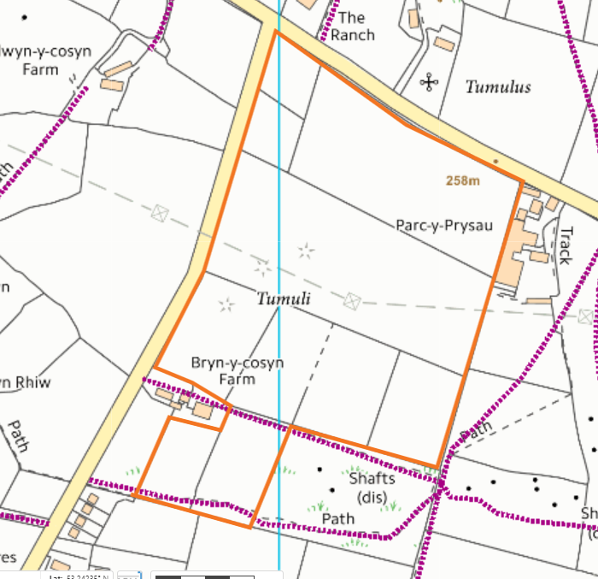

Within Groundwater Safeguard Zone
- none found

Protected Species/Protected Habitats
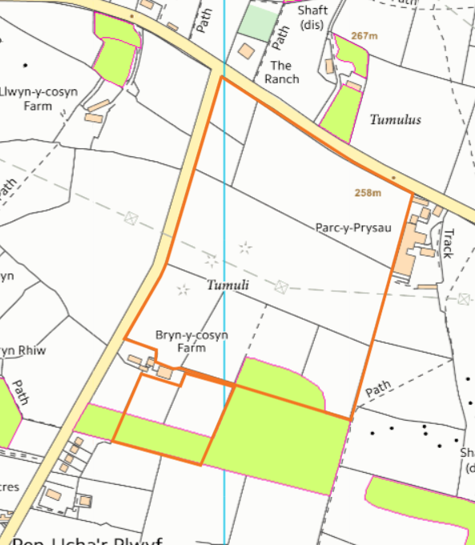
Lowland calcareous grassland-BYC4, BYC6, BYC7

Scheduled Monument
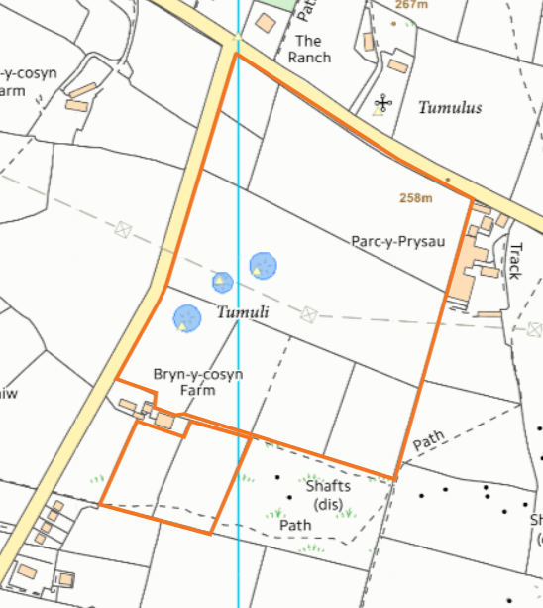
- Bryn y Cosyn Round Barrows x3
Local Nature Reserve/National Nature Reserve/Ancient Woodlands/Local Wildlife Sites (SINC)/National Park
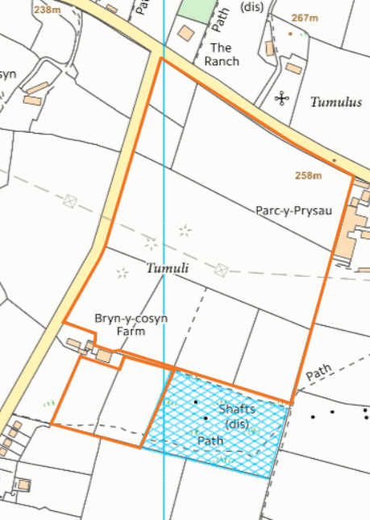
None in fields. Local wildlife site to the south of BCY4 & BCY5, and east of BYC6
Field Slope
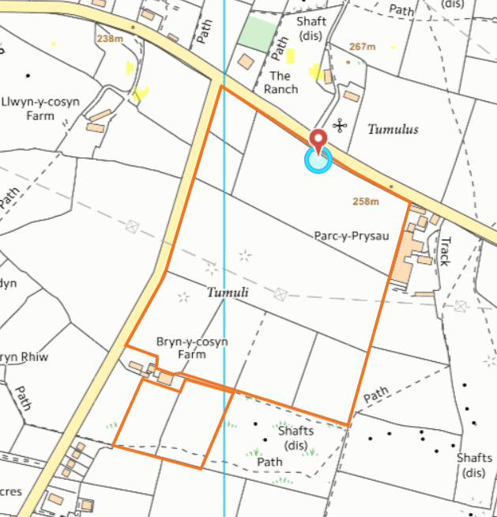
all fields 0-7 degrees

