Notice of variation with introductory note
Environmental Permitting (England & Wales) Regulations 2016

AMG Resources Limited

AMG Resources Limited
Nevills Dock
Llanelli
SA15 2HD

Variation application number

EPR/BB3793ND/V004

Permit number

EPR/BB3793ND

AMG Resources Limited

Permit number EPR/BB3793ND

Introductory note

This introductory note does not form a part of the notice

The following notice gives notice of the variation of an environmental permit.

The variation is to increase the boundary of the permitted area regulated under standard rules SR2008No21.

The schedules specify the changes made to the original permit.

The status log of a permit sets out the permitting history, including any changes to the permit reference number.

Status log of the permit
Description | Date | Comments
Permit determined  EPR/BB3793ND | 28/07/20 | Original permit issued
Application EPR/BB3793ND/V002 | Duly made  24/09/20 | Application to increase boundary of permitted area
Variation determined EPR/BB3793ND | 15//12/20 | Varied permit issued.
Application EPR/BB3793ND/V003 | Duly made  23/09/21 | Application to increase boundary of permitted area
Variation determined EPR/BB3793ND | 20/12/21 | Varied permit issued.
Application  EPR/BB3793ND/V004 | Duly Made  28/02/23 | Application to increase boundary of permitted area
Variation determined  EPR/BB3793ND | 14/06/23 | Varied permit issued

End of introductory note

Notice of variation
Environmental Permitting (England and Wales) Regulations 2016

The Natural Resources Body for Wales (“Natural Resources Wales”) in exercise of its powers under regulation 20 of the Environmental Permitting (England and Wales) Regulations 2016 varies

Permit number

EPR/BB3793ND

issued to:
AMG Resources Limited (“the operator”)

whose registered office is

AMG Resources Limited
Nevills Dock
Llanelli
Dyfed
SA15 2HD

company registration number 01516685

to operate a regulated facility at

AMG Resources Limited
Nevills Dock
Llanelli
Dyfed

SA15 2HD

to the extent set out in the schedules.

The notice shall take effect from 14/06/2023

Name | Date
Huw Davies | 14/06/2023

Authorised on behalf of Natural Resources Wales

Schedule 1 – conditions to be deleted

None

Schedule 2 – conditions to be amended

None

Schedule 3 – conditions to be added

None

Schedule 4 – amended plan

Ammended plan attached

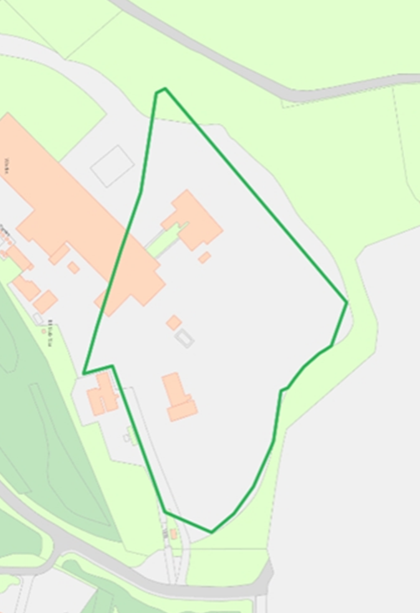

(© Crown Copyright and database right 2023. Ordnance Survey licence number 100019741.)

