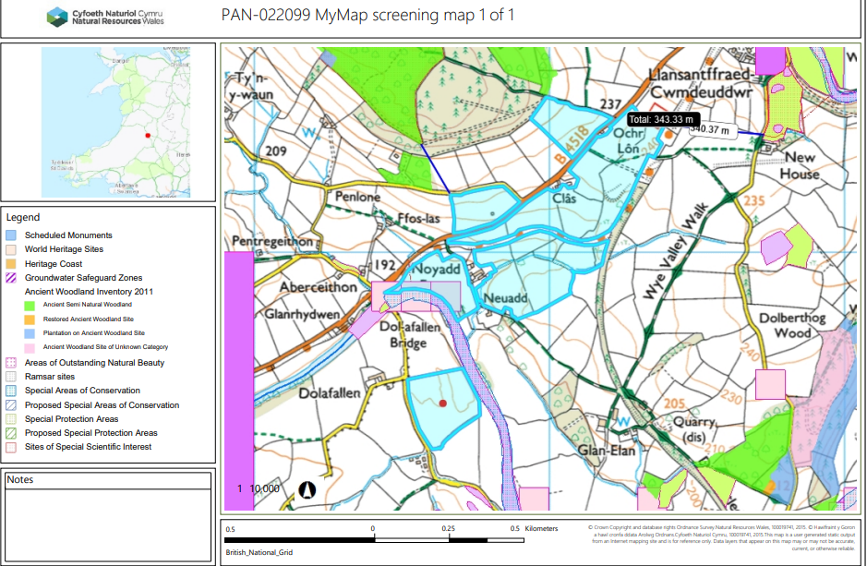
PAN-022099 My Map Report:

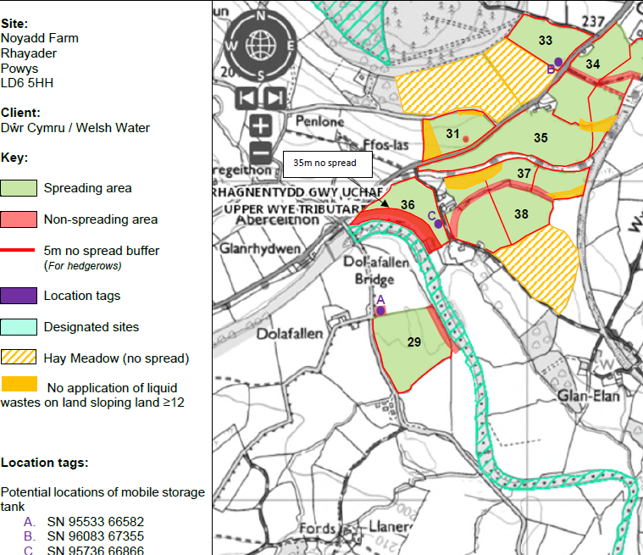
Proposed spreading map

Detailed river network:
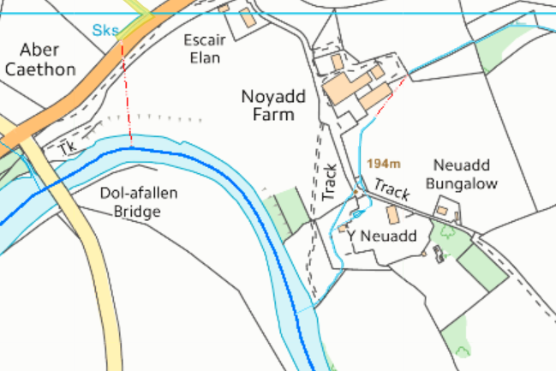
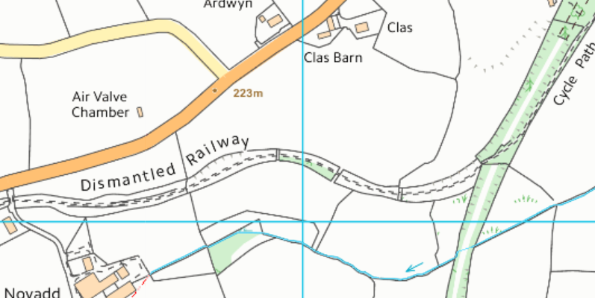
Field 37 borders water issues that drain directly into The River Wye Tributary. There is a 10 meter no spread buffer zone in place to prevent nutrients and/or PTEs from entering the water course. The buffer zones complies with the SRP.

Field 36
Field 36 borders the River Wye tributary. There is a 35 buffer zone in place to prevent nutrients and/or PTEs from entering the water course.
Field 37

Groundwater protection zones (source)
None in range.
Wells, springs or boreholes used for the supply of water for human consumption including from a private water supply or supplies
None in range.

any springs wells or boreholes not used to supply water for domestic or food production purposes
within 50m

None in range.

European designated sites- Natura 2000 (SPA, pSPA, SAC or cSAC) or Ramsar- or SSSI within 500m
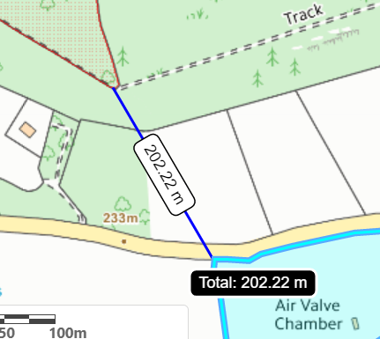
Field 31
Field 31
Field 31 is located 202 metres from the Coed y Cefn SSSI.

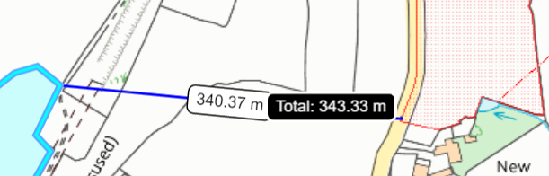
Field 39
Field 34 is located 340 meters from the New House Meadow SSSI
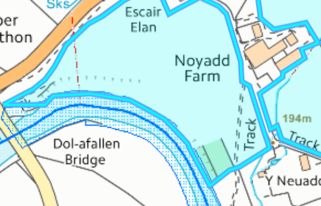
Field 36
Field 36 and 29 border the River Wye SAC & Upper Wye Tributaries SSSI.

Other protected sites:
- Protected Habitats- None in range.

- Scheduled Ancient Monument- None in range.

- Local Nature Reserve- None in range.

- National Nature Reserve- None in range.

- Ancient Woodlands- None in range.

- Local Wildlife Sites (SINC)- None in range.

- National Park- None in range.

- Groundwater Safeguard Zone- None in range.

- ANOBs - None in range.

- Heritage coast - None in range.

- World Heritage Sites - None in range.

- Hedges- There is a 5 meter no spread buffer zone around the hedgerows for this deployment to mitigate the harm to plants/ organisms that are contained within the hedges.

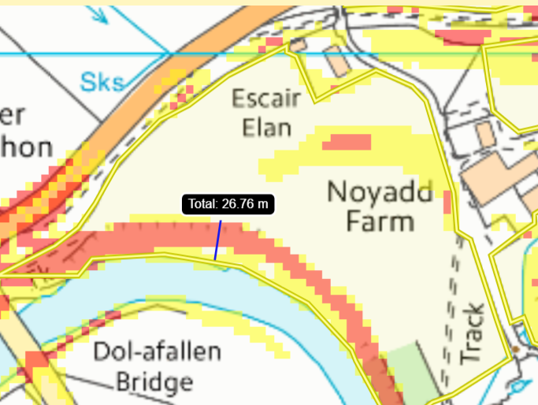
Slope Map

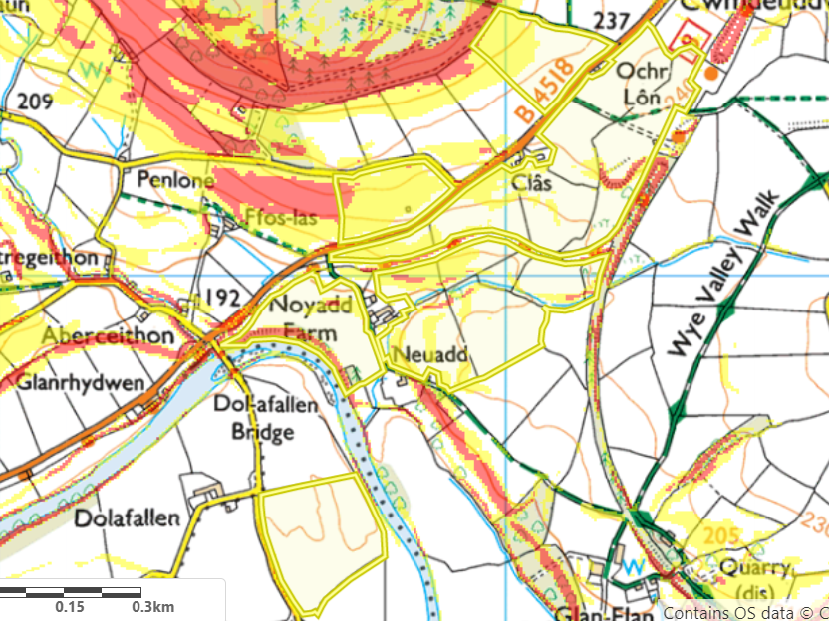
Field 36 have areas of land (27 meter in width) in red which represents highly sloping land 12º+. This area is covered by a 35 meter no spread zone to mitigation the risk of nutrients and or PTEs from enter the SAC/ SSSI.
Fields 31, 33 , 35, 37 & 38 have areas of land that are moderately sloping (7-12º) seen in yellow. The runoff risk of these wastes will be mitigated by:
- Wastes will be applied by trailing shoe which apply the wastes closer to the soil (accurate) and avoid nutrient losses.

- No more than 50t/ha will be spread on a field in any 3-week period to allow the soils to effectually uptake the wastes.

- Wastes will not be spread within the weather restrictions outlined in CoGAP.

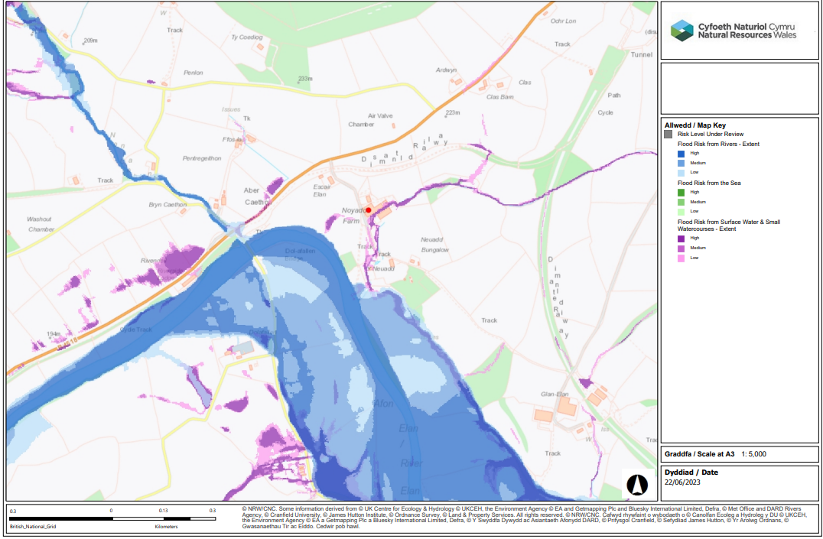
Flood Ris
The areas which have a risk of flooding relevant to this deployment are fields 29 & 36. These fields will not receive wastes between Oct and Apr as there is a chance of flooding could remove nutrients from the ground and into the River Wye SSSI/SAC.

