PAN-021115 My Map Report:
Application maps (revised following RFI)
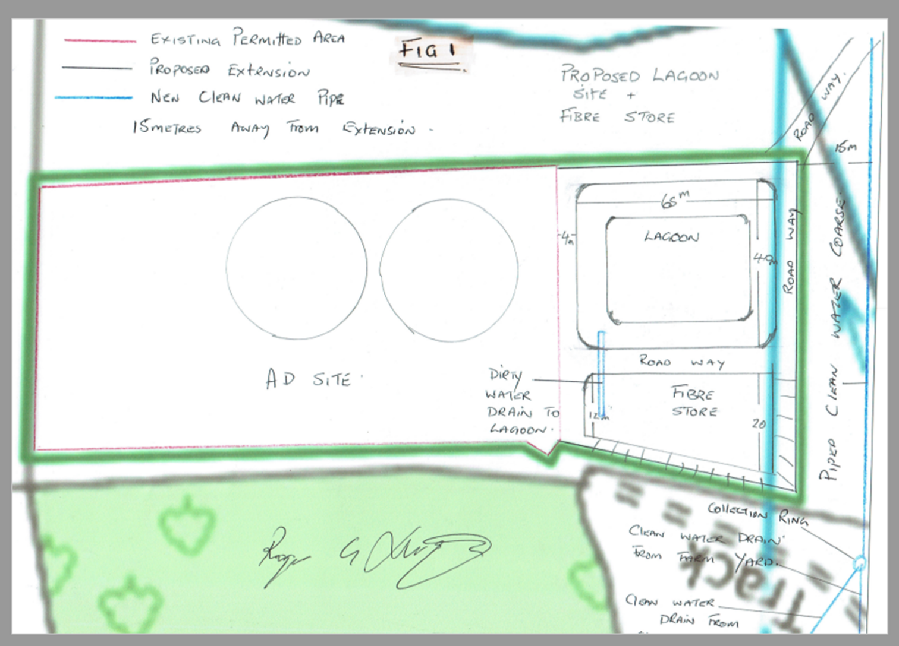
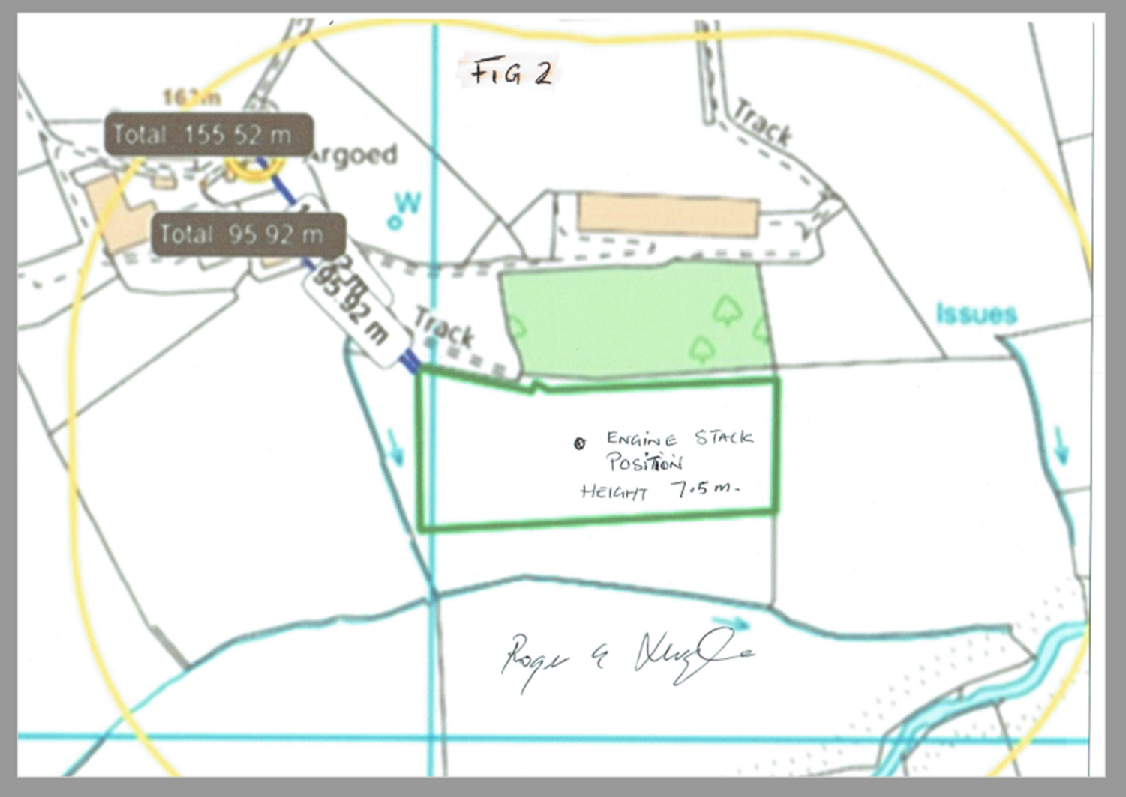

Detailed river network:
Water course within SW corner flowing N-S is 15m from boundary.
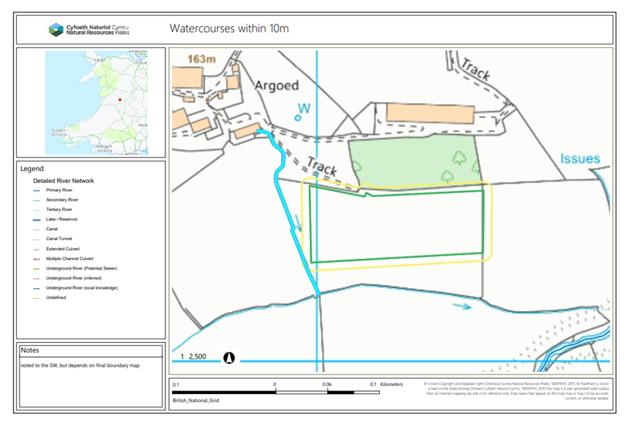
Groundwater protection zones
None
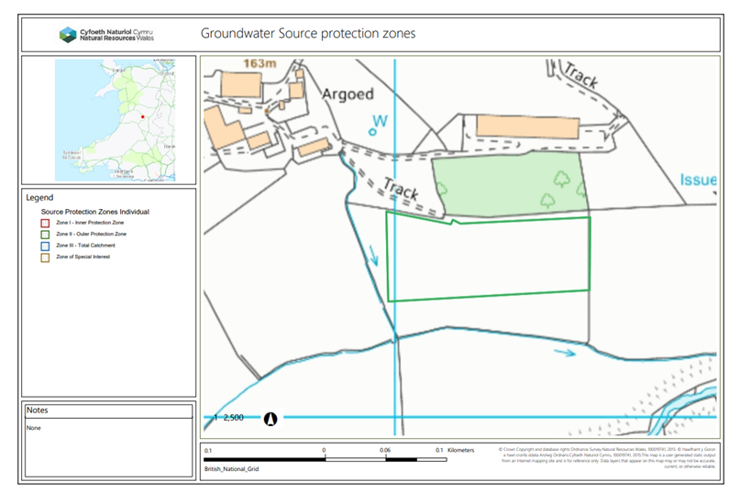

Any well, spring (or issue) or borehole used / not used for the supply of water for human consumption including from a private water supply or supplies within 50m.
None
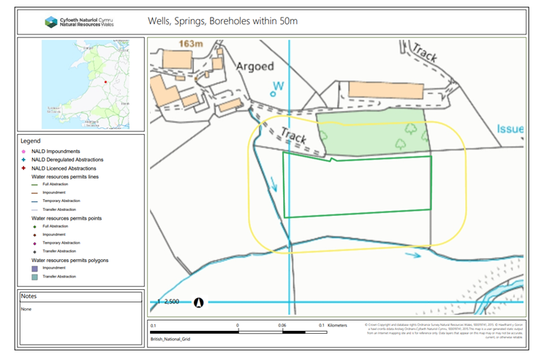

European designated sites- Natura 2000 (SPA, pSPA, SAC or cSAC) or Ramsar- or SSSI within 200m
None
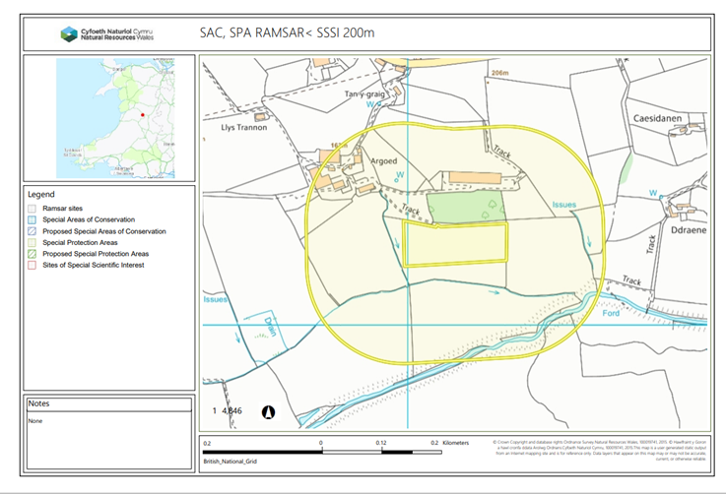

AQMA
None
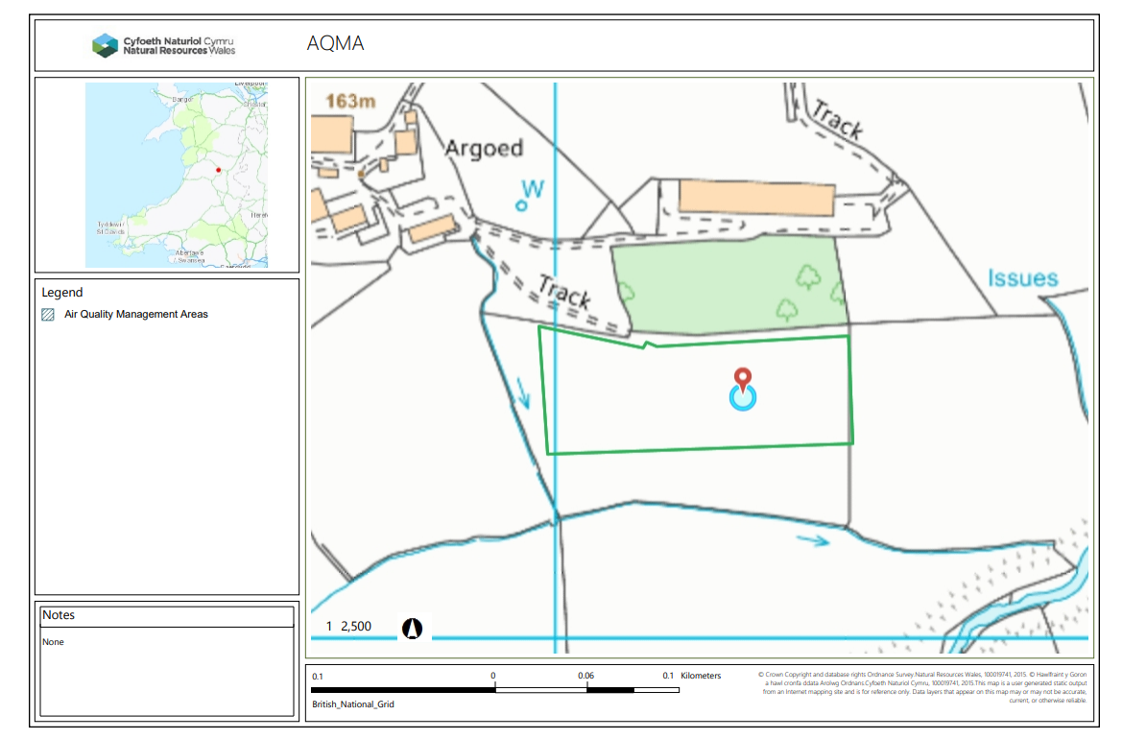
Sensitive receptors within 200m
The farm buildings from Argoed farm, to the NW, are approx 95m to the proposed boundary and 150m to OS address marker.
Section 2.2.3 of SR2012 No10 states,
‘2.2.3 The gas engine stack shall be a minimum of 3 metres in height and shall not be located within:
(b) 200 metres of the nearest sensitive receptor in any case where the stack is less than 7 metres high, unless its “effective” stack height is at least 3 metres.
Stack height and location identified on revised application maps following RFI. Beyond 200m
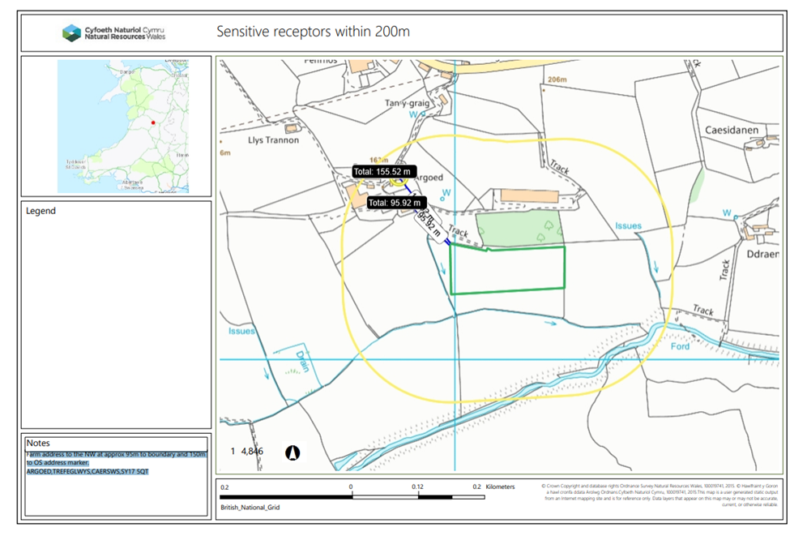

END

