CRoW Appendix 4 (140_10_SD02)  CRoW Act 2000: Natural Resources Wales application for permission - Formal Notice |  | 
Natural Resources Wales Formal Notice.
Requirements of Section 28I of the Wildlife & Countryside Act 1981 as amended by the Countryside and Rights of Way Act (CRoW) 2000.
Duty in relation to granting any consent, licence or permit for activities likely to damage Sites of Special Scientific Interest (SSSI).
Guide to filling in this form for Natural Resources Wales staff:
To be completed by Permitting Officers for any applications for a permission which the Natural Resources Wales has considered under S28G duties to protect and enhance SSSIs. This applies to all proposed permissions within a SSSI, and to operations outside the SSSI boundary which are likely to damage its special features.
Refer to OI 140_10 ‘Applying the Countryside and Rights of Way (CRoW) Act 2000 to applications for permits with potential for impact on Sites of Special Scientific Interest (SSSI)’, including the flowchart in Appendix 2.
Pink italic text – drafting notes, to be deleted before completion/consultation.
Blue text – examples, to be replaced with permission-specific information.
Ensure you have completed all sections.
- Natural Resources Wales area/region/NPS hub: | Mid Wales (North Powys)
- Name of SSSI: | Coed y Cefn, Upper Wye Tributaries, New House Meadow
- Type of permission: | Landspreading deployment under standard rules permit SR2010 No4
- Date for Natural Resources Wales permit determination: | 26/07/2023
- Predicted 28 day date for response from NRW conservation/ecology (under S28 I(4)): | 25/07/2023
- Natural Resources Wales reference no: | PAN-022099
- National grid reference: | Farm location: SN 95746 66921  Fields:  1 29 SN 95640 66486  2 31 SN 95778 67155  3 33 SN 96011 67381  4 34 SN 96218 67319  5 35 SN 96031 67136  6 36 SN 95642 66927  7 37 SN 95974 67029  8 38 SN 95920 66877  Storage:  1 SN 95533 66582  2 SN 96083 67355  3 SN 95736 66866  Coed y Cefn: SN 955677  Upper Wye Tributaries: SN 95533 66859  New House Meadow: SN 968675
- Description of proposal: | A land spreading application to spread a total of 9 waste streams for the waste codes 19 09 02 & 19 06 06 at Noyadd Farm, Rhayader. Wastes are to be spread on grass fields. The application rate ranges from 51-250 tonnes per ha, with a total tonnage to spread 6,050 tonnes.  The waste will be spread over 24.2 hectares of land within the listed fields at Noyadd farm. The water treatment sludges (EWC 19 09 02) may be stored in above storage mobile nurse tank. The tanks will be used only if an incident occurs at one of the treatments works or to store liquid waste if spreading conditions are not favourable at the intended time of spreading. Water treatment sludges will be spread via a trailing shoe. The Digestate will be spread by a tractor and tanker using a dribble bar. Both application methods are appropriate for the waste types.  Targeted periods of spreading on grass fields include spring, after cutting of silage (2 cuts), and prior to grazing through summer and autumn. Wastes will be applied when ground and weather conditions are suitable, following CoGAP to avoid soil damage including wheel ruts, compaction, structural damage, erosion and run-off. No more than 50t/ha will be spread on each field in any 3-week period and no more than 250t/ha will be spread within any 12-month period.  The wastes may be applied separately or in combination. If the wastes are applied in combination the total combined amount applied will not exceed 250t/ha, the total nitrogen loading will be less than 250kg/ha, and the amount of available nitrogen and total or available phosphate and potash (whichever is appropriate) will not exceed the fertiliser recommendation or the amount removed in crop offtake, whichever is the greater.  Fields 29, 31, 33, 34, 36, 37, 38 have soil pH below 6, therefore no alum based sludge will be spread on these field as per TGN 8.01. Fields 29 and 36 between Oct and Apr will not receive wastes as there is the possibility of flooding from the River Wye Tributary during this time.
- Is the proposed activity within (wholly or partially) the SSSI boundary? | NO  Coed y Cefn & New House Meadow are located 199m and 345m respectively from the landspreading area (see map below). Due to the distance these SSSIs are from the proposed landspreading area and the fact there is no impact pathway they do not need to be considered further in this form.  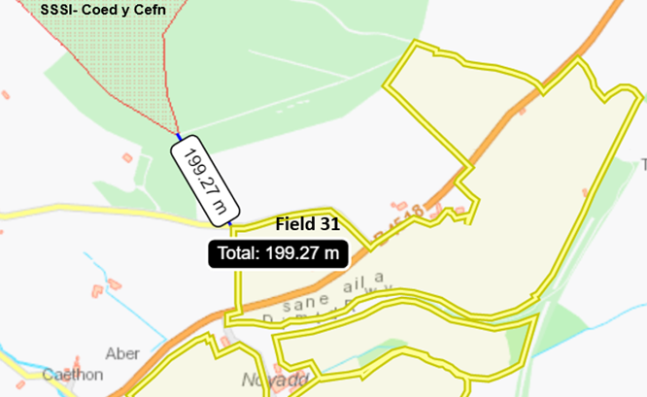  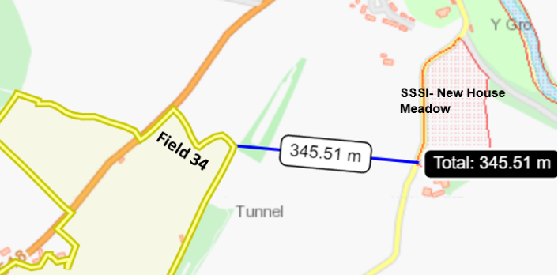  Field 29 & 36 are located next to the Upper Wye Tributaries SSSI. The landspreading activity may damage the features of this SSSI due to the close proximity the fields are to the SSSI therefore the risk to this SSSI site will be considered going forward in this form.  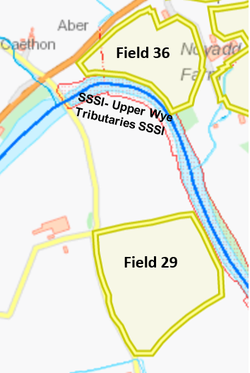
- Has there been any pre-application discussion or correspondence with NRW conservation/ecology | NO.
- What aspect(s) of the proposed permission may damage the features which are of special interest for the SSSI?

The following ‘Operations Requiring Consent’ (or other activities associated with the permission) that may cause damage) are relevant to the proposed permission.

Upper Wye Tributaries SSSI

7. Dumping, spreading, discharging or storage of any materials.

26. Use of vehicles, vessels or craft likely to damage riparian features or disturb species of interest.

The following SSSI features and mechanisms of impact have been considered to assess the likelihood of damage:

Mammals

- Otters

Fish

- Atlantic salmon

- Twaite shad

- Sea lamprey

- Brook lamprey

- River lamprey

- Bullhead

Plants

- Wild chives

- whorled water-milfoil

- scarce mosses and liverworts

- gravel grimmia

- Spruce’s bristle moss

- rock cinquefoil

Lichens

- Porocyphus kenmorensis

- Pterigiopsis lacustri

- River-jelly lichen

Habitats

Medium sized to large river with moderate nutrient status, including stands of vegetation dominated by water crowfoot, with acidic, nutrient-poor headwaters upstream. The area is also known for a wintering area for goosander.

The site also supports aquatic invertebrates i.e. Potamanthus luteus (mayfly) & shingle dwelling invertebrates.

The following SSSI features and mechanisms of impact have been considered to assess the likelihood of damage:

Deterioration of water quality, nutrient enrichment and algal blooms, through surface water run-off and/or leaching

- Decision
i) The proposed permission is not likely to damage any of the flora, fauna or geological or physiological features which are of special interest.
.
- Field 36 that borders the SSSI contains a 35 meter no spread buffer zone located next to the SSSI to account for highly sloping land. The no spread buffer zone mitigates the risk of surface runoff containing nutrients and/or PTEs (Al and Fe) into the SSSI.

- Field 29 that borders the SSSI contains a 20 meter no spread buffer. The no spread buffer zone mitigates the risk of surface runoff containing nutrients and/or PTEs (Al and Fe) into the SSSI.

- To mitigate the risk of flood waters removing nutrients from soils into the SSSI, fields that border the SSSI (fields 29 & 36) will not receive waste in Oct and Apr. Due to the area experiencing historical flooding at these times of year.

- All highly sloping areas (12º+) have been buffered by no spread zones reducing the risk of surface runoff.

- 7 out of the 8 fields in this deployment have a soil index value of 1 or 0 for phosphorous meaning the soils will effectively uptake the phosphorous reducing the risk of surface runoff and/or leaching of phosphorous. Field 36 has a soil index value of 2 where the phosphorous addition matches crop offtake meaning the phosphorus reserve of the soil will not increase over a 12 month period.

- Water treatment sludges will be spread via a trailing shoe. The Digestate will be spread by a tractor and tanker using a dribble bar. Both application methods are appropriate for the waste types and apply the wastes directly to the ground to reduce the risk of surface runoff.

- No alum rich sludges will be spread on fields with a pH of less than 6 as per TGN 8.01 page 131. This includes fields closest to the SSSI (fields 29 & 36) so there is a lower risk of Al and Fe entering the SSSI and causing detriment to the SSSI.

- There is a 5 meter no spread buffer zone around the hedgerows for this deployment to mitigate the harm to plants/ organisms that are contained within the hedges.

- Spreading will only be undertaken when weather conditions are suitable within restrictions outlined in CoGAP and any relevant closed periods.

- Liquid spreading machinery will be turned off and lifted away from soil prior to turning at the end of each run.

- Machinery will be checked daily when in use, regularly serviced and spreading equipment calibrated. Umbilical hoses will be regularly checked for damage to prevent leaks.

- No more than 50t/ha will be spread on each field in any 3-week period and no more than 250t/h will be spread within any 12-month period.

- Delivery, storage and spreading will be done in accordance with CoGAP.

- Storage locations are far away from the SSSI with the closest storage tank ‘C’ located 90 meters from SSSI.

- Machinery will be checked daily when in use, regularly serviced and spreading equipment calibrated. Umbilical hoses will be regularly checked for damage to prevent leaks.

- Machinery turns will not be executed in the buffer strips.

- Waste deliveries to field/stores will be supervised.

- All spillages will be reported immediately to NRW.

Natural Resources Wales is minded to: Issue the permission

- Name and job title of Natural Resources Wales officer: | Owen Clee  Permitting Officer
- Date form sent to NRW conservation/ecology | 26/06/2023
For Natural Resources Wales use only, once NRW conservation/ecology response received
- NRW conservation/ecology comment on assessment: | ii) NRW conservation/ecology advise the operation can go ahead with conditions:  I agree with the appropriate assessment and the conditions set out in Section 11 of this form, with particular attention to Field 36 with a buffer zone of 35 metres and Field 29 with a buffer zone of 20 metres, both of which border the Upper Wye Tribs SSSI.
- Name and job title of NRW conservation/ecology officer: | Catherine Straw, N2K Officer, North and South Powys Environment Team
- Date of receipt of NRW conservation/ecology response: | 05/07/23

